Nanoscale transport phenomena of reaction materials in polymer electrolyte fuel cell
Takashi Tokumasu, Professor, Institute of Fluid Science, Tohoku University, Japan

Abstract (300 word limit)
Polymer Electrolyte Fuel Cells (PEFC) are expected to be as one of next-generation power supply systems due to its low environmental damage, high efficiency, and availability for dispersed power systems and emergency use. Transport resistance of reactant and product materials such as proton, oxygen and water is the determining factor of its efficiency and therefore it is necessary to analyze the transport phenomena of proton, oxygen and water in PEFC as fast as possible to increase its performance and efficiency. Computational Fluid Dynamics (CFD) based on macroscopic transport equations is often used as a conventional numerical analysis. A Membrane Electrode Assembly (MEA) of PEFC, however, consists of Gas Diffusion Layers (GDL), Micro Porous Layers (MPL), Catalyst Layers (CL), and a Polymer Electrolyte Membrane (PEM), where many nanoscale structures are constructed. In such flow fields, the characteristics of transport phenomena in MEA cannot be analyzed at the macroscopic point of view. Molecular simulation is a powerful tool to analyze these phenomena. In this study these nanoscale transport phenomena are analyzed by large scale Molecular Dynamics (MD) simulations and the relation between the nanoscale structures and the transport phenomena is analyzed in detail (Figure 1). Especially, the transport phenomena of proton in PEM which has highly anisotropic water structures, oxygen permeability, oxygen scattering and proton diffusivity of ionomer in CL, and the transport phenomena of nanoscale water droplet in MPL were simulated. In the analysis of proton transfer in PEM and ionomer, we considered not only Vehicle mechanism but also Grotthus mechanism and the diffusivity of proton at various water contents was estimated. This information leads to a new design concept of materials for next generation polymer electrolyte fuel cells.

Image
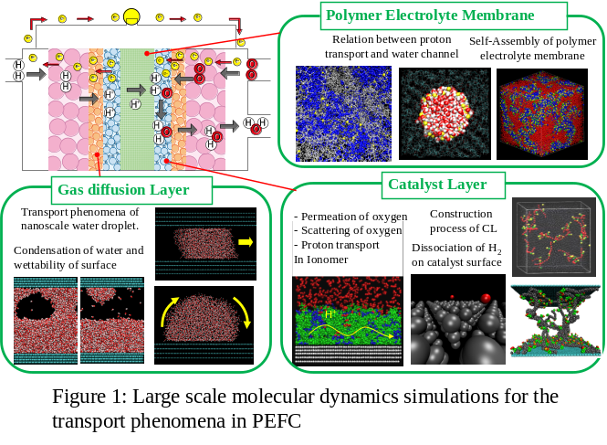
Recent Publications (minimum 5)
- Kurihara Y, Mabuchi T, Tokumasu T (2017) Molecular Analysis of Structural Effect of Ionomer on Oxygen Permeation Properties in PEFC. J. Electrochem. Soc. 164: F628-F637.
- Mashio T, Ohma A, Tokumasu T (2016) Molecular Dynamics Study of Ionomer Adsorption at a Carbon Surface in Catalyst Ink. Electrochimica Acta 202: 14-23.
- Fukushima A, Mima T, Kinefuchi I, Tokumasu T (2015) Molecular Dynamics Simulation of Channel Size Dependence of the Friction Coefficient between a Water Droplet and a Nanochannel Wall. J. Phys. Chem. C 119: 28396-28404
- Mabuchi T, Fukushima A, Tokumasu T (2015) A Modified Two-state Empirical Valence Bond Model for Proton Transport in Aqueous Solutions. J. Chem. Phys. 143: 014501.
- Sakai H, Tokumasu T (2015) Quantum Chemical Analysis of the Deprotonation of Sulfonic Acid in a Hydrocarbon Membrane Model at Low Hydration Levels. Solid State Ionics 274: 94-99.

Biography (150 word limit)
Takashi Tokumasu is a professor of Institute of Fluid Science, Tohoku University. He has his expertise in analyzing nanoscale flow phenomena. Especially, he is focusing on the effect of quantum characteristics of molecules on macroscopic flow and thermodynamic phenomena. Moreover, he applies this technique and knowledge to the development of materials for next generation fuel cells. He performs large scale molecular dynamics simulations to analyze such nanoscale flow phenomena. He developed a molecular model which can treat proton hopping by classical molecular dynamics method (Mabuchi, Fukushima and Tokumasu, 2015). By using this model the relation between nanoscale structures of material and nanoscale flow phenomena of reactant and product materials can be analyzed. He also analyzes the transport mechanism of ions in solid materials.

Email: tokumasu@ifs.tohoku.ac.jp

Notes/Comments:

