Optoelectronic Studies on Hybrid Perovskites Films for Solar Cells Applications

M. Solis de la Fuente, PhD, Lawrence Berkeley National Laboratory, USA
S. Coria Monroy, PhD, Lawrence Berkeley National Laboratory, USA
Ting Zhang, PhD, Lawrence Berkeley National Laboratory, USA.

Abstract

Novel materials have been development for overcoming the challenge of solar cells with low cost and high efficiency. Recently hybrid perovskites ABX₃ [ A= CH₃NH₃⁺, CH=CHNH₃⁺; B= Pb⁺², Sn⁺²; X= I⁻²] solar cells have reached high power conversion efficiencies above 20% using simple manufacture methods and low temperature deposition, which have generated great interest in scientific-technological areas for the commercialization. Perovskites solar cells (PSCs) could compete respect to silicon technologies however present critical issues in thermal stability under external factors (moisture, light-oxygen, heat) as well as lack of reproducibility in fabrication methods. This work is focused on structural- optoelectronic studies on CH₃NH₃PbI₃ to understand the interface influence on the degradation process.

The CH₃NH₃PbI₃ films were realized by one-step spin coating and characterized by x-Ray Diffraction and Photoluminescence PL. The films showed a smooth surface with excellent cover on glass and high PL like have been reported in previous works. We prepared solar cells (ITO/PEDOT: SS/CH₃NH₃PbI₃/PCBM/Al) and measured Current-Voltage (J-V) and Electrochemical Impedance Spectroscopy (EIS). Important differences were observed in rapid and low process (frequency) when the devices were put under illumination before IS measurements. Significant structural changes were observed by XRD. Optical studies reveal degradation mechanisms, which they are going to discuss.

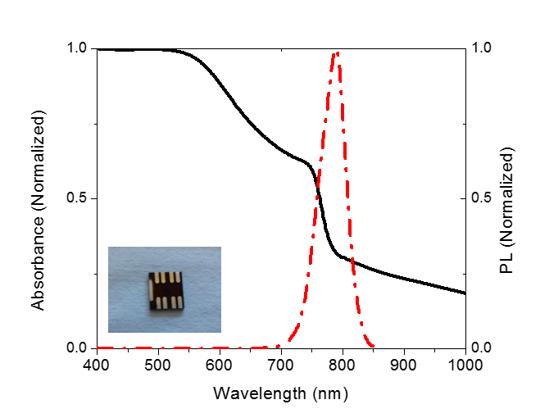
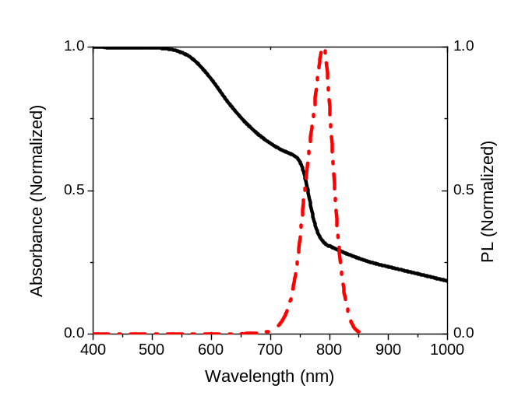

Recent Publications
1. Antonio Abate, Michael Gratzel et. al (2015). Silolothiophene –linkedtriphenylamines as stable hole transporting materials for high efficiency. Energy Environ. Sci., 8, 2946.
2. Seigo Ito (2014) Effects of surface blocking layer of Sb2S3 on Nanocristalline TiO2 for CH3NH3PbI3 Perovskite Solar Cells, J. Phys. Chem. C, 118, 2.
3. Simone Guarnera, Antonio Abate. (2015). Improving the long-term stability of perovskites solar cells with a porous Al2O3 buffer layer. J. Phys. Chem. Lett. 6. 432-437.
4. Jing Zhang, Zhelu Hu. (2015). Bifunctional Alkyl chain barriers for efficient perovskite solar cells. Chem Commun, 51, 7047-7050.
5. Xiaobao Xu. (2015). Hole Selective NiO Contact for Efficient Perovskite Solar Cells with Carbon Electrode. Nano Letters, 15, 2402-2408.

 Biography
Mauricio Solis de la Fuente PhD in engineering UNAM México. He is currently a postdoctoral student at LBNL California United States
Areas of interest: renewable energy, solar cells, light emitting diodes (LEDs), metallic oxide and semiconductor quantum dot synthesis, optoelectronic characterization hybrid perovskites, thin films growth.
..
Email: mauricio@lbl.gov

Notes/Comments:

