Enhancing the photocatalytic activity for pollutant degradation and H₂ evolution by modifying ZrO₂ with nanoclusters of BiVO₃, Ag₃PO₄, SrTiO₃ and WO₃: A first-principles study

Francis Opoku¹, Krishna Kuben Govender², Cornelia Gertina Catharina Elizabeth van Sittert³, Penny Poomani Govender^{1*}

1Department of Applied Chemistry, University of Johannesburg, P. O. Box 17011, Doornfontein Campus, 2028, Johannesburg, South Africa
2Center for High Performance Computing, 15 Lower Hope Road, Rosebank, Cape Town, 7700
3Research Focus Area for Chemical Resource Beneficiation: Laboratory of Applied Molecular Modelling, North-West University, Potchefstroom, 2520, South Africa

*Corresponding author. Tel: (+27) 011-5596555; Fax: (+27) 011 559 6425; E-mail: pennyg@uj.ac.za

Abstract
Environmental pollution and energy exhaustion has received much interest both in scientific and industrial research fields. For this reason, tremendous efforts are made to design novel environmentally friendly non-polluting and sustainable energy storage photocatalysts for efficient solar energy harvesting and conversion. Semiconductor-based photocatalysis has received increasing attention in energy storage and environmental remediation process due to the abundantly solar energy. For this purpose, several heterostructures using BiVO₄, Ag₃PO₄, SrTiO₃ and WO₃ monolayers coupled with ZrO₂ nanocluster are designed to examine their potential applications in energy storage and degradation of pollutants using density functional theory calculations for the first time. Moreover, the underlying mechanism, band edge positions, optical and electronic properties of the ZrO₂-based heterostructures are evaluated. The results displayed that the calculated band gap of the heterostructures is reduced compared to the pure ZrO₂, which favour redshift absorption. A type-I band alignment was attained for the BiVO₄/ZrO₂, Ag₃PO₄/ZrO₂ and WO₃/ZrO₂ heterostructures. More importantly, the type-II staggered band alignment formed in the SrTiO₃/ZrO₂ heterostructure restrained the charge recombination rate of the photoinduced carrier charges, as well as enhancing the photocatalytic activity. Our results display efficient charge separation and visible light response of the BiVO₄/ZrO₂, Ag₃PO₄/ZrO₂, WO₃/ZrO₂ and SrTiO₃/ZrO₂ heterostructures. In particular, suitable band alignment of SrTiO₃/ZrO₂ with enough driving forces for charge carrier transfer show overall water splitting and degradation of pollutant in which SrTiO₃ acted as the charge separation centre. Thus, the SrTiO₃/ZrO₂ heterostructure emerges as a new type of ZrO₂-based photocatalyst for efficient solar energy applications. Furthermore, h⁺, HO• and O₂^{−•} radicals played a major role in the photocatalysis process. Finally, possible charge separation and photocatalytic mechanisms of BiVO₄/ZrO₂, Ag₃PO₄/ZrO₂, WO₃/ZrO₂ and SrTiO₃/ZrO₂ heterostructures are proposed.

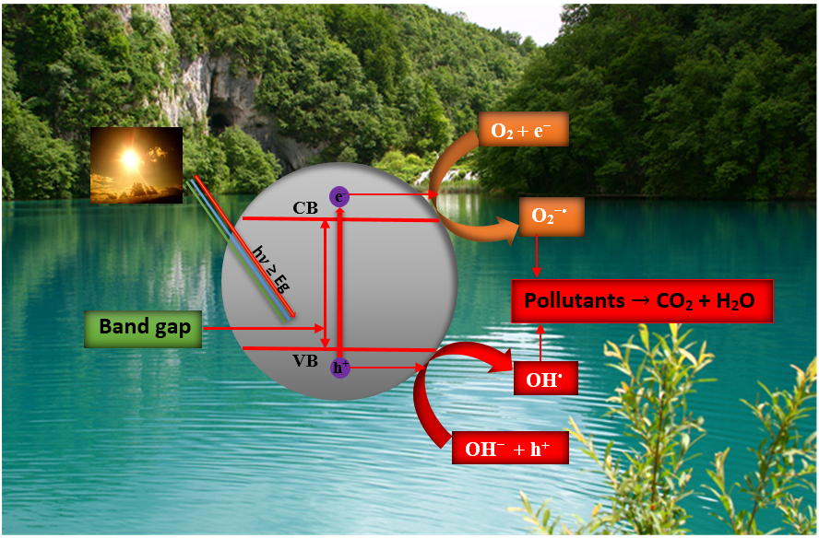
Figure 1. Schematic of the photodegradation mechanism of organic pollutants in water resources.
Recent Publications (minimum 5)
- Opoku F, Govender KK, van Sittert CGCE, Govender PP (2017) Recent progress in the development of semiconductor-based photocatalyst materials for applications in photocatalytic water splitting and degradation of pollutants. Advanced Sustainable Systems. In Press. DOI: 10.1002/adsu.201700006.
- Agorku ES, Kwaansa-Ansah EE, Voegborlo RB, Amegbletor P, Opoku F (2016) Mercury and hydroquinone content of skin toning creams and cosmetic soaps, and the potential risks to the health of Ghanaian women. SpringerPlus 5:319.
- Boateng TK, Opoku F, Acquaah SO, Akoto O (2016) Groundwater quality assessment using statistical approach and water quality index in Ejisu-Juaben Municipality, Ghana. Environmental Earth Sciences 75:1-14.
- Nkansah MA, Opoku F, Ackumey AA (2016) Risk assessment of mineral and heavy metal content of selected tea products from the Ghanaian market. Environ Monit Assess 188:1-11.
- Nkansah MA, Opoku F, Ephraim JH, Wemegah DD, Tetteh LP (2016) Characterization of Beauty Salon Wastewater from Kwame Nkrumah University of Science and Technology, Kumasi, Ghana, and Its Surrounding Communities. Environ Health Insights 10:147.
- Opoku F, Asare-Donkor NK, Adimado AA (2014) Theoretical study of the gas-phase decomposition of Pb[(C₆H₅)₂PSSe]₂ single-source precursor for the chemical vapour deposition of binary and ternary lead chalcogenides. Can J Chem 93:317-325.
- Opoku F, Asare-Donkor NK, Adimado AA (2015) Quantum mechanical study of the kinetics, mechanisms and thermodynamics of the gas-phase decomposition of Pb[(^{i}Pr)₂PSSe]₂ single-source precursor. J Organomet Chem 787:33-43.
- Opoku F, Asare-Donkor NK, Adimado AA (2015) Theoretical studies of the decomposition of Zn[(^{i} Pr)₂PSSe]₂ single-source precursor in the gas phase for the chemical vapor deposition of binary and ternary zinc chalcogenides. Comput Theor Chem 1058:1-11.
- Opoku F, Asare-Donkor NK, Adimado AA (2015) Thermal decomposition of Zn[(C₆H₅)₂PSSe]₂ single-source precursor for the chemical vapour deposition of binary and ternary zinc chalcogenides: a theoretical study. SpringerPlus 4:266.
- Opoku F, Asare-Donkor NK, Adimado AA (2016) A comprehensive understanding of the chemical vapour deposition of cadmium chalcogenides using Cd[(C₆H₅)₂PSSe]₂ single-source precursor: a density functional theory approach. Chem Cent J 10:4.
- Opoku F, Asare-Donkor NK, Adimado AA (2014) Density functional theory (DFT) study of the gas-phase decomposition of the Cd[(^{i}Pr)₂PSSe]₂ single-source precursor for the CVD of binary and ternary cadmium chalcogenides. J Mol Model 20:2484.


Francis Opoku received his BSc. (Hons) Chemistry (2010) and M.Phil. Inorganic Chemistry (2014) degrees from the Kwame Nkrumah University of Science and Technology, Ghana. He is now pursuing a PhD degree in Chemistry under the supervision of Dr Penny Poomani Govender, Dr Krishna Kuben Govender and Dr Cornelia Gertina Catharina Elizabeth van Sittert in the Department of Applied Chemistry, University of Johannesburg, South Africa. His research interests include the design of efficient semiconductor-based photocatalyst materials and their applications in water splitting as well as degradation of pollutants in wastewater/water resources.
Email: ofrancis2010@gmail.com

