Light driven directional mass transport of azo-benzene containing materials for complex tri-dimensional structures on surfaces

Stefano L. Oscurato¹, Fabio Borbone², Pasqualino Maddalena¹ and Antonio Ambrosio³

¹ Physics Department “E. Pancini”, University of Naples “Federico II”, Italy.
² Chemistry Department University of Naples “Federico II”, Italy.
³ Center for Nanoscale Systems, Harvard University, Cambridge, Massachusetts 02138, USA.

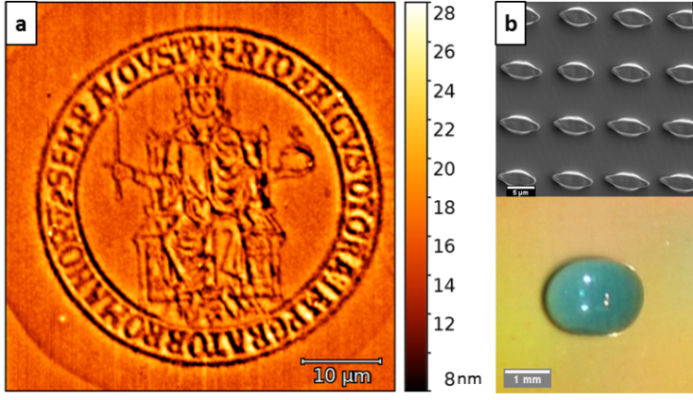
Abstract
Inspired by nature, in the last years the role of the topography of superficial textures in determining surface functionalities is increasingly recognized and the fabrication of controlled tridimensional textures became a demanding point of material science because of the potential applications in many fields as photonics, functional and smart surfaces. Standard fabrication techniques, including photo-lithography, Electron Beam and Focused Ion Beam lithography, self-assembly, soft lithography etc, often require multi-step processes in order to realize 3D architectures and the fabricated geometries are rarely further tunable. However, the light-induced mass migration phenomenon arising in photo-responsive azo-benzene containing materials opens to new fabrication approaches. Under illumination, the azo-benzene molecules exhibit photo-isomerization trans-cis-trans cycles. This microscopic motion drives a reorganization of the host material, typically a polymer, in which the molecules are embedded, resulting in a macroscopic material displacement. This material motion is highly directional and occurs in the illuminating light polarization direction. Recently, our group proposed phenomenological models to deterministically predict the topography of the azo-surfaces resulting from light-surface interaction in different configurations. So the light-driven mass migration can be actually used to fabricate new classes of surface topographies, which can be even further modified once fabricated. Here we demonstrate the potentiality of this technique by realizing tri-dimensional complex superficial patterns based either on spatially structured illumination light patterns or on reshaping of pre-patterned surface architectures. Spatially modulated intensity patterns are achieved in a versatile way by phase-modulating a laser beam through a computer controlled spatial light modulator, resulting in topography modulation of the azo-surfaces, even with high spatial resolution (Fig. 1a). On the other side, tri-dimensional architectures are obtained by reshaping pristine pre-patterned micron-posts in simple illumination condition. These resulting structures are proven to produce a change in the wetting behavior of the textured surface with a demonstrated controlled directional droplet spreading (Fig. 1b).
Figure 1|(a) AFM image of our institutional logo, holographically inscribed in azo-polymer thin film using a high NA microscope objective. (b) Asymmetric micro-sized pillars of azopolymer obtained by reshaping pristine cylindrical posts with linear polarized light, able to induce macroscopic asymmetric wetting behavior.

Image

Recent Publications
- Ambrosio, A., Marrucci, L., Borbone, F., Roviello, A., & Maddalena, P. (2012). Light-induced spiral mass transport in azo-polymer films under vortex-beam illumination. Nature communications, 3, 989.
- Galinski, H., Ambrosio, A., Maddalena, P., Schenker, I., Spolenak, R., & Capasso, F. (2014). Instability-induced pattern formation of photoactivated functional polymers. Proceedings of the National Academy of Sciences, 111(48), 17017-17022.
- Lee, S., Kang, H. S., Ambrosio, A., Park, J. K., & Marrucci, L. (2015). Directional Superficial Photofluidization for Deterministic Shaping of Complex 3D Architectures. ACS applied materials & interfaces, 7(15), 8209-8217..
Ambrosio, A., Orabona, E., Maddalena, P., Camposeo, A., Polo, M., Neves, A. A. R., ... & Roviello, A. (2009). Two-photon patterning of a polymer containing Y-shaped azochromophores. Applied Physics Letters, 94(1), 011115..
5. Ambrosio, A., Camposeo, A., Carella, A., Borbone, F., Pisignano, D., Roviello, A., & Maddalena, P. (2010). Realization of submicrometer structures by a confocal system on azopolymer films containing photoluminescent chromophores. Journal of Applied Physics, 107(8), 083110.

Email: oscurato@fisica.unina,it

