Development of an Actuation System Mechanism for Extension and Retraction of Flight Control Surface by Utilization of a Shape Memory Polymer
Mayukh Jyoti Chakraborty¹, Mukul Batra¹, Shreshth Kanugo¹
Lalit bhola² and Sudhir Kumar Chaturvedi²
¹student, ²faculty, Department of Aerospace Engineering
University of Petroleum & Energy Studies
Dehradun, India
batra.mukul1996@gmail.com, chakrabortymayukhjyoti@gmail.com, shreshthk96@gmail.com

Abstract— the following paper presents an idea of implementation of an actuation system for the extension and retraction of flaps in aircraft control surfaces, made up of shape memory polymer material having the intrinsic property of shape recovery upon application of heat. Shape memory polymers are a type of macro-molecular smart material that can respond to external stimulus with change in macroscopic properties and can recover its original shape upon heating. SMPC (Shape Memory Polymer) materials have the ability to undergo deformation which can later be recovered to transform back into its original shape. The intrinsic property of shape memory polymers of changing their shape as a function of temperature can be utilized for deflection of the flight control surfaces during flight.

Keywords— Aircraft, Flight Control Surfaces, jet Smart Materials, Shape Memory Polymer , Actuation system, polymer.

INTRODUCTION

If we look at the Global market forecast for the future upcoming years in the aviation industries and the air transport system evolution, accounting for factors such as demographic and economic growth, tourism trends, oil prices, development of new and existing route, the demand for manufacturing of more aircrafts is predicted to increase at an exponential rate to keep at per with the demand. Taking into consideration of the cost of production and the fuel consumption, emphasis should be given to reduce the weight of the aircraft as minimum as possible. Now the flight control systems which are used by the pilot to control the aircraft’s direction and attitude consists of the primary control system & the secondary control system operated by hydro-mechanical & pneumatic designs, consisting of a mechanical circuit and a hydraulic/pneumatic circuit. But Mechanical, hydro-mechanical and pneumatic flight control systems are relatively heavy and require careful routing of flight control cables through the aircraft by systems of pulleys, cranks, tension cables and hydraulic pipes, both systems often require redundant backup to deal with failures, which increases weight and both have limited ability to compensate for changing aerodynamic conditions. They require regular inspection and maintenance after every flight.
The spontaneous polarization of an anisotropic material can lead to the generation of voltage generation by utilizing the waste energy that is lost from the turbines. The energy produced is a clean energy source and can be reused for sustainable energy management.
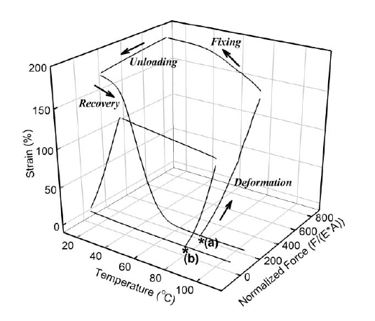
Plot-1
3-D plot of shape-memory cycle for (a) a shape-memory polymer and (b) natural rubber. The star indicates the start of the experiment (initial sample dimensions, temperature, and load). Both the SMP and the rubber were deformed under constant loading rate at constant temperature. The deformation step was then followed by a cooling step under constant load. At low temperature, the load was removed and shape fixing was observed for SMP, but an instant recovery was seen for natural rubber. Shape recovery of primary equilibrium shape was obtained by heating the SMP. This plot was adopted with reference [2].

Theory

The actuating system developed by the Shape memory polymer material, the system will be robust and light weight which substantially reduces the weight of the aircraft and ensures requisite results at the same time. The polymer can change its physical state from a rigid polymer to a very elastic state, and then back to a rigid state again. In its elastic state, it will recover its "memory" shape if left unrestrained. This polymer based actuating system will have more fatigue strength, high capacity for elastic deformation, much lower cost, lower density, easy processing, and probably exhibit superior mechanical properties. It can be stretched, folded, or otherwise conformed to other shapes, tolerating up to 200% elongation without degradation of the material even after constant engagement of temperature change. So in a way, we are cutting down the gross weight of the aircraft & at the same point of time but providing reliability of proper functioning at the same point of time. This will prove economical for it will increase the fuel efficiency and reduce the maintenance cost at the same time.
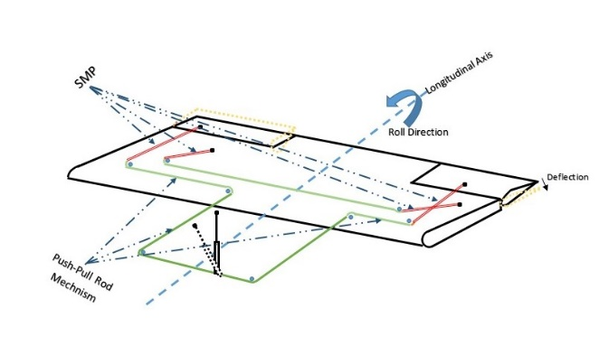

Figure-1(Aileron Deflection using shape memory polymer)

Shape memory materials as name justifies are the material which remember macroscopic shapes under specific temperature condition but later relax to the original state. With the help of shape memory effect, there are two stable crystal structures: a high temperature favored austenitic phase and a low temperature favored martensitic phase.
There are some polymeric materials that have ability to show shape memory effect unlike in some materials which show shape memory effect where recovery to the original position is done by martensite- austenite phase transition. Hence, temporary shape is fixed at a single temperature slightly below the room temperature and recovery occurs upon increasing the temperature beyond the martensitic transformation temperature. When we consider shape memory polymer, they achieve temporary strain fixing through many physical ways. Due to covalently bonded, shape memory polymers are more elastic towards strain.
The implementation of the idea in the development of the actuation system will result in manufacturing of a light weight and robust actuating mechanism, which will lead to a significant reduction in the gross aircraft weight, resulting in a reduction in the fuel requirement for each flight operation. This will significantly result in the reduction in the price for flight tickets & over surging of flight ticket price. Moreover, the hydro mechanical systems require regular checkup and replacement of hydraulic fluid after every flight operation to ensure safe flight. The systems are relatively heavy and require careful routing of flight control cables through the aircraft by systems of pulleys, cranks, tension cables and hydraulic pipes, both systems often require redundant backup to deal with failures. The proposed actuation system will require significantly less amount of maintenance, which will save time, reduce manpower, resulting in a more sustainable and economical actuating system for future.

OPERATION

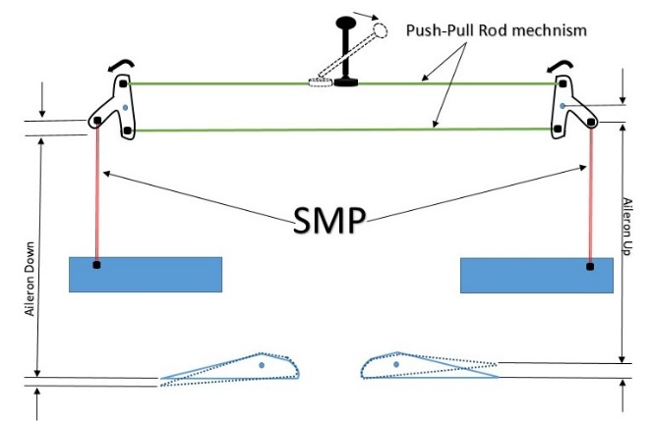
Figure-2(Experimental Setup)
In a Typical aircraft control system, the flaps in a plane are hinged with the wing and deployed with the help of pneumatic or hydraulic actuation system. Instead of using complex pneumatic and hydraulic system for the actuation of control surfaces we can use shape memory effect of shape memory polymers polymer s. We can do this by incorporating a thin SMPC strip of suitable thickness and size at the hinge location which, when actuated using heating and cooling the material, deploy the flap (extended position).
Firstly the flap will be attached to the wing using SMPC strip at the hinge position. That SMPC is connected to an electric circuit and passage of current in the circuit will generate heat due to the phenomenon of Joules law of heating. The heat produced will be the external stimuli for deforming the SMPC strip. For deploying the flaps, circuit will be switched on which will raise the temperature of the SMPC strip to glass transition temperature (TG). At this temperature the strip will bend due to weight of flaps. Now for locking the flaps in deployed position we will cool down SMPC strip by switching off the circuit.
For retraction of flaps, the SMPC strip is then again heated to glass transition temperature TG by switching on the circuit. The SMPC strip then returns to its original shape which retracts the flap in neutral position according to the shape memory effect. The material will be insulated which will isolate it from the atmospheric interference.

CONCLUSION

The application of the Shape memory polymers will help in increased overall aircraft performance enhancing the range and endurance for a particular aircraft system. This can be used as potential system for actuation as a substitute for conventional hydraulic and pneumatic systems. As shape memory polymer material has enhanced fatigue life, low creep loading, light weight, the overall actuation system developed from a Shape Memory Polymer will be simple, robust and lightweight which will increase overall efficiency of an aircraft system in terms of its aerodynamic performance.

REFERENCE

[1] Abrahamson, E.R., Lake, M.S., Munshi, N.A., Gall, K., 2003. Shape memory mechanics of an elastic memory composite resin. J. Intell. Mater. Syst. Struct. 14, 623–632.
[2] C. Liu, H. Qin and P. T. Mather, Review of progress in shape of shape-memory polymer, 2007, pp- 2,3.
[3] Davis, K.A., Burdick, J.A., 2003. Photoinitiated crosslinked degradable copolymer network for tissue engineering applications. Biomaterial 24, 2485–2495.
[4] Gall, K., Mikulas, M., Munshi, N.A., 2000. Carbon fiber reinforced shape memory polymer composites. J.Intell. Mater. Syst. Struct. 11, 877–886.
[5] Jeon, H.G., Mather, P.T., Haddad, T.S., 2000. Shape memory and nanostructure in poly(norbornyl-POSS) copolymers. Polym. Int. 49, 453–457.
[6] Jeong, H.M., Lee, S.Y., Kim, B.K., 2000. Shape memory polyurethane containing amorphous reversible phase. J. Mater. Sci. 35, 1579–1583.
[7] Lendlein, A., Langer, R., 2002. Biodegradable, elastic shape-memory polymers for potential biomedical applications. Science 296, 1673–1676.
[8] Lendlein, A., Schmidt, A.M., Langer, R., 2001. AB-polymer networks based on oligo (e-caprolactone) segments showing shape-memory properties. Proc. Natl. Acad. Sci. USA 98, 842–847.
[9] Liang, C., Rogers, C.A., Malafeew, E., 1997. Investigation of shape memory polymers and their hybrid composites. J. Intell. Mater. Syst. Struct. 8, 380–386.
[10] Metcalfe, A., Desfaits, A., Salazkin, I., 2003. Cold hibernated elastic memory foams for endovascular interventions. Biomaterials 24, 491–497.
[11] Metzger, M.F., Wilson, T.S., Schumann, D., 2002. Mechanical properties of mechanical actuator for treating ischemic stroke. Biomed. Microdevices 4, 89–96.
[12] Takahashi, T., Hayashi, N., Hayashi, S., 1996. Structure and properties of shape memory polyurethane block copolymers. J. Appl. Polym. Sci. 60, 1061–1069.
[13] Zhu, G., Liang, G., Xu, Q., Yu, Q., 2003. Shape-memory effects of radiation cross-linked poly (ecaprolactone). J. Appl. Polym. Sci. 90, 1589–1595.
[14] Shanmugasundaram,O L,2008. Shape Memory Polymers & their applications. The Indian Textile Journal January 2008.

