Preparation Of Chitosan Nano-Particles By Method Of Chemical Hydrolysis

Nada Najafzadeh¹, Sima Habibi¹, Mohammad Reza Allah GholiGhasri¹

^{A} Departmentof Technical &Engineering,Islamic Azad University OfYadegare Imam KhomeiniRah, Share-Rey Branch,
Tehran, 1815163111, Iran
Najafzadeh.neda@gmail.com

Abstract
Due to the vital contribution of Nanotechnology science in advancement of various industries, its necessary role in textile and medical industries cannot be ignored also. One of the bio-compatible polymers with biodegradability and non-toxicity is Chitosan. Chitin and Chitosan are natural amino poly saccharin, according to the unique structure and high-performance of its multi-dimensional characteristics, it have brilliant and workable usage in various industries, particularly in the medical, textile, surface modifying, tissue engineering, wound healing and drug delivery that have been focused on it mostly during recent years. If mentioned polymer transmits to Nano-phase in range of Nano surface it will cover up the surfaces with very small amounts of the substance. We are facing at pioneer research on the preparation of Chitosan Nano-particles to enhance the ratio of surface area to volume and increased use of bio-polymer at mentioned industries. To prepare the Nano-chitosan, Chitosan was hydrolyzed in acidic medium molecular weight and particle size by TEM and SEM has been confirmed. Chitosan crystalline particles were analyzed by X-ray diffraction XRD also.

Keywords:"Chitosan" “Nanotechnology” "Textile" "Tissue Engineering"

Images:

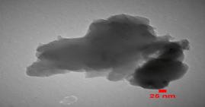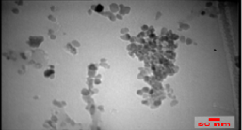
- (b)
Figure1. (A and B) SEM image of Nano-chitosan particles
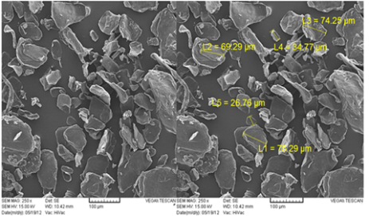
Figure2. Scanning electron micrographs of chitosan
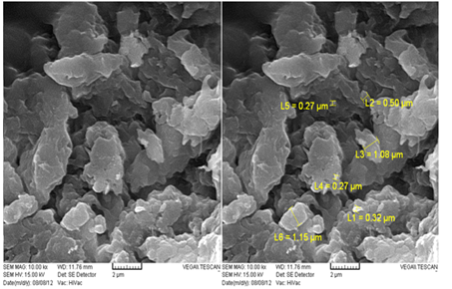
Figure3. SEM images of Nanoparticles of Chitosan
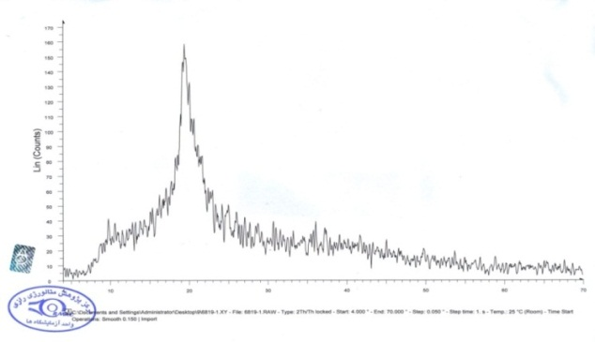
Figure4. X-ray diffraction pattern of dispersion of Nanoparticles of Chitosan
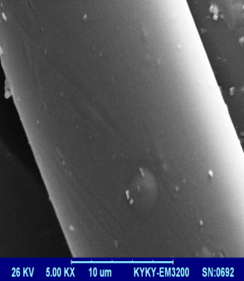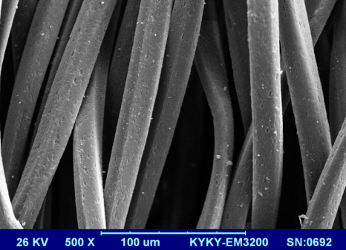
(a) (b)
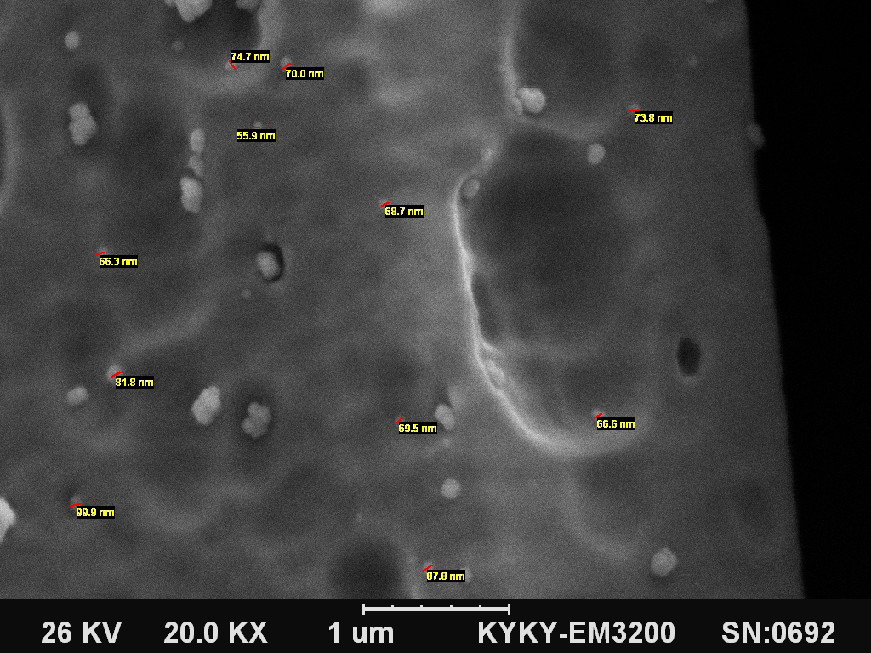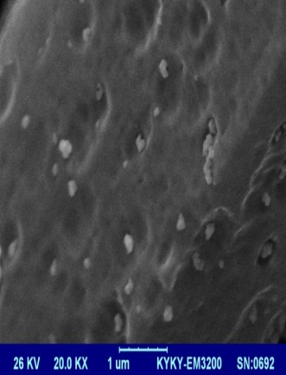
(c) (d)

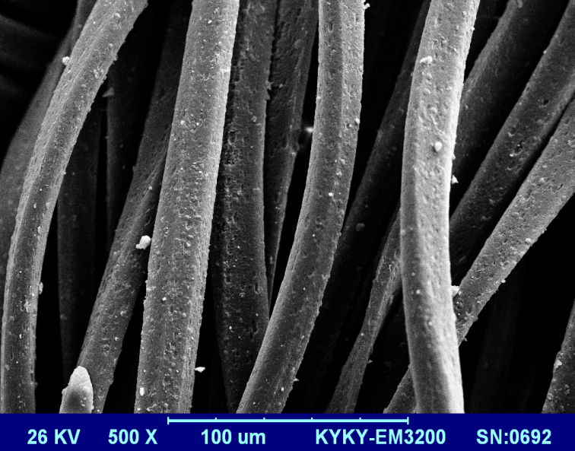
(f)
Figure5, Polyester surface coated with different percentage of Nano Chitosan

Recent Publications
- Preparing The Nanoparticles Of Chitosan To Modify Hydrolyzed Polyester” NANOTEK 2016, Arizona, Phoenix.
- Preparation Of Nano-Chitosan In Purpose Of Textile & Medical Industries, On 2nd International Conference In New Research Achievements On Chemistry & Chemical Engineering.(At Amirkabir University, Tehran, Iran), April, 2016.
- A review on preparation of Nano chitosan to surface Modification of Textiles , On 4th National Conference Of Textile Engineering , Polymer , Textile and Clothing Design at Islamic Azad University of Yazd, Iran, February 2016.
- The Different Methods of polyester modification on Industry & Textile Engineering, Conference, Islamic Azad University Yadegar-e-Imam Khomeini (RAH) Shahre Rey Branch 25 of May, 2015, Tehran , Iran.

Biography
I am a holder of Master degree in Chemical - Textile Engineering from Azad University, where is one of the best centers in this field in Iran.
I have done some researches in the areas of research in Mechanical Characterization, Bio polymers and Materials Chemistry Sciences. Moreover, I have done some of publications related to mentioned backgrounds, which mostly deals with the Nano Bio polymer and Nano Materials as well as Physical and Chemical Surface Modification in Nano Technology and Chemistry in Materials and Bio Materials.

Email: Najafzadeh.neda@gmail.com

Notes/Comments:
Appreciate your kind attention.

