Dyeing Polyester Good Modified By Chitosan Nanoparticles With Reactive Dye
Nada Najafzadeh ¹, Sima Habibi¹, Mohammad Reza Allah Gholi Ghasri ¹
^{A} Department of Technical & Engineering, Islamic Azad University Of Yadegare Imam Khomeini Rah, Share-Rey Branch, Tehran, 1815163111, Iran

Najafzadeh.neda@gmail.com

Abstract
Considering the vital role of nanotechnology in various industries, the role of this technology in the textile industry can not be ignored. Textile dyeing and finishing industry is one of the sectors that are very important to pay attention and to update it. The fibres used in the textile industry, especially man-made fibre, polyester fibre have an effective chemical and importance physical properties, alone or mixed with other fibres have many applications, but also fibre dyeing operations is very difficult.If this material is nano-phase range of non-woven surface with small amounts of the substance will cover. Considering all the above, it was expected to biomass compatibility with the modified polyester products such as chitosan, be possible with conventional dyes for dyeing of polyester dyed in normal circumstances provided by them was impossible. In this alkaline hydrolysis commodities research modifying polyester, the chitosan was coated with different percentages. To prepare the nano-chitosan, chitosan in acidic medium molecular weight and particle size by TEM and SEM that Crystalline particles of chitosan was confirmed , also studied by X-ray diffraction. To investigate the link between chitosan and polyester functional groups of FTIR spectroscopy was used infrared radiation.
Keywords: "polyester" "dyeing" "Nano technology" "Nano chitosan" "reactive dye" "Nano Particles" "Bicompatible"

Images:

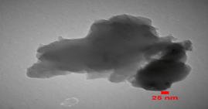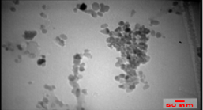
- (b)
Figure1. (A and B) SEM image of Nano-chitosan particles
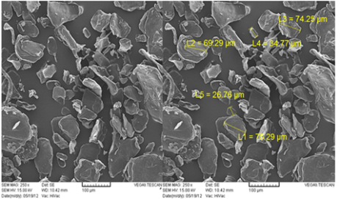
Figure2. Scanning electron micrographs of chitosan
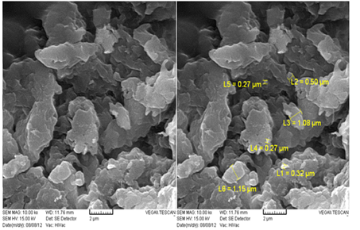
Figure3. SEM images of Nanoparticles of Chitosan
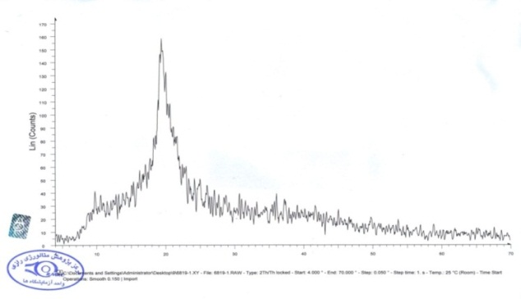
Figure4. X-ray diffraction pattern of dispersion of Nanoparticles of Chitosan
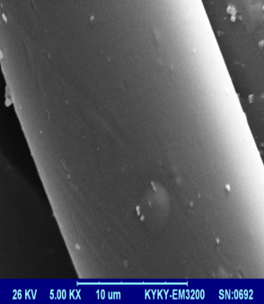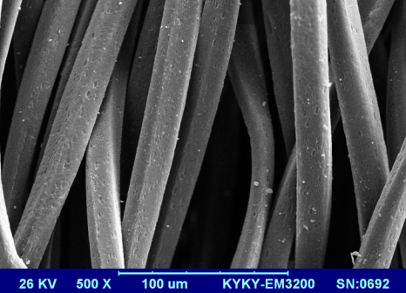
(a) (b)
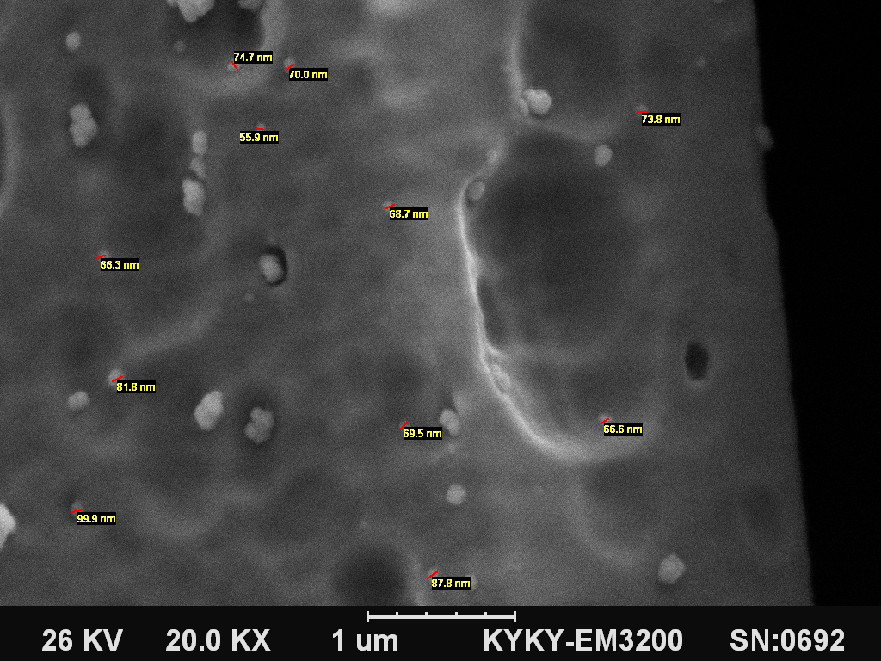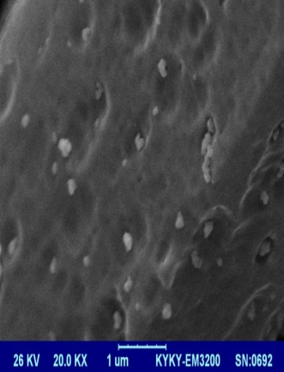
(c) (d)

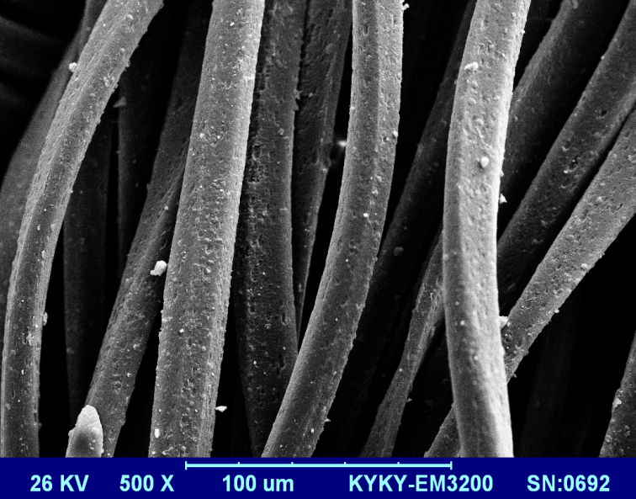
(f)
Figure5, Polyester surface coated with different percentage of Nano Chitosan

Recent Publications
- Preparing The Nanoparticles Of Chitosan To Modify Hydrolyzed Polyester” NANOTEK 2016, Arizona, Phoenix.
- Preparation Of Nano-Chitosan In Purpose Of Textile & Medical Industries, On 2nd International Conference In New Research Achievements On Chemistry & Chemical Engineering.(At Amirkabir University, Tehran, Iran), April, 2016.
- A review on preparation of Nano chitosan to surface Modification of Textiles , On 4th National Conference Of Textile Engineering , Polymer , Textile and Clothing Design at Islamic Azad University of Yazd, Iran, February 2016.
- The Different Methods of polyester modification on Industry & Textile Engineering, Conference, Islamic Azad University Yadegar-e-Imam Khomeini (RAH) Shahre Rey Branch 25 of May, 2015, Tehran , Iran.

Biography
I am a holder of Master degree in Chemical - Textile Engineering from Azad University, where is one of the best centers in this field in Iran.
I have done some researches in the areas of research in Mechanical Characterization, Bio polymers and Materials Chemistry Sciences. Moreover, I have done some of publications related to mentioned backgrounds, which mostly deals with the Nano Bio polymer and Nano Materials as well as Physical and Chemical Surface Modification in Nano Technology and Chemistry in Materials and Bio Materials.

Email: Najafzadeh.neda@gmail.com

Notes/Comments:
Appreciate your kind attention.

