Improving energy storage performance of polymers using small molecules
Jindong Wei and Z.-Y. Cheng, Materials Research and Education Center, Auburn University, Auburn, AL 36849-5341, USA

Abstract
The needs for flexible energy storage devices increase as the demands and applications of wearable electronics increase. Comparing batteries, capacitors have advantages as energy storage devices. Capacitors can be made of organics, inorganics, and organic-inorganic composites. Various polymers have been studied for energy storage application since polymers are flexible. To improve the energy storage performance of these polymers, different approaches have been studied, among which composite is widely concerned as an effective and promising method. Therefore, various dielectrics have been used to develop polymer-based composites, most of which are ceramic-polymer composites due to the fact that the ceramics have a higher dielectric constant and polymers can stand with a higher electric field so that the ceramic-polymer composites can exhibit a relative higher dielectric constant and stand with a relative higher electric field hopefully resulting in a higher energy density. Unfortunately, the embedment of ceramic particles into polymer severely reduces the flexibility of the polymer. To achieve a good uniformity, the thickness of the composite film must be much bigger than the size of ceramic particles, which limits the thickness of composite films. For polymer-polymer composites (i.e., polymer blends), the poor wettability between two polymers results in a poor morphology uniformity. Here a new approach is reported to improve the energy storage performance of dielectric polymers by mixing polymers with some special small molecules. It is experimentally found that a very small amount of these small molecules can significantly enhance the electric breakdown field of the polymers and, at the same time, the dielectric constant of the polymers also increases, which results in a significantly improved energy storage density. Additionally, the flexibility of the mixture is better than the pure polymer. Three different dielectric polymers and three different small molecules were used to demonstrate the advantage of the new approach.

Image

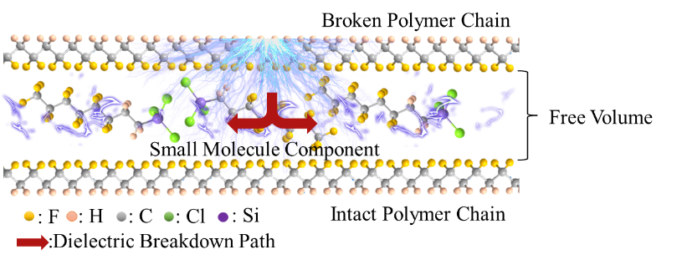
Figure 1: Effect of small molecules on electric breakdown process in dielectric polymer.
Recent Publications
- Yi Z, Wang Z, Nian W, Wang T, Chen H, and Cheng Z.-Y. (2021) ACS Appl. Energy Mater. 4:13528–13537.
- Mei Wi, Wei J, Ko Z, Cheng Z, Hu J (2021) Novel P (VDF-HFP)/BST nanocomposite films with enhanced dielectric properties and optimized energy storage performance. Ceramics International 47: 15561-15567
- Lu X, Zou X, Shen J, Zhang L, Jin L, Cheng Z (2020) High energy density with ultrahigh discharging efficiency obtained in ceramic-polymer nanocomposites using a non-ferroelectric polar polymer as matrix Nano Energy 70: 104551.
- Tong Y, Zhang L, Bass P, Rolin TD, Cheng ZY(2018) Influence of silane coupling agent on microstructure and properties of CCTO-P (VDF-CTFE) composites Journal of Advanced Dielectrics 8:1850008.
- Lu X, Zhang L, Tong Y, Cheng ZY (2019) BST-P (VDF-CTFE) nanocomposite films with high dielectric constant, low dielectric loss, and high energy-storage density Composites Part B: Engineering 168:34-43.


Biography
Jindong Wei received his master’s degree from Auburn University under the supervision of Prof. ZhongYang Cheng in 2019. He is currently pursuing his Ph.D. degree in Materials Engineering under the supervision of Prof. ZhongYang Cheng at Auburn University. His current research interests focus on energy storage and conversion materials, nanomaterials, and biomass materials, etc. After years of experience in research of polymer-based energy storage material, he found several kinds of small molecule components which can improve polymers' energy storage performance. Email: jzw0100@auburn.edu
Dr. Zhongyang (Z.-Y.) Cheng is a McWane professor in materials engineering and mechanical engineering at Auburn University. He is also leading the efforts of Auburn University Detection and Food Safety Center (AUDFS).

Notes/Comments:
Presenting author details
Full name: Zhongyang Cheng
Contact number: +1 334-844-3419
Twitter account:
Linked In account:
Session name/ number: Polymer Science and Application / Track 10
Category: (Oral presentation)

