Organic Chemistry beyond synthesis: new organic materials.

Iván Torres Moya. Department of Inorganic, Organic Chemistry and Biochemistry, Faculty of Chemical Science and Technologies, University of Castilla-La Mancha-IRICA, 13071, Ciudad Real, Spain

Abstract

Organic chemistry is the area of chemistry that deals with the study of molecules and compounds derived from carbon. The emergence of organic chemistry is often associated with the discovery in 1828 by the German chemist Friedrich Wöhler that the inorganic substance ammonium cyanate could be converted into urea.

The conception held by most of society is that an organic chemist is dedicated only to synthesis, and to "mixing" reagents to obtain new compounds, but it is necessary to take advantage of this possibility offered by organic chemistry, in collaboration with other branches of science, in what is known as interdisciplinarity, to go a step further and build what are called organic materials, which have great advantages over their inorganic analogues, such as their great chemical versatility, their capacity for modulation, their greater lightness and processability, their low cost and their biocompatibility. All this means that synthesis in the laboratory must go a step further, and that the compounds obtained in the laboratory can be applied in a wide variety of fields, such as organic electronics in the manufacture of organic field effect transistors (OFETs), in the field of photonics in the design of optical waveguides that are the fundamental components of photonic chips, as organogels for the crystallization of drugs or as biomarkers in cells and that are also capable of doing so selectively, demonstrating the potential of organic chemistry and its ability to allow the modulation of properties.

Image
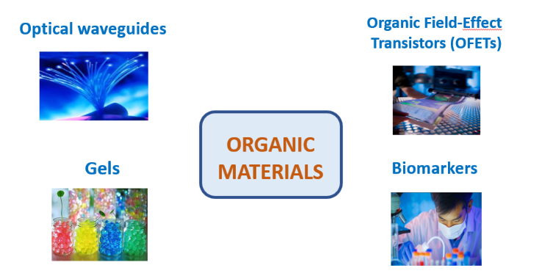Figure 1. Different fields of applications of organic materials.
Recent Publications
- Torres-Moya, I., Carrillo, J. R., Díaz-Ortiz, A., Prieto, P. New Organic Materials Based on Multitask 2H-benzo[d]1,2,3-triazole Moiety. Chemosensors, 2021, 9, 267.
- Pradeep, V.V.; Tardío, C.; Torres-Moya, I.; Rodríguez, A.M.; Kumar, A. V.; Annashasan, M.; De la Hoz, A.; Prieto, P.; Chandrasekar, R Mechanical Processing of Naturally Bent Organic Crystalline Microoptical Waveguides and Junctions. Small, 2021, 17, 2006795.

- Torres-Moya, I., Carrillo, J. R., Gómez, M. V., Velders, A. H., Donoso, B., Rodríguez, A. M., Díaz-Ortiz, Á., López-Navarrete, J., Ponce Ortiz, R., Prieto, P. Synthesis of D-π-A high-emissive 6-arylalkynyl-1,8-naphthalimides for application in Organic Field-Effect Transistors and optical waveguides. Dyes and Pigments, 2021, 191, 109358.

- Saikia, B., Mulvee, M. T., Torres-Moya, I., Sarma, B., Steed, J. W. Drug Mimetic Organogelators for the Control of Concomitant Crystallization of Barbital and Thalidomide, Cryst. Growth Des. 2020, 20, 7989–7996.

5. Vázquez-Guilló, R. Martínez Tomé, M. J, Kahyeci, Z., Torres-Moya, I., Falcó, A., Mallavia, R., Reyes-Mateo, C. Synthesis and Characterization of a Novel Green Cationic Polyfluorene and Its Potential Use as a Fluorescent Membrane Probe. Polymers, 2018, 10, 938

Biography 
Iván Torres Moya is an International Doctor by the University of Castilla-La Mancha (UCLM) in 2019, receiving the award for the best Thesis in Chemistry of that year by the Territorial Section of Castilla-La Mancha of the Royal Spanish Society of Chemistry (RSEQ) and has also received the first prize in the XII Young Science Symposium (2018).
He is currently a beneficiary of a talent retention program of the Junta de Comunidades de Castilla-La Mancha for young PhDs. His work is based on the design, synthesis, characterization and application of organic molecules in new materials, having worked in fields as diverse as optical waveguides, OFETs, solar cells, organogels, liquid crystals, organic lasers, biomarkers, polymers, etc.... Much of this training in such diverse fields is due to the 4 stays he has made at the University of Murcia, University of Malaga, Miguel Hernandez University of Elche and Durham University in UK.

Email: Ivan.TorresMoya@uclm.es

Presenting author details
Full name:
Contact number:
Twitter account:
Linked In account:
Session name/ number:
Category: (Oral presentation/ Poster presentation

