Synthesis and characterization of YMnO₃-GdMnO₃ solid solutions via sol-gel method
D. Karoblis, A. Zarkov, A. Beganskiene, A. Kareiva Institute of Chemistry, Vilnius University, Naugarduko 24, LT-03225 Vilnius, Lithuania
K. Mazeika, D. Baltrunas, Center for Physical Sciences and Technology, Vilnius LT-02300, Lithuania

Abstract

Recently, there has been a lot of interest in multiferroic materials, which exhibit two or more “ferroic” (ferromagnetism, ferroelasticity and ferroelectricity) properties at once. Those materials offer new range of applications like AC/DC magnetic field sensors, microwave resonators, new data storage media, gyrators and etc One of those materials is YMnO₃. It has a relative high Curie temperature (T_{C} ~ 900 K) and low Neel temperature (T_{N} ~ 70 K). It was shown, that this material can couple both ferroelectric and antiferromagnetic properties. Other perovskite type material, where magnetic and ferroelectric orders coexist is GdMnO₃. It was demonstrated that synthesis of different composition solid solutions is a promising tool for tuning of physical properties of functional materials.

In this study, solid solutions of YMnO3-GdMnO3 have been synthesized using an aqueous sol-gel method. The conditions for obtaining pure single-phase compounds were determined. The thermal behaviour of precursor gels was investigated by thermogravimetric and differential scanning calorimetry (TG-DSC) measurements. X-ray diffraction (XRD) analysis was performed for the characterization of phase purity and crystallinity. Rietvield analysis was employed to calculate lattice parameters of the synthesized species. For the investigation of structural properties of obtained solid solutions by Mössbauer spectroscopy, Mn ions were partially substituted with ⁵⁷Fe. Scanning electron microscopy (SEM) was employed for the estimation of morphological features. Moreover, YMnO3-GdMnO3 specimens were also characterized by FT-IR, Raman spectroscopy. Also magnetization measurements were carried out for all samples.

Acknowledgements

This work was supported by a Research grant BUNACOMP (No. S-MIP-19-9) from the Research Council of Lithuania.

XRD Image of some YMnO3-GdMnO3 solid solutions samples doped with ⁵⁷Fe
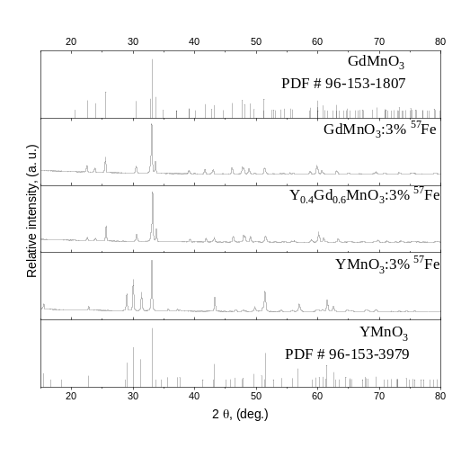
Recent Publications (minimum 5)
- N.A. Spaldin, R. Ramesh, Nat. Mater., 18 (2019) 203-212
- H. Palneedi, V. Annapureddy et al., Actuators, 5 (2016) 9.
- A. Molak, D.K. Mahato et al., Prog. Cryst. Growth Ch., 64 (2018) 1-22.
- M. Wang, T. Wang et al., Materials (Basel). (2017) Apr 28;10(5):474.
- A. Pal, C. Dhana Sekhar et al., J. Appl. Phys. 123, 014102 (2018)



 Biography
My name is Dovydas Karoblis. I’m a second Master’s course student at Vilnius University. In my first four years in Bachelor’s studies I was most focused on layered double hydroxide structures, their synthesis and determination. After that, my focus shifted on perovskite structure materials, expecially multiferroic manganites. In a short span of my scientific carrier I have attended several conferences (including Open Readings 2019, Chemistry and Chemical Technology and etc.) and participated in several projects (like BUNACOMP and TransFerr). Also I have one article in Journal of Sol-Gel Science with the title Novel synthetic approach to the preparation of single-phase BixLa1−xMnO3+δ solid solutions.
Email: karoblisd@gmail.com

Notes/Comments:

