Reduced Graphene Oxide Production by Lactic Acid Bacteria
Guldem Utkan, PhD, Marmara University, Turkey

Abstract (300 word limit)
Since graphene and graphene-related materials have found many uses from electronics to health, they attract a lot of attention in various fields of science. With the use of these materials and increasing demand from the industry, scientists have begun to look for a new, scalable and environmentally friendly techniques to produce graphene. In this study, lactic acid bacteria, Lactococcus lactis and Lactobacillus plantarum, were used for the production of graphene. These bacteria are fed with graphene oxide produced from graphite by Hummer’s method, which is then converted to graphene by removing different oxide groups. Compared to existing chemical methods for producing graphene, this process requires less energy and gives a thinner and more stable material. Graphene having different physical and surface properties and different surface area thickness ratio could be produced since the reduction of functional oxide groups by using three different bacteria were provided differently and the capacity of each bacterium was different from each other. Therefore, microbial reduction of graphene oxide appears to be a promising method for the development of new types of graphene-based materials and devices, avoiding the use of hazardous chemicals. These methods used environmentally friendly chemicals in a variety of types and applications, including nano-composites, conductive inks and biosensors.

Image

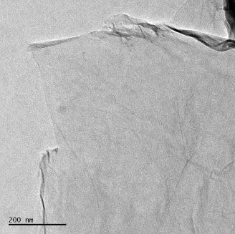
Figure 1: TEM image illustrating Lactococcus lactis reduced graphene oxide

Recent Publications (minimum 5)

- Utkan G, Ozturk T, Duygulu O, Tahtasakal E, Denizci AA (2019) Microbial Reduction of Graphene Oxide by Lactobacillus Plantarum. International Journal of Nanoscience and Nanotechnology 15:127-136.
- Agharkar M, Kochrekar S, Hidouri S, Azeez MA (2014) Trends in green reduction of graphene oxides, issues and challenges: a review. Materials Research Bulletin 59:323–328.
- Akhavan O, Ghaderi E (2012) Escherichia coli bacteria reduce graphene oxide to bactericidal graphene in a self-limiting manner. Carbon 50:1853–1860.
- Aunkor MTH, Mahbubul IM, Saidur R, Metselaar HSC (2016) The green reduction of graphene oxide. RSC Advances 6:27807–27828.
- Geim AK, Novoselov KS (2007) The Rise of Graphene. Nature Materials 183–191.
- Gurunathan S, Han JW, Eppakayala V, Kim JH (2013) Microbial reduction of graphene oxide by Escherichia coli: a green chemistry approach. Colloids and Surfaces B 102: 772-777.

 Biography (150 word limit)
Guldem Utkan is currently working at Marmara University, Chemical Engineering department. Her research and interest areas include graphene and its derivatives, synthesis and characterization of nanomaterials (magnetic, metallic and polymeric), composites, nanoparticle applications for bioseparation, biosensor, non-viral gene delivery, controlled drug release and use in diagnostic kits.
Email: guldem.utkan@marmara.edu.tr

Notes/Comments:

