Superior Thermoelectric Performance of Mechanically Robust BiSbTe Alloys: Case Study of Hierarchically Stable Nanostructured Thermoelectric Materials

IQBAL SINGH, Astt. Prof. RBIENT, Hoshiarpur, Punjab, INDIA.

Abstract
Thermoelectric materials like Bismuth telluride have been popularized for a wide scope of uses in refrigeration and power generation.In any case, the poor machinability and susceptibility to weak breaking of ingots regularly force significant constraints on the manufacturing procedure and toughness of thermoelectric devices.In the present study, both methods plasma activated sintering (MS-PAS) and melt spinning is utilized for p type zone melted (ZM) ingots of Bi_{0.5}Sb_{1.5}Te₃.This quick synthesis methodology accomplishes various hierarchical structures and in-situ nanoscale accelerates, bringing about the synchronous improvement of the thermoelectric execution and the mechanical properties.Benefitted by a solid concealment of the cross section thermal conductivity, a pinnacle ZT of 1.22 is accomplished at 340 K in MS -PAS synthesized structures, leading to about a 40% upgrade over that of ZM ingots. Also, MS-PAS specimens with hierarchical structures display predominant machinability and mechanical properties with a practically 30% improvement in their fracture toughness, joined with an eightfold and a factor of six increment in the compressive and flexural strength, individually. Accompanied by an excellent thermal stability up to 200 °C for the MS-PAS synthesized samples, the MS-PAS technique demonstrates great potential for mass production and large scale applications of Bi₂Te₃ related thermoelectrics. Besides this, MS-PAS samples with various leveled structures show predominant machinability and mechanical properties with a practically 30% improvement in their crack durability, joined with an eightfold and a factor of six increment in the compressive and flexural quality, individually.

Image
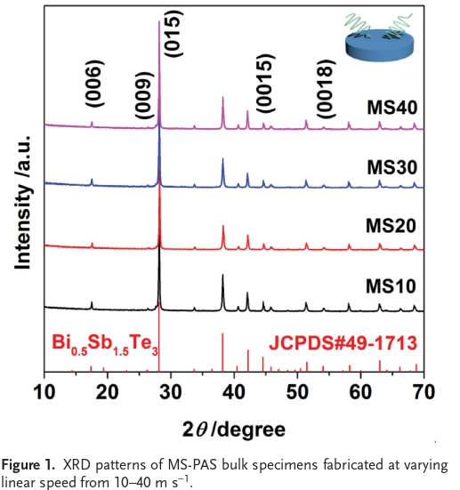
Recent Publications
- K Biswas , J He , I D Blum , C I Wu , T P Hogan , D N Seidman ,
V P Dravid , M G Kanatzidis (2012) Nature 201, 489 , 414.
2. . K. Koumoto , T Mori (2013) Thermoelectric Nanomaterials , Springer ,Heidelberg, Germany.
3. B Wachtman , W R Cannon , M J Matthewson (2999) Mechanical properties of ceramics , Wiley , Hoboken, USA.
4. M A Meyers , K K Chawla (2009) Mechanical Behavior of Materials , Cambridge University Press , Cambridge, UK.
5. J R Salvador , R A Waldo , C A Wong , M Tessema , D N Brown ,
D J Miller , H Wang , A A Wereszczak , W Cai (2013) Mater. Sci. Eng. B, 178 , 1087 .

 Biography (150 word limit)
Iqbal Singh has her expertise in evaluation and passion in technology of advanced materials. He has worked in this field of materials and metallurgy for few years and experience in research, evaluation, teaching and administration in education institutions. He has published research papers in International journals.
Email: iqbalsingh.rb@gmail.com

