Effect of Air Plasma Sprays Parameters on the Coating Performance in Al₂O₃-TiO₂-Based High Temperature, Wear and Corrosion Resistance Coatings Applications on 304 H- Austenitic Steel Alloy of Aero-Turbine Engine.
Khalid. Fared Ahmed ª , Madiha. A. Shoeib ^{b}
ª Arab Institute for Advanced Technology ( A.I.A.T ) , AOI
^{b} Head Corrosion Control and Surface protection , CMRDI
Abstract.
Material performance in many industrial applications is strongly affected by the behaviour of the surfaces. For example, corrosion response reactivity with environments, wear characteristics, and thermal properties are all critically dependent on surface character. Utilization of coatings to upgrade component performances is often a cost effective alternative to substitution of superior bulk materials. The advantage of coating technology, in general is that it marries two dissimilar materials to improve the performance of the whole. 304 H- austenitic steel alloy as a substrate material have very wide applications for: blades, mill rolls, printing, press of cylinders, piston rings, drilling equipment, gearbox, worm wheel and power generators. In such applications, the austenitic steel alloy substrate is subjected to higher thermal and mechanical loads. Increasing the anti-wear resistance and decrease of friction requires surface modification by other high wear resistant coatings. Recently, there are many surface modification processes to steel by the evolution of effective lubrication with higher performance to keep the lubricating systems running reliably and to avoid bearing and other component failures [1], and plasma thermal spray coatings process [2-6]. Plasma spraying is the most versatile of the coating technologies. It may serve for "metalizing" all sorts of articles and has great advantages over the known galvanizing process in cases where it can be used to coat electrically non-conductive surfaces with metal. Spray materials must be melted and sprayed without decomposition or excessive vaporization in plasma flame through the optimum spray parameters. In plasma spray process, the spray material in the form of powder is rapidly brought to molten or near molten state by the plasma flame and then accelerated by a gas stream to impact a suitably prepared substrate. Upon impact, the molten metal droplets are rapidly flattened and solidify to form their splats. Microstructure and physical properties of sprayed coatings are linked to dynamic properties of molten particles impinging on a substrate. There are many spray parameters that affects the properties of the sprayed plasma coating, the most common control parameters are: Chemical compositions, phase structure and crystal size of the powder input, substrate temperature, plasma gas, plasma torch, powder feeder (.e.g. grain size chemical and phase composition, shape, internal porosity (correlated with apparent density) and flow-ability), spray angle, and finally spray distance.The objective of this study is to improve the temperature wear, and corrosion resistant, properties of steel alloys materials via plasma using metal carbide or ceramic powder. Plasma spraying of ceramic or carbide coating is a prime candidate for the surface modification of steel alloys for anti-wear corrosion, erosion and thermal resistance. Ceramic powder during spraying is not quite easy process because of rapid solidification of flattened particles. There are two approaches to improve the ceramic coating in plasma spraying. One method is the optimization of the spray parameters to improve the adhesion properties and decrease the solidification rate. The other method is using high alumina content powder (97% Al₂O₃ + 3% TiO₂) .Our objective is not only to spray high content alumina, but also to get the best optimum spray parameters, by studying the effect of these parameters in microstructure, adhesion, reaction layer, micro-hardness, corrosion and pore formation.
Key words: Thermal coating, air plasma spray, alumina coatings, optimum spray parameters, corrosion resistance and Al₂O₃-TiO₂coatings

- Introduction
Plasma is quasi-neutral multi particles system which characterized by gaseous or fluid mixtures. It consists of electrons, positively changed ions and neutral gas, atoms, molecules or radicals [7]. Mono-atomic gases require only to be ionized in order to enter the plasma state, while bimolecular gases must be first dissociated before ionization, thus need larger energy to enter plasma state. Small quantities of hydrogen (or helium) added as a secondary gas to argon lead to increase of both plasma enthalpy and heat transfer rates from the plasma to the powder particles [8].Thermal spraying requires a device used for flame spraying that creates a high temperature flame in which a chemical energy of the combusting gases that power the flame spray torches. Also requires a device used for plasma spraying that creates high temperature plasma jet called plasmatron [9] i.e. a plasma generator powered by arc or high frequency discharge, whose plasma is supported by streaming gas. In which an electric currents providing energy that power the plasmatons. Air plasma spraying (APS) considered being an effective rapid solidification technique. The process can be referred to as continuous meta-stable materials forming [10, 11]. It is being considered for the production of wear- and corrosion-resistant coatings [12, 13]. Such high temperatures caused self-annealing of the deposits on the substrate which provides stress relief and re-crystallization and results in enhanced inter-particle bending [14].The powder particles are injected into the plasma flame by means of carrier gas flow through an injector. There are several ways for injection into the plasma jet. The distribution of particles in the plasma jet and the deposition efficiency are controlled by injection parameters [15, 16].Coating properties depends largely upon spray angle and nature of the material. Thus, when spray angle deviated from 90° to 45° for Mo coating, cohesion increases twice, where as for alumina coating, cohesion increases slightly. Generally, in both cases deposition efficiency decreases with increasing deviation of spray angle from 90° [17-19].Plasma spray coatings are produced by successive impacts of accelerated particles in a molten state on the substrate or previously deposited layers, the next particle impacting on an already completely solidified one. The conditions of these particles (temperature, velocity and size) and the condition of the substrate (temperature, chemistry, roughness, etc) determine the particle spreading and solidification. Achieving a coating with the desired mechanical properties requires great care and stringent control of many plasma spray parameters. Coating quality obtained during thermal spraying depends greatly on the dynamics of flattening of the molten droplets during their impinging on the substrate surface [18-21].Particles with sizes substantially larger than the main do not melt completely to their core and thus do not spread on impact. Thus it is extremely important to utilize spray powders with a narrow particle size distribution with a sufficiently small standard deviation [22]. Splat Flattening and Solidification of thermally sprayed particles (droplets) develop splats on the substrate and/or on the prior deposited coating layers. The structure and properties of a coating can be considered in terms of the dynamics of deformation and solidification of the single splats [23-25]. The flattening and cooling begin immediately after droplet impingement and the main cooling is caused by the heat removal from the lower part of the splat adjacent to the substrate [26-27]. This heat removal depends on the initial temperatures and thermo physical properties of the substrate and splat as well as on the contract thermal resistance at the splat-substrate interfaces.

2. Experimental procedures.
2.1. Plasma apparatus and process description.
PLASMA-TECHNIK AG M-1000 apparatus is used for plasma spraying has improved and developed plasma torches and auxiliary equipment for the spraying of aerospace components. It comprises: power source (PT-800), control unit (PT-M1000), plasma torch- (F4), powder feed unit (TWIN- 10), water cooler system (T-500) and holding device for the work piece, in addition to dust separator (MK-9) and wet separator (NA-100). Figure (1) shows the schematic diagram of the PLASMA-TECHNIK AG M- 1000 apparatus.
A path is pre-ionized for the direct current arc from the cathode to the anode using high frequency (HF) sparking. The direct current arc, energized from the power source ionizes the gas flowing through the torch (ionization = electron excitation). The gas flow drives the arc contact point in the anode nozzle forward and the arc stabilizes. Argon gas is used for arc initiation (easily ionized) and following stabilization, an auxiliary gas is normally added, usually H₂. Gases, such as H₂ or N₂ (with two atoms) dissociate at high temperatures before ionizing. Therefore, they exhibit a higher energy (for a certain temperature) than gases such as Ar. or He. (single atoms). The mixture of electrons, ions and neutral gas particles is the plasma i.e. a gas with an extremely high temperature (between 10000 and 30000 k) and heat capacity. The increase in temperature causes the plasma to exit from the anode nozzle with a high velocity. The spray powder is introduced into the hot, fast plasma using an injector and the particles are heated and accelerated. The powder particles become molten and impact on the surface to be coated with a high kinetic energy where they form a laminar coating. Plasma spray coating is produced by successive impacts of accelerated particles in a molten state on the substrate (i.e. a single specimen was cute from flat steel alloy sheet (304 H- austenitic steel alloy of EN designation number is 4948), with dimensions 40 ×20×1.4 mm) or previously deposited layers, the next particle impacting on an already completely solidified one. In our investigation we use 1006 (OT₃) powder corresponding to Al₂O₃-TiO₂.
2.2. Selection of plasma gases.
Argon: (Ar.): It is used as primary plasma gas. It is an inert gas and protects the power particles from any damaging atmospheric influences. It should be used with nitrides which tend to dissociate.
Hydrogen (H₂): A mixture of pure Ar and H₂ protects against oxidation. The small addition of H₂ increases the plasma voltage (dissociation and ionization) and therefore allows spraying at a higher plasma torch power level which results in a higher plasma gas heat capacity. The purity level of the gases used plasma spraying is given in the following; it must be observed at all times of investigation.

Gas | Purity (%) | Impurities (volume parts per million)
Argon | 99.997 | O₂ > 5, N₂ > 10, H₂O > 5, CO₂ > 0.2
Hydrogen | 99.997 | O₂ > 10, , H₂O > 20

2.3. Testing material.
2.3.1. Spraying material.
The chemical composition in (weight %) and powder description of sprayed materials is given in table (1). The characteristics of sprayed and their acceptance criteria for coating is given in tables (2). Table (3) shows the different spray parameters of control unit PT-M1000, powder feeder (TWIN 10) and plasma torch F4. The effect of the plasma spray parameters; the plasma gas, arc current, injection angle, cooling and spraying distance on the coating performance was studied, while keeping other parameters given in tables (2, A) (3, A, B, C) constant, such as rate of flow of primary plasma gas i.e. Ar gas, and that of powder carrier gas at 47 L/min. The injector length distance and injector diameter are kept at 5.5 mm, while the grain size was 10-45 μm. The microstructure (cross-sections) of sprayed alumina coatings at different spray parameters were examined by scanning electron microscope (SEM). The deviation of the plasma spray parameters from the optimum condition lead to the fine microstructure of high dens coating become lower in quality i.e. increase of porosity, voids (pull-out effect), un-melted phase, and delamination. The coating/ substrate interface of the as- sprayed samples is very sharp and distinct with no apparent visual evidence of any metallurgical reaction at this interface. The key parameters controlling the thermo-mechanical properties of plasma sprayed (D.C. plasma spraying) are the heat and momentum transfers between the plasma jets and the injected particles. These, beside the particles side and plasma gas nature, depends strongly on the plasma isotherms lengths and diameters which in turn controlled by nozzle.
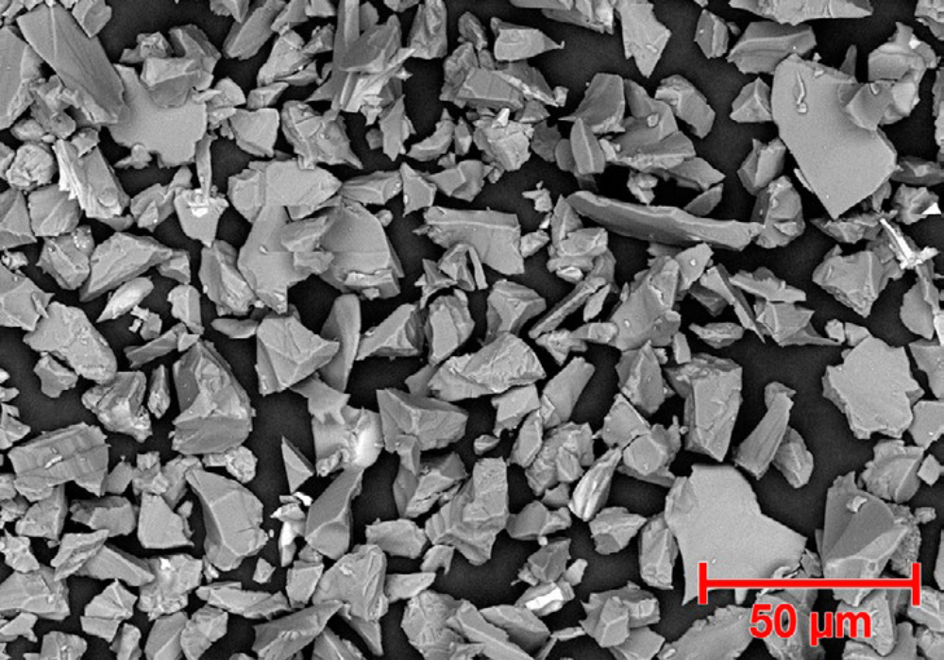
SEM Photomicrograph showing morphology Amdry plasmatex 1006 (OT3)
2.3.2. Substrate Material.
The Substrate Material is a high temperature austenitic steel possessing a minimum of 18% chromium and 8% nickel, combined with a maximum of 0.08% carbon. The 18% minimum chromium content provides corrosion and oxidation resistance. The alloy's metallurgical characteristics are established primarily by the nickel content (8% mm.), which also extends resistance to corrosion caused by reducing chemicals. Carbon, a necessity of mixed benefit, is held at a level (0.04-0.10 %) that is satisfactory for most service applications. Single specimens were cutting from flat steel alloy sheet with dimensions (40x20x1.2mm). The substrate processing includes a polishing step with emery papers followed by cleaning with tap water and acetone as final step. The specimens were preheated from 60-100ºC then rinsed with acetone again. To improve the mechanical adhesion of the coatings and induces compressive stresses into the substrate material, the substrate was roughened by sand blasting using automatic adjustable device (robotized). The chemical composition and the mechanical properties of the steel alloy substrate material used are listed in table (4) as detected by XRD (X-ray diffraction) (Fig. 2). The quantitative identification of the base material has analysed by using spectrum lable technique (EDX) analysis, Fig. (3). the optimum parameters of substrate material preparation for applying spray coating are given in table (5).
2.4. Surface Investigation.
2.4.1. Metallographic examination.
A sample, on which a deposit has been applied, is cut perpendicular to its coated surface, then encapsulated and polished. Micrographic cross-section is initially, observed overall magnified by 100 or 200 times. Area considered as representative of the sample are re-examined with a magnification of 200-1000. Cross sections were made in the plane perpendicular to the treated surface using an optical microscope with different magnification. The metallographic examination of the coat has been investigated by using scanning electron microscopic examinations (SEM). The material of a flat sheet metal specimen has dimensions of 40 mm x 20mm x 1.2mm after having coated the specimen thickness surface; make a cross-section perpendicular to the scanning direction. The coating thickness to be applied (measured with a flat anvil micrometres) is mentioned on the drawing or any additional document, with a 0.12mm minimum.
2.4.2. Mechanical properties investigation.
2.4.2.1 Micro hardness and hardness testing.
The micro-hardness of the treated and untreated surfaces was determined using identical micro-hardness tester using micro-Vickers machine with 30 gm. load for 15 second. The hardness after plasma thermal spraying process at different zones was determined for surface-treated specimens. A specimen without plasma thermal spray coating was used as reference. The Vickers micro-hardness test is used for coatings measurements under load 3N (e.g. HV₃ is the Vickers number for 3N load) describe the micro-hardness of individual lamellae. The commercially available testers flow the normal procedures (e.g. ASTM E-384-73 standard).
2.5.2.2. Tensile bonding test.
Tensile bond strength measurement was using ASTM 633-96 or DIN 50160 standards. Bonding of sprayed coating is measured by using a traction machine. The installation must allow carrying out the test perpendicular to the coated surface, and the load application rate must be constant, between 0.8 and 1.2mm/min⁻¹. Bond strength value or stress to rupture is the ratio between the rupture load and the bonding surface; this is expressed in migapascale (MPa). For coating with a single layer, thicknesses required is 150μm to 200μm. Surface preparation conditions for receiving the coating must be identical to those applied on the item. The surface to be glued must be degreased, sand blasted and dusted. Gluing process takes place by use FM1000 epoxy polyamide film glue (American Cyanamide) or equivalent.
2.5.3. Particle velocity and surface temperature measurements.
Especially in the field of particle diagnostics, many systems are available to measure particle velocity and surface temperature on-line. One of the particle measurement systems is the DPV-2000 system made by TECNAR Canada. The DPV-2000 system enables the on-line measurement of surface temperature, velocity and diameter of single particles in a spray plum by the principle of two-wavelength pyrometry. In this study, a commercially available DPV-2000 system was used to investigate APS of Al₂O₃. The investigation centred on the influence of the spray parameters on the particle in-flight properties and the melting behaviour of the power.
2.5.4. Porosity and pore distribution.
The thermally sprayed coatings are composed at least two phases: porosity and solid matrix. Very often the solid matrix contains separate phases resulting from rapid solidification and cooling. The normal procedure for coating materials (e.g. American B 328-73) seems to be quite well adapted to test thermal sprayed coatings. Porosity was tested with commercially available mercury intrusion porosimetry (MIP). The method consists of evacuating the sample and immersing in mercury at low pressure. The mercury is then pressurized and the series of pressures and corresponding volumes of intruded mercury is determined. This method enables the total porosity and pore distribution to be determined. The porosity influences many mechanical and physical properties of the coatings. Finally, the determination of the porosity in many cases enables the predication of other properties of the sprayed material. We must refer to a comparison of EDX results for typical as deposited coating of Al₂O₃-3 wt.% TiO₂, Al₂O₃-6 wt% TiO₂, and Al₂O₃-13wt% TiO₂. The chemical compositions (wt.%) of the coat have been investigated by using electron dispersive x-ray (EDX) analysis and the phases formed due to thermal spray process have been examined by means of x-ray diffraction (XRD).
2.5.5. Corrosion resistance test.
Electrochemical accelerated corrosion experiments were performed in a conventional three electrode glass cell assembly with the specimen as the working electrode. The specimen is tightened to the outside face of the cell using two screws. Stainless steel rod was used as the counter electrodes while the reference electrode was Ag/AgCl. The electrolyte was consisted of 3.5% NaCl solution made up from distilled water and reagent grade NaCl (Fisher scientific) Experiments were carried out at room temperature. The electrical contact was achieved through thick copper wires soldered to the electrodes. Linear polarization and potentiodynamic techniques were used to determine the corrosion rate as well as the corrosion behaviour of specimens. These experiments were carried out using AUTOLAP PGSTAT 30 show in fig. (4). Accelerated corrosion experiments were carried out using; linear polarization technique by subjecting the working electrode to a potential range of 25mv below and above corrosion potential (E_{corr}) at a scan rate of 0.1mv/sec. The corrosion current (I_{corr}) and hence the corrosion rate (CR) can be related to the slope of the potential vs. current plot (ΔE/ΔI), known as the polarization resistance (R_{P}) and simply by I_{corr} = B/ R_{P}, where B is a constant. Potentiodynamic polarization tests were conducted by sweeping the potential with scan rate of 1mV/s from -100 mV below E_{corr} to 1000mV above E_{corr}. This test was performed to study the corrosion behaviour of specimens before and after plasma thermal spray technique.

Table (1): Chemical composition and powder number of sprayed materials.
Spray powder | Powder no. in |  | Chemical composition (%) |  | Kind
Spray powder | Amdry plasmatex | METCO |  |  | Kind
Alumina | 1006 (OT3) | 101 | AL₂O₃ | TiO₂ | Ceramic powder
Alumina | 1006 (OT3) | 101 | 97 | 3 | Ceramic powder
Table (2): Characteristics of the spraied powder and the acceptance criteria.
Allowed thick-ness (mm) |  | Grain size (μm) | Micro-hardness (H.V₃) | Tensile bond strength (M.Pa) | Porosity (%)
Min. | Max.
150 | 250 | 10 – 45 | 650 | 45 | < 10
Table (3): Spray parameters of control unit, powder feeder and plasma torch for thermal spraying of alumina and tungsten carbide materials
Table (3-A) Control unit (PT M1000) parameters
Spray powder | Gases | Flow rate (L/min) | Pressure (bar) | Current (Amp) | Voltage (v)
Alumina | Main gas (Ar) | 47 | 2.5 | 500 | 70-72
Alumina | Secondary gas (H₂) | 12 | 2.5 | 500 | 70-72
Table (3-B) Plasma torch (Gun) parameters
Spray powder | Gun type | Injector diameter (mm) | Injector distance (mm) | Injector angle (degree)
Alumina | F4 | 1.8 | 5.5 | 90º
Table (3-C): Powder feeder (Twin 10) parameters
Spray powder | Carrier gas |  |  | Spraying distance (mm) | Flow rate (g/min) | Coating thickness (mm) | Cooling
Spray powder | Type | Pressure (bar) | Flow rate (L/min)
Alumina | Ar | 2.5 | 2.5 | 100 | 30 | 150-250 | Air
Table (4): Chemical composition in (wt %) and mechanical properties for substrate material
Table (4-A): Chemical composition
C% | Si % | Mn % | P % | S % | Cr % | Ni % | Ti % | Fe %
0.08 | 0.08 | 2 | 0.035 | 0.025 | 18 | 9 | 0.7 | Residual

Table (4-B): Mechanical Properties

Grade |  | Tensile Strength (MPa) min | Yield Strength 0.2% Proof (MPa) min | Elongation (% in 50mm) min | Hardness  Rockwell B (HR B) max | Hardness  Brinell (HB) max
EN | ASTM
4948 | 304 H | 515 | 205 | 40 | 92 | 201
Table (5): Optimum parameters for preparation of substrate material
Grain size (μm) | Pressure (K.pa) | Torch distance (mm) | Surface speed | Angle (degree) | Nozzle diameter (mm)
120 ~ 300 | 300 ~ 400 | 150 | Manual | 75º | 10

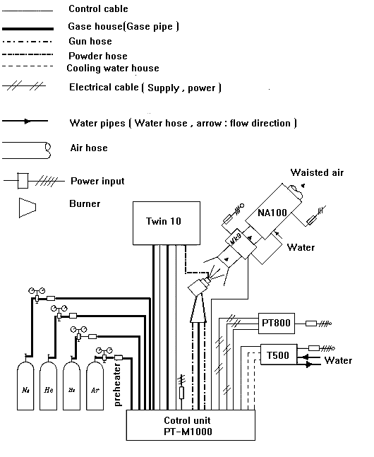

Fig. (1): Systematic diagram of Plasma Spray M-1000
(plasma-Technik-A G)

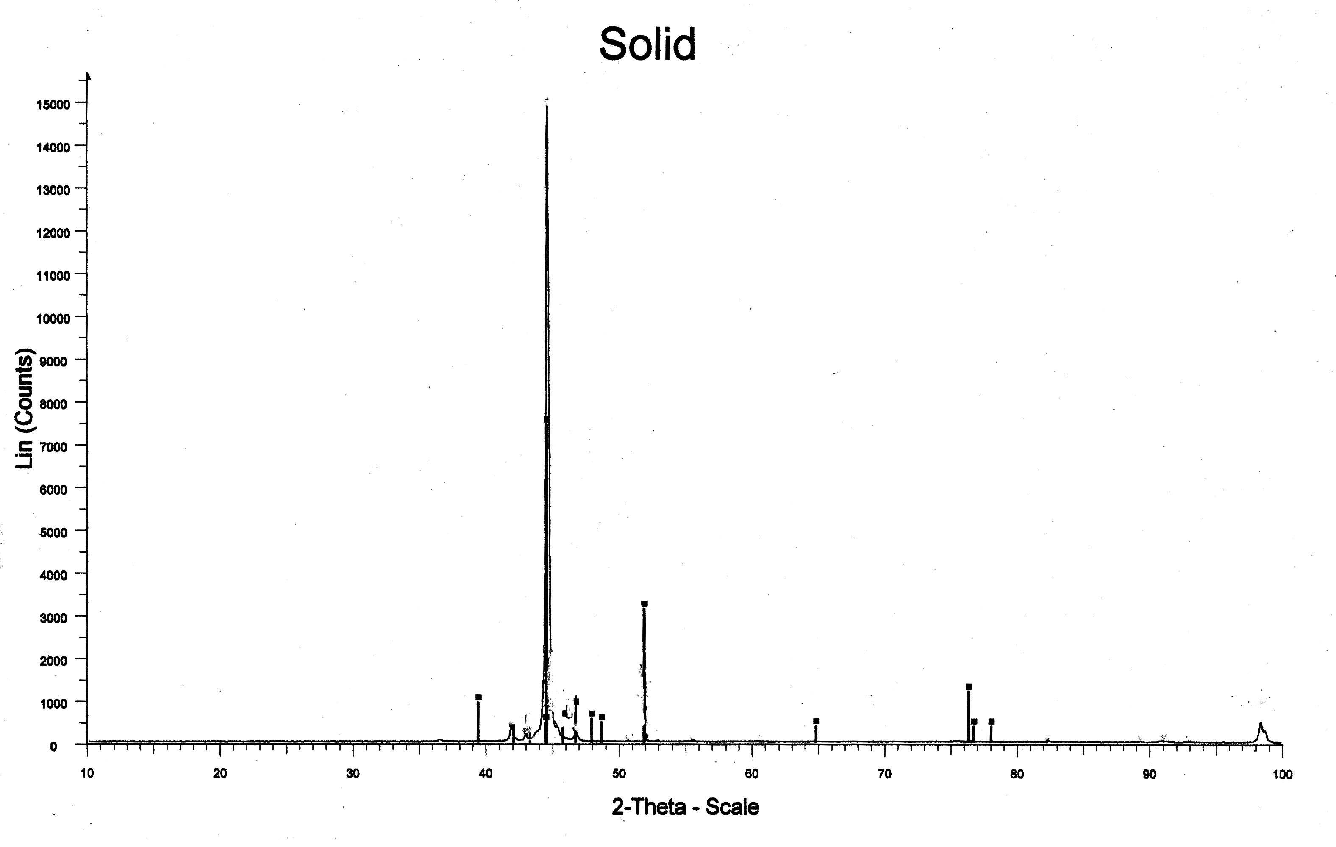
Figure (2): X-ray diffraction pattern of the base material
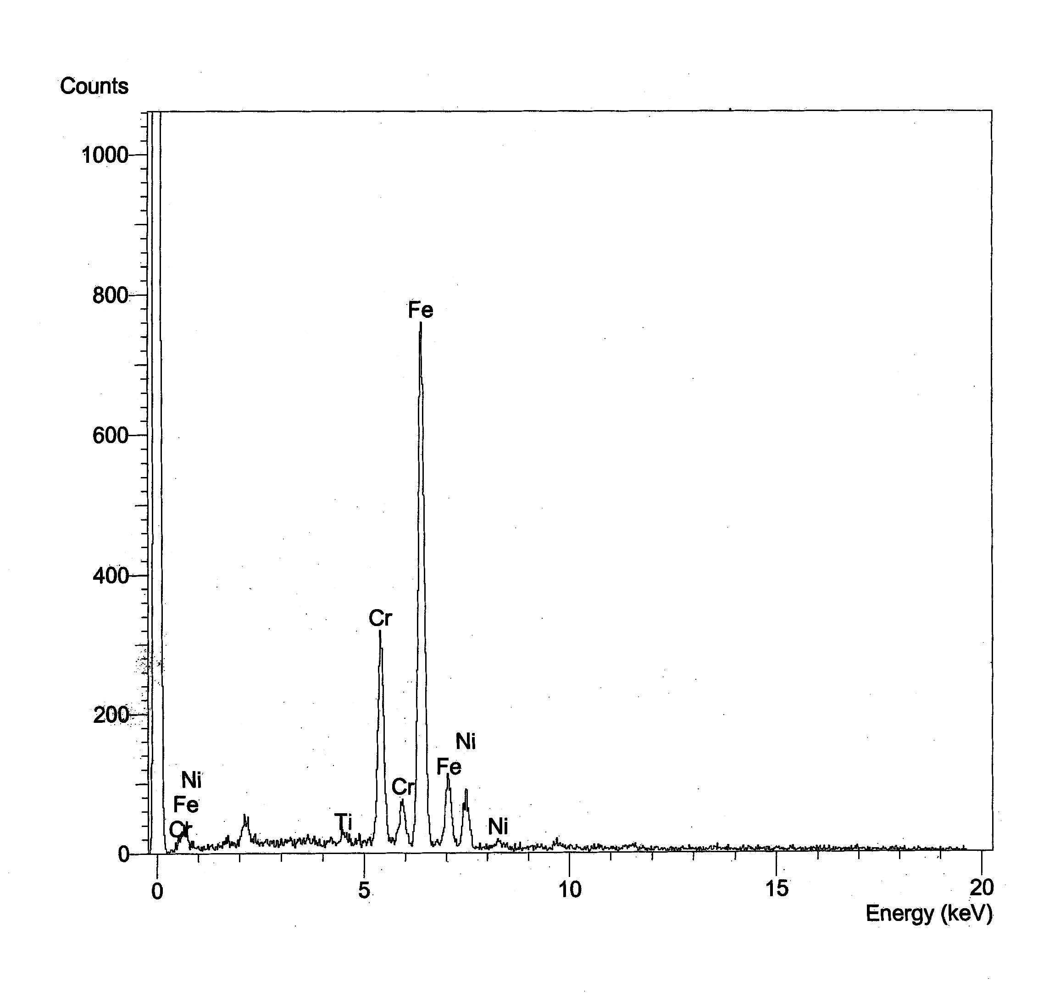
Figure (3): Electron dispersive X-ray (EDX) spectrometry pattern of the base material

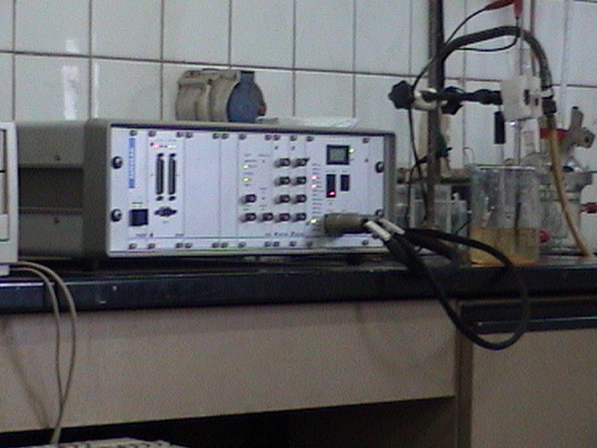
autolap pgstat 30

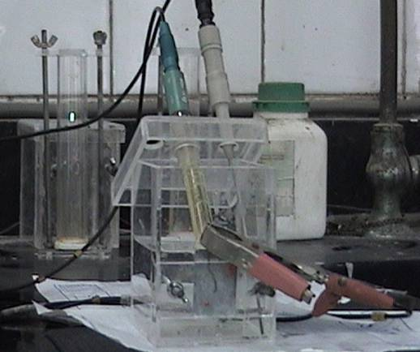
Corrosion cell
Figure (4): Photograph of autolap pgstat 30
and corrosion cell
3. Results and discussion.
3.1. Influence of the plasma spray parameters on coating performance.
The oxide ceramics are mainly sprayed with the plasma technique to obtain hard oxide ceramic coatings, it is necessary to melt particles in the flame. The melting point of oxides is generally higher than that of carbides binder cobalt, which makes their melting possible in hot plasma flames. Moreover, oxidizing the atmosphere by APS is preferable to spray oxide ceramics. On the other hand, the interlamellar contact strength and porosity, that influence hardness, are better if the particle impacts at the higher velocity gained in rapid combustion flames [28-32]. The coating parameter plays a very important role, where, the increase of the mean integral thermal conductivity in the plasma column fringes, increases plasma enthalpy and thus increases heat transfer rate from plasma to the powder particles [33-35]. In other hand, the increase of arc voltage, increases the pumping effect [36], and the number of droplets which impact normally, that’s lead to decrease the thermal decomposition (oxidation) [37]. However, the optimizations of plasma spray parameters are of great importance in controlling the plasma spray parameters. The purpose is to obtain longer and border plasma jets by optimizing the setting for the system, also by optimizing the cooling that gives the best coating performance.
3.1.1. Effect of gas flow rate.
Argon gas is used as primary gas needs only to be ionized to enter the plasma state. It facilitate the selective hardening of steel and cause rapid heat transfer rate between a plasma jet flame and the heated object, in addition to its protection for the powder particles from any atmospheric influences. Small addition of hydrogen gas which increases arc voltage required to increase plasma enthalpy and increasing heat transfer rates [38-40]. The optimization of plasma gas mixture has a great importance to decrease plasma temperature that it becomes only enough to melt the droplet just before impinging on steel surface. Table (6) shows the effect of changing H₂ gas content of the plasma gas on the coating parameters at, applied current = 500 A, injection angle = 90º, substrate temperature = 150ºC and spraying distance = 100mm. Fig. (5), represents the rapid variation of Arc voltage through increasing of H₂ content in plasma gas, where, the Arc voltage rises from 27 volts for pure Ar plasma gas to a value of 72 volts for H₂- content of 20.3% in plasma gas mixture. It is clear that H₂- content in plasma gas mixture plays an important role for increasing the mean integrated thermal conductivity, although H-ionization potential is lower than Ar-ionization potential by about tow electron-volt. The higher Arc voltage values are attributed to enhanced conductive thermal looses at temperatures higher than 4000k which lead to an increase of the electric field strength. The acceleration of particle powder depends largely upon the mass flow rate of the plasma gas, not on the H₂-flow rate. Argon ions are heavier than hydrogen ions, so, we must expect its responsibility for particle acceleration, this lead to a worse melting behaviour for powder particles. Consequently, lower deposition efficiency and lower coating thickness obtained. Coatings with plasma gases sprayed with different Ar/ H₂ ratio examined by SEM are shown in Fig. (6), microphotos "So" for H₂-content 20.3% at 12L/min and "S_{1A}" for pure Ar gas at 47L/min. Therefore, by introducing pure Argon, the hardness (HV₃) decreases from 650 to 550 because of the intensity of non bonded particles (Al₂O₃) increased. In otherwise, the hardness of the coating increases with increasing plasma energy. This is attributed to increase of γ-Al₂O₃ in coating although the original powder is mainly α-Al₂O₃ [41].Also the deposition of high dense coating with fine microstructure decreases because of the flam temperature decreased (as the flow rate of H₂ increases we need larger energy input) lead to decreases in solidification rate. This may be referred to the fact that superheated droplets has larger viscosity and thus the droplet is not easily flattened and then the fine microstructure of high dense coating become lower, due to the variations in the wetting of the droplet on the substrate, which could influence the final shape [42]. So that the porosity, pullout, unmelted phase, delaminations are decreased by introducing of H₂-gas. The image analysis (S₀, S_{1A}, and S1B) determines the percentage of unmelted grain 4.4% and their maximum and minimum size 26 and 2.6 μm respectively as well as the pore content 9.8% and their maximum and minimum size 15 and 1.5 μm respectively (Fig. 8).
3.1.2. Effect of arc current.
It must make control in the plasma current and plasma voltage to give the best results and also to make control in the plasma temperature such that it becomes enough to melt the droplet just before impinging on the substrate surface. Table (7) shows the effect of different arc currents on the coating parameters at H₂ flow rate 12L/min of H₂-content (20.3%), injection angle 90°, substrate temperature 150°C, and spraying distance 100mm. Increasing the arc current from 500A to higher values or decreasing it to lower one depends upon the torch condition of electrode and nozzle also, on arc plasma gas and to some extent on the plasma arc voltage. The pumping effect increases as the arc current increases [43]. Increase of arc current more than 500A increases particle velocity (from 260 to 268m/s) as well as particle surface temperature consequently higher plasma power leads to worse melting of particle powder. The decrease of arc current less than 500A, decrease of particle velocity (from 260 to 256m/s), that plasma power lowered much, leads to unmelted phase. In both cases the deposition efficiency decreased as well as thickness and porosity. The microstructure (cross-sections) of sprayed Alumina coatings with different arc currents was examined by scanning electron microscope SEM as shown in Fig. (6). with different arc currents S₀ at 500A, S_{2B} at 420A and S_{2A} at 570A. Therefore by increasing the arc current from 500A to 570A or decreasing the arc current from 500 to 420A. The hardness decreases from 650 HV₃ to 618Hv₃ and 635 Hv₃ respectively. This may refer to the fact that the deviation of the arc current from the optimum condition lead to the fine microstructure of high dense coating become lower i.e. increasing of the porosity, unmelted phase, and delaminations.

3.1.3. Effect of injector angle.
The plasma-technik ag torches are operated using external powder injectors. The injectors made from hardened steel. Table (8) shows the effect of injection angle on the coating performance at H₂-content (20.3%), H₂ gas flow 12L/min, current 500A, substrate temperature 150°C, and spraying distance 100mm. The effect of injector angle on Alumina splat morphology can be illustrated from the studying of the microstructure (cross-section) of sprayed alumina coating with different plasma gases flow rate were examined by SEM as show in figure (6), microphotos, "S₀" at injection angle 90° while "S_{3A}" & "S_{3B}" at injection angles 35° and 45°, respectively. By decreasing the injector angle from 90° to lower values, the hardness decreased from 650 to 620 and 630 HV_{0.3} at angles 35° and 45°, respectively HV₃. Also the thickness of the coating decreased from 230 to 170 and 190μm at the same angles, this may refer to the fact that the deviation of the injector angle from the optimum condition lead to the fine microstructure of high dens coating become lower in quality, i.e. increasing of porosity, pullout, unmelted phase, and delaminations.
3.1.4. Effect of cooling system.
All plasma-thchnik ag torches are operated using external powder injectors which made from hardened steel and have cooling system. The lifetimes for the plasma torch (electrodes and nozzles) would be extremely short. So the plasma torch and the cables have to be cooled with water due to the high power levels involved. A flow rate of 11 L/min is required to obtain satisfactory cooling of the plasma torch (F4). Since, the quality of a coating depends on many parameters which usually interact with each other. So the efficiency level of spraying and the physical properties of the coating (e.g. density, bond strength, and hardness) depends on the efficient cooling for the surface being sprayed. Cooling air jets should be mounted at angle 30:45 degree to the coating. A change in the colour of the coating being sprayed indicates that the cooling air jets are wrongly placed. Since the cooling must be slowly in order to avoid micro-cracking, the increase in temperature of the work piece depends on the use of cooling, distance between torch and work piece, type of plasma gas, amount of plasma gas, the amount of powder, and heat energy leaving the plasma torch. Normally, powder injection is carried out at 90° to the plasma jet. The spray parameters for the splat collection on changing of the mounting of the cooling air jets from 45° to 10° degrees which lead to increase the temperature from 150°C to 400°C are listed in table (9). In order to observe the effect of the changing of the mounting of the cooling air jets which lead to increase the temperature is resulting to studying of the preheat substrate temperature, the preheat substrate temperature has effect on the morphology of the droplet (splat) and the properties of the deposits. The purpose of this study is to investigate the effect of preheat substrate temperature on alumina splat morphology in this study a gas atomized alumina powder was used to determine the optimum mounting of the cooling air jet required to spray alumina with a majority of high adhesive strength. The change of the mounting of the coating air jets from 45° to 10° is resulting of increasing of the substrate temperature from 150°C to 400°C which lead to the fine microstructure of high dense coating become lower in quality i.e. increasing of the porosity, pullout, unmelted phase, and delaminations defects. The amount of oxide phase increased and thermal expansion decreased [44].The microstructure (cross – section) of sprayed alumina coatings with different substrate temperature were examined by scanning electron microscope SEM as show in fig. (6), photos S_{4A} & S_{4B}.
3.1.5. Effect of injector distance.
Spray distance is defined as the distance between the gun nozzle and the substrate surface. Spray distance affects the droplet temperature and thus the properties of spray coatings. As the spray distance increases the droplet temperature decreases. Then the microstructures of sprayed particles are changed. The effect of spray distance on splat morphology, adhesion, and microstructure were examined and given in table (10), and fig. (6) Photos S_{5A} & S_{5B}. The droplets have the highest velocity at small spraying distance; droplet impinging on a closer substrate exhibits the highest temperature. As the spray distance increases the number of droplets which impact normally decrease because deviation occurs for the droplet during flight for a long distance and the hardness value decreased. Splat sprayed at the optimum distance exhibits the highest hardness due to dense microstructure is formed and the alumina coating shall be uniformly distributed through out the coating structure. As the spray distances increases, the atmospheric oxygen incorporated with splats during impinging affect the properties of the coating because they create a kind of stress points. By increasing the spraying distance from 100mm to 150mm or decreasing the spraying distance from 100mm to 75mm, the hardness decreases from 650 HV₃ to 625 HV₃ and 630 HV₃ respectively. So the deviation of the spray distance from the optimum condition leads to increase the porosity, pullout, un-melted particles, and delaminations.
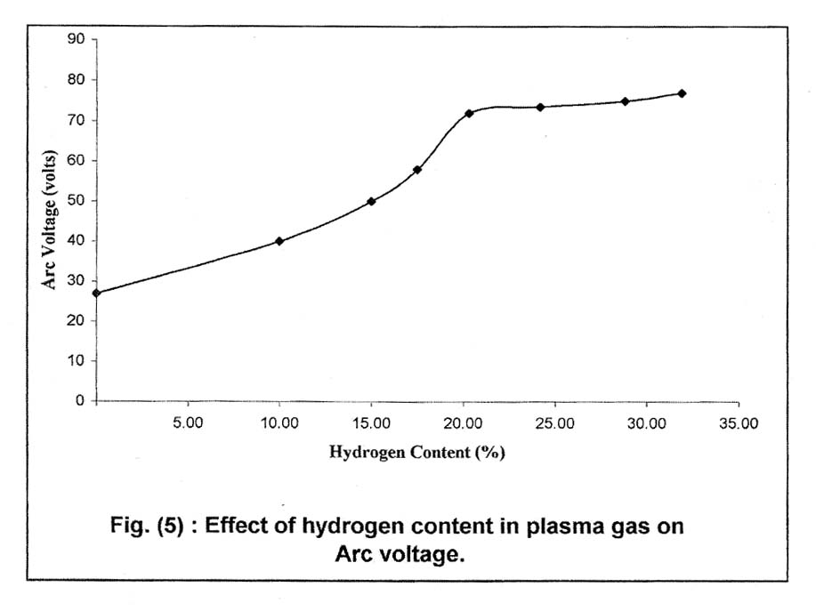
Figure (5): Effect of hydrogen content in plasma gas on Arc voltage

Table (6): The effect of the plasma gas on the coating performance, at arc current = 500A, injection angle = 90°, substrate temperature 150°C, and spraying distance =100mm
Specimen No. | Plasma gas flow rate (L/min) |  | H₂-content (%) | Arc voltage (v) | Hardness (Hv₃) | Tensile bond strength (M.Pa) | Corrosion rate (mpy) | Porosity (%) | Thickness (μm)
Specimen No. | Ar | H₂
S_{1A} | 47 | 0 | 0 | 27 | 550 | 41.6 | 0.99135 | 18.9 | 155
S_{1B} | 47 | 10 | 17.5 | 58 | 615 | 43.2 | 0.6279 | 14.5 | 160
S_{o} | 47 | 12 | 20.3 | 72 | 650 | 45 | 0.0683 | 9.8 | 230
Table (7): The effect of the applied current on the coating performance, at H₂- content (20.3%), H₂-gas flow rate=12L/min, injection angle=90°, substrate temperature=150°C, and spraying distance=100mm
Specimen No. | Arc current | Particle speed (m/s) | Particle temperature (C°) | Hardness Hv₃ | Tensile bond strength (M.Pa) | Corrosion rate (mpy) | Porosity (%) | Thickness (μm)
S_{2B} | 420 | 256 | 2644 | 635 | 44.5 | 0.6813 | 10 | 190
S_{o} | 500 | 260 | 2668 | 650 | 45 | 0.0683 | 9.8 | 230
S_{2A} | 570 | 268 | 2689 | 618 | 43.5 | 0.9521 | 12.9 | 175

Table (8): The effect of injection angle on the coating performance, at H₂-content =20.3%, H₂-gas flow rate=12L/min, arc current = 500A, substrate temperature =150°C, and spraying distance 100mm
Specimen No. | Injection angle (degree) | Hardness (Hv₃) | Tensile bond strength (M.Pa) | Corrosion rate (mpy) | Porosity (%) | Thickness (μm)
S_{o} | 90° | 650 | 45 | 0.0683 | 9.8 | 230
S_{3A} | 35° | 620 | 43.5 | 0.9128 | 13.8 | 170
S_{3B} | 45° | 630 | 44.2 | 0.8831 | 15.2 | 190
Table (9): The effect of the cooling on the coating performance, at H₂-content =20.3%, H₂-gas flow rate=12L/min, arc current =500A, injection angle=90°, and spraying distance=100mm
Specimen No. | Cooling air jet | Maximum substrate temperature (C°) | Hardness (HV₃) | Tensile bond strength (M.Pa) | Corrosion rate (mpy) | Porosity (%) | Thickness (μm)
S_{o} | Optimum placed (30°-45° to the coating) | 150 | 650 | 45 | 0.0683 | 9.8 | 230
S_{4A} | Wrongly placed  (10° to the coating) | 400 | 626 | 44 | 0.9506 | 12.6 | 180
S_{4B} | Wrongly placed (20° to the coating) | 300 | 628 | 44.6 | 0.6431 | 12.3 | 180
Table (10): The effect of the spraying distance on coating performance, at H₂-gas content =20.3%, H₂-gas flow rate =12L/min, arc current =500A, injection angle=90°, and substrate temperature =150°C
Specimen No. | Spraying distance (mm) | Substrate temperature (C°) | Hardness (HV₃) | Tensile bond strength (M.Pa) | Corrosion rate (mpy) | Porosity (%) | Thickness (μm)
S_{o} | 100 | 150 | 650 | 45 | 0.0683 | 9.8 | 230
S_{5A} | 75 | 350 | 630 | 44.3 | 0.556 | 12 | 180
S₅B | 150 | 100 | 625 | 43.8 | 0.964 | 13 | 175
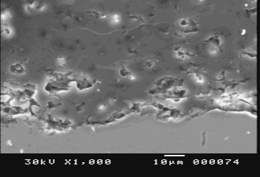 | 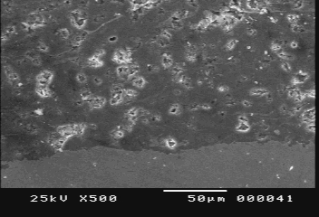
S₀ | S₀
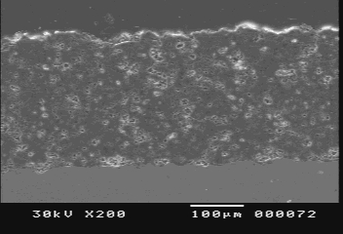
S₀
Alumina coatings sprayed with the optimum conditions
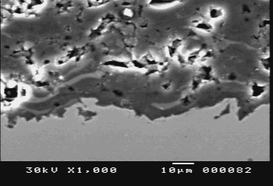 | 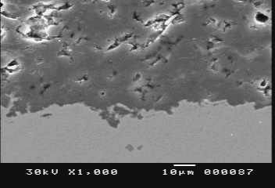
S_{1A} | S_{1B}
Pure ar (no H₂)  Arc voltages 58 V | H₂-content 17.5%  Arc voltages 58V
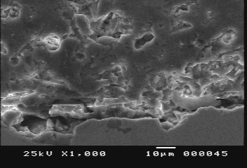 | 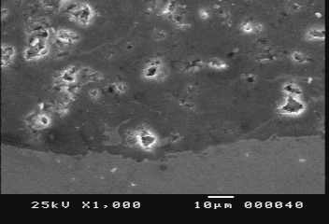
S_{2A} | S_{2B}
570 A  particle speed 268 m/s  , particle temperature 2689Cº | 420 A  particle sped 256 m/s  , particle temperature 2644 Cº
Fig. (6A)

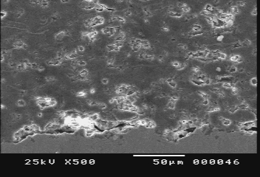 | 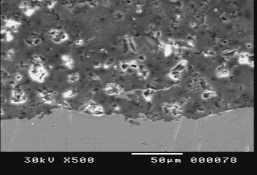
S_{3A}, Injection angle 35º | S_{3B}, Injection angle 45º
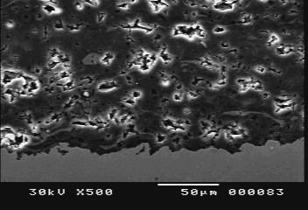 | 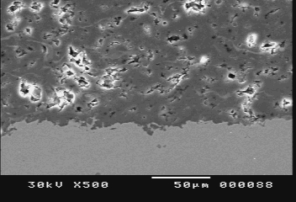
S_{4A},Wrongly placed of applied cooling air jet (10º to the coating)  Substrate temperature 400 Cº | S_{4B} , Wrongly placed of applied cooling air jet (20º to the coating)  Substrate temperature 300 Cº
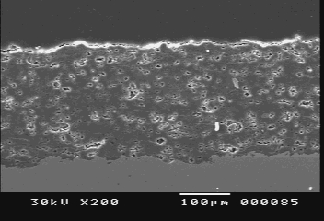 | 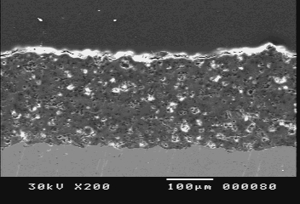
S_{5A} , Spraying distance 75 mm  Substrate temperature 350Cº | S_{5B} , Spraying distance 150 mm  Substrate temperature 100C º
Fig. (6 B)
Fig. (6 A) , (6 B): Back scattered SEM image for cross section view of alumina coatings sprayed with different conditions.

  - Powder structure and phase composition.
The alumina (Al₂O₃-3% wt TiO₂) can be prepared by fusing and crushing, the aluminum oxide containing 3% wt TiO₂ and average grains of 10-45μm gives the greatest microhardness after plasma spraying. Rapid solidification and rapid cooling are the phenomena that occur after the impact of the particle with the substrate (or previously deposited coating). These phenomena may result in the formation of metastable phases. The best known example is the formation of the gama-alumina phase (being meta-stable at room temperature) while spraying the alpha-alumina phase. The original alumina powder consists of the alpha-phase and rapid solidification of 10⁶K/S that occurs in the APS process lead to the formation of the gama-phase (γ) out of the molten material, the amount of the residual alpha-phase (α) in a coating can be taken as a measure for the un-molten part during spraying. Therefore, the phase construction of the powder and the coating was analyzed by XRD. X-ray analysis is a comparison of x-ray diffraction results for the initial alumina spray powder and typical as-deposited coating as indicated in fig. (7), the alpha-alumina present in the sprayed coatings results from the inclusion of non-melted grains, Fig. (7B). The image analysis determines the unmelted grains (4.4%) and their maximum and minimum size (26 and 2.6μm, respectively) as well as the pore content (9.8%) and maximum and minimum size of the pores (15 and 1.5 μm, respectively). Powder was fused and crushed alfa-alumina and had particle sizes in the range (10-45) μm (Fig. 8). The interfacial variations are presumed in terms of the structural observations and results of diffraction analysis, the boundary between substrate and alumina film coating reverses right the distribution of Al and Ti at interface, leading to the idea that the adhesion strength is purely due to mechanical anchoring [45]. The x-ray diffraction analysis has revealed that the alumina film consists of a mixture of α-and γ-alumina [46-47].

  - Effect of TiO₂ ratio in alumina powder on the interfacial structure of coatings onto austnitic steel substrate.
Alumina was thermally sprayed on the steel alloy substrate as protective coatings to improve wear and corrosion resistance. The coatings were heat treated for diffusion at interface between the alumina layer and the substrate. The diffusion occurred mutually and intermetallic compounds were formed in the coated layer and in the substrate near the interface. The effect of TiO₂ ratio in sprayed alumina powder on the diffusion for intermetallic compounds between substrate and alumina coatings was studied by using three different powders for comparison ( Powder 1: alumina-3% wt TiO₂ , Powder 2: alumina-6% wt TiO₂ and Powder 3: alumina-13.75% wt TiO₂ ) . The plasma spray parameters are all kept at the optimum conditions. The electron dispersive x-ray (EDX) analysis was examined on cross-section samples. The analysis of outer coating and inner coating (coating/ substrate interface) taken at different positions for each coating was measured. The EDX analysis of specimens is shown in table (11) and the typical EDX patterns are shown in Fig. (9-11). The major change of the specimens at substrate/ coating interface caused by thermal cyclings is the formation of iron-oxide phase, attributed to oxygen penetrating into steel substrate through pores and cracks.

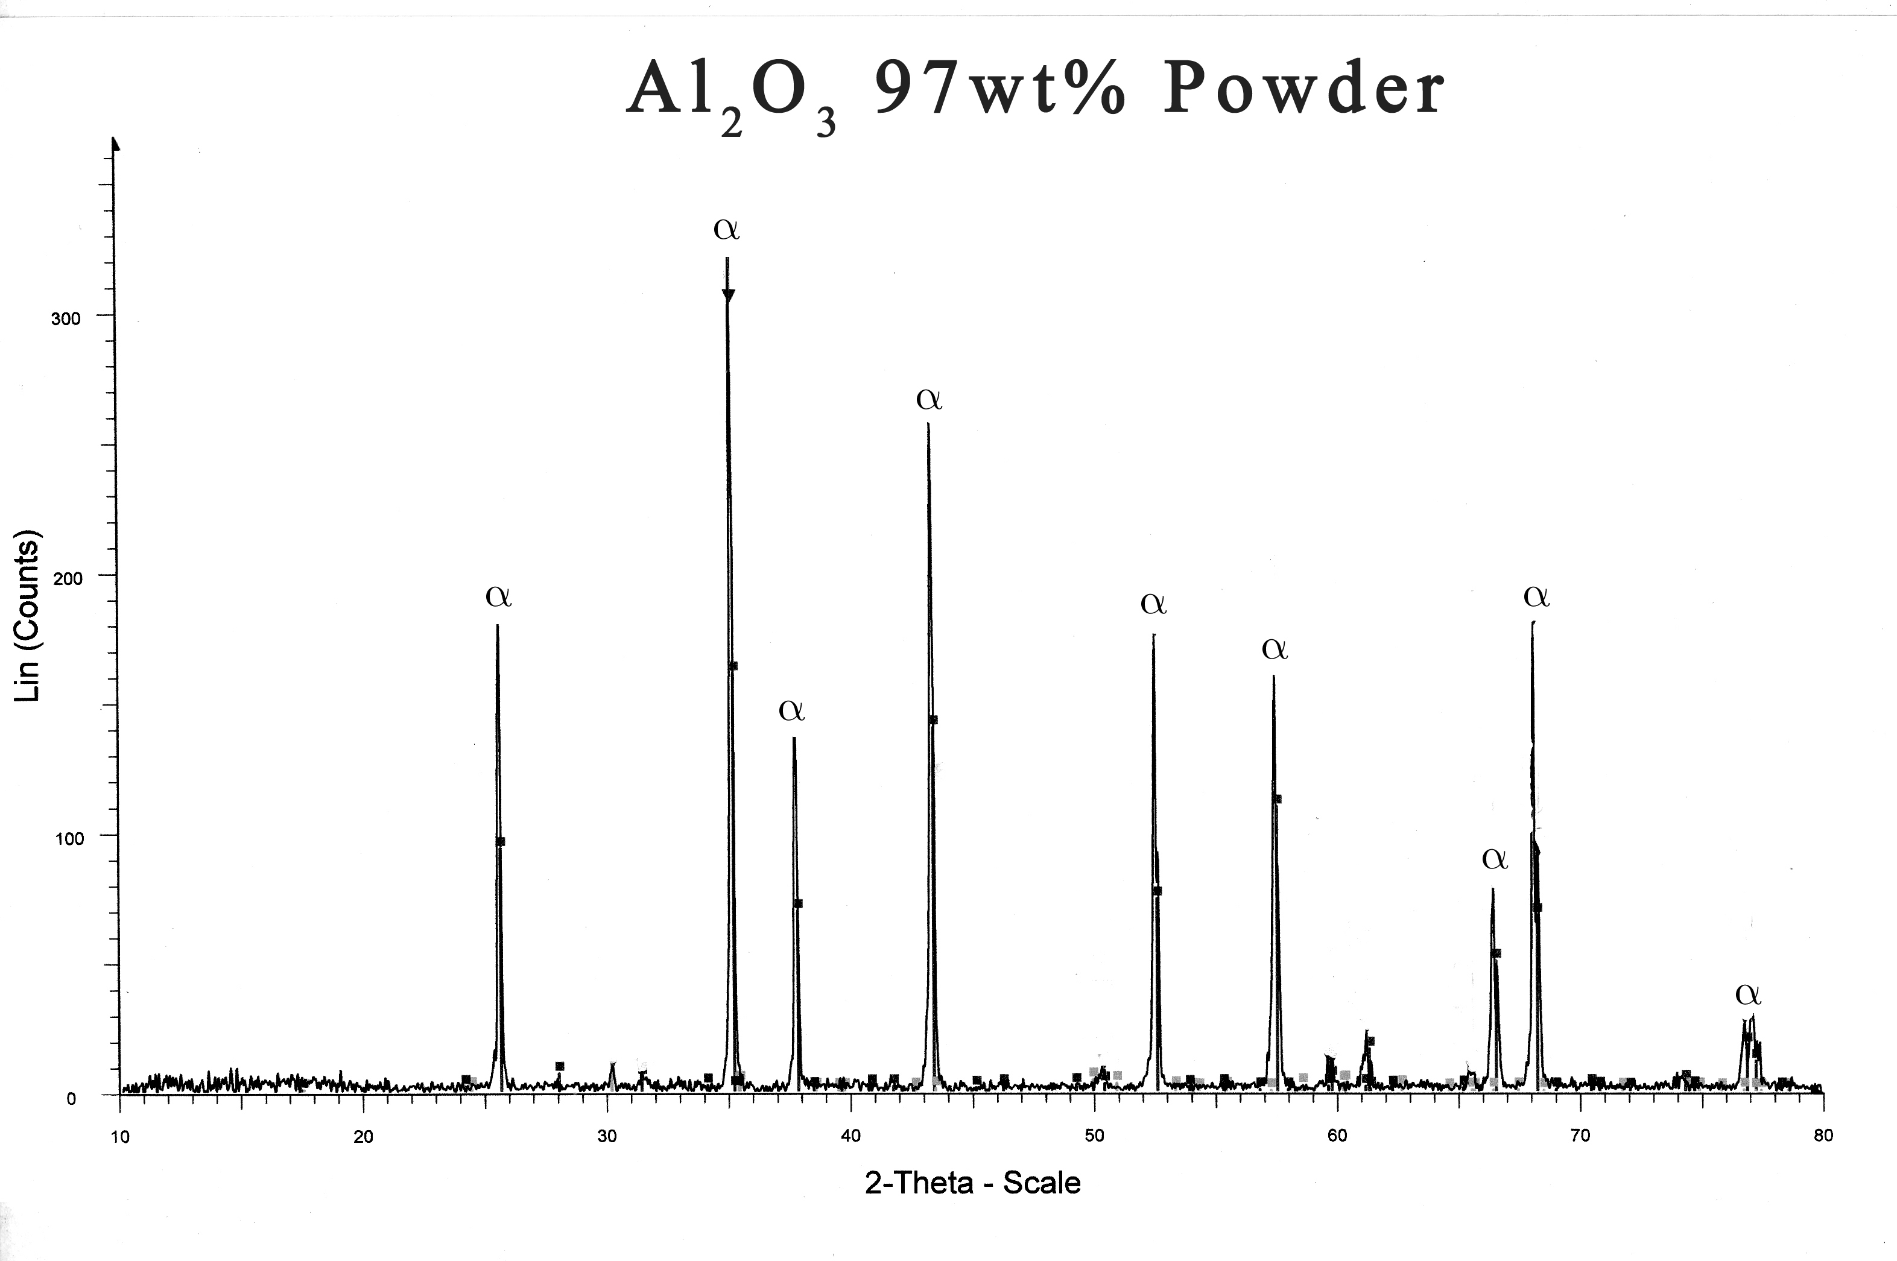
Fig. (7A): Al₂O₃-3% wt TiO₂ spray powder
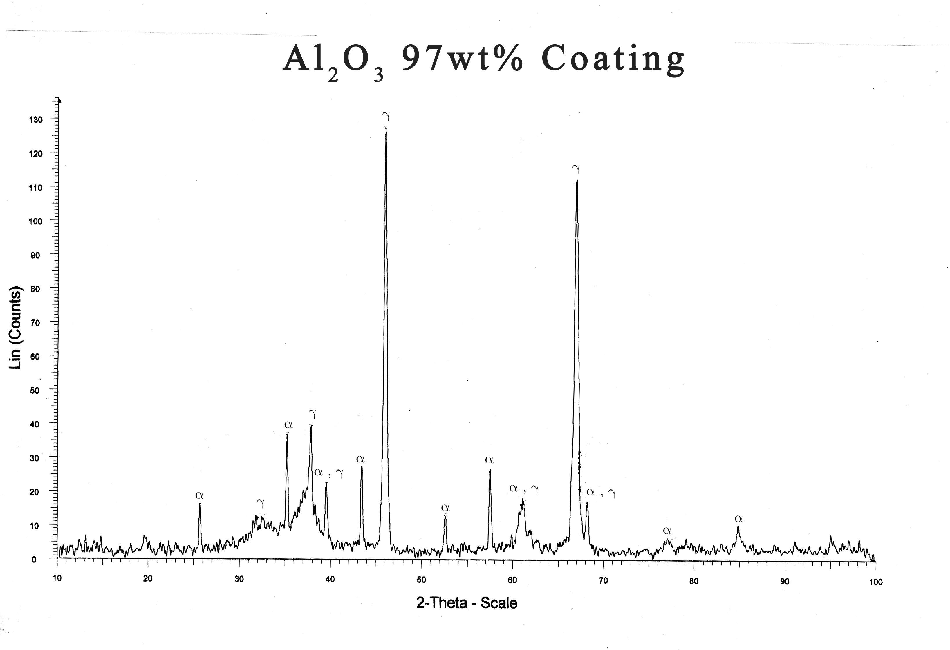
Fig. (7B): A baseline coating.

Fig. (7A, B): X-ray diffraction results show that a small amount of the gamma alumina was converted to alpha-alumina during the plasma spray process.
Fig. (8): The optical micrograph (1000x) alumina coating obtained with the plasma technique and composed of the gamma-alumina matrix, unmelted grain of alpha-alumina and pores.
Table (11): EDX results showing the diffusion between substrate elements and coating elements occurs at the coat/ substrate interface
Sample number | Position of analysis | Compound wt % |  |  |  |  |  |  |  |  | Element wt %
Sample number | Position of analysis | Al₂O₃ | TiO₂ |  | Fe₂O₃ |  | Cr₂O₃ |  | NiO |  | Al |  | Ti | Fe | Cr |  | Ni | O
1 | At outer coating | 96.72 | 3.24 |  | — |  | — |  | — |  | 51.43 |  | 1.94 | — | — |  | — | 46.63
1 | At inner coating | 70.97 | 1.14 |  | 19.75 |  | 5.47 |  | 2.67 |  | 37.6 |  | 0.69 | 13.81 | 3.75 |  | 2.1 | 41.9
2 | At outer coating | 93 | 6 |  | — |  | — |  | — |  | 49.33 |  | 4.08 | — | — |  | — | 46.00
2 | At inner coating | 92.57 | 5.9 |  | 1.53 |  | — |  | — |  | 48.64 |  | 3.94 | 1.07 | — |  | — | 46.35
3 | At outer coating | 86.25 | 13.75 |  | — |  | — |  | — |  | 45.65 |  | 8.25 | — | — |  | — | 46.11
3 | At inner coating | 86.45 | 11.29 |  | 2.25 |  | — |  | — |  | 45.76 |  | 6.77 | 1.58 | — |  | — | 45.90
Element wt %
Substrate –Base metal |  |  |  | C |  | Si |  | Mn |  | P |  | S |  | Cr | Ni | Ti |  | Fe
 |  |  |  | 0.08 |  | 0.08 |  | 2 |  | 0.035 |  | 0.025 |  | 18 | 9 | 0.7 |  | 70.08

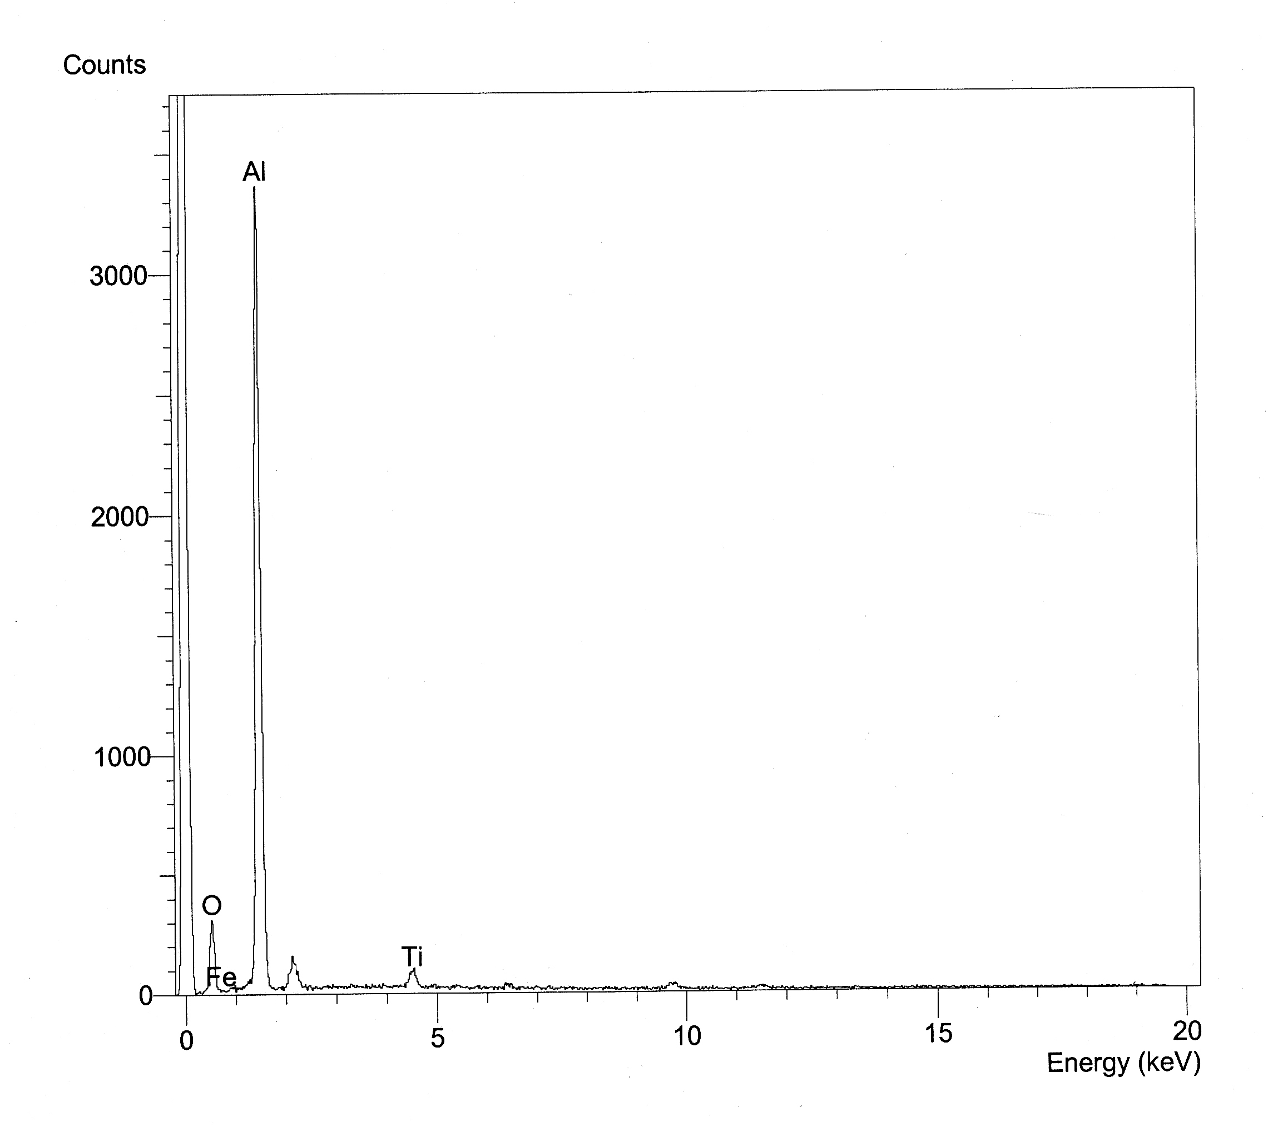
Fig. (9-A): EDX Patterns For Outer Coating of the Powder No. (1): Al₂O₃ + 3% Wt. TiO₂
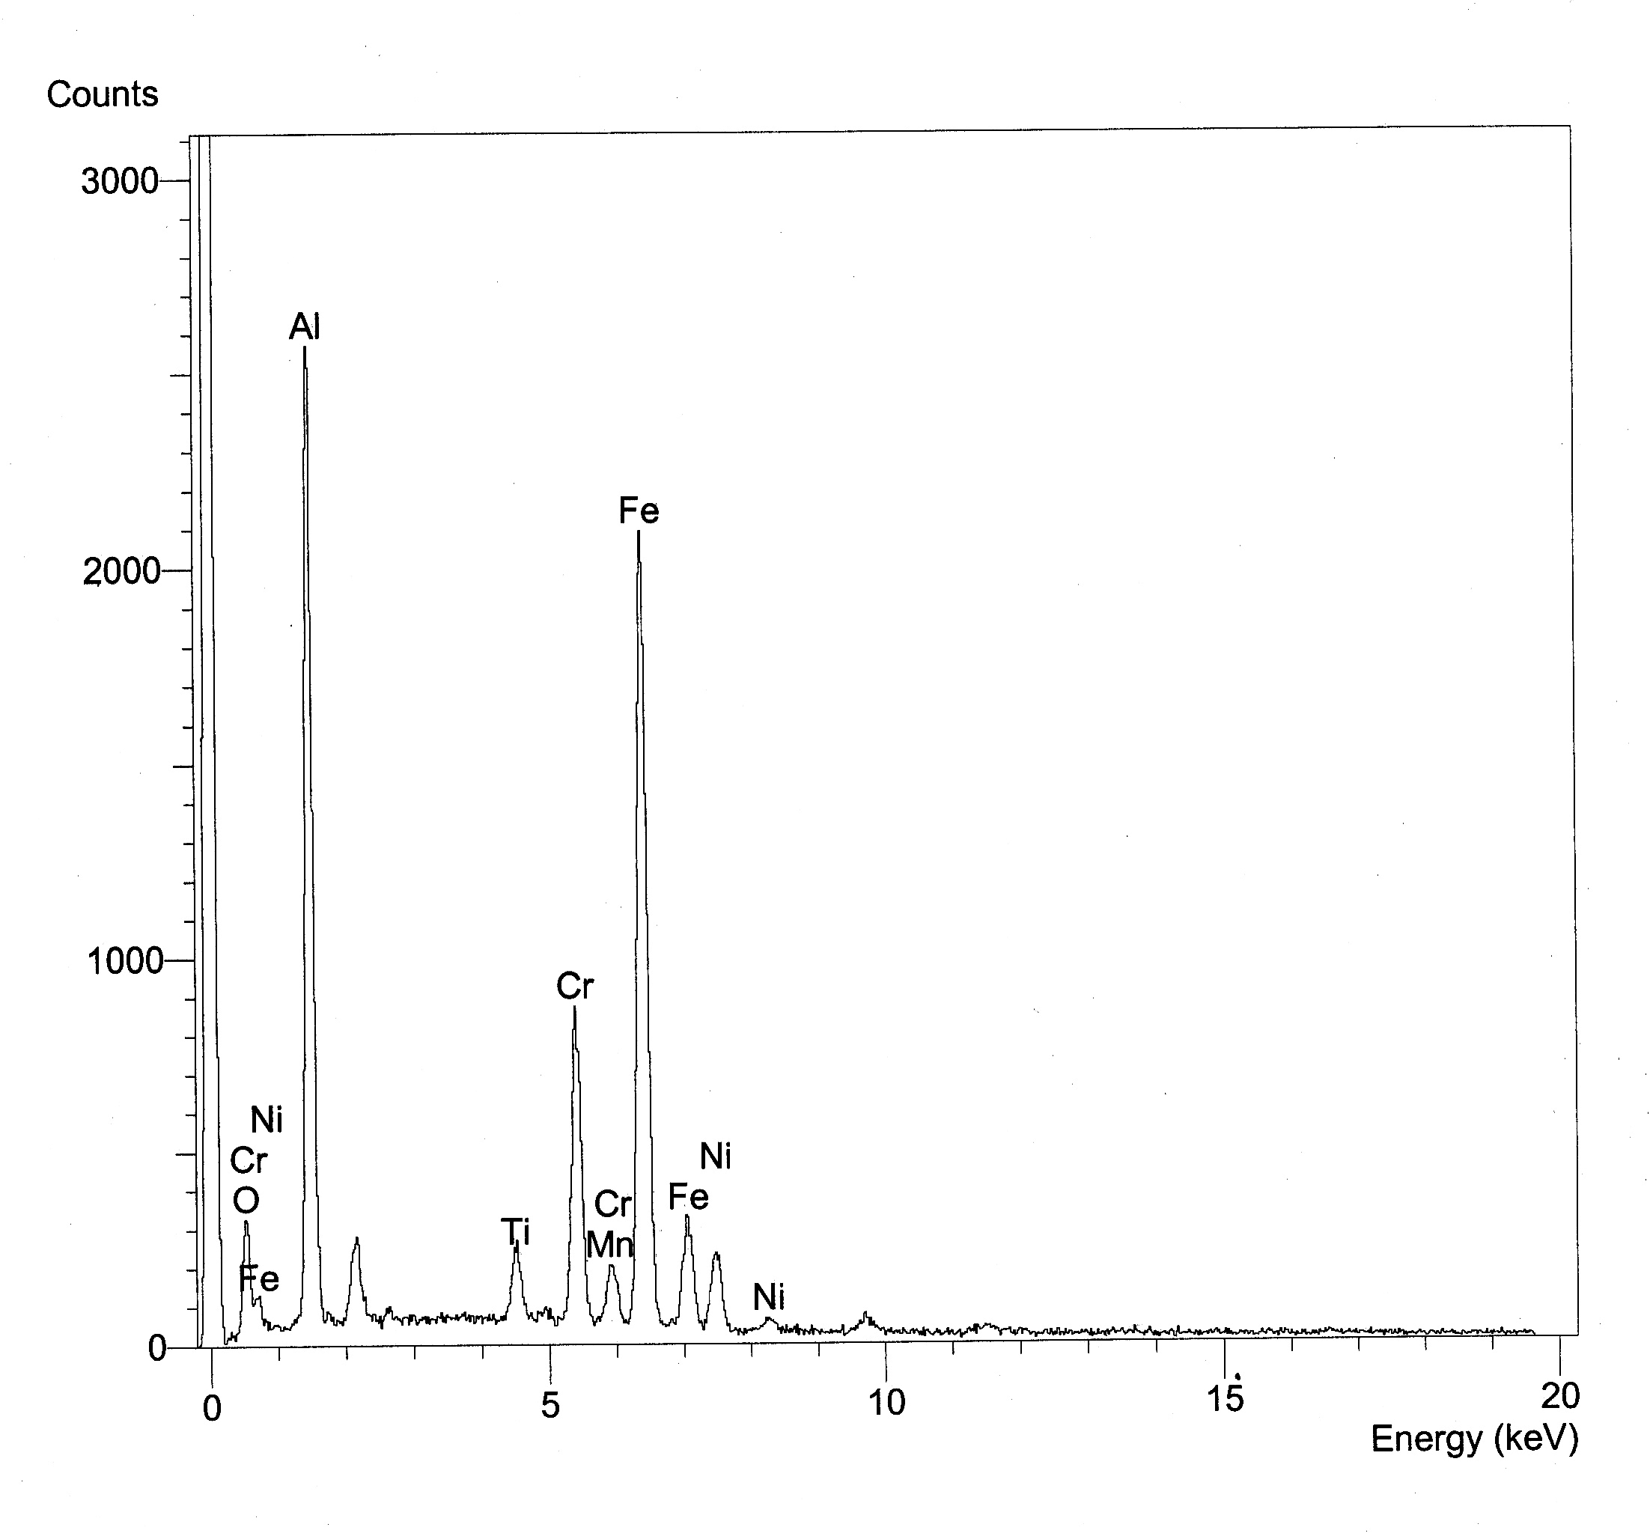
Fig. (9-B): EDX Patterns For Inner Coating of the Powder No. (1): Al₂O₃ + 3% Wt. TiO₂

Fig. (9-A), (9-B): EDX patterns for powder number (1), EDX analysis, at outer and inner coating (coating/ substrate interface).
Fig. (10-A): EDX Patterns for Outer Coating of the Powder No. (2): Al₂O₃ + 6% wt. TiO₂
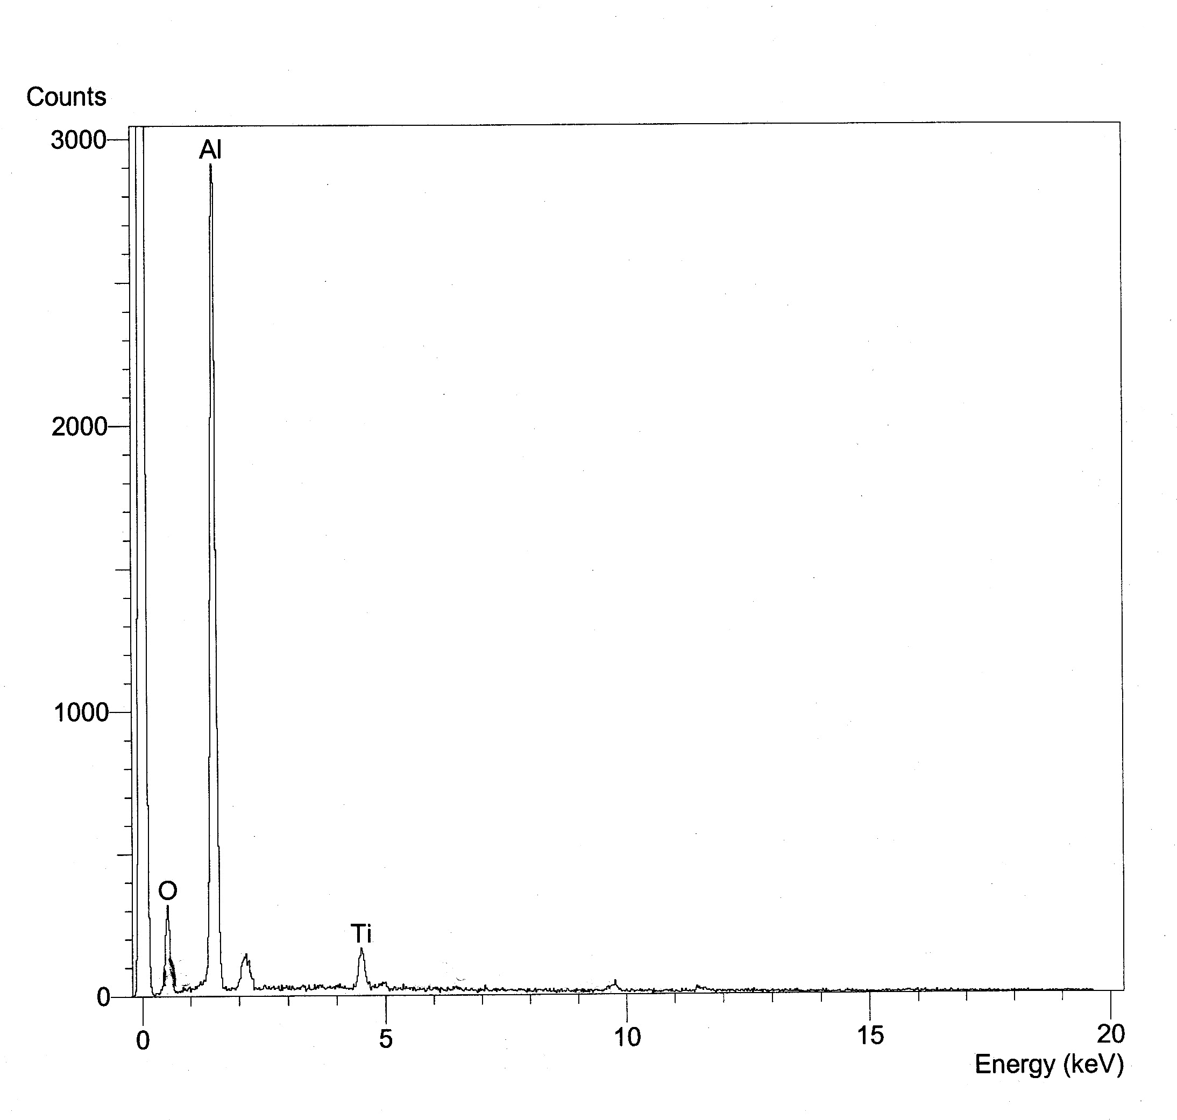
Fig. (10-B): EDX Patterns for Inner Coating of the Powder No. (2): Al₂O₃ + 6% wt. TiO₂
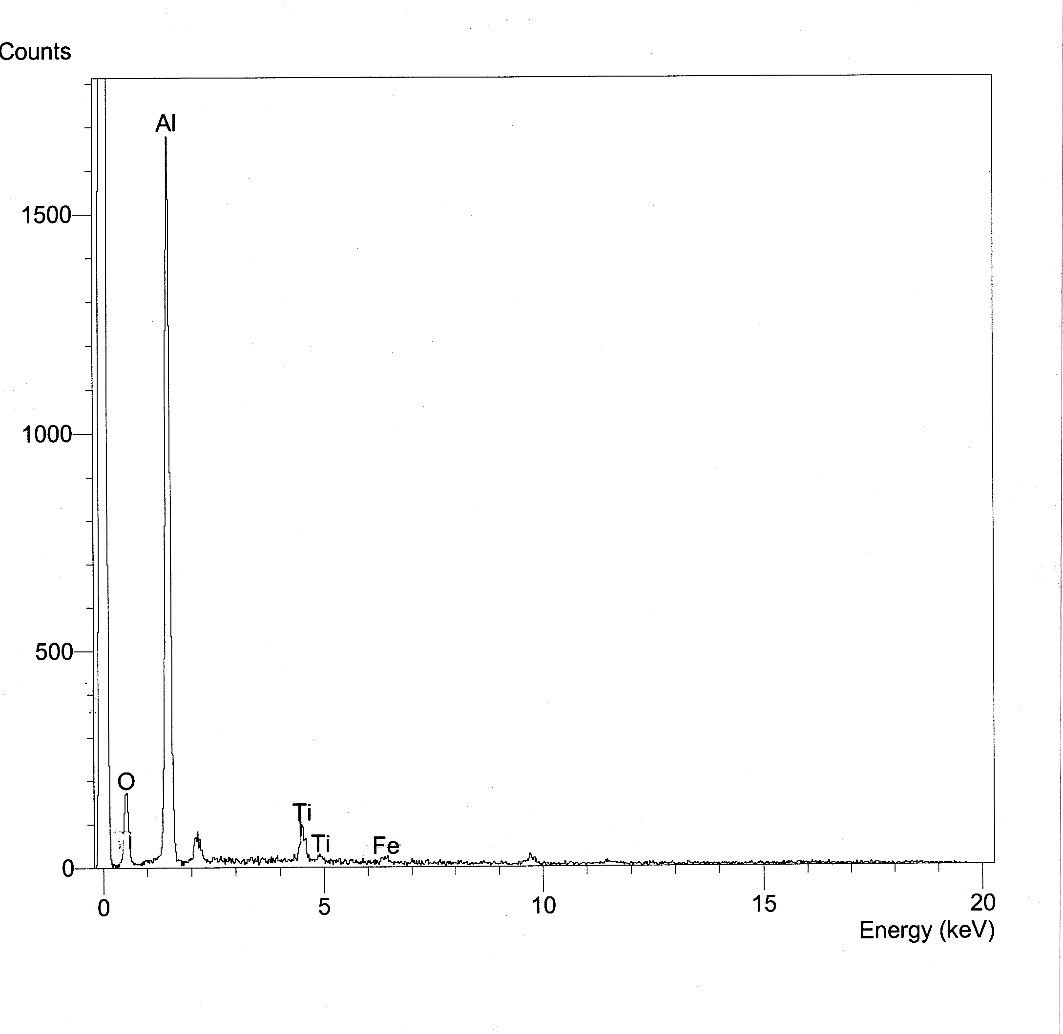
Fig. (10-A ), (10-A ): EDX patterns for powder number (2), EDX analysis, at outer and inner coating (coating/ substrate interface).

Fig. (11-A): EDX Patterns for Outer Coating of the Powder No. (3): Al₂O₃ + 13% wt TiO₂
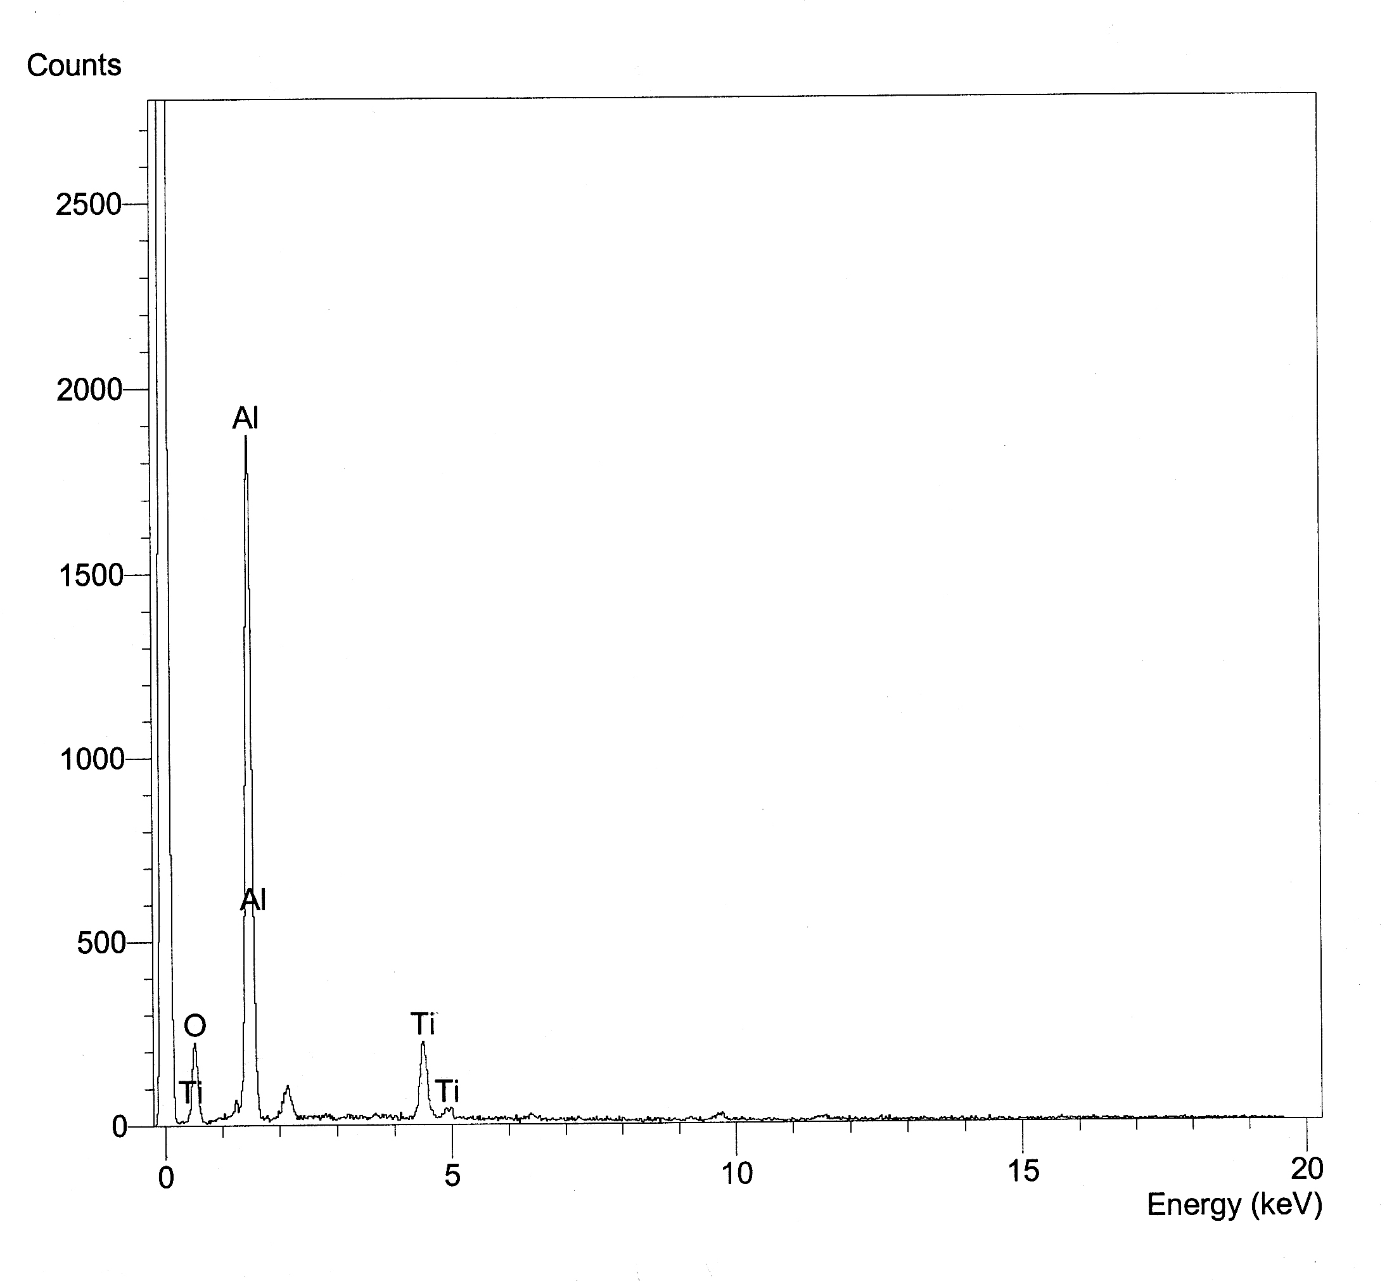
Fig. (11-B): EDX Patterns for Inner Coating of the Powder No. (3): Al₂O₃ + 13% wt TiO₂
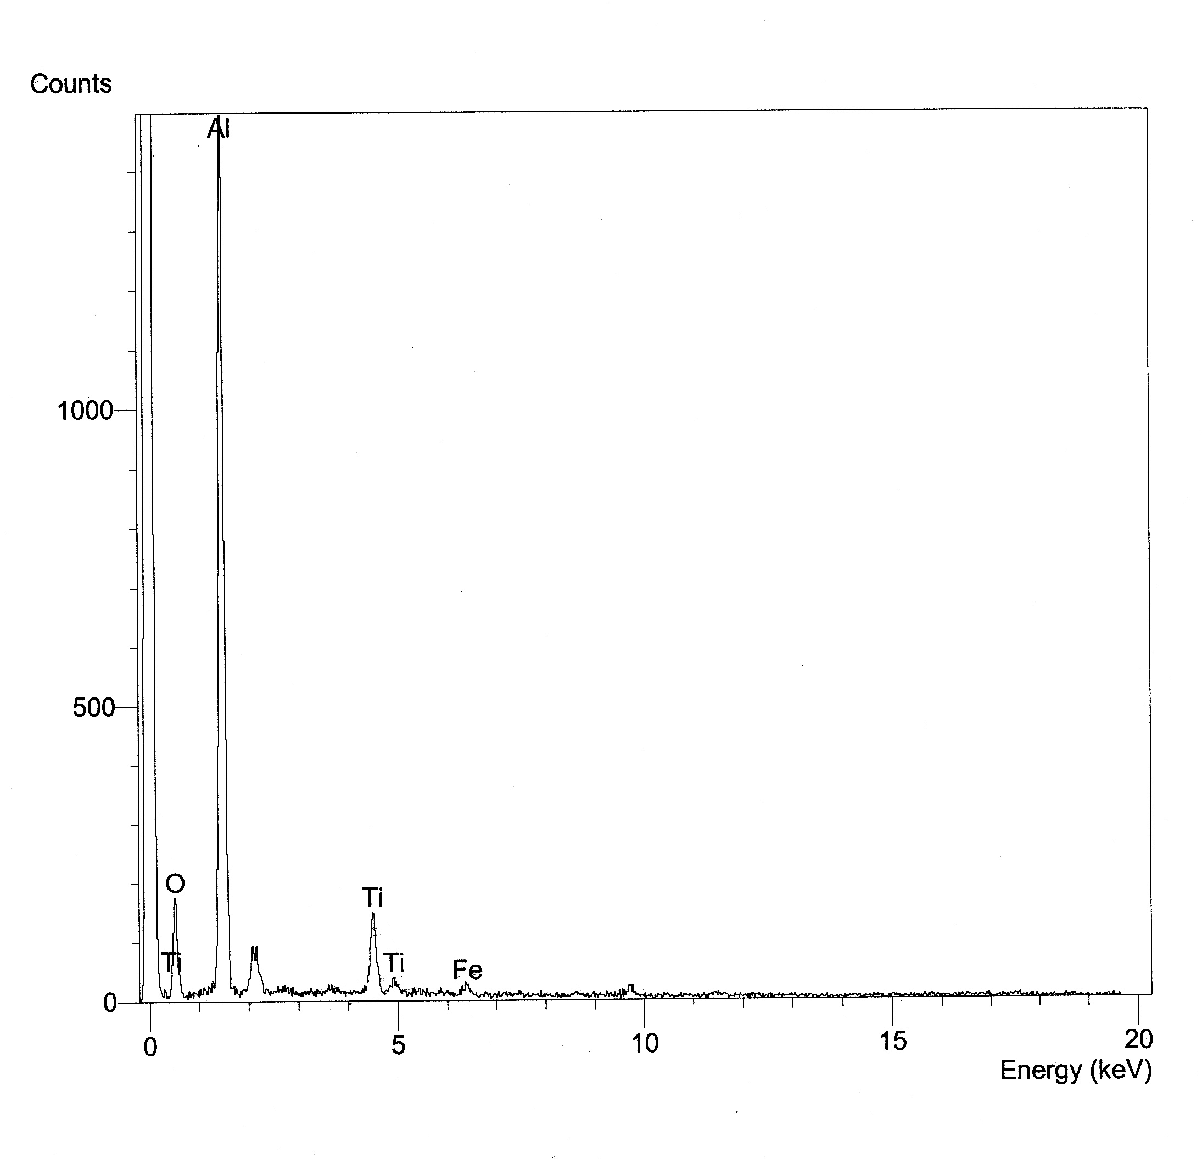
Fig. (11-A) , (11-B): EDX patterns for powder number (3), EDX analysis, at outer and inner coating (coating/ substrate interface).

3.4. Hardness test.
A comparison of hardness results for the alumina coatings of different spray conditions given in tables (6-10) and the substrate (blank) materials can be illustrated in table (12) in terms of corresponding porosity (%). According to our hardness results, the higher surface hardness value (650HV₃) is obtained when the Ar-gas flow rate = 47L/min, H2-gas flow rate =12L/min, Arc current =500A, injection angle = 90°, maximum substrate temperature =150°C, and spraying distance = 100mm. The changes of the microhardness values of the alumina coatings with different spray conditions are due to grain size and appearance or disappearance of some phases as show in XRD diagrams fig. (7). the hardness properties of austnitic steel alloy are enhanced significantly by thermal plasma spray treatment.
3.5. Tensile bond strength test.
Tensile bond strength measurement using ASTM 633-69 or DIN 50160 standards describes bonding of coating to the substrate and failure occurs at the coating to substrate interface. The failure occurs in the coating, is attributed to strongest bonding than coating cohesion. The cohesion being depends on the material used for spraying and processing technique. Tables (6-10), show the effect of changing coating parameters on tensile bond strength of different coatings obtained. Tensile bond strength of the substrate is studied for alumina coatings sprayed at optimum conditions on substrate surface while changing substrate roughness. Fig. (12) Shows the variation of tensile strength measured with substrate surface roughness. The oxide coatings adhere to the metals mostly by a mechanical anchorage mechanism. This is evidenced by a clear increase in adhesion with an increase in the substrate roughness. As the surface roughness increases, the tensile bond strength increases. According to our tensile bond strength results, the higher tensile bond strength value (45 M.Pa) is obtained when the substrate surface roughness (Ra) is equal to 3.2 μm. The strengths are taken at the same material used to spray, the same size and method of preparation, the same process technique, and the same selection of parameter (optimum conditions). The substrate/ coating temperature during deposition should be high enough to promote good cohesion coating, but not so high that coating adhesion is seriously impaired.
Table (12): Show the hardness of substrate material and alumina coatings with different spray conditions
Specimen No. | Substrate material | Alumina coating material
Specimen No. | S | S₀ | S_{1A} | S_{1B} | S_{2A} | S_{2B} | S_{3A} | S_{3B} | S_{4A} | S_{4B} | S_{5A} | S_{5B}
Hardness (H.V) | 250 | 650 | 550 | 615 | 618 | 635 | 620 | 630 | 626 | 628 | 630 | 625
Porosity (%) | — | 9.8 | 18.9 | 14.5 | 12.9 | 10 | 13.8 | 15.2 | 12.6 | 12.3 | 12 | 13
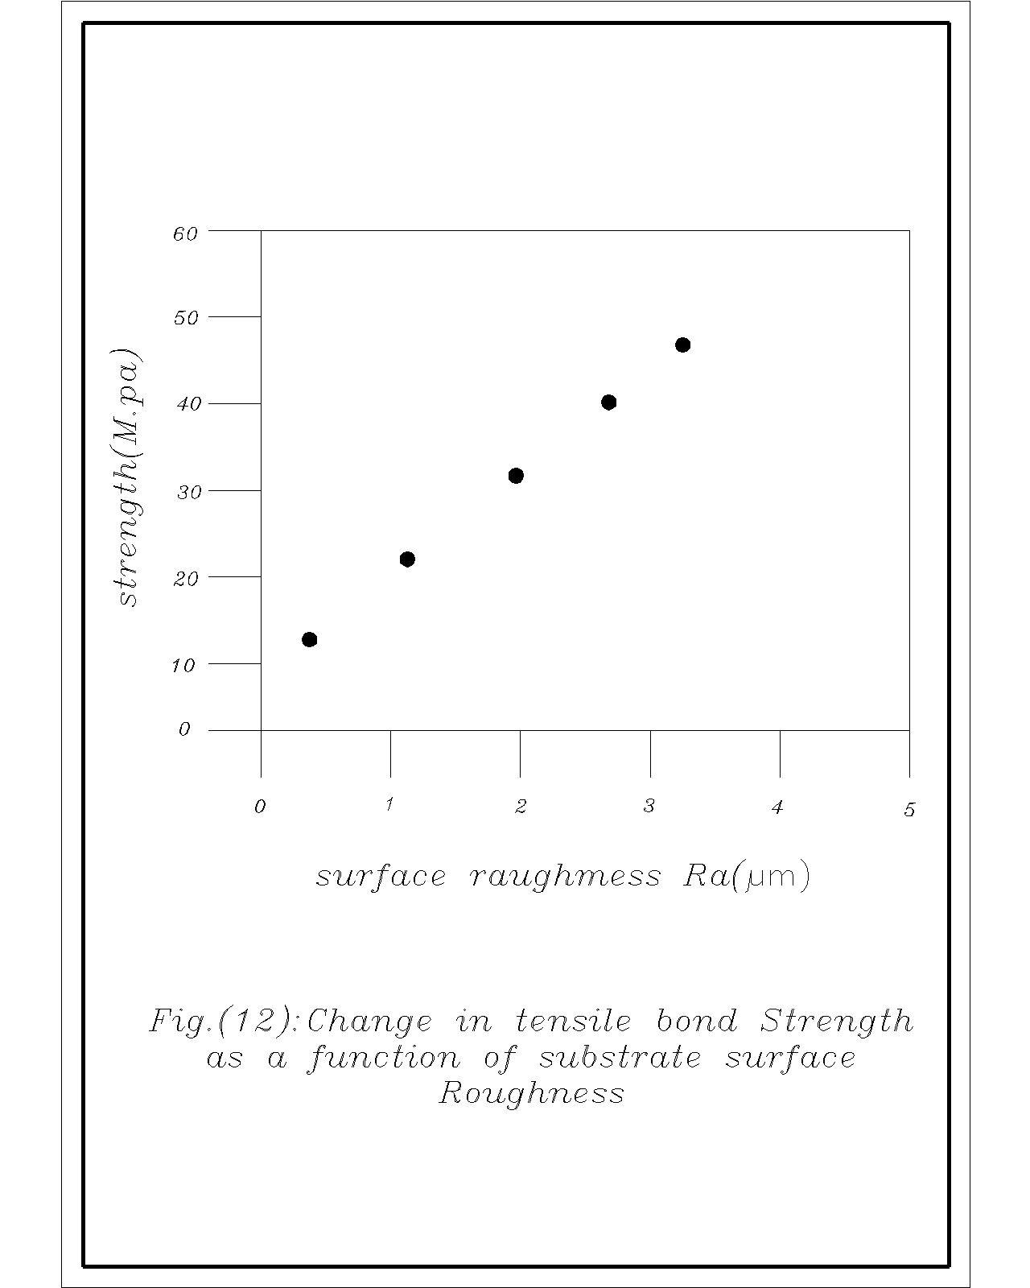
Strength (M.pa)
Surface roughness Ra (μm)
Fig. (12): Change in tensile bond strength as a function of substrate surface roughness
3.6. Corrosion protection tests.
Table (13) show the electrochemical parameters (corrosion potential E_{Corr}, corrosion current I_{Corr}, polarization resistance R_{P}, and corrosion rate (CR) derived from linear polarization experiments for the alumina coatings of different spray conditions. Treated specimens give lower corrosion rates in comparison to the blank specimens in spite of the fact that the blank still show a low value of corrosion rate. The efficiency of thermal plasma spray coating protection may be represented by equation (1).
EPSP = 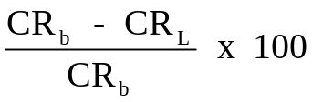 (1)
Where CR_{b} is the corrosion rate of blank specimen and CR_{L} is the corrosion rate of thermal plasma spray coating specimen at certain spraying condition. The highest efficiency of thermal plasma spray coating protection under the optimum condition amounts to 93.01% for specimen S₀. However, the efficiency depends on applied alumina coating parameters. Therefore, the following specimens are choosed for comparison, decreasing the H₂-gas flow rate from 12 L/min to 10L/min (S_{1B}), increasing of the arc current from 500 A to 570A (S_{2A}), decreasing of the arc current from 500A to 420 A(S_{2B}), decreasing of the injector angle from 90° to 35°(S_{3A}), wrongly placed of cooling air jets (S_{4A}), decreasing of the spraying distance from 100 mm to 75mm (S_{5A}), and increasing of the spraying distance from 100 mm to 150 mm (S_{5B}) while, keeping all other parameters constant. The microscopic structure of heat treated specimens shows reactive diffusion occurred between alumina coating and steel substrate. The maximum Vicker hardness value in diffused layer is about 650 HV₃. X-ray diffraction shows that the alumina layer changed from α- to γ- phases in addition to Al-Fe phase due to the diffusion. The substrate near the interface changes to intermetallic compounds of Al, Fe, Ti, Cr and Ni. The corrosion rate of the steel substrate (S) was largely decreased through plasma spraying alumina coating at optimum condition for specimen (S₀), the efficiency of corrosion inhibition was 93% as the Vicker hardness rises from 250 (uncoated substrate) to 650 (alumina plasma coating). The deviation of plasma parameters from the optimum conditions lead to fine structure of increasing porosity and cracks in addition to unmelted phase. Thus the change of plasma parameters from optimum as arc current (420A), H₂-content (20.3%) and spraying distance (75mm) decrease the Vicker hardness 650 to about 630 of corrosion inhibition range (30-43%), as shown for specimens S_{2B}, S_{1B} and S_{5B}, respectively. The specimen of S_{1B} exhibit less Vickers hardness 615, than expected, due to low arc voltage (58V) which lead to unmelted phases and delaminations. High corrosion rates with lower efficiencies <6% are characterized for the specimens S5B (150mm spraying distance), S_{2A} (570A arc current) S_{4A} (400° substance temperature) and S_{3A} (35° injection angle) of Vicker hardness less than 625. The corrosion resistance properties of austnitic steel alloy are enhanced significantly by thermal plasma spray treatment. The specimens which treated under the optimum conditions have the lowest corrosion rate and the thickest oxide layer which consists of both Al₂O₃ and TiO₂.

Table (13): Results of linear polarization experiments show the corrosion rate of the blank specimen and alumina coatings with different spray conditions
Specimen no. | E_{Corr}  (V) | R_{P} (ohm.Cm² x10³) | I_{Corr} (μA/Cm²) | Corrosion rate (mpy) | Efficiency (%)
S (blank) substrate | -0.297 | 8.416 | 3.2906 | 0.97832 | —
S₀ | -0.237 | 185.8 | 0.22988 | 0.06834 | 93.01%
S_{1B} | -0.290 | 54.58 | 2.11229 | 0.62798 | 35.8%
S_{2A} | -0.323 | 8.648 | 3.2024 | 0.9521 | 2.6%
S_{2B} | -0.231 | 18.67 | 2.2877 | 0.6813 | 30.3%
S_{3A} | -0.266 | 13.91 | 3.0705 | 0.9128 | 6.6%
S_{4A} | -0.477 | 8.661 | 3.1976 | 0.9506 | 2.8%
S_{5A} | -0.469 | 148 | 1.8712 | 0.556 | 43.1%
S_{5B} | -0.461 | 8.541 | 3.2425 | 0.964 | 1.4%

- Conclusion.
In this study, APS of Al₂O₃ – 3wt% TiO₂ is investigated using several systems to conclude the influence of plasma spray parameters on the coating performance, from the obtained data, discussion and interpretation of the results, it could be concluded that:
- The introducing a small amount of hydrogen improved the coating performance due to the hydrogen ionization potential is lower than Argon only by about two electron volt, and the high thermal conductivity of hydrogen at temperature higher than 400k results in a severe constriction of the arc column reducing the enhanced conductive thermal looses. These phenomena load to an increase of the electric field strength, and thus, of the plasma voltage.
- The hydrogen flow rate has no effect on the particle velocity due to the acceleration of particle is linked to the flow momentum, which means that it depends strongly on the mass flow rate of the plasma gas. Because Argon ions are much heavier than hydrogen ions. The mass flow rate of Argon was much higher than that of hydrogen. Correspondingly, Argon was mainly responsible for accelerating the powder particles. The higher particle velocity resulted in a worse melting behaviour of the powder due to the shorter dwell time, leading to a lower coating thickness, namely a lower deposition efficiency of the powder.
- The plasma current play a very important role with the increase of the pumping effect led to an increase in the particle velocity as well as in the particle surface temperature. The decrease in the plasma powder led to a decrease in the deposition efficiency.
- A change in color of the coating being sprayed indicates that the cooling jets are wrongly placed, the efficiency level of the spraying and the physical properties of the coating e.g. density, bond strength, and hardness. The pumping of the cooling air jets (which cools the Ar-H₂ plasma jet and the substrate) prevents the supper heating effect and deformation of the substrate because during spraying, heat could be transferred to the substrate from the plasma plume through two mechanisms during the solidification of the molten particles, the latent heat of solidification associated with the phase change from liquid to solid state will be released and conducted to the lower layers. After solidification, the newly solid layers continue to transfer heat due to high initial temperature (close to melting point) to lower temperature underlying layers and substrate.
- As the injection angle decreases (or as the injection distance increases), the droplet temperature decreases, the number of droplets which impact normally decreases because a deviation occurs for the droplet during flight for long distance; and the oxides appeared because the droplet dwell time is high enough to allow the droplets to react with the atmospheric oxygen.
- Both amorphous microcrystalline, and metastable phase are commonly observed in plasma sprayed materials due to the high rate (rapid solidification and rapid cooling).
- The electron dispersive x-ray (E.D.X) analysis of outer coating and inner coating (coating/ substrate interface) are not the same due to the diffusion of powder (alumina) into the substrate material leading to increase of the tensile bond strength.
- As the surface roughness increases, the tensile bond strength increases..
- The highest efficiency of thermal plasma spray coating protection (EPSP) under the optimum condition, amounts to 93.01% (for specimen S_{o}). The deviation of the spray parameters from the optimum condition lead to high corrosion rates with lower efficiencies. The corrosion resistance properties of austenitic steal alloy are enhanced significantly by thermal spray treatment.

- References.
- R.L. Hao, Thermal Spraying Technology and Its Applications in the Iron & Steel Industry in China, Thermal Spray 2007: Global Coating Solutions, B.R. Marple, M.M. Hyland, Y.C. Lau, C.J. Li, R.S. Lima, and G. Montavon, Ed., 14-16 May, 2007 (Beijing, China), ASM International, Materials Park, OH, 2007, p 291-296.
- Giacobbe, F.W., High Temperature Technology, 8(1), pp. 3-8 (1990).
- F. Azarmi, M. Bashirzadeh, C. Leither, and G. Karami, Investigation on Relationship between Mechanical Properties and Microstructural Characteristics of Metal Matrix Composites Fabricated by Cold Spraying Technique, Proceedings of the International Meeting on Developments in Materials, Processes and Applications of Emerging Technologies, July 2-4, 2012, Alvor, Portugal.
- F. Azarmi, V.J. Gelling, and M. Yan, Corrosion Behavior of Air Plasma Sprayed Alloy 625 on Nickel Foam Substrate, Proceedings of 2011 International Annual Corrosion Conference and Exposition (NACE), March 13-17, 2011 Houston, TX, USA.
- T. Chandanayaka and F. Azarmi, Investigation on Microstructural and Mechanical Properties of Cold Sprayed & P/M Processed Ni-Ni₃Al Composites, ITSC 2013- Proceedings of the International Thermal Spray 2013, pp. 149-154, May 13-15, Busan, South Korea.
- S. Yılmaz, Ceramics International 35, 2017 (2009).
- F. Vargas, H. Ageorges, P. Fournier, P. Fauchais, M. E. Lopez, Surface and Coatings Technology 205, 1132 (2010).
- S. T. Aruna, N. Balaji, J. Shedthi, V. K. W. Grips, Effect of critical plasma spray parameters on the microstructure, microhardness and wear and corrosion resistance of plasma sprayed alumina coatings, Surface & Coatings Technology 208 (2012)92–100.
- N. Dejang, A. Watcharapasorn, et al.: Surface and Coatings Technology, Vol. 204(2010), p. 1651
- Omidiji, B.V., Owolabi, H.A. and Khan, R.H. (2015) Application of Taguchi’s Approach for Obtaining Mechanical Properties and Microstructures of Evaporative Pattern Castings. The International Journal of Advanced Manufacturing Technology, 79, 461-468.
http://dx.doi.org/10.1007/s00170-015-6856-1
- M. Moss, Dispersion Hardening in Al-V by Plasma Jet Spray Quenching, Acta Metall., vol. 16, 1968, p. 321-326.
- Azarmi, F., Coyle, T., Mostaghimi, J. and Pershin, L. (2009) A New Approach to Develop High Temperature Foam Core Sandwich Structures Using Air Plasma Spraying. International Journal of Advanced Manufacturing Technology, 44, 900-905.
http://dx.doi.org/10.1007/s00170-008-1913-7
- Bolleddu, V., Racherla, V. and Bandyopadhyay, P.P. (2014) Microstructural and Tribological Characterization of Air Plasma Sprayed Nanostructured Alumina-Titania Coatings Deposited with Nitrogen and Argon as Primary Plasma Gases. Materials & Design, 59, 252-263.
http://dx.doi.org/10.1016/j.matdes.2014.02.040
- Pickard, J., Carretaro, J.A. and Bhavsar, V.C. (2016) On the Convergence and Origin Bias of the Teaching-Learning-Based-Optimization Algorithm. Applied Soft Computing, 46, 115-127.
http://dx.doi.org/10.1016/j.asoc.2016.04.029
- Rao, R.V. (2016) Jaya: A Simple and New Optimization Algorithm for Solving Constrained and Unconstrained Optimization Problems. International Journal of Industrial Engineering Computations, 7, 19-34.
- Maity, S.R. and Chakraborty, S. (2015) Tool Steel Material Selection Using PROMETHEE II Method. The International Journal of Advanced Manufacturing Technology, 78, 1537-1547.
http://dx.doi.org/10.1007/s00170-014-6760-0
- Zhang, Y.W., Zou, P., Li, B.Z. and Liang, S. (2015) Study on Optimized Principles of Process Parameters for Environmentally Friendly Machining Austenitic Stainless Steel with High Efficiency and Little Energy Consumption. The International Journal of Advanced Manufacturing Technology, 79, 89-99.
http://dx.doi.org/10.1007/s00170-014-6763-x
- V.V. Sobolev, J.M. Guilemany, Influence of Droplet Impact Angle on Droplet-Substrate Mechanical Interaction in Thermal Spraying, Mater. Lett. 33, 1998, p. 315-319.
- G. Montavon, S. Sampath, C.C. Berndt, H. Herman C. Coddet, Effects of Spray Angle on Splat Morphology during Thermal Spraying, Surface and Coat Technol., 91, 1997, p. 107-115.
- P. Ctibor, P. Bohac, M. Stranyanek, R. Ctvrtlik, Structured and Mechanical Properties of Plasma Sprayed Coatings of Titania and Alumina, J. Eur. Ceram. Soc., 26, 2006, p. 3509-3514
- X. Jiang, J. Matejicek, S. Sampath, Substrate Temperature Effects on Splat Formation, Microstructure, Development and Properties of Plasma Sprayed Coatings Part II: Case Study for Molybdneum, Mater. Sci. Eng. A272, 1999, p. 189-198.
- A. Satapathy, S. P. Sahu, and D. Mishra, “Development of protective coatings using fly ash premixed with metal powder on Aluminium substrates,” Waste Management and Research, vol. 28, no. 7, pp. 660–666, 2010. View at Publisher · View at Google Scholar · View at Scopus
- T. Watanabe, I. Kuribayashi, T. Honda, and A. Kanzawa, Deformation and solidification of a droplet on a cold substrate, Chem. Eng. Sci., Vol. 47 (No. 12), 1992, p. 3059-3065.
- C. San Marchi, H. Liu, E.J. Lavernia, R.H. Rangel, A. Sickinger, and E. Muehlberger, Numerical analysis of the deformation and solidification of a single droplet impinging onto a flat substrate, J. Mater. Sci., Vol. 28, 1993, p3313-21.
- G. Gupta and A. Satapathy, “Modified mechanical and wear characteristics of epoxy filled with borosilicate glass micro-spheres,” in Proceedings of the International Conference on Advancements in Polymeric Materials, CIPET, Lucknow, India, 2013.
- V.V. Sobolev, J.M. Guilemany, and J.A. Calero, Substrate-coating thermal interaction during high velocity oxy-fuel (HVOF) spraying, part 1, Heat transfer processes, Mater. Sci. Technol., Vol. 11 (No. 8), 1995, p.810-819.
- Fauchais, P., Fukomoto, M., Vardelle, A. and Vardelle, M., Knowledge Concerning Splat Formation: An Invited Review, Journal of Thermal Spray Technology, 13 (3), pp. 337 - 360, (2004).
- Raessi, M., Mostaghimi, J. and Bussmann, M., “Droplet Impact during the Plasma Spray Coating Process-Effect of Surface Roughness on Splat Shapes,” Proc. 17th Int. Symposium on Plasma Chemistry – ISPC 17, Toronto, Canada, (2005)
- D. Landes, T.V. Streibel, J. Zierhut, (2002) Proceedings of ITSC 2002, Essen, Germany, 2002, pp. 45.
- P. Bertrand, I. Smurov, M. Ignatiev, (2002) Proceedings of ITSC 2002, Essen, Germany, 2002, pp. 66.
- Gómez J, Salazar A, Múnez C, Utrilla V and Poza P 2007 Bol. Soc. Esp. Ceram. 46 232
- Ivosevic, M., Cairncross, R. A. and Knight, R., “Heating and Impact Modeling of HVOF Sprayed Polymer Particles,” Proc. 2004 International Thermal Spray Conference (ITSC-2004), DVS/IIW/ASM-TSS, Osaka, Japan, (2004).
- A. Ozturk and B.M. Cetegen, Modeling of Precipitate Formation in Precursor Droplets Injected Axially into an Oxygen/Acetylene Combustion Flame, Mater. Sci. Eng.: A, 2006, 422(1-2), p 163-175
- G.E. Kim, Proven and Promising Applications Thermal Sprayed Nanostructured Coatings, PDF file in Proceedings of the International Thermal Spray Conference 2006, PDF file in Building on 100 Years of Success: Proceedings of the International Thermal Spray Conference 2006, B.R. Marple, M.M. Hyland, Y-C. Lau, R.S. Lima, and J. Voyer, Ed., May 15-18, 2006 (Seattle, WA, USA), ASM International, Materials Park, OH, USA, 2006
- C. Delbos, J. Fazilleau, V. Rat, J.F. Coudert, P. Fauchais, B. Pateyron, Phenomena Involved in Suspension Plasma Spraying, Part 1: Suspension Injection and Behaviour, Plasma Chem. Plasma Process., 2006, 26(4), 371–391
- R. Siegert, A Novel Process for the Liquid Feedstock Plasma Spray of Ceramic Coatings with Nanostructural Features, Juelich Press, Germany, 2006, Jül-4205
- J.B. Nerz, A. Kushner, A. J. Rotolico, J. Therm. Spray Technol. 1 (2) (1992) 147.
- Milewski, 1973, Vinoyo et al., 1985b, Rangaswamy and Herman, 1986
- Kohal, R.J.; Bächle, M.; Att, W.; Chaar, S.; Altmann, B.; Renz, A.; Butz, F. Osteoblast and bone tissue response to surface modified zirconia and titanium implant materials. Dent. Mater. 2013, 29, 763–776. David L. Poerschke, Jason S. Van Sluytman, Kimberly Wong, Carlos G. Levi, Acta Materialia 61 (2013) 6743-6755.
- Roualdes, O.; Duclos, M.-E.; Gutknecht, D.; Frappart, L.; Chevalier, J.; Hartmann, D.J. In vitro and in vivo evaluation of an alumina-zirconia composite for arthroplasty applications. Biomaterials 2010, 31, 2043–2054.
- Elisa M. Zaleski, Charlotte Ensslen and Carlos G. Levi, Journal of the American Ceramic Society (submitted, December 2013).
- J.Y. Jeong, J. Park, I. Henins, S.E. Babayan, V.J. Tu, G.S. Selwyn, G. Ding and R.F. Hicks, J. Phys. Chem.,2000, 8027 (2000)
- Sarikaya, O. (2005) Materials and design, 26 (1), pp. 53-57.
- S. Kitahara, Japan. J. of composite materials, 13, 37-44 (1987).
- D.M. Lipkin, J.A. Krogstad, Y. Gao, C.A. Johnson, W.A. Nelson, and C.G. Levi, Journal of the American Ceramic Society, 96 [1] 290-298 (2013).
- Lusty, P.J.; Tai, C.C.; Sew-Hoy, R.P.; Walter, W.L.; Walter, W.K.; Zicat, B.A. Third-generation alumina-on-alumina ceramic bearings in cementless total hip arthroplasty. J. Bone Jt. Surg. 2007, 89, 2676–2683.

