Preceramic organomagnesiumoxaneyttriumoxanealumoxanes: synthesis, properties and pyrolysis
Galina I. Shcherbakova, Doctor of Chemistry, SSC RF GNIIChTEOS, Russian Federation
Pavel A. Storozhenko, Doctor of Chemistry, SSC RF GNIIChTEOS, Russian Federation

Abstract
Statement of the Problem: Development of efficient synthesis methods of ceramics forming elementoxane oligomers – precursors for the production of components (binders, impregnating compositions, fibers, powders) of highly pure ceramic composites based on aluminum, yttrium and magnesium oxides (Y₃Al₅O₁₂, MgAl₂O₄, α-Al₂O₃) [1-5]. Methodology & Theoretical Orientation: Organomagnesiumoxaneyttriumoxanealumoxanes were prepared by magnesium and yttrium acetylacetonates co- condensation with ethylacetoacetateethoxyhydroxyalumoxanes [5-7]. Organometallic synthesis provides high purity, perfect nanostructure and unchallenged physic-mechanical properties of ceramic composites based on organomagnesiumoxaneyttriumoxanealumoxanes. Findings: Ceramics forming organomagnesiumoxaneyttriumoxanealumoxanes with the specified molar ratio of Al:Y and Al:Mg hydrolytically stable in air and soluble in organic solvents have been synthesized [5]. Conclusion & Significance: Thermal transformation of organomagnesiumoxaneyttriumoxanealumoxanes results in the production of Y₃Al₅O₁₂, MgAl₂O₄, α-Al₂O₃, that is, similar oligomers can be used to create a new generation of heat-resistant, optically transparent, corrosion- and radiation-resistant ceramic composites. The particular advantages in the use of ceramic forming organoelement oligomers consist in the ability to control the composition and structure of ceramic compositions at all levels (microcrystalline, nanostructured or amorphous), which cannot be completely achieved by any other known methods.

Image
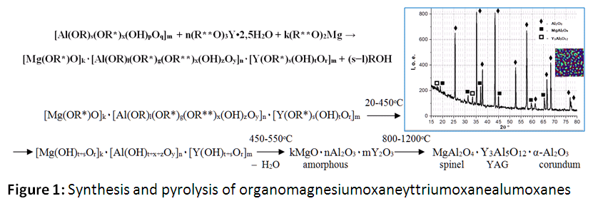
Recent Publications
- Shcherbakova G, Storozhenko P, et al. (2012) Synthesis of yttrium-containing organoalumoxanes. Inorganic Materials 48: 1058-1063.
- Shcherbakova G, Storozhenko P, et al. (2017) Preceramic organomagnesiumoxanealumoxanes: synthesis, properties and pyrolysis. Polyhedron 135:144–152.
- Shcherbakova G, Storozhenko P, et al. Method for organomagnesiumoxaneyttriumoxanealumoxanes production, binders and impregnating materials based thereon. The application for a patent of the Russian Federation No. 2017104275 from 09.02.2017.
- Liu Y, Zhang Z, Halloran J, Laine R. (1998) Yttrium aluminum garnet fibers from metalloorganic precursors. J. Am. Ceram. Soc. 81: 629-645
- Liu Y, Laine RM. (1999) Spinel fibers from carboxylate precursor. J Eur. Ceram Soc 19:1949-1959.


G.I. Shcherbakova, Doctor of Chemistry (2009), Leading Researcher of the State Research Institute for Chemistry and Technology of Organoelement Compounds. Her scientific interests include synthesis, structure and reactivity of organoelement and organometallic compounds; fundamentals of new materials creation; nanoparticles, nanomaterials; development of new structural materials and coatings.
Email: galina7479@mail.ru
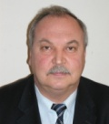
P.A. Storozhenko, Corresponding Member of the Russian Academy of Sciences, Professor, Doctor of Chemistry (1996), Vice President of the RF Association of State Scientific Centers, General Director of the State Research Institute for Chemistry and Technology of Organoelement Compounds, RF Government prizewinner. His scientific interests cover synthesis, structure and reactivity of organoelement and organometallic compounds; nano- and microstructures; fundamentals of innovative activity in the area of metals, ceramics and composite materials for constructional purposes; solutions, melts - structure and properties; crystals formation and structure.
Email: info@eos.su

Notes/Comments: This work was supported by the Russian Foundation for Basic Research, project no. 17-03-00331 A

