Synthesis of Co-free & Li-excess positive electrode materials for lithium-ion battery
Mitsuharu Tabuchi, PhD, National Institute of Advanced Industrial Science and Technology (AIST), 1-8-31 Midorigaoka Ikeda Osaka, 563-8577, Japan.
Nobuhiro Kuriyama, PhD, National Institute of Advanced Industrial Science and Technology (AIST), 1-8-31 Midorigaoka Ikeda Osaka, 563-8577, Japan.

Abstract (300 word limit)
The Co-free positive electrode material is necessary as constituent material for large-scale lithium-ion battery to use Electronic Vehicle (EV) and Plug-in hybrid one (PHEV). As shown in following image part, we developing seven high-capacity material systems (>200mAh/g) having above 3.2 V of discharge voltages. Our main strategy is utilizing Fe ion for oxide-based positive electrode material, because iron is cheap and environmental-friendly element and LiFeO₂ is known as electrochemically-inactive as positive electrode material. To activate the LiFeO₂ component, we have been trying to make novel LiFeO₂-Li₂MnO₃ solid solution (FM system). The first paper was published from 2001 and the study is still continued to improve its electrochemical property [1]. To synthesize homogeneous FM sample with high Fe content, careful optimization of preparation condition must be needed. Original coprecipitation – calcination method was constructed. The coprecipitation temperature was kept to low temperature (-10ºC) to avoid spinel ferrite formation and then it wet-oxidized by bubbling with air. This precursor preparation technique is very important. After washing and mixing with Li salt, the mixture was dried for pulverization. It calcined in air or N₂ flow. Other systems (see image.) were derived from the FM one. Among them, the LiFe_{1/2}Ni_{1/2}O₂-Li₂MnO₃ solid solution (FNM system) was designed to raise discharge voltage close to 3.5 V [2]. Applying stepwise-charging method, its electrochemical properties was rather improved [2]. LiFeO₂-Li₂MnO₃-Li₂TiO₃ (FMT system [3]) and Li₂TiO₃-Li₂MnO₃ (TM system [3]) solid solutions were synthesized by coprecipitation – calcination - carbothermal reduction process. NiO-Li₂MnO₃ (NM system [4]) and NiO-Li₂MnO₃-Li₂TiO₃ (NMT system [4]) was prepared by coprecipitation – hydrothermal – calcination process. The LN system was considered as Li-excess LiNiO₂ which was synthesized by thermal decomposition of Li₂NiO₃ [5]. Research details for these selected systems will be presented.
Image
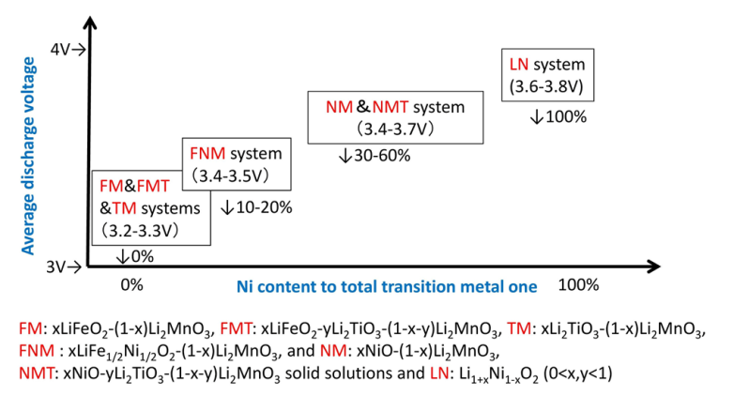
Our developed positive electrode materials vs. their average discharge voltages.

Acknowledgements
A part of this work (FNM system) was financially supported by the New Energy and Industrial Technology Development Organization (NEDO) as a national project: “Li-ion and Excellent Advanced Battery Development “and “Advanced Technology Development Project for Lithium-ion Battery Application.”
Recent Publications (minimum 5)
- M. Tabuchi, Y. Nabeshima, T. Takeuchi, K. Tatsumi, J. Imaizumi, and Y. Nitta (2010) J. Power Sources, 195:834-844.
- M. Tabuchi, H. Kageyama, H. Shibuya, K. Doumae, R. Yuge and N. Tamura (2016) J. Power Sources, 313:120-127.
- M. Tabuchi, Y. Nabeshima, T. Takeuchi, H. Kageyama, J. Imaizumi, H. Shibuya and J. Akimoto (2013) J. Power Sources, 221:427-434.
- M. Tabuchi, H. Kageyama, K. Takamori, Y. Imanari and K. Nakane (2016) Electrochmica Acta, 210:105-110.
- M. Tabuchi, N. Kuriyama, K. Takamori, Y. Imanari and K. Nakane (2016) J. Elecrtochem. Soc., 163:A2312-A2317.


Biography (150 word limit)
Mitsuharu Tabuchi is a solid-state chemist for developing novel positive electrode material for Lithium-ion battery. He developed original synthetic route to accomplish a complete mixing two or three kind of transition metal ions in AIST from 1994. He also has skills for X-ray Rietveld analysis and ⁵⁷Fe Mössbauer spectroscopy for material characterization.
Email: m-tabuchi@aist.go.jp

Notes/Comments:

