Optical SERS response of long distance organizations of metallic nanoparticles (Ag, Au, Cu)
Alexa Courty, Laboratoire MONARIS, Sorbonne Universités, Universite Pierre et Marie Curie, Paris France.

Abstract (300 word limit)

There is a considerable interest for producing and understanding the optical and spectroscopic properties of ordered nanocrystals (NCs) assemblies. We report unique properties of highly ordered 3D plasmonic superlattices made of NCs (Ag, Au or Cu) called supercrystals. For 3D assemblies, previous optical measurements were made on collections of supracrystal assemblies [1], which complicated the analysis particularly since the substrate contribution and individual properties depend on the supercrystal height.

Apart from usual systems used in SERS, the NCs we synthesized have a low diameter (between 4 and 10 nm) and a narrow size distribution (<10%) [2,3]. They are capped with alkyl chain to prevent their coalescence and oxidation. This ligand can also be used as vibrational probe. Because of their very narrow size distribution, these NCs self-organize in fcc superlattices [5] onto very large distances (several micrometres). These superlattices, could thus be studied individually under an optical microscope.

We describe the formation and characterization of NCs supercrystals, together with their optical and SERS properties [4,5]. The enhancement Factors have been calculated depending on the nature of the metallic NCs, the alkyl chain length and the NCs size.

Image

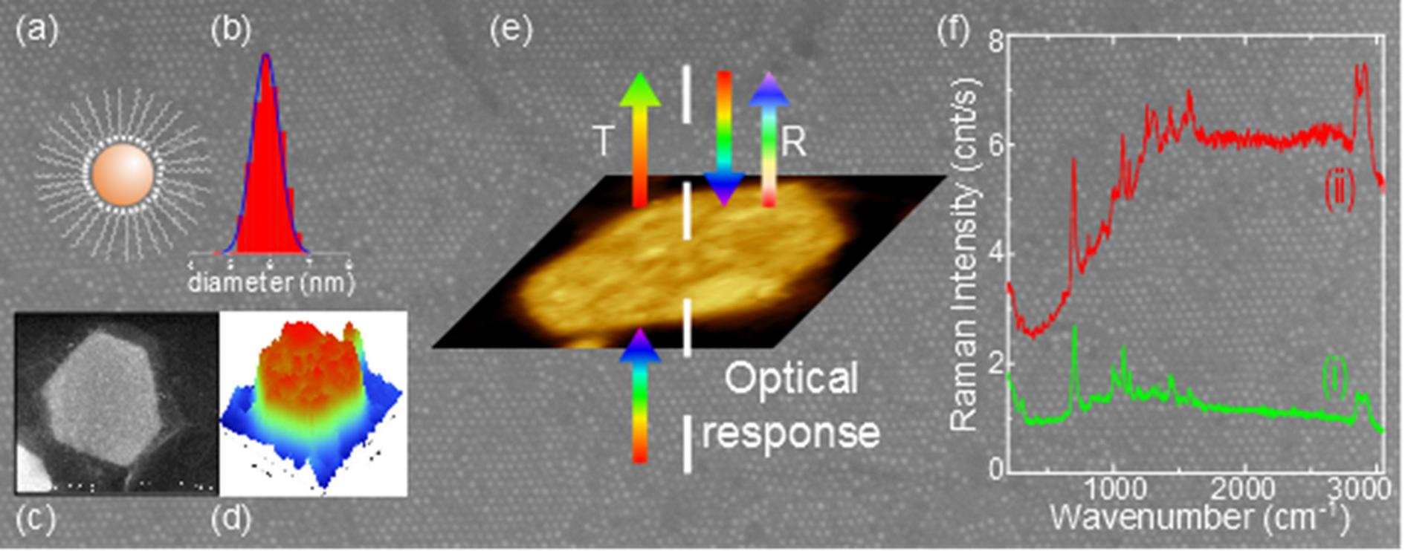
Figure 1: (a) Nanocrystals coated by dodecanethiol and (b) their size distribution. (c) SEM-FEG and (d) AFM images of a silver supra-crystal. (e) Optical response of a single supra-crystal. (f) SERS spectra of a supra-crystal functionalized by thiophenol.

Recent Publications (minimum 5)
1. N. Pinna, M.Maillard, A. Courty, V.Russier M.P. Pileni, Phys.Rev B, 66, 045415-1-045415-6 (2002) “Optical properties of silver anocrystals self-organized in a two dimensional superlattice : substrate effect”
2. A. Andrieux–Ledier, B. Tremblay and A.Courty, J.Phys.Chem.C, 117, 14850-14857, (2013). “Synthesis of Silver Nanoparticles Using Different Silver Phosphine Precursors: Formation Mechanism and Size Control
3. M.A.B. Aissa, B.Tremblay, A. Andrieux-Ledier, E. Maisonhaute ; N. Raouafi and A.Courty., Nanoscale. 7, 3189, (2015). “Copper nanoparticles of well-controlled size and shape: a new advance in synthesis and self-organization”.
4. P. Aubertin, M. A.B Aissa, N. Raouafi, S. Joiret, A. Courty and E. Maisonhaute. Nanoresearch. 8, 1615 (2015). “Optical response and SERS properties of individual large-scale supracrystals made of small silver nanocrystal”
5. L. Chapus, P. Aubertin, S. Joiret, I.T. Lucas, E. Maisonhaute and A. Courty, Tunable SERS platforms from small nanoparticles 3D superlattices: comparison between gold, silver and copper.: a tunable SERS platform, Chem.Phys.Chem. (2017). DOI: 10.1002/cphc.201700601

 Biography (150 word limit)
Alexa Courty is full professor at the University Pierre and Maris Curie (UPMC Paris, France) since 2010. She is co-director of the doctoral school “Physical Chemistry and Analytical Chemistry Paris Centre” since 2016 at UPMC. She has her expertise in chemical synthesis of metallic nanoparticles (Ag, Au, Cu) of controlled size and shape, their organization at long range and the study of their physical properties. She showed that 2D and 3D organization of silver nanoparticles present optical and vibrational collective properties, specific to the organization. She extended this work to gold and copper nanoparticles. Her work allowed to control the crystalline structure of the 3D superlattices made of nanoparticles from non compact to compact.
.
Email: alexa.courty@upmc.fr

Notes/Comments:

