Dithienothiophene Based Quinoidal Solution-Processable n-type Organic semiconductors
Sureshraju Vegiraju, National Central University, Taiwan
Chen Ming-Chou, National Central University, Taiwan

Abstract
The conjugated organic materials have attracted much attention for the potential applications of organic field effect transistors (OFETs) in memory devices, smart cards, radio frequency identification tags, electronic papers, flexible displays and sensors due to their low cost process ability and high flexibility. Currently solution processable small molecular organic semiconductors are of great interest to develop high performance and ambient stable organic materials for OFETs. A versatile π−building blocks with efficient solubility is important in developing solution processable organic semiconductors in which alkyl chains are a fundamental units. The alkyl chain modifications such as changing in length, installing branched alkyl side chains and position of branching are important features in achieving better device performances, molecular packing, and intermolecular interactions. Dithieno[3,2-b:2′,3′-d]thiophene (DTT) unit has shown as one of promising building block of conjugated materials with p and n channel charge carrier mobilities. We have designed and synthesized a series of dialkyldithieno[3,2-b:2',3'-d]-thiophene based dicyanomethylene end capped quinoidal n-channel organic semiconductors with various alkyl chains (DTTQ-3, DTTQ-6, DTTQ-11 DTTQ-15). We have applied one pot synthetic route for the preparation of dialkyldithieno[3,2-b:2',3'-d]-thiophene. Among the synthesized quinoidal compounds DTTQ-11 has exhibited the electron mobility of 0.45 cm² V⁻¹ s⁻¹. The single crystal X-ray Diffraction of DTTQ-6 was determined and the charge transport in this packing structures can be achieved either through face-to-face parallel molecules in the same stack or through the well zip-zap connected neighboring molecules.

Image
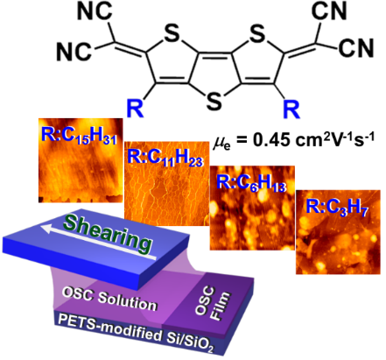

Recent Publications (minimum 5)

- Vegiraju S, Huang D Y, Priyanka P, Li Y S, Luo X L, Hong S H, Ni J S, Tung S H, Wang C L, Yau S L, Liu C L, Chen M C and Facchetti A (2017). Solution-processable Tetrathienoacene (TTAR) based Small Molecules for Organic Field Effect Transistor Applications, Chem Comm ( Just Accepted).
- Vegiraju S, He G Y, Kim C, Priyanka P, Chiu Y J, Liu C W, Huang C Y, Ni J S, Wu Y W, Chen Z, Lee G H, Tung S H, Liu C L, Chen M C and Facchetti A (2017). "Solution‐Processable Dithienothiopheno-quinoid (DTTQ) Structures for Ambient‐Stable n‐Channel Organic Field Effect Transistors." Advanced Functional Materials: 1606761.
- Vegiraju S, Liu Y-Y, Prabakaran K, Ni J-S, Ezhumalai Y, Yu H-C, Yau S L, Lin J T, Chen M-C and Lin T-C (2015). "Synthesis and characterization of novel symmetrical two-photon chromophores derived from bis(triphenylaminotetrathienoacenyl) and fused-thiophene units." RSC Advances 5(67): 54003-54010.
- Vegiraju S, Hsieh C-M, Huang D-Y, Chen Y-C, Priyanka P, Ni J-S, Esya F A, Kim C, Yau S L, Chen C-P, Liu C-L and Chen M-C (2016). "Synthesis and characterization of solution-processable diketopyrrolopyrrole (DPP) and tetrathienothiophene (TTA)-based small molecules for organic thin film transistors and organic photovoltaic cells." Dyes and Pigments 133: 280-291.
- Chen M-C, Vegiraju S, Huang C-M, Huang P-Y, Prabakaran K, Yau S L, Chen W-C, Peng W-T, Chao I, Kim C and Tao Y-T (2014). "Asymmetric fused thiophenes for field-effect transistors: crystal structure-film microstructure-transistor performance correlations." Journal of Materials Chemistry C 2(42): 8892-8902.
- Youn J, Vegiraju S, Emery J D, Leever B J, Kewalramani S, Lou S J, Zhang S, Prabakaran K, Ezhumalai Y, Kim C, Huang P-Y, Stern C, Chang W-C, Bedzyk M J, Chen L X, Chen M-C, Facchetti A and Marks T J (2015). "Diperfluorophenyl Fused Thiophene Semiconductors for n-Type Organic Thin Film Transistors (OTFTs)." Advanced Electronic Materials 1(8): 1500098.

 Biography (150 word limit)
Sureshraju Vegiraju has his expertise in synthetic organic chemistry. He develops conjugated organic materials for the applications in organic electronics and studies the opto electronic properties.
Email: suresh.vegiraju@gmail.com
Notes/Comments

