Single Particle Spectroscopic Studies on Two-Photon Photoluminescence of Plasmon Coupled Gold Nanotriangle Dimers
Monalisa Garai, MSc, NUS, Singapore
Qing-Hua Xu, PhD, NUS, Singapore

Abstract
Surface plasmon resonance (SPR) coupling between adjacent metal nanoparticles in aggregated nanoclusters results in significant enhancements in many optical responses, such as fluorescence, surface enhanced Raman scattering (SERS) and two-photon photoluminescence (2PPL). Here, 2PPL properties of gold nanotriangle (Au NT) dimers with different spatial arrangements have been investigated on single particle level to understand their different plasmon coupling effects on 2PPL enhancement mechanism and explore the limit of maximum achievable enhancement factor.
Compared to NT monomer, scattering spectra of both side-by-side and tip-to-tip coupled NT dimers are red-shifted by 101 nm and 175 nm respectively with strong polarization dependence along their assembly axis, which can be understood in terms of plasmon hybridization theory. A close resemblance between scattering spectra and 2PPL spectra indicated SPR is the origin of observed 2PPL signal. 2PPL intensities of side-by-side and tip-to-tip dimers are enhanced by 1.0×10³ fold and 2.6×10⁴ fold respectively, compared to the NT monomer. Such a huge enhancement in tip-to-tip dimer is a combined effect of plasmon-coupling-induced red-shifted SPR band which has better overlap with the excitation wavelength and giant local electric field amplification due to the presence of sharp tips in interparticle gap. The influence of sharp tips has been further demonstrated by comparing Au NT monomer and dimers with Au nanosphere (NS) monomer and dimer of similar dimensions. The 2PPL intensity of Au NT monomer is 20 times stronger compared to Au NS monomer, where as that of Au NT tip-to-tip dimer is 93.5 times stronger compared to Au NS dimer. All our experimental results show excellent agreement with numerically calculated integrated |E/E₀|⁴ results. These findings offer a deeper insight in fundamental understanding of plasmon coupling enhanced 2PPL properties and provide a platform for various sensing and imaging applications.

Image
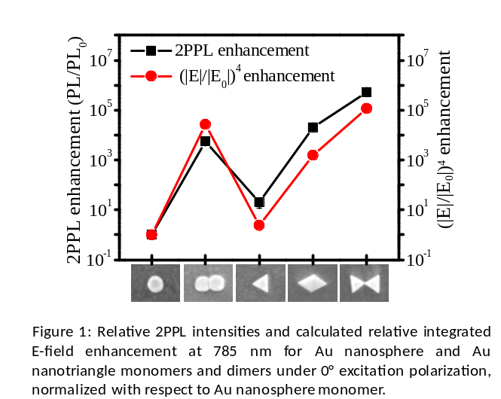
Recent Publications
- Garai M, Zhang T, Gao N Y, Zhu H, Xu Q-H (2016) Single Particle Studies on Two-Photon Photoluminescence of Gold Nanorod−Nanosphere Heterodimers. J. Phys. Chem. C 120: 11621-11630.
- Guan Z P, Gao N Y, Jiang X F, Yuan P Y, Han F, Xu Q-H (2013) Huge Enhancement in Two-Photon Photoluminescence of Au Nanoparticle Clusters Revealed by Single-Particle Spectroscopy. J. Am. Chem. Soc. 135:7272−7277.
- Schuck P J, Fromm D P, Sundaramurthy A, Kino G S, Moerner W E (2005) Improving the Mismatch between Light and Nanoscale Objects with Gold Bowtie Nanoantennas. Phys. Rev. Lett. 94:017402−017402
- Gao N, Chen Y, Li L, Guan Z, Zhao T, Zhou N, Yuan P, Yao S Q, Xu Q-H (2014) Shape-Dependent Two-Photon Photoluminescence of Single Gold Nanoparticles. J. Phys. Chem. C 118:13904−13911.
- Halas N J, Lal S, Chang W-S, Link S, Nordlander P (2011) Plasmons in Strongly Coupled Metallic Nanostructures. Chem. Rev. 111:3913−3961.

Biography
Monalisa Garai is currently a fourth year PhD student under the supervision of Assoc. Prof. Xu QingHua in Department of Chemistry, NUS. Monalisa received her Master's degree with a specialization in Material Chemistry from department of Chemistry, NUS. Before joining NUS, she finished her Bachelor and Master's degree from University of Calcultta, India. Her research interests include single particle spectroscopy, plasmonic nanostructures, nonlinear optics and nanophotonics.
Email: A0107206@u.nus.edu

