Long Term Real-Time Traffic Flow Prediction Using LSTM Recurrent Neural Network
Wei Cai

Abstract

Real-time traffic volume prediction plays a vital role in proactive network management, and many forecasting models have been proposed to address this issue in the literature. However, most of them suffer from the inability to fully use the rich information in traffic data to generate efficient and accurate traffic predictions for a longer term (i.e., 7-day predictions at a 5-min interval).

In this paper, we focus on predicting multi-step real-time traffic volume using two types of Long Short-Term Memory (LSTM) networks: many-to-one LSTM and many-to-many LSTM by creating a flexible ensemble forecasting system that combines numbers of neural network and predictions out of interpolation. Considering the large amount of data points in the current dataset, in order to address one of the typical concerns we have with RNN models with respect to longer training time, we do sampling on the original dataset by each 12 data points (about an hour), and training is applied on the sampled data. In order to effectively evaluate the model performance, we add 11 data points using interpolation between each pair of two sampled data points. Similar methods are applied to generate a longer term of predictions at a 5-min time interval. Experimental results demonstrate that the proposed approach can effectively deal with the changing traffic pattern and show good performance in generating multi-step predictions.

Based on experimental comparisons, we also observe that many-to-many appears to be more appropriate for sequence predictions where multiple input time steps are required in order to predict a sequence of output time steps.

Bio

Wei Cai

Wei Cai was born in China. She received her master degrees in Actuarial Science and Business Anlysis from Georgia State University, Atlanta, Georgia. She is currently seeking master degree with the concentration on computing and analysis from Georgia Institute of Technology, Altana, Georgia, and is expected to graduate in 2019.

She joined Cox Communication, Atlanta, Georgia, in 2013. Since 2016, she made transition from building statistical model and doing analysis using R and SAS to developing machine learning models processing streaming telemetry data using python, scala, and Java. She successfully developed both statistical models and deep learning models for company to build a 10-year capacity planning budget. She is working on building models to compute to maximize network availability.

Her major areas of research interest are building deep learning models to help proactive network management.

The previous experimental comparisons and conclusions were drawn based on the prediction of the one-step ahead horizon prediction and all experiment are made under complete dataset. In this section, we give some further discussion including prediction with longer horizon.
Predicting traffic flow on several time horizons in the future allows for a wider range of application to make use of the prediction. For DTC, predicting a longer horizon only means that more entries of real-time tensor pattern are set to unknown. Simply, for a prediction horizon of 15 min with 5 min scale data, the first 6 data points are used to forecast the 7-9th data points (horizon of 15 min) and the 7-9th data points are et to unknown in the dynamic tensor pattern. Then, the 9-period tensor window of size 11 x 7 x 7 x 9 incorporates the 7-9th data points and the model is refit to forecast the 10-12th data points.

many-to-one LSTM and many-to-many LSTM, in which the every 5-min real-time data are represented as tensor pattern, which is able capture more information of traffic flow than traditional methods, namely, temporal variabilities, spatial characteristics, and multimode periodicity.

A DTC algorithm is designed to use the multimode information to forecast traffic flow with a low-rank constraint. The proposed method is evaluated on real-world data sets and compared with other state-of-the-art methods, and the efficacy of the proposed approach is validated on the experiments of traffic flow prediction, particularly when dealing with incomplete traffic data.

This study focuses on predicting market values using LSTM networks. Both two types of LSTM network (many-to-one and many-to-many) show good performance in predicting future time series data. The previous experimental comparisons and conclusions were drawn based on the prediction of the one-step ahead horizon prediction and all experiment are made under complete dataset. In this section, we give some further discussion including prediction with longer horizon.
Predicting traffic flow on several time horizons in the future allows for a wider range of application to make use of the prediction. For DTC, predicting a longer horizon only means that more entries of real-time tensor pattern are set to unknown. Simply, for a prediction horizon of 15 min with 5 min scale data, the first 6 data points are used to forecast the 7-9th data points (horizon of 15 min) and the 7-9th data points are et to unknown in the dynamic tensor pattern. Then, the 9-period tensor window of size 11 x 7 x 7 x 9 incorporates the 7-9th data points and the model is refit to forecast the 10-12th data points.

Therefore it is very important to have the ability to timely, accurately and efficiently predict the traffic flow and provide network operators the possibility for real-time monitoring.
The many-to-many LSTM achieves better performance than many-to-one LSTM.

The main contributions of this paper include the following

- We proposed a dynamic tensor completion method dealing with dynamic tensor stream constructed from time series with multi-mode structure. The tensor completion problem is solved by fast matrix factorization. In contrasts to our previous tensor completion models such as reported in [29],[40] and [45], where, static tensor, not dynamic tensor, model was used.
- The dynamic tensor completion method is applied to short-term traffic flow prediction. The prediction is purely fulfilled by tensor completion without a training process of the predictors. And it can effectively deal with missing data issues.
- We designed a dynamic traffic flow tensor model according to the multi-mode correlation of traffic flow data. And we use a method to dynamically find suitable low-n-rank of the dynamic tensor model.

Short-term traffic prediction plays a critical role in many important applications of intelligent transportation systems such as traffic congestion control and smart routing, and numerous methods have been proposed to address this issue in the literature. However, most, if not all, of them suffer from the inability to fully use the rich information in traffic data. In this paper, we present a novel short-term traffic flow prediction approach based on dynamic tensor completion (DTC), in which the traffic data are represented as a dynamic tensor pattern, which is able capture more information of traffic flow than traditional methods, namely, temporal variabilities, spatial characteristics, and multimode periodicity. A DTC algorithm is designed to use the multimode information to forecast traffic flow with a low-rank constraint. The proposed method is evaluated on real-world data sets and compared with other state-of-the-art methods, and the efficacy of the proposed approach is validated on the experiments of traffic flow prediction, particularly when dealing with incomplete traffic data.

Introduction
While all the previously mentioned prediction approaches are powerful and useful methods for traffic flow prediction, they also have some drawbacks facing with complex traffic flow data pattern that have a multi-node structure (time, space, week, day, et al.) [29]-[30][31]. Generally, the more the multi-mode information prediction method incorporated, the more accurate the prediction method is. For example, prediction model with both spatial mode and temporal mode information outperforms the prediction model purely exploiting temporal information, and the performance of prediction method can be improved by utilizing the week mode and day mode periodicity. However, most of the conventional prediction methods construct traffic data into time series (1-way) or matrix pattern (2-way) [32]. The one-way vector and two way pattern only mine limited mode characteristics because the mode number off traffic flow data is more than the model dimension of matrix pattern (2-way). In order to mine more multi-mode information under the umbrella of one-way and two-way data structure pattern, many research studies propose hybrid models to forecast short-term traffic flow. Although some hybrid methods achieve promising performance, the combination rule of different methods is difficult to determine and the combination may add complexity to the prediction tool. In view of these deficiencies, this paper focuses on developing a method can make full use of the multi-mode information of traffic data to improve short-term traffic flow prediction.

In the last decades, one of the most popular method to characterize the data with multi-mode structure is to construct such data into tensor (multi-way array), which is the multi-way generalizations of vector and matrix [33]-[34][35]. It has been shown in numerous research areas, including face recognition [36], social networks [37], video processing [38], and neuroscience [39].
Constructing data with multi-mode structure into tensor pattern with advantages over 1-way and 2-way pattern in terms of extension of the multi-mode structure utilization capability. Particularly, recent studies show that the tensor-based methods outperform 1-way and 2-way based methods for missing traffic data imputation [29] and recovery of traffic data with outliers [40]. Recently, there are attempts to develop tensor decomposition algorithm for traffic speed prediction. In [41], the tensor decomposition is utilized to provide a low-dimensional representation of traffic state. The solution of traffic prediction in [41] is a combination of tensor decomposition and SVR. It should be noted that the application of tensor decomposition in [41] was focused on the low-dimensional representation of traffic state. And this method did not consider the problem of missing data, which is a major issue in traffic data sets.

Motivated by the success of tensor-based methods, which consider the multi-mode information of traffic data in the area of traffic data processing, we adopt the dynamic tensor pattern to model traffic flow data for short-term traffic data and propose a novel dynamic tensor completion method (DTC). DTC can utilize the temporal mode, spatial mode, day mode and week mode information of traffic flow data. Also, we use a tensor completion method, which is believed to be one of the best multi-way unknown data estimation method. Consequently, the proposed DTC accurately forecasts the near-term traffic flow with the multi-mode information. For evaluation, the proposed method is tested on real-world data sets and compared with other classic prediction models. The experimental results show that the proposed DTC achieves satisfactory performance.

In summary, this paper first proposes dynamic tensor completion (DTC) algorithm using the multi-mode low-rank properites is proposed to estimate the unknown data, and it is further demonstrated can still accurately traffic data on a data sets with missing data.

LSTM is a RNN architecture that was designed by Hochreiter and Schmidhuber [15] to address the vanishing and exploding gradient problems of conventional RNNs. RNN and LSTMs have been successfully used for handwriting recognition [1], language modeling, phonetic labeling of acoustic frames [10]. Unlike feed forward neural networks (FFNN), Recurrent Neural Network (RNNs) have cyclic connections over time. The activations from each time step are stored in the internal state of the network to provide a temporal memory and influence predictions at the current time step. These activations are stored in the internal states of the network as temporal contextual information [10]. This capability makes RNNs better suited for sequence modeling tasks such as time series prediction and sequence labeling tasks [2]. Long-short term memory network is able to learn temporal features across time series. In this paper, we present many-to-one LSTM and many-to-many LSTM two frameworks to investigate effects of LSTM networks on predicting large scale real-time one-dimension time series data. We train and compare two LSTM models across different markets. We show that LSTM many-to-many (seq2seq) performs better when predicting the next time in a time series sequential data.

Dataset
To provide a fair comparison, a time series dataset comprised of hub market values collected from a cable company backbone network is used for both models in this study. Time series data of a total of 242 hub markets are stored in a large JSON format file. The sampling period is from April 2018 to December 2018. Our analysis is based on the archived 5-minute historical data. Model calibration for some conventional methods is carried out using 70% of the data for training, and 30% of the traffic data are used for evaluating the prediction performance.

Most of markets have more than 10k data points, while some of them only has less than 5k data points. A sample (5000 data points) of values of market “chndmcdl” is showed in Figure 1, where periodicity of values can be found.

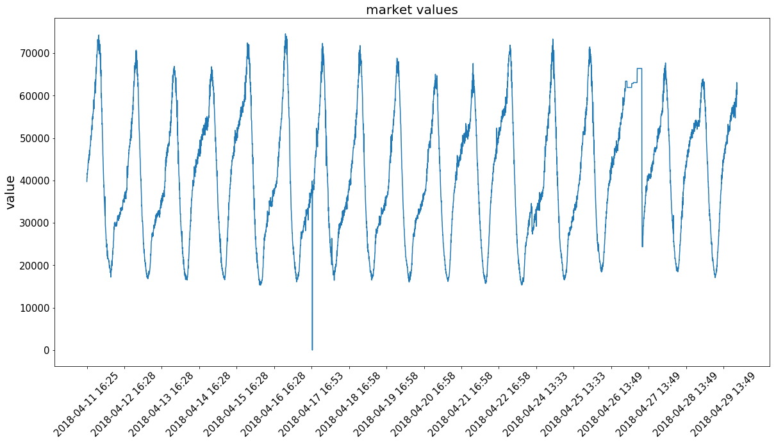
Figure 1. First 5000 data points of market “chndmcdl”

Methodology
Two types of LSTM networks are applied to predict the time series data. Many-to-one LSTM network uses values of multiple continuous data points to predict the next data point, while many-to-many LSTM network (seq2seq) learns time series state by an encoder with input of continuous data points and a decoder that outputs estimated future data points. In this paper, the mean squared error (MSE) is used to compare the performance of traffic forecasting.
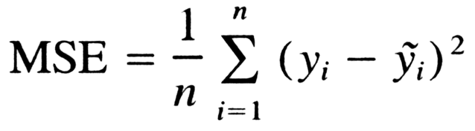

1. Many-to-one LSTM network
The architecture of many-to-one LSTM network for time series prediction is showed in Figure 2. Each time we choose k continuous data points as the inputs to a LSTM cell, and obtain the predicted value for the $({k+1)}^{th}$ data point. To keep things simple, our input matrix contains a sequence of x1, x2, … xk scaled traffic numbers and the output vector contains x(k+1). In this case, the encoder just needs to keep track of all the previous traffic numbers that it has seen and write them into the output vector. The network aims to minimize the difference between the predicted value and the true value of the $({k+1)}^{th}$ data point. Before entering training or testing phase, data points are preprocessed by minmax normalization.
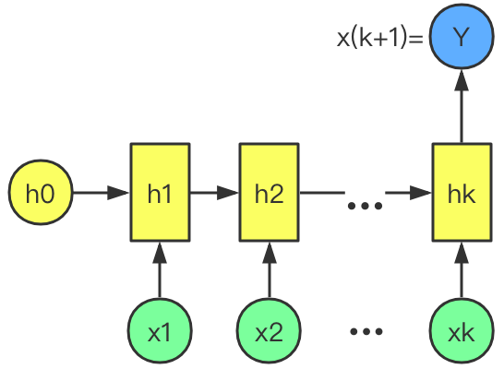
Fig. 2: Network structure of many-to-one LSTM

Result of many-to-one LSTM network
First 2/3 data points are used as training set, while the remaining 1/3 data points are tested by trained network. Figure 3 and Figure 4 show result of prediction of two markets, “chndmcdl” and “chndmetr”, respectively. Market “chndmcdl” contains more than 60k data points while market “chndmetr” has less than 2000 data points, but both the results show many-to-one LSTM network achieve good performance in predicting time series of market values.

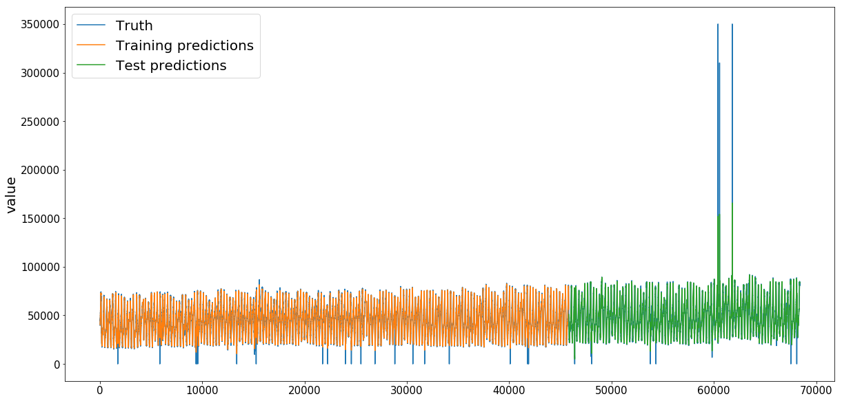
Figure 3. Prediction of market “chndmcdl” by many-to-one LSTM network
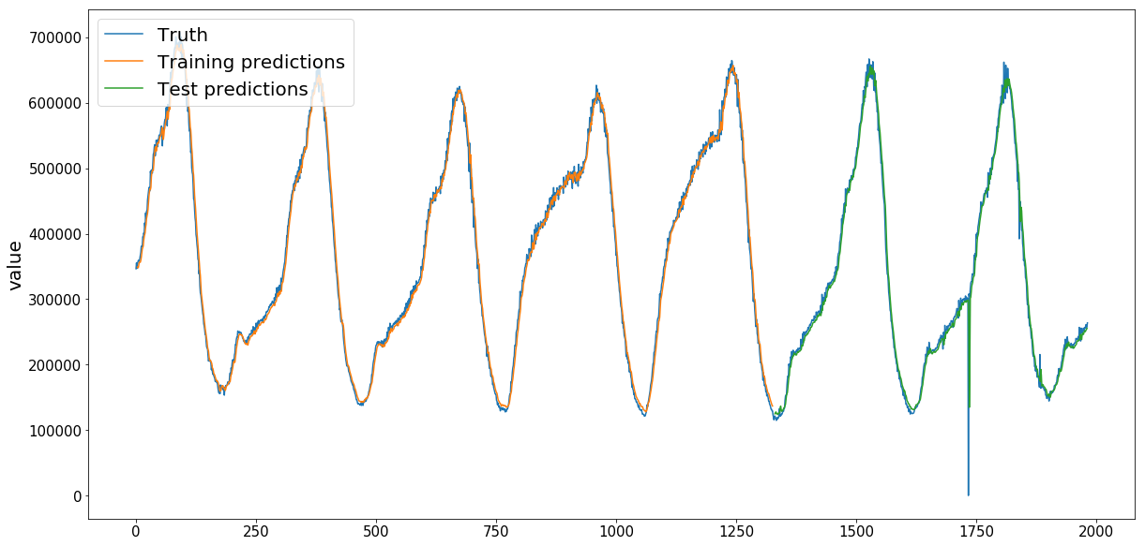
Figure 4. Prediction of market “chndmetr” by many-to-one LSTM network

All 242 markets are trained and tested by many-to-one LSTM network. RMSE (root mean squared error) is computed for each market. Finally mean of RMSE for testing achieves 2158.3.
According to the result above, good performance suggests many-to-one LSTM network works well in predicting time series data. However, we realize that many-to-one LSTM requires continuous input data points but can only predict one value (the next data point) at once, which cannot support prediction of a period of time. An improved method to solve the issue is many-to-many LSTM network (seq2seq).

2. Many-to-many LSTM network (seq2seq)
The many-to-many LSTM network (seq2seq) for time series prediction is showed in Figure 5. In this scenario, the input and output sequence lengths are necessarily the same. Each time we choose k continuous data points as the inputs to a LSTM cell (also called encoder). The encoder learns to encode in input sequence into an embedding, which an internal state. The decoder learns to decode that embedding state, and obtain predicted values for the following n data points. The network aims to minimize the difference between the predicted values and the true values of the following n data points. In this way, we can predict a list of n following time series data by k previous data points, instead of predicting only one data point like many-to-one LSTM network above. Before entering training or testing phase, dat
a points are preprocessed by minmax normalization.

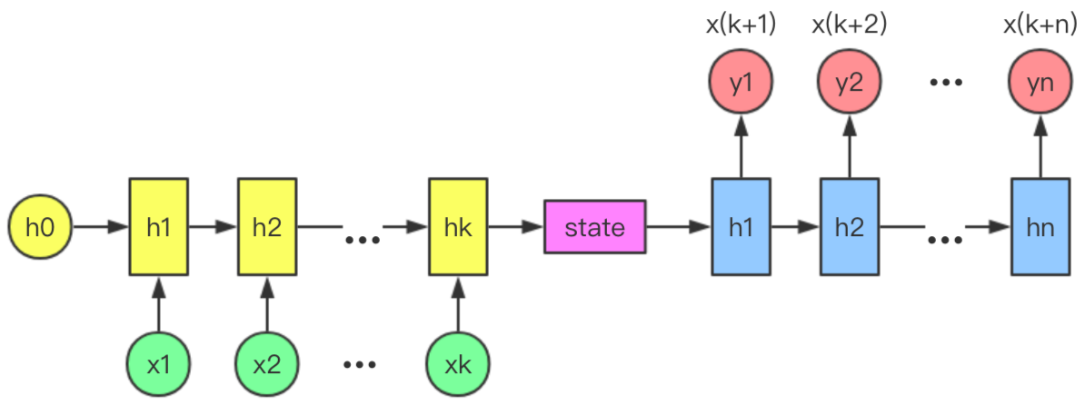
Figure 5. Network structure of many-to-many LSTM (seq2seq)

Considering the large amount of data points in the current dataset, in order to speeding up training phase, we do sampling on the original dataset by each 12 data points (about an hour). Training is applied on the sampled data.
In order to evaluate the model performance, we need to do interpolation (adding 11 data points) between each pair of two sampled data points.

Result of many-to-many LSTM network (seq2seq)
In this section, we compare many-to-one LSTM with many-to-many LSTM. Comparing the performance of different forecasting methods is difficult as their objectives can differ considerably from one to another. Since this paper aims at higher prediction accuracy, the performance can be compared roughly under an equivalent condition.

We choose 72 data points (about 3 days) from training set (sampled) as the input sequence, and predict the following 72 data points. A sample (market “chndmcdl”) of the prediction before interpolation is showed in Figure 6. Result after interpolation (b-spline interpolation) is showed in Figure 7.
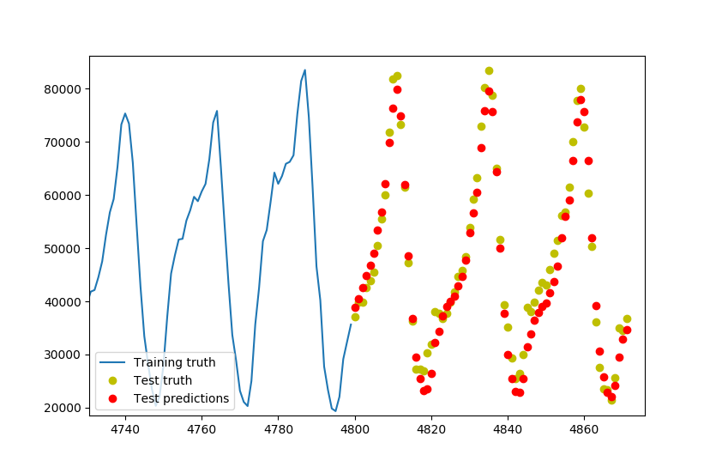
Figure 6. Prediction of market “chndmcdl” by many-to-many LSTM network before interpolation
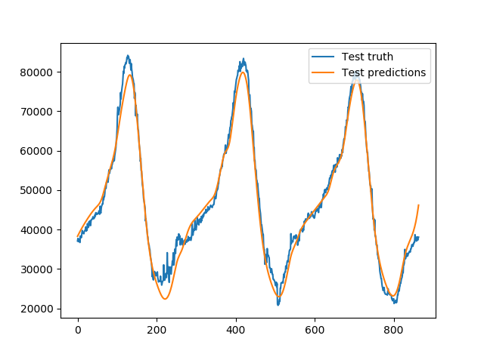
Figure 7. Prediction of market “chndmcdl” by many-to-many LSTM network after interpolation

All the markets are trained and tested by many-to-one LSTM network, except for markets with not enough data size. RMSEs (root mean squared error) are computed for these markets. Finally, mean of RMSEs for testing achieves 7551.5.
The result above suggests that many-to-many LSTM network (seq2seq) can predict market values well. Compared with many-to-one LSTM network, seq2seq makes it possible to predict future data of a period of time. By making length of output sequence longer, the model can predict longer time periods. However, the disadvantage is that the training phase may cost longer time than many-to-one LSTM. Sampling and interpolation applied in this study may be a feasible solution.

Conclusion
This study focuses on predicting market values using LSTM networks. Both two types of LSTM network (many-to-one and many-to-many) show good performance in predicting future time series data. The previous experimental comparisons and conclusions were drawn based on the prediction of the one-step ahead horizon prediction and all experiment are made under complete dataset. In this section, we give some further discussion including prediction with longer horizon.
Predicting traffic flow on several time horizons in the future allows for a wider range of application to make use of the prediction. For DTC, predicting a longer horizon only means that more entries of real-time tensor pattern are set to unknown. Simply, for a prediction horizon of 15 min with 5 min scale data, the first 6 data points are used to forecast the 7-9th data points (horizon of 15 min) and the 7-9th data points are et to unknown in the dynamic tensor pattern. Then, the 9-period tensor window of size 11 x 7 x 7 x 9 incorporates the 7-9th data points and the model is refit to forecast the 10-12th data points.

It can be found that the longer horizon did not deteriorate the prediction accuracy significantly. Even when the prediction horizon reaches

REFERENCES
[1] Liwicki, Marcus, et al. ”A novel approach to on-line handwriting recognition based on bidirectional long short-term memory networks.” Proc. 9th Int. Conf. on Document Analysis and Recognition. Vol. 1. 2007.
[2] Azzouni, Abdelhadi & Pujolle, Guy. “A Long Short-Term Memory Recurrent Neural Network Framework for Network Traffic Matrix Prediction.”
[10] Sak, Hasim, Andrew W. Senior, and Franoise Beaufays. ”Long shortterm memory recurrent neural network architectures for large scale acoustic modeling.” Interspeech. 2014.
[15] Hochreiter, Sepp, and Jrgen Schmidhuber. ”Long short-term memory.” Neural computation 9.8 (1997): 1735-1780

29. H. Tan et al., "A tensor-based method for missing traffic data completion", Transp. Res. C Emerging Technol., vol. 28, pp. 15-27, Mar. 2013.

30. D. Ni, J. D. Leonard, A. Guin, C. Feng, "Multiple imputation scheme for overcoming the missing values and variability issues in ITS data", J. Transp. Eng., vol. 131, no. 12, pp. 931-938, 2005.

31. M. T. Asif, N. Mitrovic, L. Garg, J. Dauwels, P. Jaillet, "Low-dimensional models for missing data imputation in road networks", Proc. IEEE ICASSP, pp. 3527-3531, 2013.

32. T. T. Tchrakian, B. Basu, M. O'Mahony, "Real-time traffic flow forecasting using spectral analysis", IEEE Trans. Intell. Transp. Syst., vol. 13, no. 2, pp. 519-526, Jun. 2012.

33. A. Cichocki, R. Zdunek, A. H. Phan, S. I. Amari, Nonnegative Matrix and Tensor Factorizations: Applications to Exploratory Multi-Way Data Analysis and Blind Source Separation, Chichester, U.K.:Wiley, 2009.

34. T. G. Kolda, B. W. Bader, "Tensor decompositions and applications", SIAM Rev., vol. 51, no. 3, pp. 455-500, 2009.

35. E. Acar, B. Yener, "Unsupervised multiway data analysis: A literature survey", IEEE Trans. Knowl. Data Eng., vol. 21, no. 1, pp. 6-20, Jan. 2009.

36. M. A. O. Vasilescu, D. Terzopoulos, "Multilinear subspace analysis of image ensembles. In computer vision and pattern recognition", Proc. IEEE Comput. Soc. Conf., vol. 2, pp. 2-93, 2003.

37. E. Acar, D. M. Dunlavy, T. G. Kolda, "Link prediction on evolving data using matrix and tensor factorizations", Proc. IEEE ICDMW, pp. 262-269, 2009.

38. M. Li, V. Monga, "Robust video hashing via multilinear subspace projections", IEEE Trans. Image Process., vol. 21, no. 10, pp. 4397-4409, Oct. 2012.

39. H. Lee, Y. D. Kim, A. Cichocki, S. Choi, "Nonnegative tensor factorization for continuous EEG classification", Int. J. Neural Syst., vol. 17, no. 4, pp. 305-317, 2007.

29. H. Tan et al., "A tensor-based method for missing traffic data completion", Transp. Res. C Emerging Technol., vol. 28, pp. 15-27, Mar. 2013.

40. H. Tan, J. Feng, G. Feng, W. Wang, Y. J. Zhang, "Traffic volume data outlier recovery via tensor model", Math. Prob. Eng., vol. 2013, pp. 1-8, 2013.

41. J. Dauwels et al., "Predicting traffic speed in urban transportation subnetworks for multiple horizons", Proc. IEEE 13th ICARCV, pp. 1-6, Dec. 2014.

