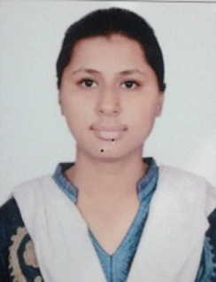
Inhalable spray dried surfactant based lipid-nanoparticles of paclitaxel in drug resistance lung cancer
Prabhjot Kaurª, Goutam Rath^{b}
ªLovely Professional University, Jalandhar, Punjab, India
^{b}Siksha ‘O'Anusandhan (Deemed to Be University), Bhubaneswar, Odisha, India

Abstract
Surfactant loaded nanoparticulate based Dry powder inhaler were prepared based on pulmonary delivery system. The objectives of the present study are (1) to prepare and optimize Nanocarriers using suitable surfactants which also have the drug resistance activity (2) to prepare and characterize the drug (paclitaxel and doxorubicin) loaded nanocarriers, (3) to prepare and characterize the combinational drug (paclitaxel and doxorubicin) loaded nanocarriers, (4) to incorporate the lyophilized dry powder NLCs into dry powder inhalation devices, (5) to evaluate the lung localization study and plasma profile on animal model and (6) to evaluate reversal of resistance using in-vivo cell uptake study. Differrent surfactants i.e. Cremophor EL, Tween 80 and Tween 20 loaded Nanolipid carriers shows varying range of particle size values 394.1 ± 5.6 nm, 575.6 ± 3.3 nm and 460.7 ± 2.6 nm respectively. The optimized formulations were prepared with different surfactants and drug loaded NLCs shows best drug loading and entrapment efficiency in combination as well as individual combination. The in vitro drug release experiment of drug loaded (paclitaxel) show as biphasic in nature that is because of the burst release at the early stage and afterwards a sustained release in the later times. Various surfactants loaded NLCs containing PTX were formulated to ensure the entrance of nanoparticles into the cells where Cremophor EL loaded NLCs demonstrate greatest cellular uptake of nanoparticles. Microscopic image and SEM) showed uniform size; mono-dispersed round shaped NLCs. Differential Scanning Calorimetric thermograms and X-ray diffraction pattern of paclitaxel show no change after formulation in form of nanoparticulate DPI. The animals treated drug(s) loaded DPI shows no behavioural changes, after 24 h of treatment lung tissue’s normal histomorphological structure after the H & E staining. Organ distribution studies of optimized formulations at different time intervals were done on male wistar rats. Doses were delivered through pulmonary route by using insufflators. The bio-analytical method was developed by HPLC spectroscopy. In comparison to plain drug suspension, drug(s) uptake from the DPI was higher in lungs. For the reason so as in case of lyophilized NLCs, drug clearance from the organ was a lesser amount because of slow release of the drug from the NLC. Therefore, the optimized, processed surfactants loaded DPI were prepared and tested for drug resistance lung cancer A549 cell-lines which shows maximum reversal by Cremophor EL loaded DPI. The general mode of action of surfactants towards reduce P-gp might involve binding efficiency of drugs among surfactants that results in interaction of surfactants and P-gp which fluidizes membrane that leads destabilization of indirect protein. In our research, above discussed factors on the basis of explained theories we will develop a surfactant based system for reversal of drug resistance using nanoparticle based inhalation therapy. This approach might be possible by using surfactants as excipients and co-administration of nanoparticles in form of dry powder inhaler on A549 cell-lines which have increased P-gp.
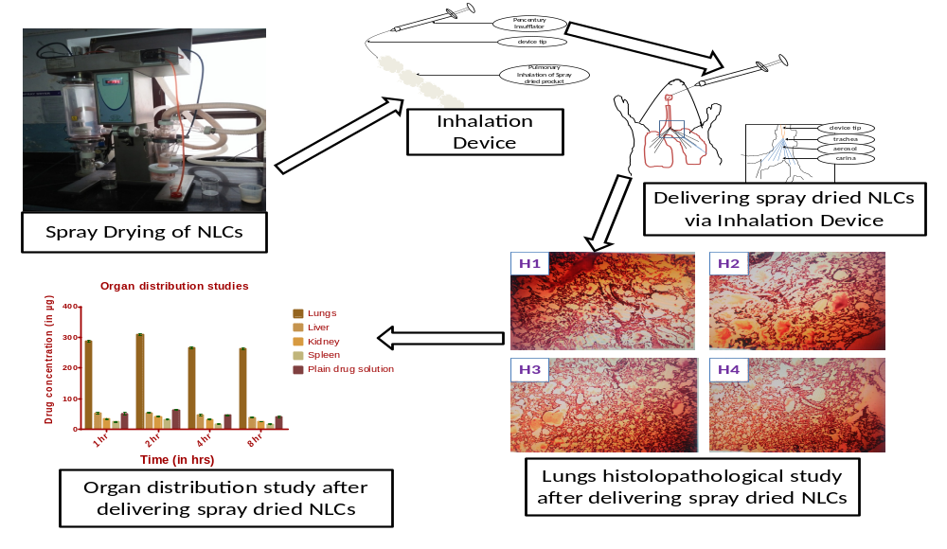
Biography
Prabhjot Kaur is Post-graduate in Pharmaceutics and doing her Ph.D in Pharmaceutical Sciences from Lovely Professional University, Punjab, India. She is worked on Drug resistance Lung Cancer from last 7 years. She is worked as Assistant Professsor since 5 years in reputated pharmacy colleges in Punjab, India. She has published 6 papers in reputed journals and presented many papers in National and International conferences. She has been serving as a project guide of 10 students for under graduate level students.
Presenting author details
Full name: Prabhjot Kaur
Contact number: +919501079886
Email id: prabhjotkaur.kaur82@gmail.com
Category: (Oral presentation/ Poster presentation) Oral presentation
Session name: Chemotherapy for Lung Cancer 2020
Research interest: Chemotherapy for Lung Cancer

