EVALUATION PD-L1 EXPRESSION OF LUNG ADENOCARCINOMA WITH SP263 ANTIBODY KIT OF VETANA AND COMPARE TO SOME
OF CLINICAL AND HISTOPATHOLOGICAL CHARACTERISTICS, SUPPORT IMMUNOTHERAPY - A CROSS – SECTIONAL STUDY
IN VIETNAM NATIONAL LUNG HOSPITAL
Anh Tran TT¹, Tho Le T ², Khiem Dang V ³, Lanh Nguyen S ⁴,
Hop Le V⁴, Phuong Pham TT¹, Tuan Bui A¹
¹: Pathology Department – National Lung Hospital
²: Pathology Department – Hanoi Medical University – Chief of Pathology Department – National Lung Hospital
³: Oncology Department – National Lung Hospital
⁴: Pathology àn Forensis Medicine – Vietnam – Germany Hospital.

Abtract:
Immunotherapy enhances natural immunity to fight cancer. Through PD-L1 check - points, this treatment activates patient's immune system to help identify cancer cells, select and skill them. This therapy is determined to be effective even in patients with PD-L1 expression, including weakness positive. This treatment brings opportunities for many people with cancer, especially lung cancer with non small cell carcinoma type, so the most subtyp is adenocarcinoma. The development in medicine science helps more and more patients having benefit and improving the quality of life with modern treatments. Currently there are many immunohistochemistry antibodies kít used for evaluating PD-L1 expression with each of the anti-PD1 or PD-L1 drugs. Ventana's SP263 kit is the most common in using to diagnose for widely responds to the patients’s demand in treatment
Our study has 102 patients with lung adenocarcinoma in the Department of Oncology – Vietnam National Lung Hospital, stain PD – L1 with Ventana's SP263 antibodies kit by automatic system BenchMark of VENTANA with OptiView DAB IHC Detection KIT, to increase the amplification expresion of PD-L1. Also, 44 patients were tested for EGFR mutations by COBAS z480 ver2 system.
The result for the rate of PD-L1 expression is 52%, the strong positive is 21.6%. In particular, the proportion of patient having PD-L1 expression with TPS from 1-10% is 9.8% and TPS> 10% is 42.2%. PD-L1 revealed the predominance in male, smoker, advanced stage, solid subtype, grade III, age group from 60 to 69 (p <0.05). The rate of EGFR mutations was 34.1%; the most is EGFR del19 and then is L858R in exon 21; 4.5% patients had T790M mutation. However, the correlation between the expression of PDL1 and EGFR mutation has not been determined because the number of patient who tested EGFR mutations in the study was not enough for calculation.
Tables and Figures:
Table 1: Age group and PD-L1 expression
Age Group | PD-L1 (+) (53) |  | PD-L1 (-) (49)
Age Group | (n) | (%) | (n) | (%)
30 – 39 (3) | 0 | _ | 3 | 6,1 | <0,05
40 – 49 (8) | 5 | 9,4 | 3 | 6,1 | <0,05
50 – 59 (35) | 15 | 28,3 | 20 | 40,8 | <0,05
60 – 69 (35) | 22 | 41,5 | 13 | 26,6 | <0,05
≥ 70 (21) | 11 | 20,8 | 10 | 20,4 | <0,05

Figure 1: PD-L1 expression and gender, smoker history and stage
Table 2: PD-L1 expression and histopathology classification
 |  | PD-L1 (+) (53) |  | PD-L1 (+) (49)
 |  | (n) | (%) | (n) | (%)
Histopathology  Classification | Lepidic (3) | 1 | 1,9 | 2 | 4,1 | <0,05  (*)
Histopathology  Classification | Acinar (40) | 16 | 24,6 | 24 | 48,9 | <0,05  (*)
Histopathology  Classification | Papillary (13) | 6 | 11,3 | 7 | 14,3 | <0,05  (*)
Histopathology  Classification | Micropapallary (11) | 6 | 11,3 | 5 | 10,2 | <0,05  (*)
Histopathology  Classification | Solid (23) | 19 | 35,9 | 4 | 8,2 | <0,05  (*)
Histopathology  Classification | Variants (12) | 5 | 9,4 | 7 | 14,3 | <0,05  (*)
Table 3 : PD-L1 expression and EGFR mutation
EGFR mutation | PD-L1 (+) (7) |  | PD-L1 (+) (8) |  | p
EGFR mutation | n | % | n | % | p
Del19 | 6 | 85,7 | 2 | 25 | >0,05
L858R in exon 21 | 1 | 14,3 | 5 | 62,5 | >0,05
Exon 20 | 0 | _ | 1 | 12,5 | >0,05

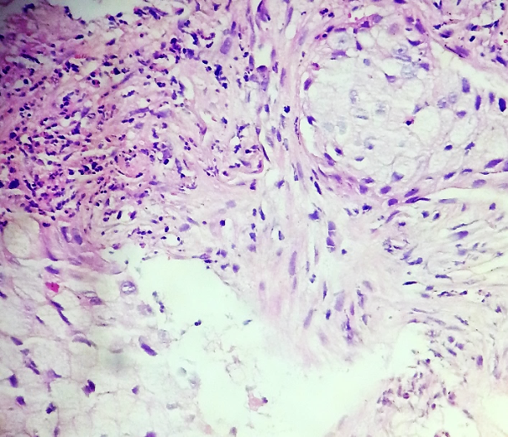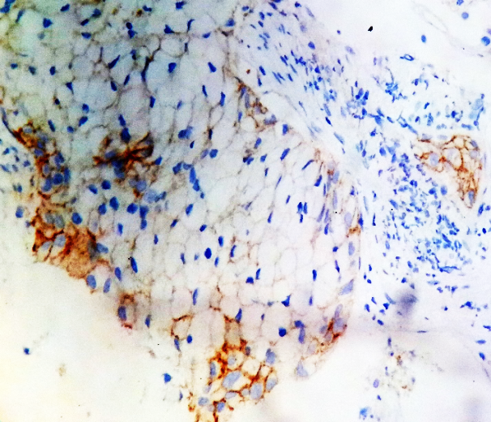
A
B
Lung adenocarcinoma, solid subtype with ringet cells, PD-L1 expression in 85%..
Pt. Trần Nguyên Q., Male, 76 yrs. Code: 9976 – B17
A: HE x 400; B: (HMMD x400): 2+ (red arow), 1+ (green arrow), Âm tính (black arrow)

Recent Publications (minimum 5)
- Report a rare case: Castleman’s disease in Horizontal fissure pulmonary, National Journal of Tuberculosis and lung Diseases, No16 – 2014, p47
- Lung metastases neuroblastoma: A case report, National Journal of Tuberculosis and lung Diseases, No18 – 2014, p52
- Histiocytosis X invasive in lung: report a rare case, National Journal of Tuberculosis and lung Diseases, No21 – 20115, p62
- Revue des caractéristiques de la mutation de l’EGFR et essvaluation de l’expression du PD-L1 dans une petite pièce en biopsie chez les patients atteints d’adenocarcinome pulmonaire à L’Hôpital National Pulmoaire, La procédure 10 ème congrès de pneumologie et chirugie thoracique – VIFCOR 2018, p145-6
- Apply the WHO classification 2014 of lung tumor for diagnosing lung adenocarcinoma in small biopsies at national lung hospital, National Journal of Tuberculosis and lung Diseases, No 27, 2018, p3.
- Determine the rate of PD-L1 expression and confront with some characteristics of lung adenocarcinoma, Vietnam Medicine Journal, No 471, 2018
- Collate the features of PD-L1 expression with histopathology characteristics of lung adenocarcinoma at national lung hospital, Vietnam Oncology Journal, No 5 – 2018, p224

Recent Photograph:
Biography:
Anh Tran Thị Tuan has completed his Master of Medicine specialized in Cytology and Histopathology in 2018 at Hanoi Medical University in Vietnam. She is the pathologist in Pathology Department of Vietnam National Lung Hospital, a premier hospital of Tuberculosis and Lung disease in Vietnam. She has published more than 10 papers in medicine journals of Vietnam about Lung cancer, PD-L1, tumor of the lung
Presenting author details
Full name: Anh Tran Thi Tuan
Contact number: +84935276255
Session name/ number: Pulmonary pathology
Category: Oral presentation or Poster presentation are both good
E-mail: drtrananhbvp@gmail.com

