The Source of Fibre and Roxazyme® G2 Interacted to Influence the Length of Villi in the Ileal Epithelium of Growing Pigs Fed Fibrous Corn-Soybean Diets

F Fushai, University of Venda, South Africa
M Tekere, University of South Africa, South Africa
M Masafu, University of South Africa, South Africa
F Siebrits, Tshwane University of Technology, South Africa
F V Nherera-Chokuda, Agricultural Research Council, South Africa
A T Kanengoni, Johannesburg Zoo, South Africa

Abstract
The effects of dietary fibre source on the histomorphology of the ileal epithelium were examined in growing pigs fed high fibre (242-250 g total dietary fibre kg⁻¹ dry matter) diets fortified with Roxazyme® G2. The control was a standard, low fibre (141 g total dietary fibre kg⁻¹ dry matter) diet formulated from dehulled soybean (Glycine max), corn (Zea Mays) meal and hominy chop. Five fibrous diets were evaluated in which fibre was increased by incorporating corn cobs, soybean hulls, barley (Hordeum vulgare L) brewer’s grains, Lucerne (Medicago sativa) hay or wheat (Triticum aestivum) bran into the control diet. Each diet was duplicated and 220 mg Roxazyme® G2 kg⁻¹ dry mater was added to one of the mixtures. Seventy-two intact Large White X Landrace male pigs of weight 32 ± 5.6 kg pigs were allocated to the diets to balance pig live weight in a complete randomized design with a 2 (fibre source) X (enzyme) factorial arrangement of treatments. The pigs were fed ad libitum until slaughter at 94-± 2.6 kg live weight. Ileal tissue samples were taken at a point 50cm above the ileal-caecal valve. Villi length and area, and crypt depth were measured by computerised image analyses. The villi length: crypt ratio was calculated. The diet and the supplemental enzyme did not affect (p>0.05) any of the measured parameters. Diet X enzyme interaction was significant (p=0.016) for villi length, whereby the enzyme reduced the villi length of pigs on the soy-hulls, standard and wheat bran diets, with an opposite effect on pigs on the corn cob, brewer’s grain, lucerne diets.
Biography



Felix Fushai has expertise in animal nutrition, with an interest in both monograstric and ruminant nutrition. His main research interest is in optimizing nutritional, economic and environmental outcomes in the utilisation of nonconventional feedstuffs in mitigation of the effects of climate change on the conventional livestock feed supply chain.
Email: felix.fushai@univen.ac.za

Image

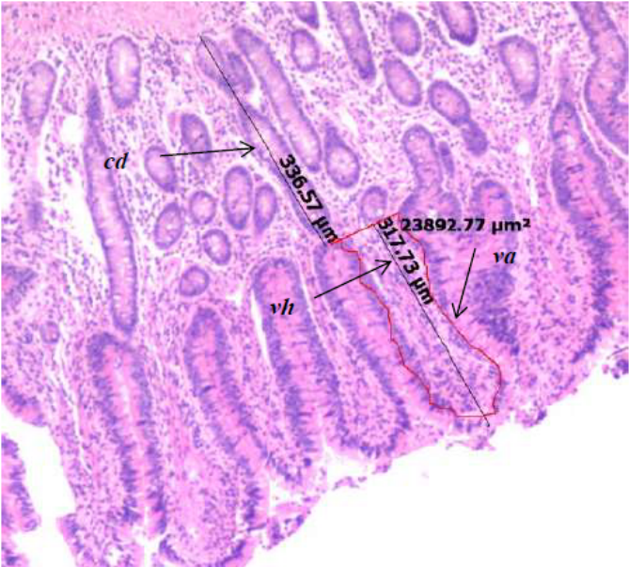
Notes

Histometry of the ileal epithelium in samples taken approximately 50 cm above the ileo-caecal valve of a growing pig fed a corn-soybean diet enriched in fibre from soybean hulls to 246 g kg-1 DM, illustrating the measurement of villi height (Vh), villi corss-sectional area (va) and the crypt depth (cd).

Recent Publications
- Rambau, M.D. F. Fushai & J.J. Baloyi. 2016. Productivity, chemical composition and ruminal degradability of irrigated Napier grass leaves harvested at three stages of maturity. South African Journal of Animal Sciences 46 (4): 398-408.
- Chivandi, E., Fushai, F. and Masaka, J., 2010. Land Ownership and Range Resources Management in Zimbabwe: A Historical Review. Midlands State University Journal of Science, Agriculture and Technology Volume 2(1), 13-24.
- Fushai, F. 2006. Estimates of intake and digestibility using n-alkanes in Holstein-Friesian and Hereford heifers on kikuyu (Pennisetum clandestinum) pasture. Short communication. Animal Feed Science and Technology 128 (3-4), 331-336.
- Chivandi, E., Kachigunda, B. and Fushai, F., 2005. A comparison of the nutrient and antinutrient composition of industrially processed Zimbabwean Jatropha curcus and Glycine max meals. Pakistan Journal of Biological Sciences, 8 (1) 49-53.
- Fushai, F., & Stewart, G., 2004. Rate of Passage of Digesta in the Rumen in Holstein-Friesian and Hereford Heifers Grazing on Kikuyu (Pennisetum clandestinum) Pasture. Pakistan Journal of Biological Sciences 7 (1): 1194-1197.

