A CASE OF PULMONARY EMBOLISM IN A PATIENT WITH HEPATITIS C

Adventist medical center Manila, Philippines
Background:
Acute pulmonary embolism (PE) is a prevalent condition, affecting up to one out of every 1,000 to 2,000 Americans each year. After acute PE, mortality surpasses 15% within the first three months, ^{ko6} and up to 30% of the patients will die without treatment. Pulmonary embolism remain a common and potentially life threatening cardiovascular emergency. Many risk factors have been identified for the development of thromboembolic disease. Prolonged immobilization, malignancy, trauma, surgery and hematologic hypercoagulable states such as protein C, protein s and antithrombin III deficiencies, factor V laiden and anticardiolipin antibodies.
Case presentation:
A case of a 57 years old male, French, without cardiovascular co-morbidities who presented with sudden shortness of breath. No family history of coagulopathy, hypertension, diabetes, and heart disease. Past medical history was unremarkable except for Hepatitis C Infection on Interferon treatment. Patient presented with diaphoresis, tachycardia, tachypnea, desaturation but improved with oxygen inhalation. Breath sounds were broncho-vesicular. Cardiac examination revealed palpable P2 at the base with good S1 at the apex, no murmurs appreciated. There was no hepatomegaly and splenomegaly. Varicosities noted at lower extremities with full pulses.
12 lead ECG noted with Q and T wave inversion in lead III. Chest X-ray was unremarkable. Coagulation studies were prolonged. Cardiac makers such as Trop I was elevated (1.38x) with normal CKMB. Electrolytes and other blood chemistries are within normal values. D dimer was significantly elevated at 7449.32 (14.8x elevated). Hepatitis profile results were HBSAg non-reactive, anti-HBS reactive and anti-HCV reactive. Child Pugh score of 5, Class A chronic liver disease
Venous duplex scan showed venous reflux with no evidence of acute deep vein thrombosis. V/Q scan showed V/Q defect in the left basal lower lobe. Non-segmental perfusion defects in the right upper lobe, right middle lobe and anterior left upper lobe are without corresponding ventilation defects. ^{(Figure:1a)} Pulmonary embolism was highly considered. Hence, low molecular weight heparin (Enoxaparin) was started
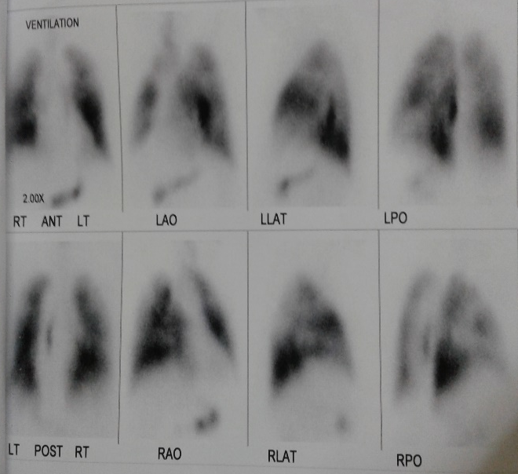
Figure 1a. V/Q scan matching V/Q defect in the left basal lower lobe. Non-segmental perfusion defects in the right upper lobe, right middle lobe and anterior left upper lobe are without corresponding ventilation defects.
Pulmonary angiography reveled bilateral pulmonary embolism with filling defect measuring 4-5 cm at the distal right pulmonary artery straddling and giving rise to a partial obstruction of the branches. Likewise a filling defect in the distal left pulmonary artery 3-4cm. Thrombolysis was started using streptokinase.
A Chest CTPA revealed pulmonary thromboses in the bilateral arteries with almost complete occlusion on the right. (1b). Patient was sent home and followed up about 6 weeks from discharged, repeat CTPA revealed resolution of pulmonary thromboses in the bilateral pulmonary arteries as well as its branches (1c)
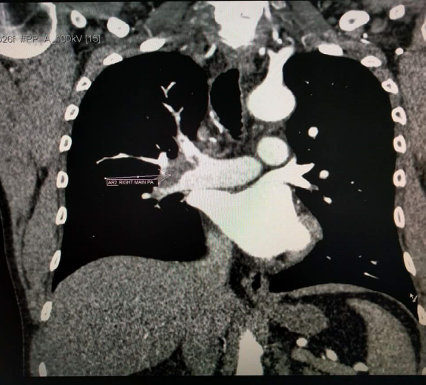
Figure 1b.Chest CTPA shows pulmonary thromboses in the bilateral arteries with almost complete occlusion on the right
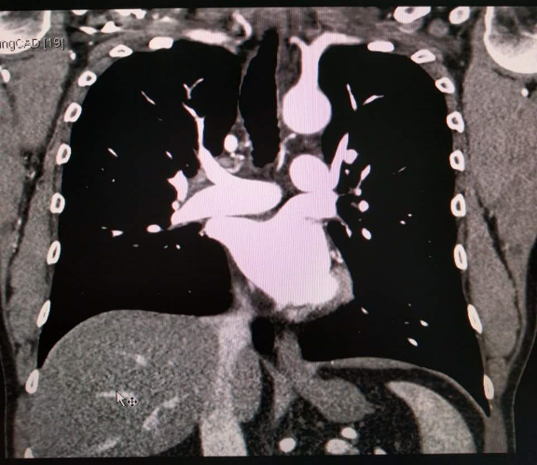
Figure 1c.Repeat CTPA revealed resolution of pulmonary thromboses.
CONCLUSION:
Our primary aim is to give importance on early diagnoses of recognition of diasease in order to reduce risk of Hepatitis C complications. Hypercoagulabilitty among patients with Hepatitis C should be evaluated and considered as among the possible causes of venous Thromboembolism.

