New Leadership Techniques that Positively Catapult Workplace Parameters – research of TUFMINDS benefits in the Workplace (culture, atmosphere, mental health and engagement!)

Dr John McIntosh (MBChB, MRCP, MRCGP, FIML) and Dr Eli McIntosh (PhD) of Mackay Superclinics and Exqisit Life Foundation, Australia

Abstract (300 word limit)
Statement of the Problem: With the impacts of mental illness and workplace claims rising dramatically around the world, practical solutions are needed.

This research was used to measure if the TUFMINDs Program created measurable changes in attitudes, coping skills, mental illness scores, workplace function and mental resilience in workplaces. TUFMINDS trains leaders and staff new ways to deal with problems, communicate and improve attitudes by controlling negative thinking and reactions.
Methodology & Theoretical Orientation:
Aims – Before and after scores of:
- Individuals actual versus perceived optimism scores (LOT-R)
- Mental resilience scores (BRC score).
- Depression, anxiety and stress scores (DASS-21) and perceived stress levels at work.
- Workplace atmosphere, engagement, trust and communication
TUFMINDS is a dynamic structured mindfulness process that improves individual’s awareness and mindset. It also provides leaders with positive communication skills, cultural standards, elimination of drama, gossip and sarcasm and positive management of conflict and complaints. The studies were performed in 190 individuals in multiple workplaces.
Conclusion & Significance:
Individuals are 15% less positive than they think they are. This score fell by a dramatic 40% when faced with everyday (non critical) challenges.

The following improvements were found after the training:
Optimism 14% Workplace Parameters:
Mental resilience 30% - Atmosphere 16%
Depression 29% - Satisfaction 15% Anxiety 14% - Communication 15%
Stress 14% - Clarity of Roles 19%
- Engagement 12%
Suicide Self Efficacy 31%
Suicide Knowledge 45%

This research shows that TUFMINDS improves workplace parameters dramatically. There are dramatic improvements in individuals’ mental resilience, coping, and mood scores, resulting in lower risk of mental illness and suicide. There are added benefits of individuals being much more willing to ask, assess and take action when faced with an emotional upset or suicidal person.

The potential to benefit individuals, businesses and communities is huge. These processes need to be shared and used widely!

Recent Publications (minimum 5)
1. McIntosh E 2017 - “The Misconception that People believe that they are more Positive and Optimistic than they are in Actuality” University of Sedona, Masters Thesis

2. McIntosh E 2018 - “The Ability to Control Your Thoughts is the Key to Happiness. The Taming of Negative Thoughts that Produce Negative Feelings can be Controlled by Anyone” University of Sedona, Doctoral Dissertation.

3. Tretow, A, McIntosh J 2018 – “Study of TUFMINDS training impact on mental health and workplace parameters – Pilot Study” Central Queensland University research project (unpublished).
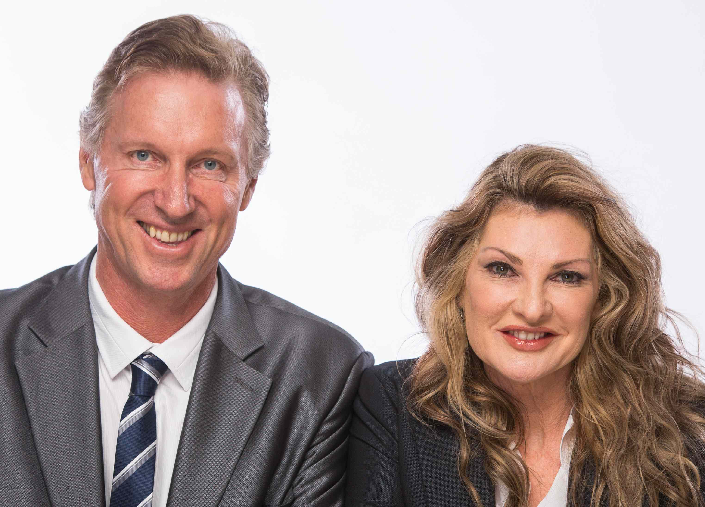

Biography (150 word limit)
Dr John McIntosh, is an Australian medical specialist and Dr Elizabeth McIntosh, is known as the “Positivity Expert” from her decades of experience. She is a Doctor of Philosophy PhD (Metaphysics), an Ordained Minister, fitness trainer, meditation teacher, Reiki Master, NLP practitioner, and hypnotherapist. They are both authors, entrepreneurs, international motivational speakers, radio presenters and humanitarians.
Together they created “Positive Mindfulness Cognition” and TUFMINDs Program, a free mental wellbeing and suicide intervention program. Success has been seen globally and even in Bali’s notorious Kerobokan Prison!

They have also co-authored award winning and best selling books, ‘Mastering Negative Impulsive Thoughts’ and ‘CEO Principles’. They are also multi award winners for business, community and medical.

They funded the creation of TUFMINDs App themselves and give it away for FREE to create effective solutions for suicide reduction and psychosomatic illnesses created by negativity and want to share the benefits widely.

