Hydrothermal Synthesis and Luminescence Properties of Ni²⁺, Cd²⁺ and Nb⁵⁺ ions Doped CeO₂ Nanoparticles

G. Jayakumar #, PG and Research Department of Physics, Sacred Heart College, Tirupattur, Tamil Nadu, India
A. Albert Irudayaraj *, PG and Research Department of Physics, Sacred Heart College, Tirupattur, Tamil Nadu, India

Abstract
Hydrothermal method is employed to synthesis undoped and metal (Ni²⁺, Cd²⁺ and Nb⁵⁺) doped CeO₂ nanoparticles with different doping concentrations. The structural, morphological, chemical and optical properties of undoped and metal doped CeO₂ nanoparticles are studied using Powder XRD, SEM, BET, FTIR, Raman, UV-Vis. and PL analyses. The powder XRD studies tells that all the samples have cubic fluorite structure. The dopant concentration do not seems to have any effect on the crystal structure of CeO₂ nanoparticles. However, in the Nb⁵⁺ doped CeO₂ nanoparticles additionally have a minor second phase when the doping concentration reaches 10M% and 15M%. We found that the crystallite size decreases with the dopant ions concentration. From the SEM images of undoped and doped CeO₂ nanoparticles, all the samples have spherical morphology and the Particle size of the Ni²⁺ ions and Cd²⁺ doped CeO₂ nanoparticles decreases as the dopant concentration increases. But, no significant change in the particle size of Nb⁵⁺ ions doped CeO₂ nanoparticles is noticed when the Nb⁵⁺ doping concentration is increased. The BET study shows that the specific surface area of the CeO₂ nanoparticles increases with the Ni²⁺ ions and Cd²⁺ ions concentration. However, for Nb⁵⁺ doped CeO₂ nanoparticles, a decrease in the specific surface area with doping is observed which may be due to the formation of fergusonite (CeNbO₄) phase at higher doping levels. The band gap energy of Ni²⁺doped and Cd²⁺ doped CeO₂ nanoparticles increases with increase in doping which could be attributed to the decrease in particle size with doping. The band gap energy of Nb⁵⁺doped CeO₂ nanoparticles decrease with increase in doping which could be attributed to the increased formation of Fergusonite phase with doping. From the Raman spectra, a decrease in the intensity of the peak as well as a small shift in the position of the peak with increasing dopant concentration are observed. This affirms the enhancement of oxygen vacancy with increased dopant concentration. PL spectra of undoped CeO₂ nanoparticles shows that the Ce³⁺ electrons transitions (f-d transitions) can generate the strong emission bands. The intensity of PL emission of doped samples decreases as the dopant concentration increases. These emissions are due to the merger of the peaks attributed to the 5d – 4f transitions of Ce³⁺ ions and oxygen vacancy defects levels to O 2p level transitions.

Keywords: Cerium oxide, spherical morphology, Oxygen vacancy, f-d transitions.

Image

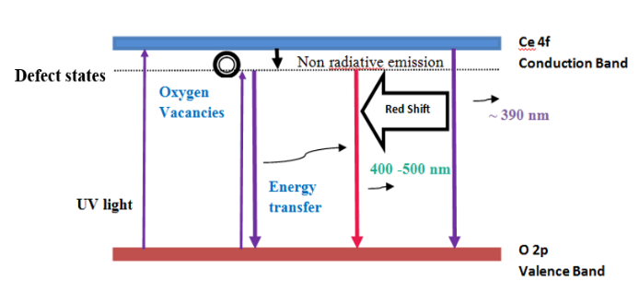
Recent Publications
- G. Jayakumar, A. Albert Irudayaraj, A. Dhayal Raj, S. John Sundaram, K. Kaviyarasu, Electrical and magnetic properties of nanostructured Ni doped CeO₂ for optoelectronic applications, Journal of Physics and Chemistry of Solids, 2022, 160, 110369.

- G. Jayakumar, A. Albert Irudayaraj, D. Poomagal, A. Dhayal Raj, S. KethrinThresa, P. Akshadha, Study on structural, magnetic and electrical properties of perovskite lanthanum strontium manganite nanoparticles, Journal of Materials Science: Materials in Electronics, 2020, 31, 20945 - 20953.
- G. Jayakumar, A. Albert Irudayaraj, A. Dhayal Raj, A comprehensive investigation on the properties of nanostructural cerium oxide, Optical and Quantum electronics, 2019, 5(9), 1-15.
- G. Jayakumar, A. Albert Irudayaraj and A. Dhayal Raj, Investigation on the synthesis and photo catalytic activity of activated carbon-cerium oxide (AC-CeO₂) nanocomposite Applied physics A materials Science & Processing, 2019,125(11),1-9.
- G. Jayakumar, A. Albert Irudayaraj and A. Dhayal Raj, Photocatalytic Degradation of Methylene Blue by Nickel Oxide Nanoparticles, Materials Today: Proceedings, 2017, 4, 11690–11695
- G. Jayakumar, A. Albert Irudayaraj, A. Dhayal Raj, Particle Size Effect on the Properties of Cerium Oxide (CeO₂) Nanoparticles Synthesized by Hydrothermal Method, Mechanics, Materials Science & Engineering, 2017, 9, 1-5.
- G. Jayakumar, A. Albert Irudayaraj, A. Dhayal Raj, M. Anusuya, Investigation on the preparation and properties of nanostructured cerium oxide, Nanosystems: Physics, Chemistry, Mathematics, 2016, 7 (4), 728–731 (ISSN 2220-8054)




Mr. G. Jayakumar is the Asst. Professor of Physics. He got University rank in M.Sc. Physics. He has published 10 research articles in international journals, 2 papers in national journals. His fields of interest are Metal oxide nanomaterials, Photocatalyst and Waste Water Purification. He has been served as President of Rotaract Club for four years. He is very much appreciated for his practical skills, teaching and commitment.
Email: gjayaphysics@gmail.com

Notes/Comments:

Presenting author details

Full name : Mr. G. Jayakumar

Email id : gjayaphysics@gmail.com

Contact number : +91-9943215683
Twitter account : https://twitter.com/Jayakum43248418

Google Scholar account : https://scholar.google.com/citations?user=Etp-hpcAAAAJ&hl=en&authuser=2
Linked In account : https://www.linkedin.com/in/jaya-kumar-01071015/

Category : Oral presentation

