Investigate the Effect of Two Types of Laser on Growth, Chemical Composition and Biochemical Genetic Markers on Tagetes officinalis Plant
A.M. Sami, H. A. Bedour, M. T. Nermeen, M. S. Rashad
¹Ornamental Plant and Woody Trees Dept. ²Water Relation and Field Irrigation Dept.³Genetics and Cytology Department
National Research Centre, Cairo, Egypt

Recent Publications (minimum 5)

Abstract (300 word limit)

This study was carried out at the greenhouse of National Research Centre, Egypt, to study the response of Tagetes sp. to different doses from two types of laser helium-neon laser (He-Ne) and cadmium laser (He-Cd ) were used at different exposure times (0,20,30 and 40 min.). The results indicated that plant height (cm), branches number/plant, stem diameter (mm), root length (cm), flowers number, plant fresh and dry weight, chlorophyll a, chlorophyll b, carotenoids, anthocyanine flowers contents, and electrical conductivity recorded significant increase at 20, 40 min. the exposure time of helium-neon and cadmium laser rays. On the contrary, the previously mentioned treatments recorded decreased anthocyanine stem contents, days from planting to flowering (earllying the flowering), and carbohydrates content. Moreover, the data of SDS PAGE demonstrated, the effect of laser beam increased proportionally with laser exposure time. In conclusion, the high exposure time of laser beam can be used to exchange gene expiration which enhances a new protein formulation may provide a better alternative of petals.

Key words: Tagets sp., growth, laser rays, chemical constituents, SDS-PAGE, gene expiration

Image
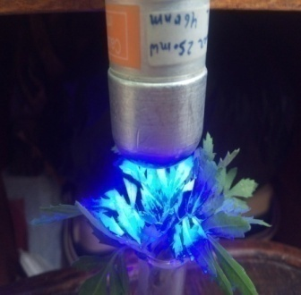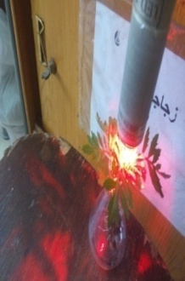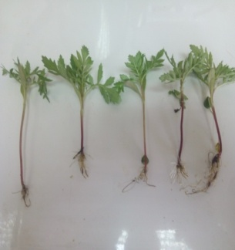
Fig..showed Tagates seedlings and blue and red laser rays

Recent Publications (minimum 5)
- Abou-Dahab M. Abou-Dahab1, Tarek A. Mohammed1, Amaal A. Heikal1, Lobna S. Taha, Ahmed M. M. Gabr, Sami A. Metwally and Awatef I. R. Ali (2019). In vitro laser radiation induces mutation and growth in Eustoma grandiflorum plant. The Bulletin of the National Research Centre, 43:3.
- Tayeb (2019).Effect of non-ionizing rays on growth, chemical constituents and molecular aspects of Catharanthus roseus plant. Egyptian Pharmaceutical Journal, 18:141–148.
- María Guadalupe Costilla-Hermosillo, Martín Ortiz-Morales, Sofía Loza-Cornejo Claudio Frausto-Reyes and Sami Ali Metwally (2019).Laser biostimulation for improving seeds germinative capacity and seedlings growth of Prosopis leavigata and jacaranda mimosifolia.Madera y bisques, 25(2):1-38.
- Sami Ali Metwally, Bedour Helmy Abou Leila and Mybelle Saad Gaballah(2020). LASER APPLICATION IN AGRICULTURE AND ITS PHYSIOLOGICAL EFFECT ON PLANT: A REVIEW. Plant Archives Volume 20 No. 2, 2020 pp. 9535-9543.
- Sami A. Metwally, M. I. Ezzo, Bedour H. Abou Leila (2021). Effect of Diluted Red Sea Water on Growth Behavior and Chemical Component of Moringa Plant. Annual Research & Review in Biology,36 (4), 72-82 DOI: 10.9734/arrb/2021/v36i430364
- Sami Ali Metwally and Bedour Helmy Abou-Leila, Desertification, environmental, climatic change and role of trees, shrubs and green areas, Open Access Research Journal of Science and Technology, 2021, 03(01), 037–050




Occupation: Prof.Doctor Researcher
Public URL: http://scholar.google.com.eg/citations? user=3od8ZvcAAAAJ&hl=en
Scopus ID: https://www.scopus.com/authid/detail.uri?authorId=55330747400
ORCID iD: http://orcid.org/0000-0002-5106-0703
Researchgate: https://www.researchgate.net/profile/Sami_Metwally3
https://www.researchgate.net/profile/Sami_Mettwally
Email: samialimetwally@gmail.com
Presenting author details
Full name: Sami Ali Metwally
Contact number: 012228771905-01100822071
Twitter account: Linked In account: Sami Ali Metwally Session name/ number: Category: (Oral prese

