Abstract (300 word limit)

We present a 4U laser heterodyne radiometer (LHR) payload to measure methane (CH4) and carbon dioxide (CO2) in the atmospheric limb. The LHR payload leverages previous development efforts of NASA Goddard Space Flight Center (GSFC)’s ground-based miniaturized laser heterodyne radiometer (mini-LHR) network.

This CubeSat, with expected launch in 2018, will make atmospheric limb measurements with higher resolution than any current passive satellite instruments (GOSAT, OCO-2, etc) at a much lower cost than a traditional flight instrument. Deployed in low earth orbit (LEO) and at high inclination, the instrument will measure CH4 with a precision of .5% and CO2 with a precision of .25%. These measurements are key inputs to stratospheric circulation models, and will provide the scientific community with invaluable data. 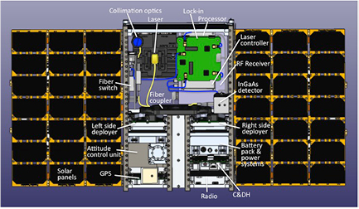

Recent Publications (minimum 5)

A 4 U Laser Heterodyne Radiometer for Methane (CH4) and Carbon Dioxide (CO2) Measurements from an Occultation-Viewing CubeSat
Emily L Wilson, A.J. DiGregorio, Vincent J Riot, Mark S Ammons, William W Bruner, Darrell Carter, Jianping Mao, Anand Ramanathan, Susan E Strahan, Luke D Oman

Characterizing thawing permafrost with the Miniaturized Laser Heterodyne Radiometer (mini-LHR) through column measurements of methane
A.J. DiGregorio

Miniaturized laser heterodyne radiometer for measurements of CO2 in the atmospheric column
E.L. Wilson, M.L. McLinden, J.H. Miller, G.R. Allan, L.E. Ott, H.R. Melroy, G.B. Clarke

Autonomous field measurements of CO2 in the atmospheric column with the miniaturized laser heterodyne radiometer (Mini-LHR)
H.R. Melroy, E.L. Wilson, G.B. Clarke, L.E. Ott, J. Mao, A.K. Ramanathan, M.L. McLinden

Uncertainty analysis for the miniaturized laser heterodyne radiometer (mini-LHR) for the measurement of carbon dioxide in the atmospheric column
G.B. Clarke, E.L. Wilson, J.H. Miller, H.R. Melroy

Biography (150 word limit)
AJ DiGregorio is an instrument engineer working at NASA Goddard Space Flight Center for Science Systems Applications, Incorporated. His primary focus is on the development of low-cost, robust technologies for harsh environments.
Email: a.j.digregorio@nasa.gov
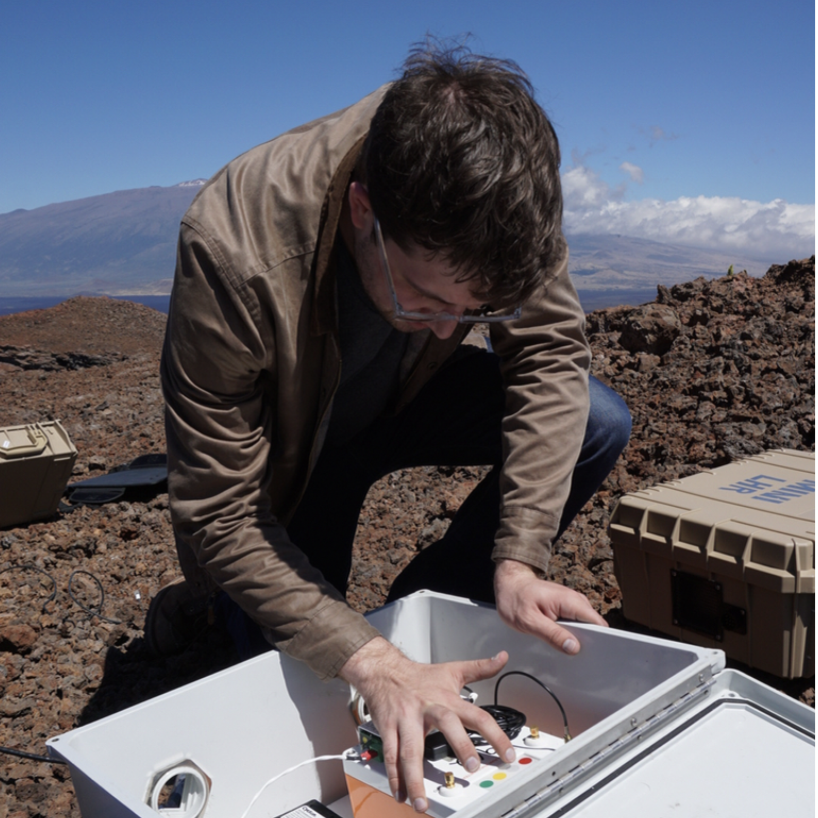

Presenting author details:
Full name: A.J. DiGregorio
University/Industry/Organization name: Science Systems Applications Incorporated
Designation (Director/Prof/Assistant or Associate prof/Researcher/Student): Instrument Engineer
Country: United States
Telephone: 301.614.6264
Email: a.j.digregorio@nasa.gov
Track name: none
Category (Oral presentation/ Poster presentation/Young researcher forum/E-poster): poster
Research interest: heterodyne radiometry

Linked In account: https://www.linkedin.com/in/aj-digregorio-49350472/

Note: Please fill up the Red mark fields so that it would be easier for us to cite your details in the conference particulars. (Please do not forget to fix your photo above the title)

Notes/Comments:

