Abstract (300 word limit)

Helmholtz–Gauss beams (HGBs), nearly non-diffraction beams that can propagate a long distance without significant divergence, have attracted considerable attention for its potential applications in science and technology. Mathieu-Gauss beams (MGBs) is one kind of Helmholtz–Gauss beams, which are the ideal non-diffraction Mathieu beams apodized by Gaussian transmittance. Unlike the ideal non-diffracting Mathieu beams, MGBs can be realized experimentally for the reason that MGBs carry a reasonable finite power. The nearly non-diffraction properties of MGMs shows their potential to lots of practical applications, such as: optical interconnections, laser machining, collimation and measurement, optical manipulation, and etc. Alvarez-Elizondo et al. first generated MGBs in an axicon-based stable resonator in a real CO₂ laser by slightly breaking the symmetry of the cavity in 2008. Later, Tokunaga et al. adopted special micro-grain Nd:YAG laser crystals, they also achieved spontaneous MGMs oscillation in end-pumped solid-state lasers. A general approach for the selectively excitation of any specified MGM in a laser system is necessary for the development of future MGBs’ applications. This study investigated in finding a way to selectively excite any specified MGM in an end-pumped solid-state laser system with an intra-cavity spatial light modulator. We drafted codes to simulate the lasing operation of the laser system to explore the selectively exciting a specified MGM in end-pumped solid-state lasers using numerical simulation. This study proposed a systematic approach to the selective excitations of all Mathieu-Gauss modes (MGMs) in end-pumped solid-state lasers with a SLM-based stable laser resonator. Figure shows propagation of amplitude profile along plane (x, z) or plane (y, z) of an even MGB from the simulated laser resonator with mode order m=2 and ellipticity parameter q=5.

Image

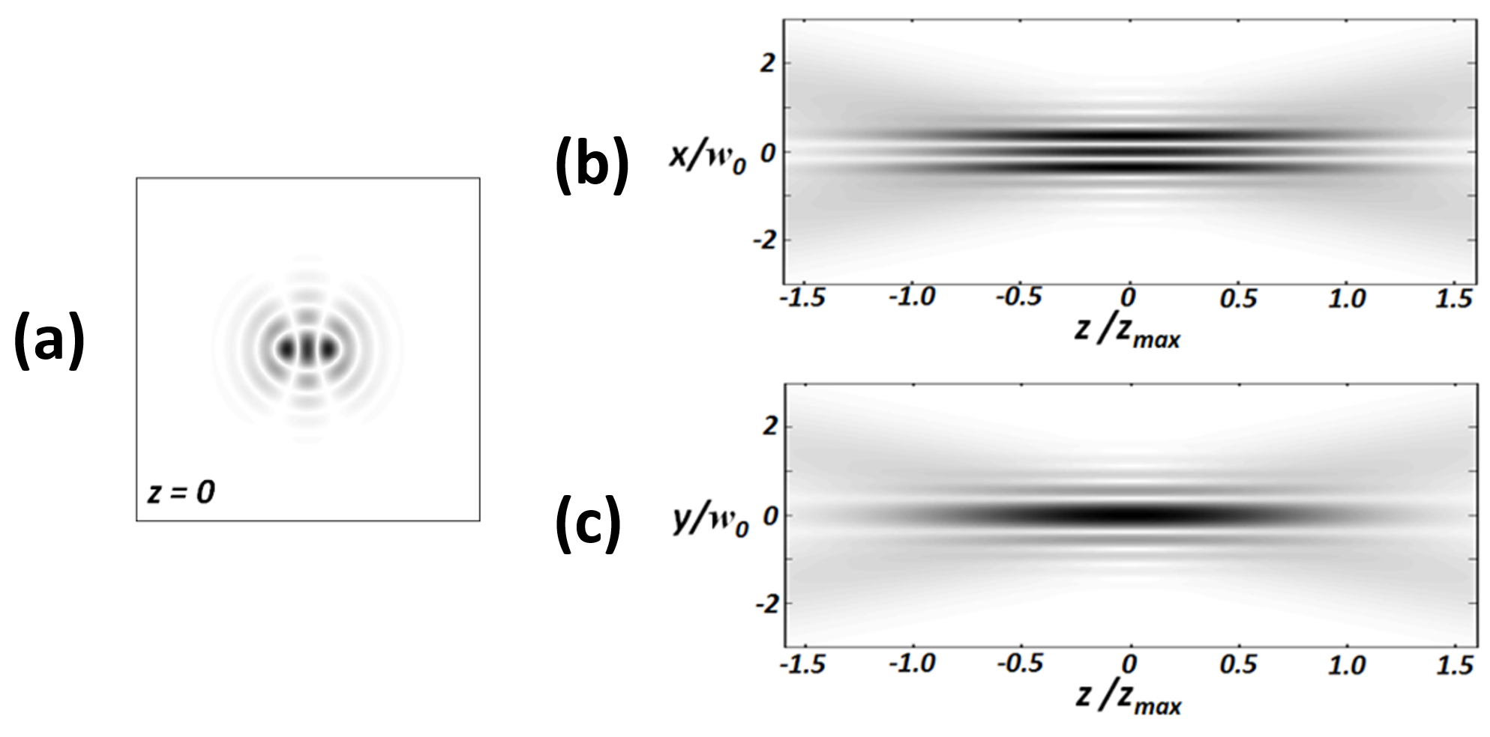
Recent Publications (minimum 5)

K.-F. Tsai and S.-C. Chu, "Characteristic matrix operation for finding global solution of one-time ray-tracing optimization method," Opt. Express 24(19), 21340-21352.

S.-C. Chu, H.-L. Yang, Y.-H. Liao, H.-Y. Wu, and C. Wang, "One-time ray-tracing optimization method and its application to the design of an illuminator for a tube photo-bioreactor," Opt. Express 22(5), 5357-5374.

C.-F. Kuo and S.-C. Chu, "Numerical study of the properties of optical vortex array laser tweezers," Opt. Express 21(22), 26418-26431).

H.-Y. Wu and S.-C. Chu, "Ray-leakage-free sawtooth-shaped planar lightguide solar concentrators," Opt. Express 21(17), 20073-20089.

K. Otsuka, and S.-C. Chu, "Microchip solid-state cylindrical vector lasers with orthogonally polarized dual laser-diode end pumping," Opt. Lett. 38, 1434-1436.

Biography (150 word limit)
Shu-Chun Chu received her Ph.D degree from the Institute of Electro-Optical Engineering, National Chiao Tung Univisity. She currently serves as a professor in Dept. of Physics, National Cheng Kung University. She has her expertise in designing laser cavity and finding approaches for generating various structure beams in solid-state lasers. She also has expertise in designing non-imaging optical systems, such as solar concentrators, LED illuminators, backlight modules, and etc.
Email: scchu@mail.ncku.edu.tw

Presenting author details:
Full name: Shu-Chun Chu
University/Industry/Organization name: National Cheng Kung University
Designation (Director/Prof/Assistant or Associate prof/Researcher/Student): Prof
Country: Taiwan
Telephone: +886-6-2757575 ext.65227
Email:scchu@mail.ncku.edu.tw
Track name: Solid-State lasers
Category (Oral presentation/ Poster presentation/Young researcher forum/E-poster): Oral presentation
Research interest: solid-state lasers, non-imaging optical system designs.

Linked In account:

Note: Please fill up the Red mark fields so that it would be easier for us to cite your details in the conference particulars. (Please do not forget to fix your photo above the title)

Notes/Comments:

