Abstract (300 word limit)

Laser heterodyne radiometry is a technique based on radio receiver technology that has been in use since the 1970s for measuring trace gases in the atmosphere such as ozone, water vapor, methane, ammonia, and chlorine monoxide. Earlier iterations of this technique featured large, high-powered lasers that limited widespread use and the potential for commericalization. With the relatively recent availability of distributive feedback (DFB) lasers, it has become possible to make this technique low-cost, low-power, and portable.

The miniaturized laser heterodyne radiometer (mini-LHR) is a passive variation of this technology developed at NASA Goddard Space Flight Center that measures methane (CH₄) and carbon dioxide (CO₂) in the atmospheric column by mixing sunlight and DFB laser light in the infrared. The entire instrument fits on a backpack and operates on a fold-out 35 watt solar panel.

Over the course of its development, the mini-LHR has been field tested in a range of locations and conditions including urban locations in Washington, DC and Los Angeles, a high-altitude site at Mauna Loa observatory in Hawaii, a rural location in upper Wisconsin, and a dairy farm in California. Recently, the mini-LHR was used to monitor CH₄ and CO₂ over varying thawing permafrost terrains. In the image, the mini-LHR (right) is shown in a collapse scar bog next to an eddy flux tower (left) at a field site near Fairbanks, Alaska.

The mini-LHR operates in tandem with AERONET - a global network of more than 500 sensors that measure aerosol optical depth. The benefit of this partnership is that the mini-LHR could be readily deployed into this global network and provide validation for satellite missions as well as a long-term stand alone data product.

Image

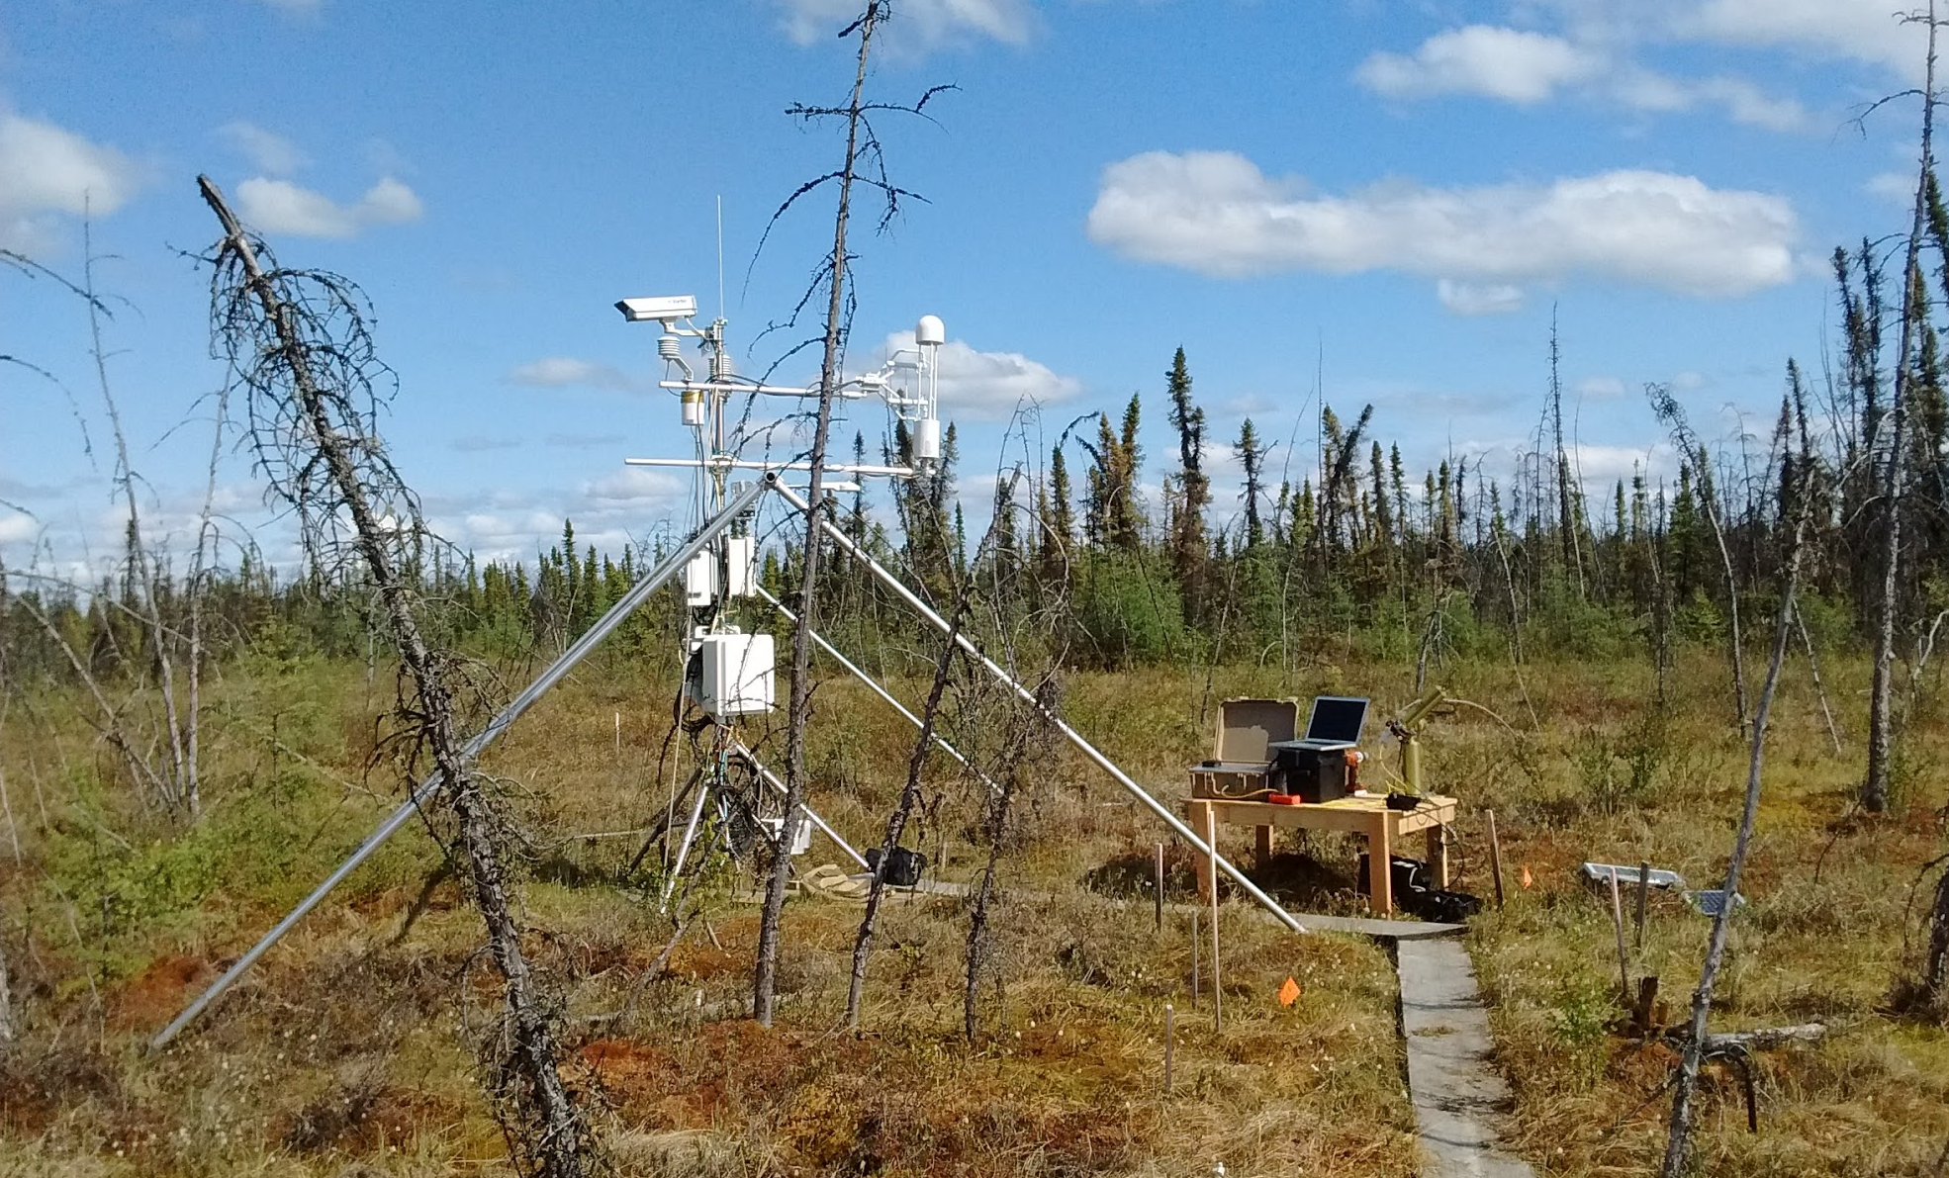

Recent Publications (minimum 5)

Wilson, E. L. et al. A 4 U laser heterodyne radiometer for methane (CH4) and carbon dioxide (CO2) measurements from an occultation-viewing CubeSat, Measurement Science and Technology 28, 035902 (2017).

Melroy, H. R. et al. Autonomous field measurements of CO2 in the atmospheric column with the miniaturized laser heterodyne radiometer (Mini‑LHR). Applied Physics B 120, 609-615 (2015).

Wilson, E. L. et al. Miniaturized Laser Heterodyne Radiometer for Measurements of CO2 in the Atmospheric Column. Applied Physics B: Lasers & Optics 114, 385-393, doi:10.1007/s00340-013-5531-1 (2014).

Clarke, G. B., Wilson, E. L., Miller, J. H. & Melroy, H. R. Uncertainty analysis for the miniaturized laser heterodyne radiometer (mini-LHR). Measurement Science and Technology 25, 055204-055209 (2014).

Sinclair, J. A., Irwin, P. G. J., Calcutt, S. B. Calcutt, Wilson, E. L. On the detectability of trace chemical species in the martian atmosphere using gas correlation filter radiometry. ICARUS 260, 103-127 (2015).

Biography (150 word limit)
Dr. Wilson specializes in instrument development for measurement of atmospheric trace gases. She joined NASA in 2005 after working there as an NRC postdoc. She leads two instrument developments: a Laser Heterodyne Radiometer for column measurements of CO₂, CH₄, and H₂O, and a Miniaturized Gas Correlation Radiometer for measurements of CH₄, CH₂O, H₂O, and CO₂ in the Martian atmosphere.
Email: Emily.L.Wilson@nasa.gov

Presenting author details:
Full name: Emily Wilson
University/Industry/Organization name: NASA Goddard Space Flight Center
Designation (Director/Prof/Assistant or Associate prof/Researcher/Student): Research Physical Scientist
Country: USA
Telephone: 301-614-6730
Email: Emily.L.Wilson@nasa.gov
Track name: laser applications
Category (Oral presentation/ Poster presentation/Young researcher forum/E-poster): Oral presentation
Research interest: instrument development

Linked In account: https://www.linkedin.com/in/emily-wilson-3663963

Note: Please fill up the Red mark fields so that it would be easier for us to cite your details in the conference particulars. (Please do not forget to fix your photo above the title)

Notes/Comments:

