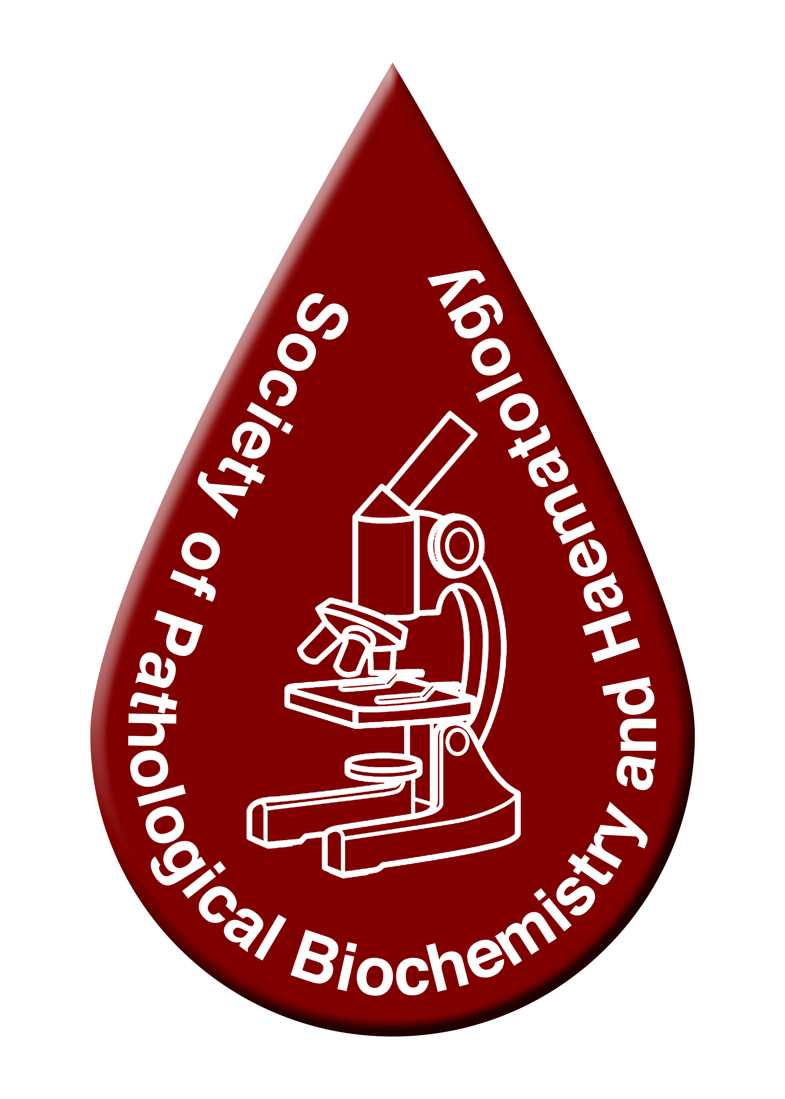 | 
Dr. Ahmed A. Yameny
Biography
Ahmed A. Yameny is the head of Society of Pathological Biochemistry and Hematology. He is the chairman of Medical Laboratory syndicate in Egypt, he was the Chairman for five international conferences of medical laboratory and four international conferences of the Society of pathological biochemistry and hematology, he is Expert and medical laboratory consultant. He is chief editor Journal of Bioscience and Applied Research (www.jbaar.org), He is chief editor International journal of pathology and biomarkers (www.ijpb.org) , He is chief editor Journal of Medical and Life Science(www.jmals.org) , he has a PHD in Microbiology, he has five high diplomas in (1- bacteriology 2-Public health of parasitology and medical entomology 3-Analytical Biochemistry 4- Hematology 5- Genetic Analysis) , he has a B.Sc. in Biochemistry (Alexandria University in Egypt ), and he has a B.Sc.in Biochemistry/Chemistry(Tanta University in Egypt). He is a researcher and interested in Molecular Pathology.

