13th International Conference on

Laboratory Medicine & Pathology

June 25-26, 2018 Berlin, Germany
Fluorescence in-situ hybridization versus chromogenic in-situ hybridization in evaluating HER2 status in breast cancer by adopting tissue microarray technique
Samir Amer a , Rasha Khairy b , Omnia M. Badawya , Riham Farouka and Amira Raafata
a Department of Pathology, National Cancer Institute and b Department of Pathology, Kasr El Ainy Faculty of Medicine, Cairo University, Cairo, Egypt
Background: Accurate HER2 assessment is crucial for determining the prognosis of breast cancer patients and for selecting patients who are candidates for targeted therapy. In Egypt, all breast cancer cases are subjected to HER2 protein expression testing with immunohistochemistry (IHC). Only those patients with score 2 and selected cases of score 3 are subjected for further analysis using in-situ hybridization technique to detect HER2 gene status. Fluorescence in-situ hybridization (FISH) is considered the gold standard method, but recently newer alternative techniques such as chromogenic in-situ hybridization (CISH) have evolved. However, the cost of both FISH and CISH is considered an economic burden, especially in view of the increasing frequency of breast cancer cases in Egypt. Aim: This work aimed to analyze HER2 positivity results and report the concordance rate between IHC, CISH, and FISH techniques in invasive breast carcinomas using tissue microarray (TMA). Materials and methods A total of 46 invasive duct carcinoma paraffin blocks were retrieved, TMA was constructed, and then subjected to CISH and FISH analysis. Results: There was no difference in results between FISH and CISH techniques in evaluating HER2 gene status with highly significant match, as concordance was 100%, j value was 1, and P value was 0.001. All diagnostic indices (sensitivity, specificity, positive predictive value, negative predictive value, and efficacy) with regard to positive and negative cases were 100%. However, FISH is still the gold standard method, especially in the equivocal cases. Conclusion: HER2 testing by IHC and in-situ hybridization can be applied on TMA with high degree of sensitivity, specificity, and concordance. The low cost technique of TMA can replace automated TMAs in developing countries like Egypt, especially when using triplet cores.
Keywords: breast cancer, chromogenic in-situ hybridization, fluorescence in-situ hybridization, tissue microarray

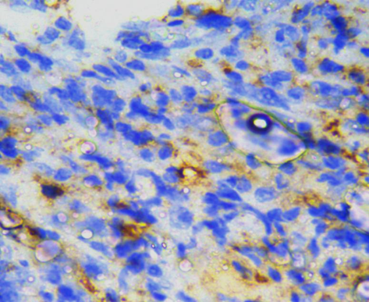
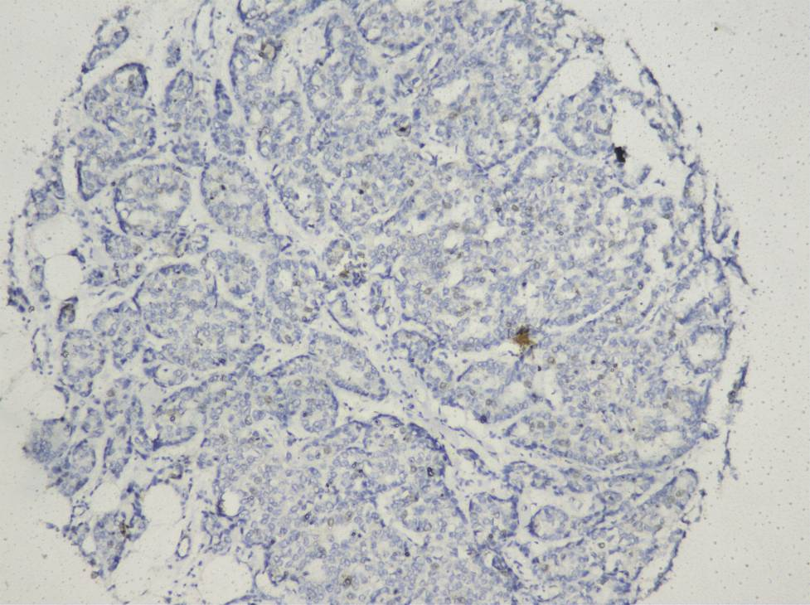
Fig 1: Negative Her 2 score 0 (IHC, 10X) Fig 2: Negative Her 2 score 1+ (IHC, 40X)
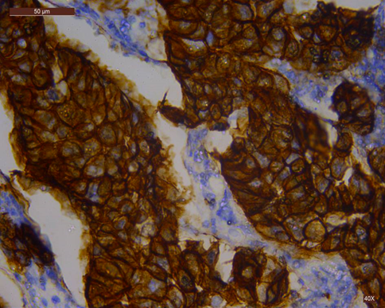
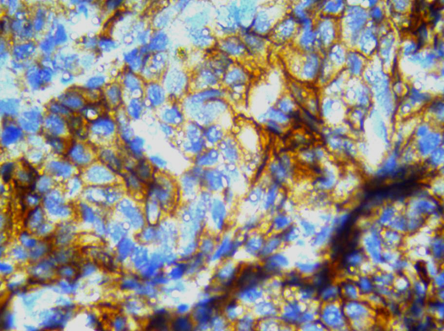

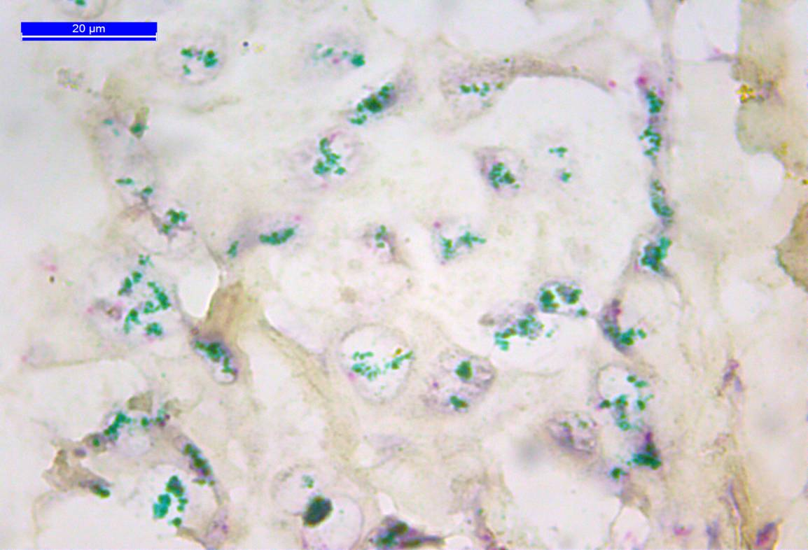
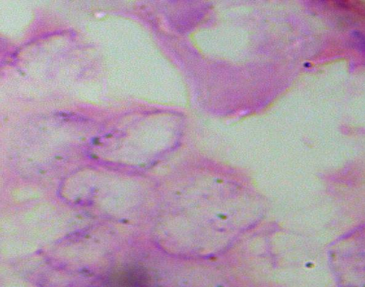
Fig 3: Equivocal Her2 score 2+ (IHC, 40X) Fig 4: Positive Her2 score 3+ (IHC, 40X)

Fig 6: Her 2 amplified (CISH)
Fig 6: Her 2 amplified (CISH, 100X)
Fig 5: Her2 not amplified (CISH, 100X)

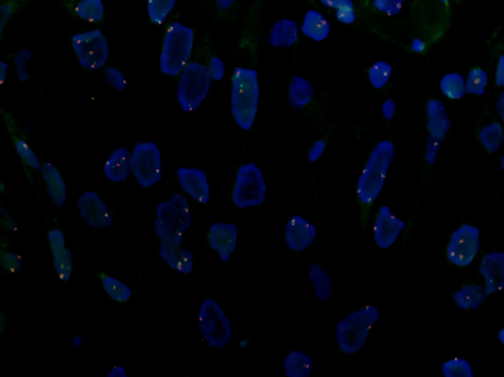

Fig 7: FISH analysis of a case of invasive duct carcinoma showing tumor nuclei counterstained with DAPI (blue color) with 2 green (CEP17) and 2 orange signals (Her-2 gene) in almost all nuceli denoting that Her2 gene is not amplified with a Her-2 /CEP 17 ratio:1 ( X1000)

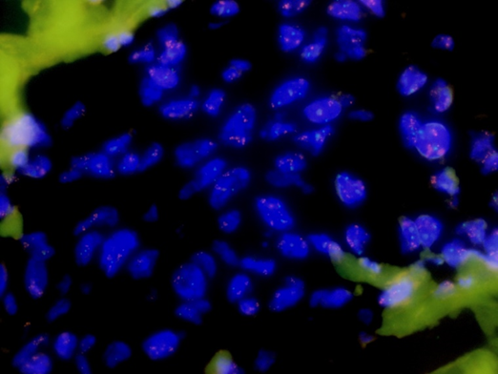
Fig 8: FISH analysis of a case of invasive duct carcinoma showing tumor nuclei counterstained with DAPI (blue color) with 2 green (CEP17) signals and clusters of orange signals (Her-2 gene) in almost all nuceli denoting that Her2 gene is amplified with an average Her-2 /CEP 17 ratio:5 ( X1000)

Biography

Rasha Ahmed Khairy has completed her M.D at the age of 33 years from Faculty of medicine, Cairo University . She is lecturer of pathology in faculty of medicine, Cairo University.She has published 9 papers in reputed journals and has joined as a reviwer in reputed journal.
Presenting author details
Full name: Rasha Ahmed Khairy
Contact number: 01227415257
Linked In account:Rasha Khairy
Category: (Oral presentation)

