Title: Sensing and healing efficiencies of cementitious composites incorporated carbon materials
Hocine Siad, PhD, Ryerson University, Canada; Mohamed Lachemi, Ryerson University, Canada; Mustafa Sahmaran, Hacettepe University, Turkey

Abstract
In recent years, the development of a new generation of smart structures has attracted researchers worldwide. Efforts in this area have been directed toward the use of highly-conductive materials such as carbon nanotubes (CNT) and carbon fibers (CF) in cementitious materials for multifunctionality purposes. This study focused on developing a new generation of engineered cementitious composites (ECCs) with combined sensing and healing efficiencies. The goal was to detect and evaluate the damage in ECCs at their early time of occurrence, while insuring an automatic and repeated recovery of microcracks. Carbon nanotubes were incorporated in ECC compositions at 0.50% and 0.25% by mass of the cementitious materials, and carbon fibers occupied 1% and 0.5% by the total volume. Special mixing method was used for casting CNT-ECCs to insure a homogeneous dispersion of CNT particles and PVA fibers. Mechanical strengths, ductility and electrical resistivity (ER) of sound and pre-cracked specimens were assessed to evaluate the effect of CNTs and CFs on the intrinsic properties of ECCs. The quantitative sensing/healing of microcracks was measured by comparing the fractional change in ER before and after pre-cracking, and at different recovery time. Microstructural investigations were completed on the healed crack lines to determine the relation between carbon materials and elf-sensing/self-healing efficiency. The results showed improvements in compressive and flexural strengths with the use of CNTs and CFs. Unlike CFs, CNTs in ECC showed equivalent ductility, increased crack numbers and decreased crack widths than control specimens, resulting in greater recovery rates in mechanical properties and ERs. In addition, CFs influenced negatively the sensing ability of microcracks and consequently, the accuracy of self-healing evaluation, while CNT-ECCs showed high precision in quantifying pre-cracking and self-healing rates. The SEM analyses showed bridged CFs across the healed microcracks, which explains the reduced sensing of initial cracking and healing in CF-ECCs.

Image
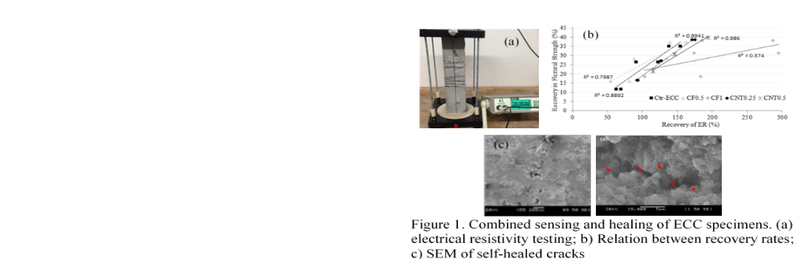

Recent Publications
- Siad, H., Lachemi, M., Sahmaran, M., & Hossain, K. M. A. (2017). Mechanical, physical, and self-healing behaviors of engineered cementitious composites with glass powder. Journal of Materials in Civil Engineering, 29(6).
- Siad, H., Lachemi, M., Sahmaran, M., & Hossain, K. A. (2017). Potential for Using Waste Recycled Glass in Engineered Cementitious Composites. Special Publication, 320, 34-1.
- Ismail, M. K., Sherir, M. A., Siad, H., Hassan, A. A., & Lachemi, M. (2018). Properties of Self-Consolidating Engineered Cementitious Composite Modified with Rubber. Journal of Materials in Civil Engineering, 30(4), 04018031.
Siad, H., Lachemi, M., Sahmaran, M., Mesbah, H. A., & Hossain, K. M. A. (2018). Use of recycled glass powder to improve the performance properties of high volume fly ash-engineered cementitious composites. Construction and Building Materials, 163, 53-62.
5. Siad, H., Lachemi, M., Sahmaran, M., Mesbah, H. A., & Hossain, K. A. (2018). Advanced engineered cementitious composites with combined self-sensing and self-healing functionalities. Construction and Building Materials, 176, 313-322..

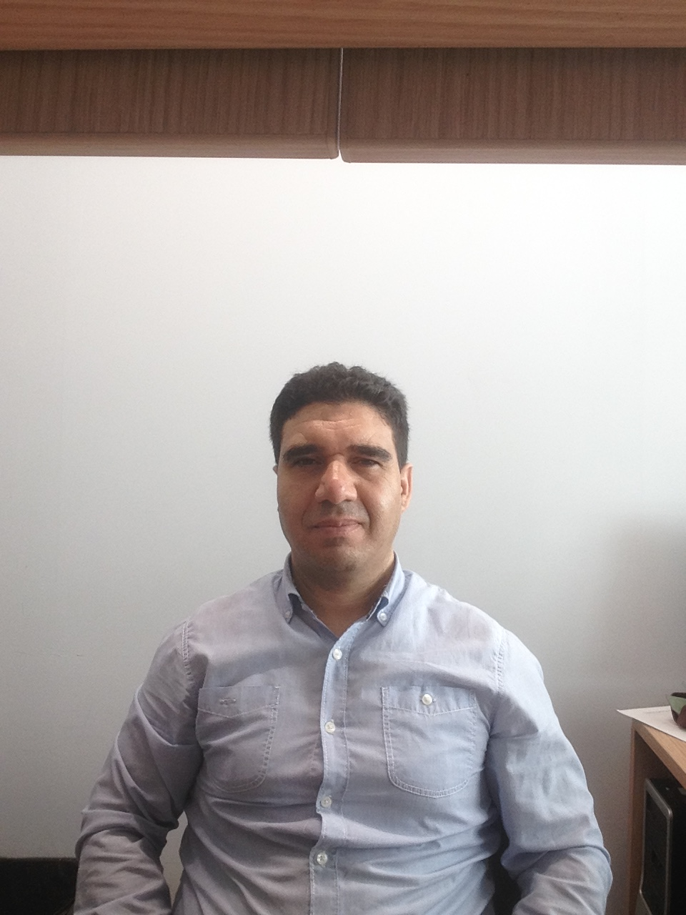

Biography
Dr. Hocine Siad is a research associate in the Department of Civil Engineering, at Ryerson University, Toronto, Canada. His research interests include microstructure, durability and transfer properties of cementitious materials; sulfate and acid attack; development of new test methods; use of waste, recycled and industrial by-products/volcanic materials in sustainable applications; self-healing of engineered cementitious composites; new geopolymer concretes; nanomaterial technology and the development of smart multifunctional composites.
Email:hsiad@ryerson.ca
- Full Name: Hocine Siad
- Personal Email: hsiad@ryerson.ca
- Mobile Number:+14379813743
- Linked In: https://www.linkedin.com/in/hocine-siad-447b5934/
- Session Name: Capturing the Innovations of Pure and Applied Chemistry
- Category: Speacker
- Date of Birth: 06/03/1976
- Postal Addres: M5B 2K3

