MUCOCUTANEOUS AMYLOIDOSIS, A PRELUDE MANIFESTATION OF PLASMA CELL MYELOMA: A REPORT OF TWO CASES AND REVIEW OF LITERATURE
JAMES MANUEL, MD
RHODERICK FUSILERO MD, FPCP, DPSHBT, DPCHTM

Background
Seeing a dermatological manifestation, yet so apparent, could be an intricate challenge to identify the pathology. Skin problems may precede, occur with, or follow the discovery of an underlying internal disease. As such, a mucocutaneous amyloidosis could be an index of an elusive plasma cell malignancy as multiple myeloma. Herein, we report two cases of plasma cell myeloma with preexisting amyloidosis.

Case Report
A 68-year-old male was admitted with multiple skin lesions ranging from hyperpigmented patches and plaques to thickening and enlargement of hands, fingers, and tongue. These were accompanied with cough, chestpain, easy fatigability, and pallor. Chest tomography showed pleural-based masses with multiple rib and vertebral lytic bone lesions. Probe biopsies of the bone marrow and skin fat pads supported a plasma cell malignancy and amorphous dermal collagenization respectively. Serum protein electrophoresis defined the presence of a monoclonal gammopathy, likely a myeloma.
A review of medical records showed a comparable case of a 62-year-old male patient who also presented with gradual thickening of palms, soles and fingers with dystrophic changes of the nails, accompanied with jointpains and low backpain. Laboratory results showed anemia, elevated serum calcium and creatinine levels. An L4 vertebral compression fracture was detected on skeletal survey. Skin biopsy showed an apple-green birefringence, signifying amyloid deposits. Trepine biopsy revealed significant plasmacytosis. Electrophoretic tracer demonstrated a monoclonal gammopathy as well.

Conclusion
We report two cases of a complex hematologic malignancy which initially presented with variegating dermatologic lesions consistent with AL-type amyloidosis. Further investigation of the anemia, azotemia, hypercalcemia, and lytic bone lesions has established that beyond amyloidosis lies plasma cell myeloma. To date this is the first documented consecutive cases of mucocutaneous amyloidosis as the initial presentation of multiple myeloma in a local setting.
Case 1
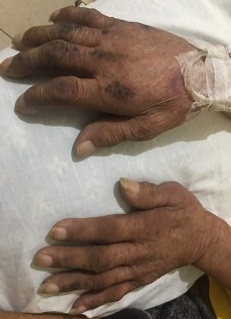
CASE 2
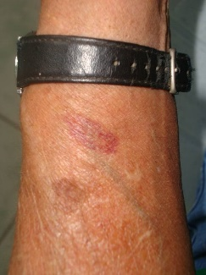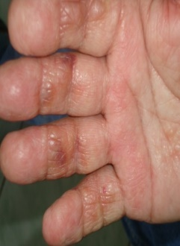
Figure 1. Mucocutaneous Amyloidosis. Appearance of macroglossia and thickened and enlarged hands and fingers (Case 1), waxy salmon pink patches and papules on arm and fingers (Case 2).


James Manuel is currently a third year internal medicine resident at Ilocos Training Regional Medical center.
Email: jamesmanuel111886@gmail.com

Notes/Comments:
Presenting author details
Full name: JAMES L. MANUEL
Contact number: +639053714106
Twitter account:
Linked In account:
Session name/ number:
Category: (Oral presentation/ Poster presentation)

