Safranal ameliorates glomerulopathy in experimentally induced in diabetic rats
Amir Abbas Farshid¹, Esmaeal Tamaddonfard², Farahnaz Noroozinia³ and Fatemeh Delkhosh-Kasmaeia¹

1- Division of Pathology, Department of Pathobiology, Faculty of Veterinary Medicine, Urmia University, Urmia, Iran
2- Division of Physiology, Department of Basic Sciences, Faculty of Veterinary Medicine, Urmia University, Urmia, Iran
3- Division of Pathology, Department of Basic Sciences, School of Medicine, Urmia University of Medical Sciences, Urmia, Iran
Abstract
Statement of the Problem: Nephropathy is one of the major complications of diabetes. Many drugs are used to manage diabetes outcome. Insulin is used routinely in treatment of diabetes. Pharmacological evidences have suggested anti-oxidant, anti-inflammatory, anti-aging and anti-cancer activities of safranal. This investigation was design to study the effects of safranal on diabetic glomerulopathy in rats. Insulin, as an anti-diabetic drug, was used to compare results. Methodology: Diabetes was induced by intraperitoneal injection of streptozotocin (55 mg/kg) dissolved in sodium citrate buffer (0.1 M, pH 4.5). After confirmation of diabetes (blood glucose level > 250 mg/kg), treatments with intraperitoneal injections of normal saline (control), safranal (0.025, 0.1 and 0.4 mg/kg) and insulin (5 IU/kg) were started and continued for six weeks. On 42th day, animals were euthanized and kidney tissues were collected, fixed and processed routinely and 5-7 µm sections were prepared and stained with H&E, PAS and Masson trichrome and were subjected to semi-quantification analysis. Findings: The glomerular changes in diabetic group were, thickening and splitting of glomerular basement membrane, expansion of mesangial matrix, mesangiolysis, hyperplasia and fibrosis. Safranal at a dose of 0.025 mg/kg did not have significant effects on any of the lesions, and at a dose of 0.1 mg/kg showed significant effects only on mesangiolysis and hyperplasia. Safranal (0.4 mg/kg) and insulin (5 IU/kg) produced similar improving effects by amelioration of all glomerular histopathological changes. Conclusion & Significance: Safranal, as a biologically active substance of saffron, and insulin, a synthetic anti-diabetic drug produce similar tissue protective effects on diabetic glomerulopathy. It is recommended that safranal be considered for diabetes management.

Image
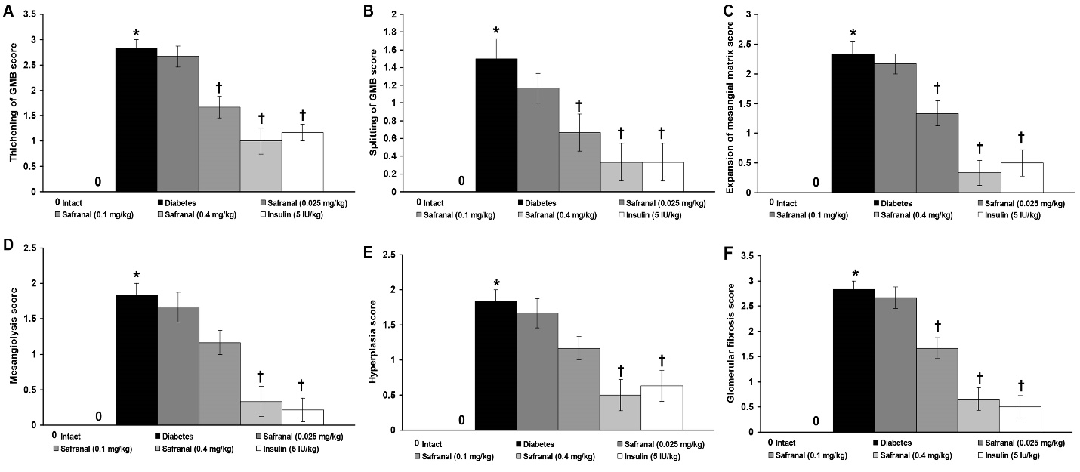
Figure 1. Effects of safranal and insulin on diabetic glomerulopathy in rats. Data are presented as mean ‡ SEM from six rats in each group. * p < 005 indicates a significant difference with intact group. † p < 0.05 indicates significant differences with diabetes group.
Recent Publications
Bukhari SI, Manzoor M , Dhar,MK (20180). comprehensive review of the pharmacological potential of Crocus sativus and its bioactive apocarotenoids, Biomed. Pharmacother. 98 : 733–745.
Farshid AA, Tamaddonfard E (2015). Histopathological and behavioral evaluations of the effects of crocin, safranal and insulin on diabetic peripheral neuropathy in rats, Avicenna J. Phytomed. 5 (5) : 469–478.
Marca, E. Gianchecchi, A. Fierabracci, Type 1 diabetes and its multi-factorial pathogenesis: the putative role of NK cells, Int. J. Mol. Sci. 10 : 19.
Rameshrad M, Razavi BM, Hosseinzadeh H (2018). Saffron and its derivatives, crocin, crocetin and safranal: a patent review, Expert Opin. Ther. Pat. 28 (2) : 147–165.
Samarghandian S, Borji A, Delkhosh MB, Samini F (2013). Safranal treatment improves hyperglycemia, hyperlipidemia and oxidative stress in streptozotocin-induced diabetic rats, J. Pharm. Pharm. Sci. 16 (2) : 352–362.

Biography
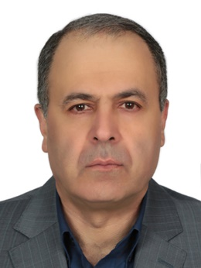
Dr. Amir Abbas Farshid, is Professor of veterinary pathology , Faculty of Veterinary Medicine, as well as Head, Electron Microscope Center , Urmia University, Urmia, Iran, with more than 86 research papers published in reputed Journals.
Presenting author details
Email: aa.farshid@urmia.ac.ir
Full name: Amir Abbas Farshid
Mobile number: 914 341 4911
Session name/number:
Category: Oral presentation
Date of Birth: 06/09/1961
Postal Address: Division of Pathology, Faculty of Veterinary Medicine, Urmia University, PO Box 1177, Urmia 57153, Urmia, Iran
Notes or Comments:
My 3rd co-author Dr Farahnaz Noroozinia is also participating in the congress.

