Organometallics Against Bacteria and Viruses
Joseph Merola¹*, Christine DuChane¹ , Chad Bernier¹
Department of Chemistry and the Virginia Tech Center for Drug Discovery, Virginia Tech, Blacksburg, VA 24060, USA
Email: jmerola@vt.edu, +1 540-231-4510}
Abstract: The age of highly antibiotic-resistant strains of bacteria such as methicillin-resistant Staphylococcus aureus (MRSA) and tuberculosis (TB) has been identified as a world-health crisis given the number of cases and deaths from these two pathogens alone. The Infectious Disease Society of America made a statement in 2010 that at least 10 new antibiotics would need to be developed by 2020 (The “10 x ‘20 Initiative) and, unfortunately, that did not happen. As serious as the problem of antibiotic resistance is, it has recently paled in comparison to the world health crisis of the pandemic of COVID-19. In the COVID crisis, the lack of an effective vaccine and of effective anti-virals has resulted in a massive loss of life around the globe.
This talk will present findings on how organometallic complexes with appropriate ligands, such as amino acids, can combat resistant bacteria while still being safe for mammalian cells and, in our latest results, some compounds may show anti-viral activity. A class of compounds effective against tuberculosis and a second class effective against MRSA will be described. Preliminary results on a newer class of organometallic compounds with anti-viral activity will be touched on only briefly since the results are very preliminary.
Biography: Joseph S. Merola received his Ph.D. in 1978 with Dietmar Seyferth at MIT. He joined the Corporate Research Laboratories of Exxon Research &Engineering Company in New Jersey. In 1987, he moved to the Department of Chemistry at Virginia Tech where he has remained since. He carries out work in the areas of transition metal organometallic complexes, primarily of rhodium and iridium. This work began as an investigation into their catalytic activity and morphed into examining their biological activity. Professor Merola is a Fellow of the American Chemical Society and a Fellow of the American Association for the Advancement of Science.

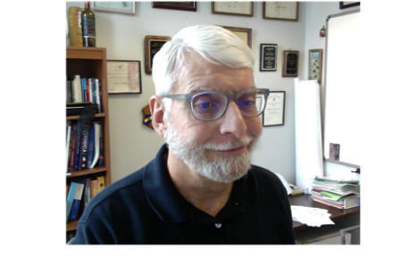
Recent Photo:

