Humanoid for Immersive Virtual Teaching
R. Rajkumar, PhD, School of Computing, SRMIST, Chennai. India

Abstract
Form the traditional learning process educational institutions communication technologies (ICT) but at a very near future there are vast advantages of educational robots’ different sectors like navigation application, search and rescue application and industrial applications have achieved in the efficient use of robotics. And now it is time for the educational institutes for their advancements in educational robotic technology.
Augmented Reality (AR), Virtual Reality (VR), and Mixed Reality (MR) have become popular emerging immersive reality technologies in teaching and self-learning space. These technologies have been used for advancing teaching methods with a custom-made feature to empower learners with engaged experience. Artificial Intelligence (AI) techniques are enabled to machines for their capacity to complete complex errands with practically zero management. The use of humanoid robot has numerous advantages in education context to improve efficiency in teaching and learning process.
The proposed work is to have the ability to understand the emotion of the students and act according to it so by this student will never feel the replacement of a teacher and make the class sessions more interesting. We are building three models of our humanoid robot for better accuracy and feasibility. At the very first module the robot will have a 360-degree camera which will act as an eye of the teacher and a screen attached to it where the teacher will be connected through the online mode, furthermore the second module of the proposed humanoid robot we will accomplish the non- verbal communication like to imitate the body language instructor. This module of the proposed humanoid consists of various wearable devices and different emerging technologies like the Augmented Reality (AR), Virtual Reality (VR), and Mixed Reality (MR) to give a lively experience of the educational objectives. At last, the third module of the proposed humanoid robot where will achieve the asynchronous learning/teaching. The humanoid fed with appropriate information which is recorded earlier. The information such as motion commands, audio and video deliverables with knowledge of different subjects from different instructors. At the synchronous mode of delivery control, the humanoid robot can be controlled through the motion tracking technology without placing any wearable sensors with instructors. Our humanoid can be globally controlled by the teachers using the 5th generation of the connectivity technology the 5G in education 4.0. This technology of robot will bring ease to human life and increase the interaction of human and human like humanoid robots.
Image

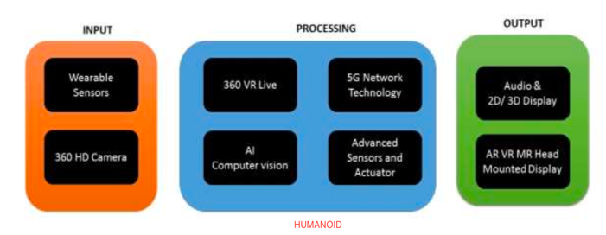

Recent Publications
- R Rajkumar, V Ganapathy, Bio-inspiring learning style chatbot inventory using brain computing interface to increase the efficiency of e-learning, IEEE Access 8, 67377- 67395,2020.
- V Raman, S Balaji, R Rajkumar, An Augmented Reality Greenhouse to Demonstrate Game- Based Learning, 2021, IEEE Intelligent Technologies, 1-4, 2021.
- R Rajkumar, A Murugan, GA Balaji, , Anatomy MR: A Multi-User Mixed Reality Platform for Medical Education, Journal of Physics: Conference Series 1362 (1), 012099, 2019.
- R Rajkumar, V Ganapathy, DETECTION OF PANIC AND RECOVERY FROM PANIC USING BRAIN COMPUTER INTERFACE, International Journal of Pure and Applied Mathematics 119 (16), 3655-3662, 2018
- R. Rajkumar, T. Arunashree, Agathamudi Vikram Naidu, Credit Card Fraud Prediction System Using Machine Learning Algorithms, International Journal of Advanced Science and Technology 29 (7), 8295-8304, 2020
- R Rajkumar, V Ganapathy, D Shunmuganathan, , BRAIN COMPUTER INTERFACE TO IDENTIFY THE STATE OF MIND OF THE LEARNERS, International Journal of Pure and Applied Mathematics 119 (16), 3645-3654, 2018

Biography
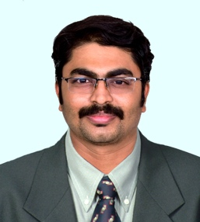

Dr. R. Rajkumar is working as a faculty in Data Science and Business Systems under School of Computing at SRM Institute of Science and Technology (SRMIST), Chennai, India. He is also working as an adjacent faculty member in Centre for Immersive technologies, SRM IST. He is passionate on training, writing, research and development. He is interested in strategy and policy making. He received his Phd from SRMIST. He is expertise in Artificial Intelligence, Brain Computer Interface, Compiler Design, E-Learning Technologies, AR, VR and MR. His research work published in various International Journals and presented in various national and international conferences. He has organized number of technical conferences in national and international engineering forums. He is inviting to give speech about technologies and skills to various Industries and Institutions. He addressed in IE (India), IET, IEEE Media like Doordarshan (DD), Private Televisions and All India Radio (AIR). Education Qualifications. He has been awarded as Best Innovative Professor from Lifeline Awards, India, 2021. He was awarded Technology and Youth Empowerment by Curtin University- Dubai, 2018. He has been awarded as Inspiring Author of India for his book INDIA 2030 from Indian Awards, Kolkata, 2017.
Email: rajkumar2@srmist.edu,in

