C1: How the C1 Platform Will Change the Production Approach for Recombinant Vaccines
Ronen Tchelet, PhD, Dyadic Inc., USA.

Abstract
For over 30 years Dyadic has proven itself, commercially and scientifically, as a high quality and highly productive producer of enzymes and proteins using a proprietary and patented expression system based on the Myceliopthora thermophila fungus, nicknamed C1.
The C1 platform technology is a hyper-productive fungal expression system used to develop & manufacture large quantities of desired proteins at industrial scale at significantly lower CapEx and OpEx costs.
Since the successful sale of Dyadic’s industrial biotech business to DuPont for US$75 million on December 31, 2015, we have been focused on applying the C1 technology platform to help enhance the development and manufacturing of biologic vaccines and drugs.
We achieved encouraging results, knowledge and experience in vaccine development from our prior research collaboration with Sanofi Pasteur that we believe can be leveraged and built upon with other partners. During the collaboration, meaningful improvements were made to the C1 expression system to produce antigens of interest at high level with potentially better immune response.
Dyadic is one of a consortium of companies participating in the EU sponsored ZAPI research program. ZAPI is a program sponsored by the EU suitable for the rapid development and production of vaccines and protocols to fast-track registration of developed products to combat epidemic Zoonotic diseases that have the potential to affect the human population. Insight on the development of antigens by C1 will be presented.
Dyadic has also displayed the ability to easily express mAb’s.
The C1 expression system Dyadic’s C1 technology has the potential to change the way in which both animal health and human biotech and pharmaceutical companies bring their biologic vaccines and drugs to market faster, in greater volumes, at lower cost, and with newer beneficial properties, and most importantly save lives.
Dyadic believes that our current efforts, with or without potential partners, to successfully express several therapeutic proteins, will validate the C1 technology as one of the vital production platforms for developing & manufacturing biologic Vaccines and BioPharmaceuticals.

Biography
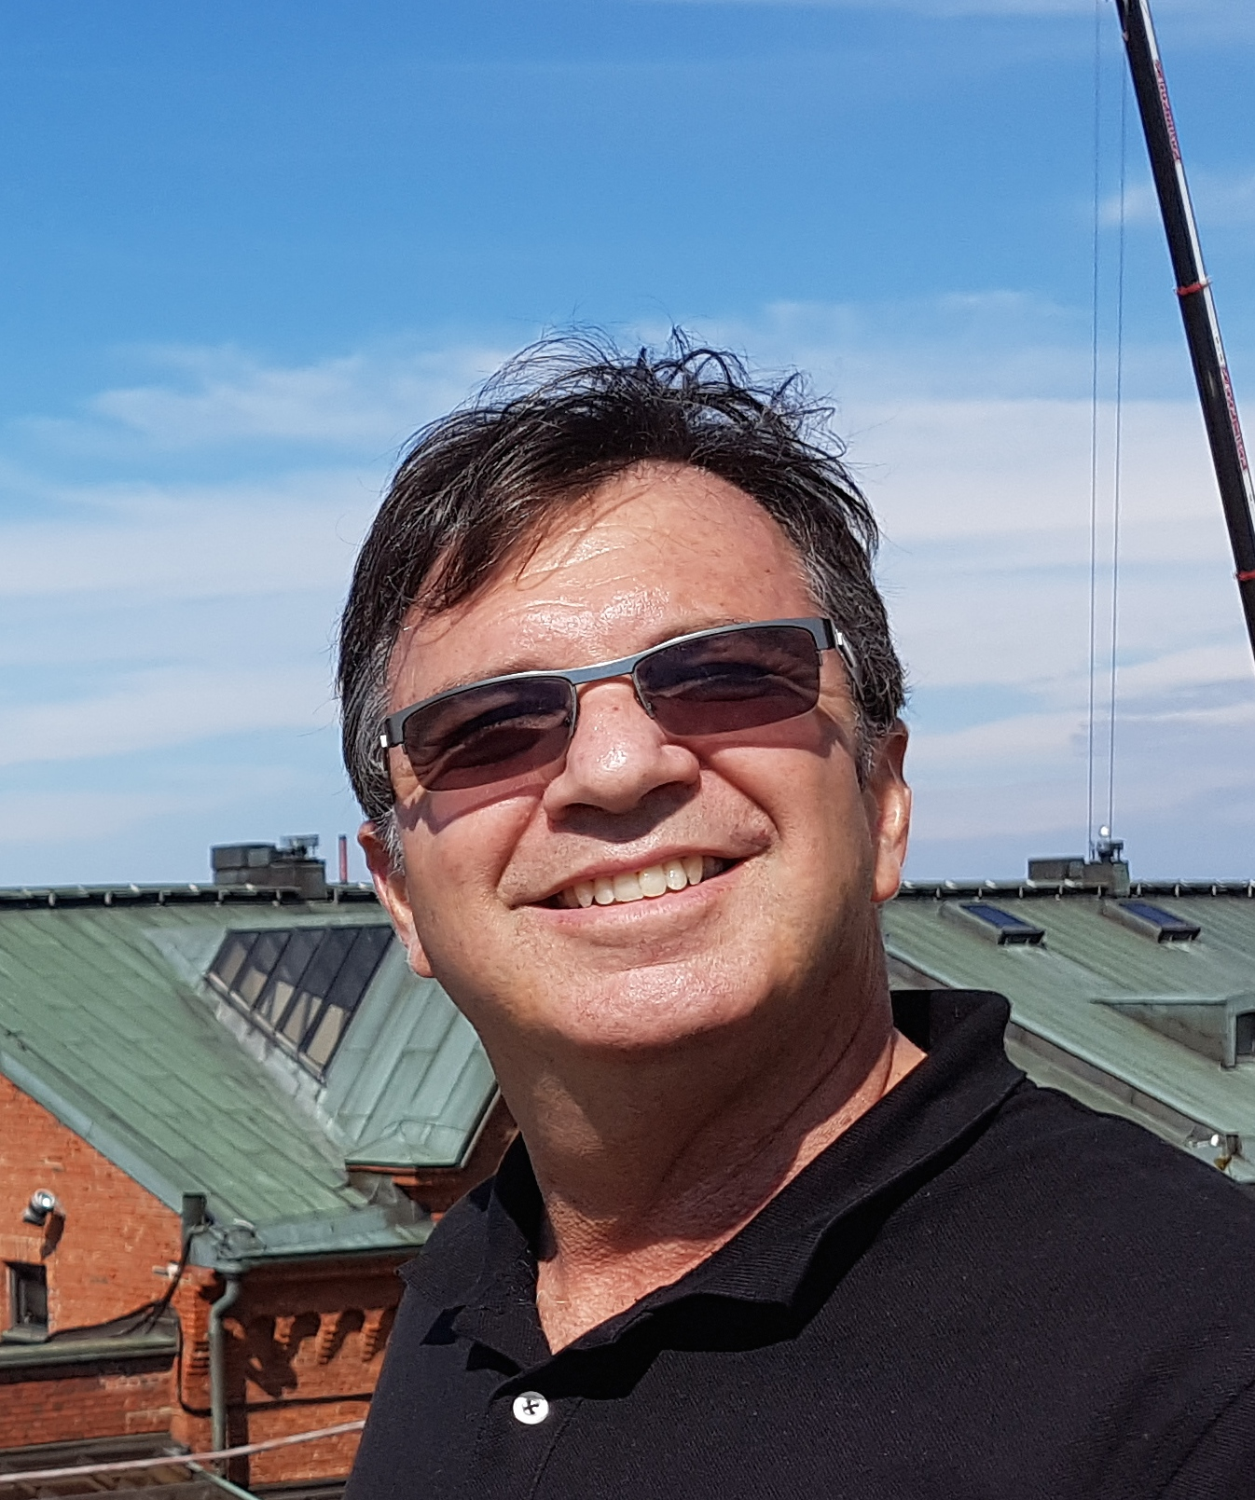
Ronen Tchelet joined Dyadic in May 2014 and has been Dyadic’s Vice President of Research and Business Development since January 2016. Dr. Tchelet received his Ph.D. in Molecular Microbiology and Biotechnology from Tel Aviv University in 1993 and did his postdoctoral as an EERO fellow at the Institute of Environmental Science and Technology (EAWAG) in Switzerland. In the late 2000’s, he joined the API Division of TEVA Pharmaceutical Industries LTD., where he served as a Chief Technology Officer of Biotechnology and was the QA manager of COPAXONE® the flag ship TEVA¹s innovative drug. From 2007 through 2013, prior to joining Dyadic, Dr. Tchelet became the founder and the Managing Director of Codexis Laboratories Hungary kft. (CLH) At CLH, he established a state-of-the-art laboratory for strain engineering and all aspects of fermentation work including process optimization and scaling up. It was during this time that Dr. Tchelet engaged with the C1 technology that was successfully developed for the Biofuel and the Bio-Industrial enzymes fields.

