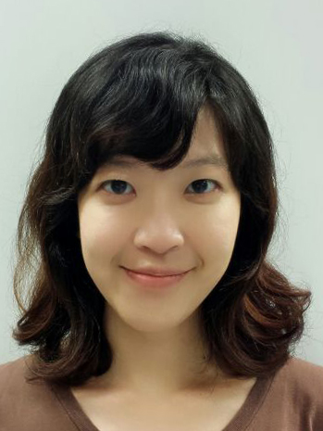

Title: Genome hypermobility by lateral transduction in Staphylococcus aureus

Yin Ning CHIANG
National University of Singapore, Department of Microbiology and Immunology, Singapore

Genetic transduction is a major evolutionary force that drives microbial speciation. All bacteriophage-mediated gene transfer is known to occur by one of two well-described mechanisms: generalized and specialized transduction. Herein we report that the temperate phages of Staphylococcus aureus engage in lateral transduction and that numerous staphylococcal prophages excise late in their lytic program, rather than early like most phages, so that DNA packaging initiates in situ and proceeds for up to seven or more successive capsid headfuls. Large metameric spans up to several hundred kb of the bacterial chromosome are packaged and horizontally transferred at frequencies that are unprecedented for most mechanisms of gene transfer. Since S. aureus genomes typically carry multiple prophages, a single lytic event can potentially transmit a large portion of the bacterial genome at exceptionally high frequencies. These results suggest that certain regions of the bacterial chromosome can be considered as hypermobile platforms of gene transfer. In summary, our results show that phage-mediated gene transfer can occur on a scale that is many orders of magnitude greater than previously appreciated, and will lead to a shift in our perception of the impact that phages have on pathogen evolution and the effects of large scale phage therapy.

Biography

Yin Ning CHIANG graduated from National University of Singapore with a BSc.with Honours in Life Sciences and is currently pursuing her PhD in the Department of Microbiology and Immunology at the National University of Singapore.
Presenting author details
Full name: Yin Ning CHIANG
Contact number: +65 9825 7532
Twitter account: -
Linked In account: -
Session name/ number: Track 1-2 Infectious Diseases (Evolutionary biology)
Category: Poster presentation

