Anticoccidial effect of garlic (Allium sativum) and ginger (Zingiber officinale) against experimentally induced coccidiosis in broiler chickens
Naila Chand¹, Majid Ali¹ and Rifat Ullah Khan²
¹Department of Poultry Science, Faculty of Animal Husbandry & Veterinary Sciences, The University of Agriculture, Peshawar, Pakistan; ²Department of Animal Health, Faculty of Animal Husbandry & Veterinary Sciences, The University of Agriculture, Peshawar, Pakistan

Abstract (300 word limit)

The present study was designed to find the effect of ginger and garlic on the performance and integrity of gut in experimentally induced coccidiosis in broiler chickens. A total of two hundred day-old Hubbard broiler chicks were divided into six equal groups as following: T1, Control (basal diet only); T2, Infected–untreated (positive control); T3, Infected and supplemented with garlic at 15 g/kg feed; T4, Infected and supplemented with gingers at 5 g/kg feed; T5, Infected and treated with amprolium hydrochloride at 1.25 g/liter drinking water; T6, Infected and supplemented with mixture of garlic and ginger at the rate of 2.5 and 7.5 g/kg feed. The results showed that feed intake, body weight and feed conversion ratio (FCR) was significantly (P<0.05) high in ginger and garlic supplemented birds compared to the positive control. Similarly, oocysts shedding, lesion score and histopathology of the small intestines improved in ginger and garlic supplemented birds after induced-infection in broiler. The findings of the present study showed that ginger and garlic produced encouraging results in comparison to amprolium in broiler chickens infected with experimental coccidiosis.

Image

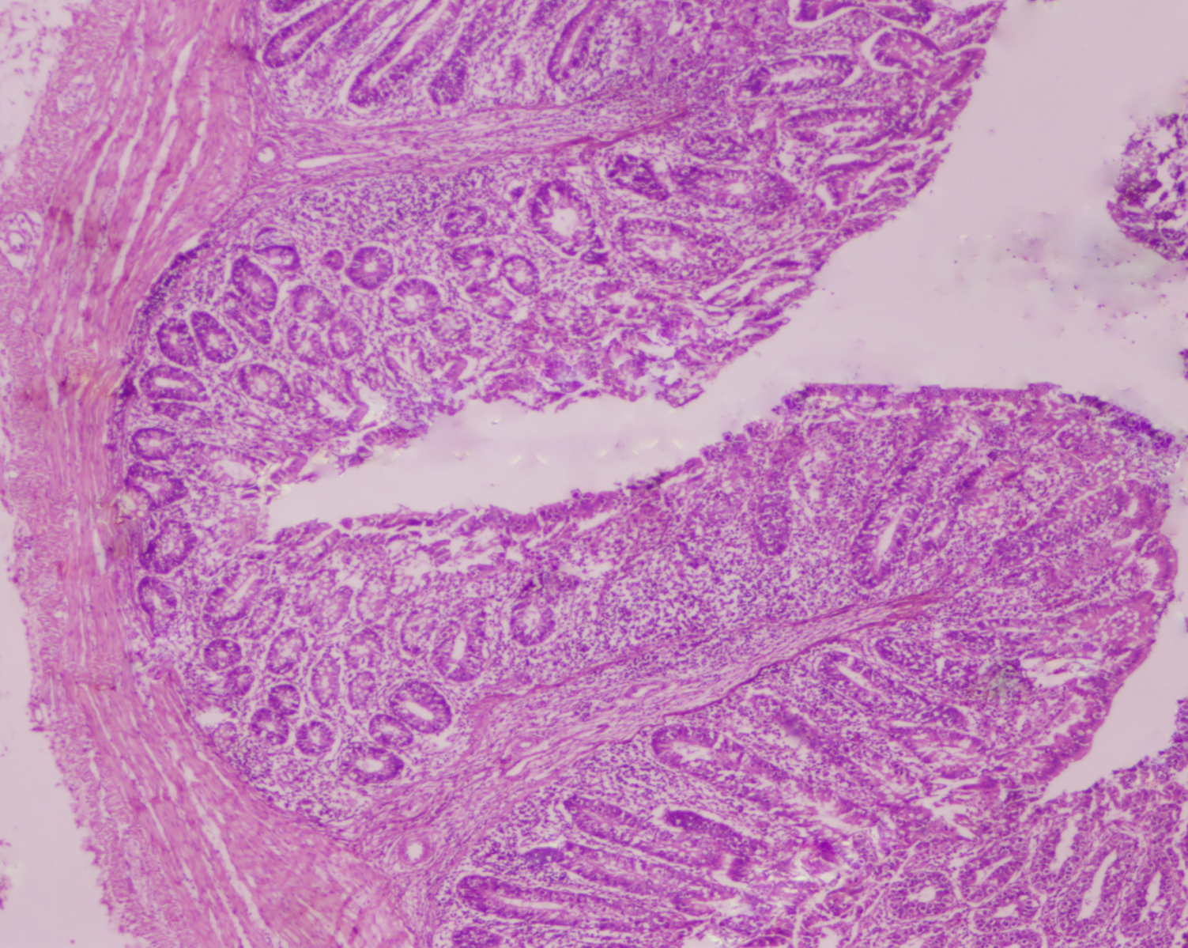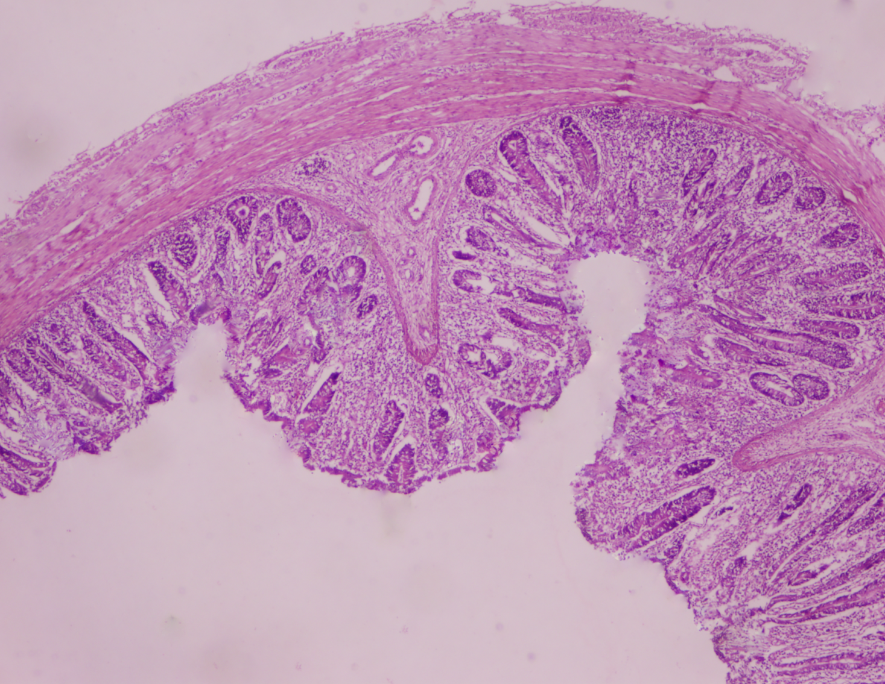

a A
b

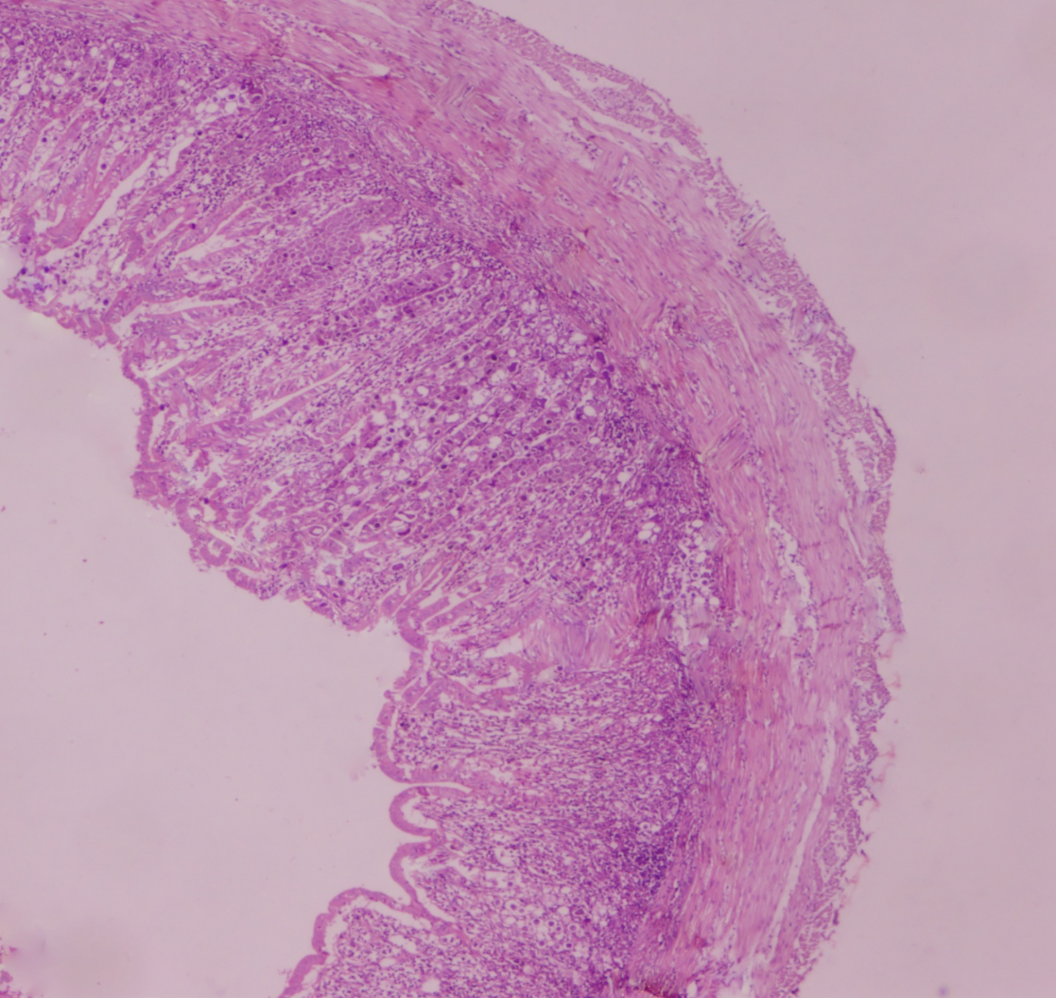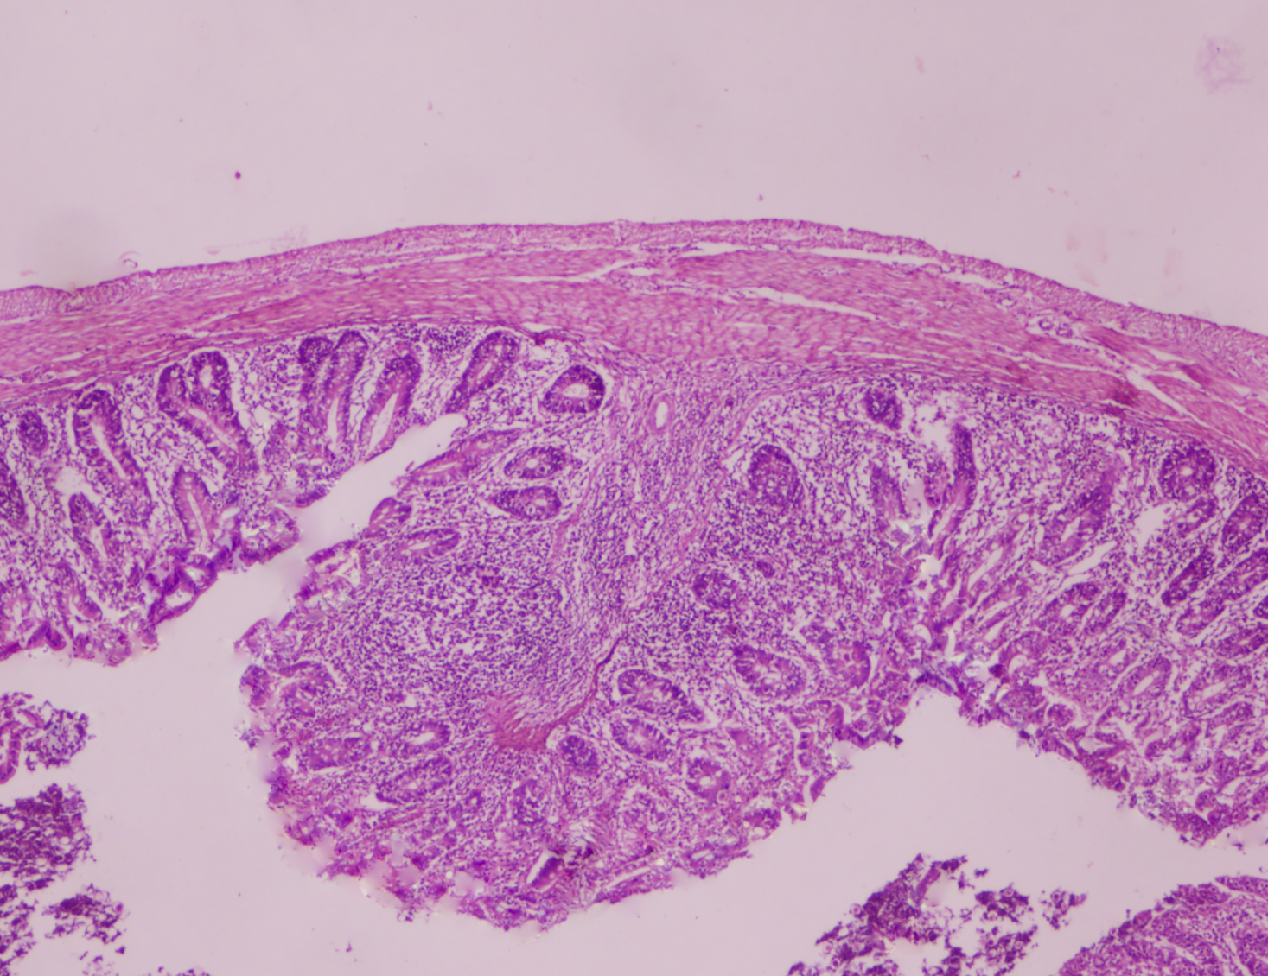

d
c

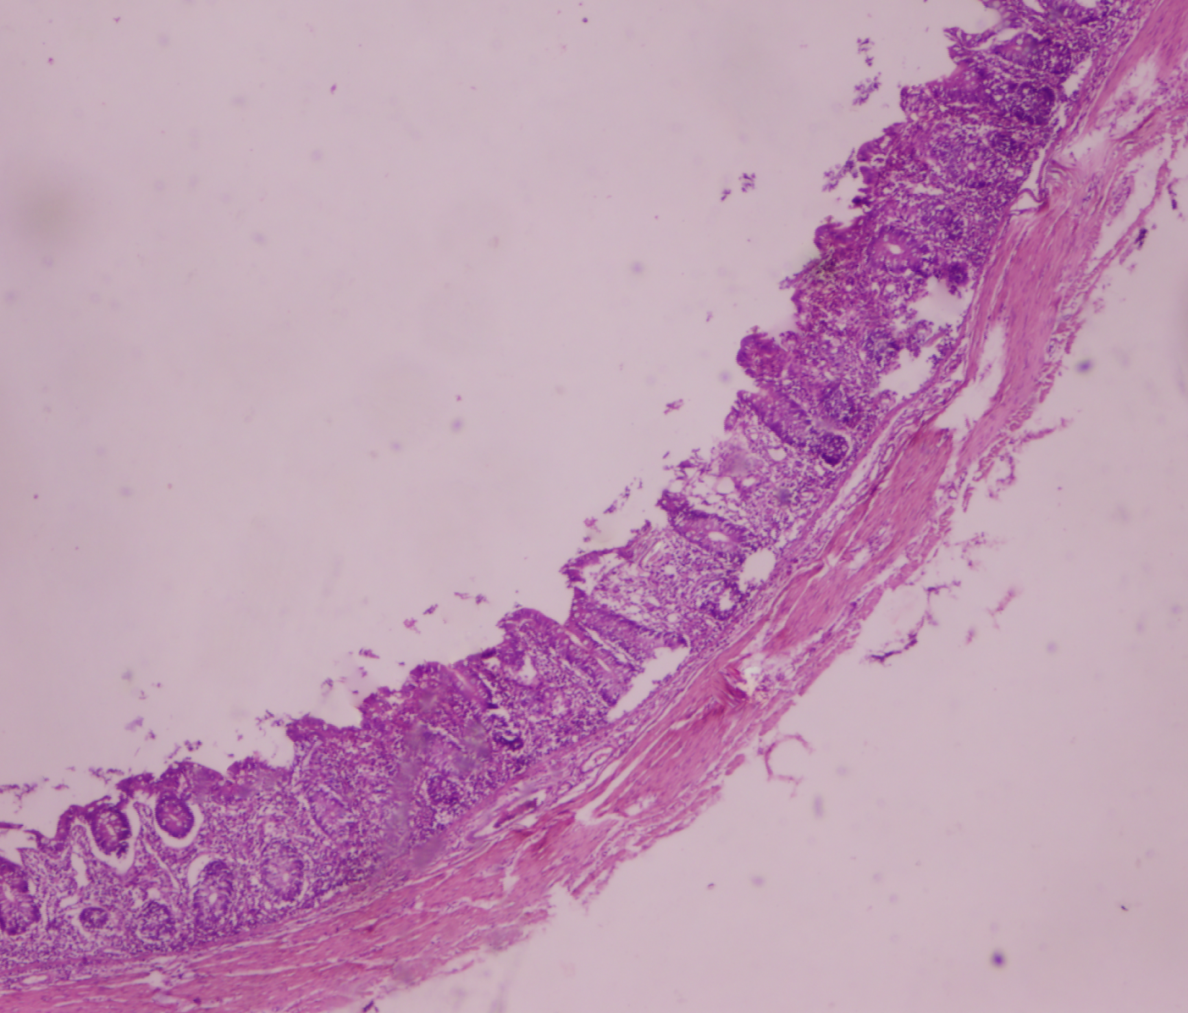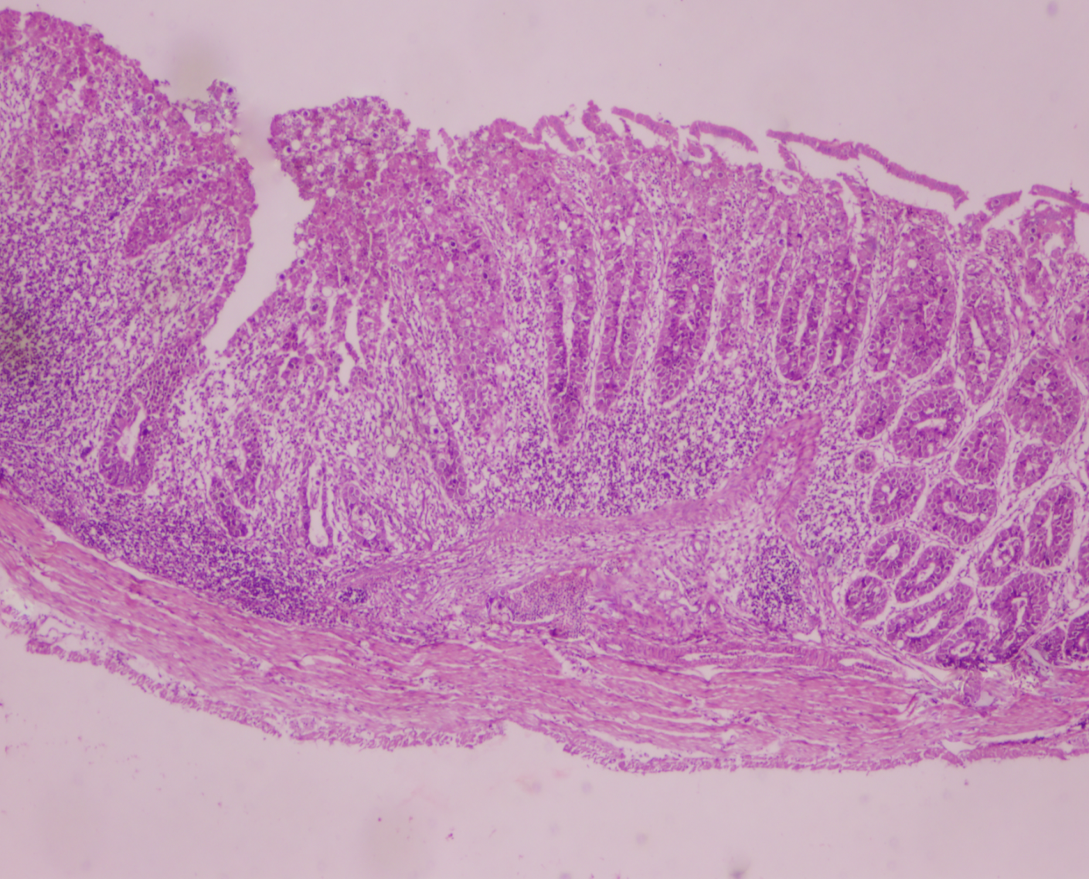

E
F

Fig. 1: Negative control (A); Amprolium treated (B); Garlic treated (C); Ginger treated (D); Ginger and garlic treated (E); positive control (F) H & E stain (40 X) n=100 µm



Recent Publications (minimum 5)
1) Abd El-Hack, M., Alagawany, M., Arif, M., Emam, M., Saeed, M., Arain, M.A., Siyal, F.A., Patra, A., Elnesr, S.S. and R.U. Khan. 2018. The uses of microbial phytase as a feed additive in poultry nutrition – a review. Annals of Animal Science (In press) doi 10.2478/aoas-2018-0009
2) Shah, M., H. Zaneb, S. Masood, R.U. Khan, S. Ashraf, A. Sikandar, H. Faseeh Ur Rehman, H. Rehman. 2018. Effect of dietary supplementation of zinc and multi-microbe probiotic on growth traits and alteration of intestinal architecture in broiler. Probiotics and Antimicrobial Proteins
3) Chand, N., Naz, S., Irfan, M., R.U. Khan and Zia ur Rehman. 2018. Effect of sea buckthorn (Hippophae rhamnoides L.) seed supplementation on egg quality and cholesterol of Rhode Island Red × Fayoumi laying hens. Korean Journal of Food Science of Animal Resources
4) Sutlan, A, Ahmad, S, Khan S, R.U. Khan, Chand N, Tahir M. and Ahmad S. 2018. Comparative effect of zinc oxide and silymarin on growth, nutrient utilization and hematological parameters of heat stressed broiler. Pakistan Journal of Zoology 50: 751-756. Impact factor, 0.54
5) Chand, N., Naz, S., Zia ur Rehman and R.U. Khan. 2018. Blood biochemical profile of four fast-growing broiler strains under high ambient temperature. Journal of the Korean Society of Biological Chemistry 61(3): 273-279. Impact factor: 1.129

Biography (150 word limit)

Dr. Rifat Ullah Khan is working as one of the extensively involved researcher in the field of poultry nutrition and production. Improved results have been produced as a results of safe feed additives which may act as substitutes to antibiotics. Currently the use of antibiotics have been banned due to its negative impact on the animal and human lives as well as environmental pollution. The use of novel feed additives have been proven substitutes of antibiotics in poultry production for the safe use for the consumers and the environment.
Email: rifatullahkhhan@gmail.com

Presenting author details
Full name: Dr. Rifat Ullah Khan
Contact number: 00923157080951
Linked In account: www.aup.edu.pk
Session name/ number:
Food toxicology
Category: (Oral presentation/ Poster presentation)
Oral
Notes/Comments:

