The antiseptics and antiseptic agents activity: concept of infection prevention in cell culture model
Anna G.Afinogenova, St. Petersburg Pasteur Institute; St. Petersburg State University
Gennady E.Afinogenov, St. Petersburg State University
Olga V. Shamova, St. Petersburg State University
Anna A. Spiridonova, St. Petersburg State Medical University n.a. I.P. Pavlov,
St. Petersburg, Russian Federation

Abstract (300 word limit)
Purpose. The concept of anti-infective action is associated with any xenobiotic effect, which reduces the contamination of the biotic and abiotic surface by microorganisms. We believe that antiseptic agents are sorbents, immunoglobulins, probiotics, bacteriophages. The objective of the study was to show the antiadhesive, antitoxic effect of antiseptics and antiseptic agents, their ability to prevent the formation of microbial biofilms on a model of a fibroblast culture. Materials&methods. This model allows to evaluate the influence of subbactericidal concentrations of antiseptics on the microbial factors of adhesion, colonization and their reproduction in tissues, as well as on secreted pathogenicity factors (enzymes, toxins). Evaluation criteria: adhesion index, morphological assessment of the state of fibroblasts according to the FDA scale. Results. The effect of the polyhexanide subbactericidal dose to prevent the formation of a streptococcal biofilm has been evaluated. Polyhexanide also has an antitoxic effect, which manifests itself in a dose 4,000 times less than the clinical one. This indicates a prolonged antimicrobial action of polyhexanide, which retains its antitoxic effect in subbactericidal concentration, which confirms the absence of antiseptic “depletion” during the observation time (up to 2 hours). The sorption properties of a carbon fiber sorbent impede the formation of a staphylococcal biofilm. Immune drugs have anti-adhesive and anti-toxic effects, suppress protein A of Staphylococcus. Probiotic (Corynebacterium xerosis) has an anti-adhesive effect. Staphylococcal bacteriophage exerted a rapid lytic effect, preventing contamination of the fibroblast monolayer and the cytotoxic effect of the microbe. Conclusions. This model of fibroblasts culture is adequate for studying the adhesive properties of microorganisms and the formation of microbial biofilms in the presence of different xenobiotics. It is essential that this approach can be used in relation to a large number of pathogens that are involved in the formation of microbial biofilms on the surface of wounds and medical devices.

Image

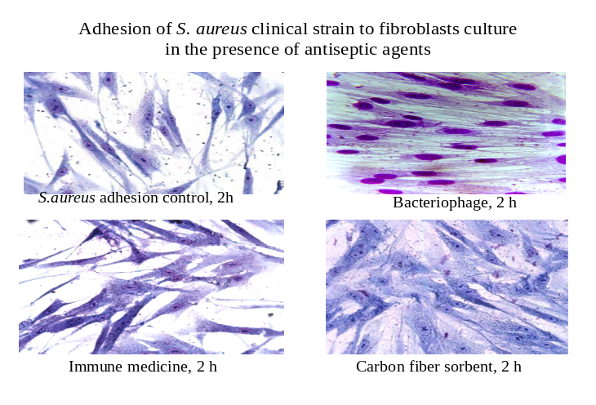Recent Publications (If any)
- Afinogenova A.G., Kraeva L.A., Afinogenov G.E., Veretennikov V.V. Probiotic-based sanitation as alternatives to chemical disinfectants. Russian Journal of Infection and Immunity. 2017;7(4):419-424. (In Russ.) https://doi.org/10.15789/2220-7619-2017-4-419-424.

Biography (150 word limit)
Anna G. Afinogenova is a pharmacist, microbiologist, doctor of biological science since 2011, specialized in clinical microbiology. She is the head of laboratorial centre of St. Petersburg Pasteur Institute, professor of St. Petersburg State University. She has published more than 30 papers in profile journals, has got 17 patents. She is the member of EWMA since 2010.
Email:
spbtestcenter@mail.ru

Notes/Comments:

*Photograph of presenting author, Biography and image related to the presentation are mandatory.

