Tuberculosis of the Stomach, Diagnostic Role of Endoscopic Cytology
Case Report and Review of Literature

Nabeel Shamsan¹, Yahia Elficki², Linah Faiz Faour³,Hadeel Ali AlQahtani³, Tammani Mohsen Alghamdi³ and Abdulraheem Fadel Alsadat³

¹ Consultant Gastroenterology King Abdulaziz Hospital, Jeddah, KSA.
² Consultant Internal Medicine King Abdulaziz Hospital, Jeddah, KSA.
³ Research Assistant and Coordinator at King Abdulaziz Hospital, Jeddah, KSA.
profelficki@yahoo.com

Abstract: Gastric tuberculosis is an uncommon site of extra-pulmonary tuberculosis infection; clinically gastric tuberculosis resembles peptic ulcer disease or less likely a gastric malignant growth. We report a case of an endoscopic large gastric mass in an HIV negative immunocompetent male patient secondary to pulmonary tuberculosis presented with severe chronic abdominal pain and vomiting found to have a large tuberculoma at the fundus of the stomach, follow up endoscopy after 12 month of antituberculous treatment showed remnants of fibrotic bands with complete recovery of the patient from his pulmonary as well as the extra pulmonary gastric TB. This case report highlight the utility of endoscopic brush smears in the diagnosis of tuberculosis in clinically suspected cases and necessity of application of Z-N stain smear on endoscopic brush cytology as a reliable and simple modality for the diagnosis of gastric tuberculosis .
[Nabeel Shamsan, Yehya Alficki, Linah Faiz Faour, Hadeel Ali AlQahtani, Tammani Mohsen Alghamdi and Abdulraheem Fadel Alsadat. Tuberculosis of The Stomach, Diagnostic Role of Endoscopic Cytology, Case Report and Review of Literature] J Am Sci.2017;13(X):X-X]. ISSN 1545-1003 (print); ISSN 2375-7264 (online).http://www.jofamericanscience.org

Key words: Gastrodudenal TB, Endoscopic Brush cytology, Z-N Stain.

Introduction
Extra-pulmonary tuberculosis accounts for 10-15% of all cases of tuberculosis and the incidence reaches higher in immunocompromised patients (1).
Gastro-intestinal tract is the sixth most frequent extra-pulmonary site involved by tuberculosis, and ileocecal region is the most common site of involvement in gastro-intestinal tract tuberculosis(2).Gastro-duodenal or isolated gastric tuberculosis is rare even in parts of the world where intestinal tuberculosis is more endemic such as India where gastric and gastro-duodenal tuberculosis is around 1%, and 0.2% respectively, on routine gastric biopsies(3).However, through the last decades surveys and epidemiology studies has shown marked increase in the frequency of gastric tuberculosis up to 4.5% in individuals with moderate pulmonary disease and up to 25% in those with severe disseminated disease(5).Role of upper endoscopic brush cytology and biopsy in diagnosis of gastric TB remains reliable and simple modality only when samples obtained are requested by the endoscopists for Acid fast Bacilli Z-N stain and Lewenstien-jenssen culture for TB (23).
Case report:
A 42 years old male patient known case of untreated chronic active hepatitis virus C was referred from Gastroenterology outpatient clinic and admitted through the ER department with a history of persistent vomiting, chronic diarrhea ,weight loss about 17 kilograms , night fever, night sweat ,anorexia , productive cough, pleuritic chest pain and excessive dyspnea for more than 4 months. There was a history of contact with his brother a known TB patient, and a long history of smoking and occasional alcohol drinking. The patient was admitted to our department and isolated as a case of a suspected TB versus malignancy.
On physical examination, he was pale and emaciated with body mass index 19, no palpable lymph nodes could be felt . A clinical examination of the chest showed bilateral equal air entry, bilateral basal dullness and fine basal crackles, normal heart sounds. An Arterial Blood Gas sample (ABG) sp O₂ 100%, PH 7.44, PCO₂ 42., HCO₃ 29. The patient was non-diabetic and sero-negative for HIV. Four Sputum samples for AFB were negative . His hemoglobin level was 11.6 mg/dl and the erythrocyte sedimentation rate (ESR) was 112 mm. The total leukocytic count was 10.35 k/uL neutrophil 66.3%, lymphocytes 21.1%, and monocytes 9.96%. His total bilirubin was a normal 8.8 mmol/L and ALT 15 U/L. albumin of 15 U/L. His coagulation profile and renal function tests were normal. His coagulation profile , renal and thyroid function tests were normal.
The tumor markers were investigated and the results were within normal ranges CA19-9 3.59 U/ml, CEA 2.62 ng/mL and Alpha Feto Protein ( AFP) 0.62 ng/mL.
Autoimmune profile was also negative for ANA, Anti double strands DNA, Total and cANCA, Rheumatoid factor and anti smooth muscle antibodies.
X-ray chest and high resolution chest CT revealed bilateral basal pleural effusion and hilar adenopathy, abdominal ultrasound showed mild splenomegaly, mild ascites and bilateral pleural effusion, Abdominal cat scan with contrast showed paraaotic lymphadenopathy and mild ascites. Ultrasound guided Pleural and ascetic diagnostic tapping had confirmed the exudative pattern of fluids with relatively high proteins and LDH but cytology and microbiology studies of the obtained samples were not conclusive for either malignancy or TB. Due to his persistent vomiting and diarrhea colonoscopy was arranged and biopsies from terminal ileum were unremarkable at histopathology studies.
Eventually, Upper Endoscopy at day 3 of admission ( due to persistent vomiting) was arranged and revealed: Normal esophagus with no evidence of varices. In the stomach there was a mass in the fundal area smooth surface, around 4x6 cm with deep small ulcer in the center. Duodenum was normal down to the second part Figure (1a,1b) Brush cytology and multiple specimens were obtained from the Hypertrophied (edematous) gastric folds and the fundal mass ,biopsy report revealed fragments of gastric mucosa mixed with suppurative inflammation, and focal area of necrosis: an ulcerative slough with granulomatous tissue and granulomatous reaction with few multinucleated giant cells, upon endoscopist request Z-N stain for AFB was done and acid fast bacilli were clearly visualized microscopically ,confirming the diagnosis of TB .
The patient was started on antituberculous treatment regimen consisting of isoniazide, rifampicin, ethambutol and pyrizinamide for two months followed by isoniazide and rifampicin for another 9 months. with dramatic improvement of all his symptoms gaining weight and recovery of all clinical and lab inflammatory markers .
Follow up endoscopy after 12 month revealed normal upper GI findings apart from 2 to 3cm fine streaks of fibrotic bands deep in the fundal gastric mucosal folds and disappearance of the gastric mass (Figure2).

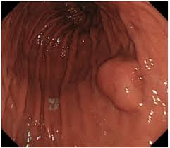
(A)
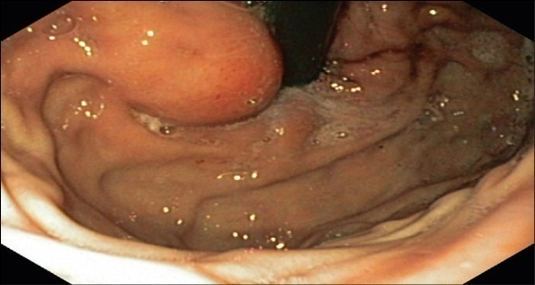
(B)
Figure (1)
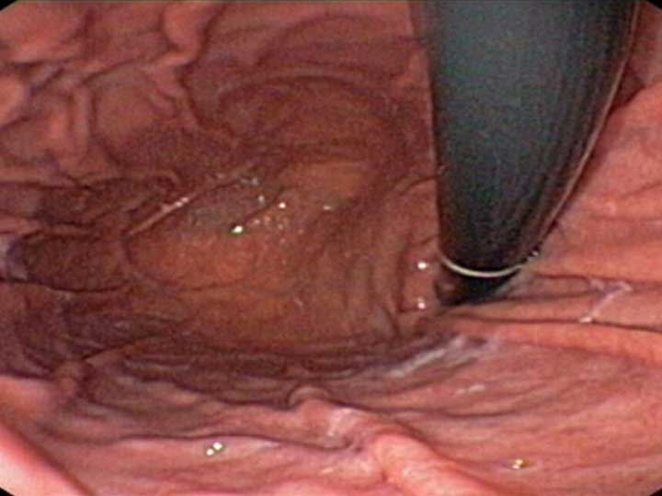
Figure (2)

Discussion:
Abdominal TB is defined as infection of the peritoneum, hollow or solid abdominal organs with mycobacterium tuberculin [1]. The natural course of intestinal TB follows three patterns: ulcerative, hypertrophic, or ulcero-hypertrophic. In the ulcerative form, transverse ulcer occurs perpendicular to the bowel axis and may bleed, perforate, or form fistulas[2]. The gastric tract is an uncommon site of extra pulmonary tuberculosis infection [3]. Gastric tuberculosis is rare because of the presence of gastric acid, the continuous motor activity of the stomach, and the scarcity of lymphatic follicles in the gastric wall [4]. Commonest site for intra-abdominal tuberculosis is the ileocecal region.[5] Involvement of stomach is considered to be rare. Usually gastric tuberculosis is secondary to pulmonary tuberculosis. [6] Primary and isolated gastric tuberculosis without evidence of lesions elsewhere is uncommon. [7] The reason for relative rarity is attributed to bactericidal property of gastric acid, scarcity of lymphoid tissue in gastric wall and intact gastric mucosa of the stomach. Although abdominal TB can develop at any age, it is most common in patients between 25 and 45 years of age and females slightly predominate [8]. Patients with gastroduodenal TB can present with obstruction or mass and an endoscopic biopsy has a poor yield [9]. Gastric lesions typically cause dyspeptic complaints, and generally, peptic ulcer is suspected. If the patient has lost weight, in addition to these complaints, gastric cancer should be considered first [10]. Commonly those patients mimic peptic ulcer disease or malignancy but at times clinical presentation may be misleading [11] Reported two patients of gastric tuberculosis with unusual presentations. One of those two patients was elderly man suspected to have abdominal malignancy but subsequently found to be extensive, complicated gastric tuberculosis coexisting with chronic peptic ulcer disease. The second patient was female who developed gastro-bronchial fistula due to tuberculosis, which was evident radiologically. Another report by Chetri et al has shown a case of gastric tuberculosis presenting as non-healing gastric ulcer[12]. Gastric tuberculosis is usually associated with an immunodeficient state [13]. Another study showed that long-term therapy with H2 blockers increases the incidence of gastroduodenal TB [14]. The diagnosis of gastric tuberculosis can only be made by histological study of the resected stomach or of a biopsy specimen of this organ. Endoscopic brush cytology and biopsy is only occasionally successful in diagnosis [15]. Submucosal location of the lesion has been cited as a reason for failure of endoscopic biopsies [16,17]. The diagnosis of tuberculosis also requires demonstration of caseating epitheloid granuloma or presence of acid-fast bacilli in tissue. When granulomas are non-caseating, small and discrete, the differential diagnosis on histology includes Crohn's disease, sarcoidosis, syphilis, mycotic lesions and exposure to beryllium, silicates or reserpine[18, 19].
In our case study, many lesions had been suspected and investigated accordingly. Endoscopic biopsy showed fragments of gastric mucosa at the fundus of the stomach, mixed with suppurative inflammation, scattered multinucleated giant cell reaction with areas of activity and necrosis consistent with tuberculosis and acid fast bacilli had been seen. However, sputum acid-fast bacilli was negative. The results showed no evidence of atypical cellularity or malignancy. In five previously reported cases of gastric perforation, four were diagnosed with TB by the presence of acid-fast bacilli on gastric biopsy or the presence of lymph nodes with caseating necrosis [20, 21, 22]. Similar to our case, one of the reported cases in this review had nonspecific inflammation on gastric biopsy. The diagnosis of tuberculosis was done on histopathological examination showing caseating epitheloid cell granulomas. After considering alternative diagnosis, gastric tuberculosis remains the most likely one. However , endoscopic brush smears in favor of definitive and rapid diagnosis of gastric tuberculosis still relies on Z-N stain smear and direct visualization of the acid fast bacilli microscopically (26). Further work up by the lewenstien –jenssen culture might be needed if Z-N Stain specimens were negative and histopathology results are suggestive of granulomatous reaction and /or central necrosis of the granulomas
Antituberculous treatment is the mainstay of therapy of uncomplicated infection diagnosed by endoscopic biopsy [23]. In our patient, he was treated successfully and discharged on anti TB medications. He had been followed up for two years and only some remnants of fibrotic streaks at the gastric mucosal folds of the fundus and the body of the stomach been visualized through his routine endoscopic follow up.
As been mentioned in most pathology literature that hypertrophic granulomatous TB of the gastrointestinal tract is less likely to be followed by surgical complications like strictures , obstruction or perforation than the TB ulcerative pattern of involvement(17). Role of acid suppressors like H2 blockers or proton pump inhibitors in dissemination of TB lesions to the gastric wall is not well established, and hence their use concomitantly (when needed to relieve ulcer and/or non-ulcer dyspepsia)before or during the course of treatment of TB is still debatable and further studies are needed to address their exact implication in stomach involvement with TB(23).
Our case study proved again that the hallmark for diagnosis of gastric TB relied on the endoscopists requests for pattern of studies needed to the collected specimens through the endoscopy procedure , since Z-N satin for AFB and L-j culture are not part of the routine cytology work up on specimens obtained endoscopically from the gastrointestinal tract.

Conclusion:
Endoscopic brush cytology is a reliable modality for the diagnosis of gastric tuberculosis only when cytology study is directed towards assessment for TB by the endoscopists.

References
- Tariq Al Fawaz, Fahad Al Zamil, Abdulrahman Al Mazrou (2010) Abdominal tuberculosis in children-Case Report. CurrPediatr Res 14: 106-107.
- 2.Wang D, Zhang JJ, Huang HF, Shen K, Cui QC, Xiang Y( 2012) Comparison between peritoneal tuberculosis and primary peritoneal carcinoma: a 16-year, single-center experience. Chin Med J (Engl) 18: 3256-3260
- Gupta B, Mathew S, Bhalla S (1990) Pyloric obstruction due to gastric tuberculosis: an endoscopic diagnosis. Postgrad Med J 66: 63-65.
- Subei I, Attar B, Schmitt G, Levendoglu H (1987) Primary gastric tuberculosis: A case report and literature review. Am J Gastroenterol 82: 769-772.
- Abrams JS, Holden WD: Tuberculosis of gastrointestinal tract. Arch Surg. 1964, 89: 282-293.View ArticlePubMedGoogle Scholar
- Brody JM, Miller DK, Zeman RK, Klappenbach RS, Jaffe MH, Clark LR, Benjamin SB, Choyke PL: Gastric tuberculosis: A manifestations of acquired immunodeficiency syndrome. Radiology. 1986, 159: 347-348.View ArticlePubMedGoogle Scholar
- Subei I, Attar B, Schmitt G, Levendoglu H: Primary gastric tuberculosis: A case report and literature review. Am J Gastroenterol. 1987, 82: 769-772.PubMedGoogle Scholar
- Akgun Y. Intestinal and peritoneal tuberculosis: changing trends over 10 years and a review of 80 patients. Can J Surg. 2005;48(2):131–6. [PMC free article] [PubMed]
- Rao YG, Pande GK, Sahni P, Chattopadhyay TK. Gastroduodenal tuberculosis management guidelines, based on a large experience and a review of the literature. Can J Surg. 2004;47:364–8. [PMC free article][PubMed]
- CemEray İ, Rencüzoğulları A, Yalav O, et al. Primary gastric tuberculosis mimicking gastric cancer.UlusCerrahiDerg. 2015;31(3):177–179. [PMC free article] [PubMed]
- Okoro EO, Komolafe OF: Gastric tuberculosis: unusual presentations in two patients. ClinRadiol. 1999, 54: 257-9.View ArticlePubMedGoogle Scholar
- Chetri K, Prasad KK, Jain M, Choudhuri G: Gastric tuberculosis presenting as non-healing ulcer: case report. Trop Gastroenterol. 2000, 21: 180-1.PubMedGoogle Scholar
- Brody J.M., Miller D.K., Zeman R.K., et al. Gastric tuberculosis: A manifestations of acquired immunodeficiency syndrome. Radiology 1986; 159:347-8.
- Placido RD, Pietroletti R, Leardi S, Simi M. Primary gastroduodenal tuberculosis infection presenting as pyloric outlet obstruction. Am J Gastroenterol. 1996;91:807–8. [PubMed]
- Sharma B.L., Prasad H., Bhasin D.K., Singh K. Gastroduodenal Tuberculosis presenting with massive hematemesis in a pregnant woman. J ClinGastroenterol 2000;30: 336.
- Salpeter S.R., Shapiro R.M., Gasman J.D. Gastric tuberculosis presenting as fever of unknown origin. West J Med 1991;155:412-3.
- Kuganeswaran E., Smith O.J., Quiason S.G., et al. Both massive upper and lower gastrointestinal haemorrhage secondary to tuberculosis. Am J Gastroenterol 1998;94:271-2.
- Gupta B, Mathew S, Bhalla S: Pyloric obstruction due to gastric tuberculosis: An endoscopic diagnosis. Postgrad Med J. 1990, 66: 62-65.Google Scholar
- Petroianni A, Mugnaini L, Laurendi G, Giousue S, Schinina V, Bibbolino C, Bisetti A: Abdominal tuberculosis mimicking Crohn's disease: a difficult diagnosis. Report of a case. Panminerva Med. 2002, 44: 155-8.PubMedGoogle Scholar
- D. Sharma, A. Gupta, B. K. Jain et al., “Tuberculous gastric perforation: report of a case,” Surgery Today, vol. 34, no. 6, pp. 537–541, 2004. View at Publisher · View at Google Scholar · View at Scopus
- H. W. Ostrum and W. Serker, “Tuberculosis of stomach and duodenum,” American Journal of Roentgenology, vol. 60, pp. 315–322, 1948. View at Google Scholar
- P. Kossick, “Gastric tuberculosis,” South African Medical Journal, vol. 34, pp. 29–32, 1969. View at Google Scholar
- S. Jain, N. Kumar, and S. K. Jain, “Gastric tuberculosis: endoscopic cytology as a diagnostic tool,” ActaCytologica, vol. 44, no. 6, pp. 987–992, 2000. View at Google Scholar · View at Scopus

