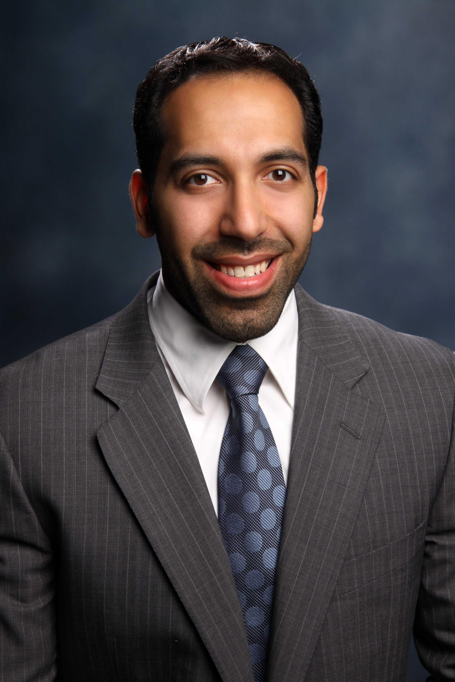
Physical Activity Levels, Swimming Ability, and Smoking Status among Kuwaiti Physical Education College Students

Department of Physical Education & Sports, College of Basic Education
Public Authority for Applied Education & Training, Kuwait.

Abstract

Introduction: Recent and comprehensive lifestyle data of Kuwaiti college age students is lacking. Purpose: The purpose of this study was to determine the prevalence of physical activity (PA) levels, swimming ability and smoking status among Kuwaiti physical education colleges students. Methods: A cross-sectional study was conducted on 418 randomly selected college students (198 males; and 220 females) aged 18-25 years from the College of Basic Education during the 2017 - 2018 academic year. Physical activity levels were assessed using the ATLS questionnaire and swimming ability and smoking status were assessed using Godin questionnaire. Anthropometric measurements included weight (kg), height (cm), body fat (%), and muscle mass (kg, using bioelectrical impedance analysis). Body mass index (BMI) was calculated using height and weight (kg/m²). Statistics: Independent t-tests were used to detect significant differences between the mean values of male and female students. Results: Male students had more muscle mass (39.1±4 kg vs. 25±4 kg) and were more physically active compared with females (645±40 vs. 443±56 min/week) (p<0.05). Body fat was greater in females (32±7%) compared with males (21±10%) (p<0.05). Both groups had similar mean (SD) BMI values (23.7±4 kg/m² vs. 23.1±3 kg/m² in males and females, respectively). Smoking prevalence was 45% in males and 7% in females. Three percent of males and 18% of females did not know how to swim. Conclusion: Male college students are more physically active compared with females. Smoking prevalence is high in male college students warranting increased education about the health effects of smoking in this population.

Biography
Mohammed Alkatan has completed his PhD at the age of 32 years from the University of Texas at Austin. He is an assistant professors at Public Authority for Applied Education & Training- Department of Physical Education & Sports. He has published more than 10 papers in reputed journals.

Presenting author details
Full name: Mohammed Alkatan
Contact number: +965 98700098
Category: (Oral presentation)

