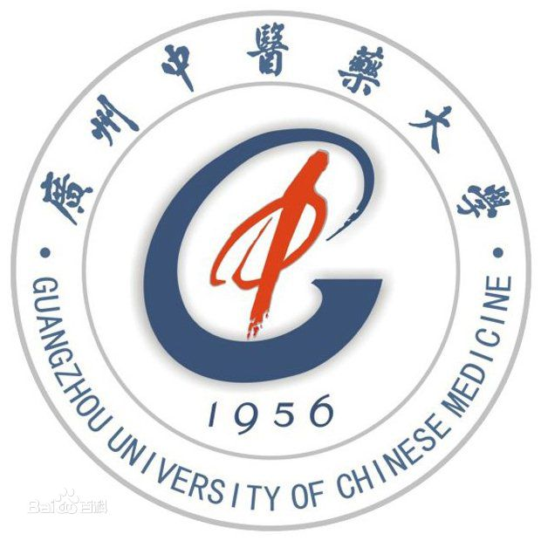


Official Photo University/Organization Logo

Study on Fuzhengkang’ai decoction in treating lung cancer
Sumei Wang, MD, PhD, Guangzhou University of Chinese Medicine, Guangzhou, China
Wanyin Wu, MD, PhD, Guangzhou University of Chinese Medicine, Guangzhou, China

Abstract (300 word limit)
Our previous clinical study has shown that Chinese herbal medicine (CHM) Fuzheng Kang-Ai (FZKA for short) decoction is effective in treating advanced lung cancer patients through prolonging the drug resistance to gefitinib. Our basic study found that FZKA decoction could enhance the inhibition effect of gefitinib in lung cancer by inactivating PI3K/Akt pathway. Moreover, our recent work showed that FZKA induced lung cancer cell apoptosis via STAT3/Bcl-2/Caspase-3 Pathway. Thus in this study, we aim to elucidate how FZKA enhances the effect of gefitinib in lung cancer from the perspective of cell apoptosis. Firstly, our results showed that FZKA enhanced the inhibition effect of gefitinib in lung cancer both in vitro and in vivo. Secondly, cell apoptosis was enhanced when treated lung cancer cells with both FZKA and gefitinib, especially in a mitochondrial way. And Bcl-2 family was involved in this process. Interestingly, STAT3 plays a critical role on mediating the above process. Last but not the least, the enhanced effect of cell apoptosis induction of gefitinib by FZKA was validated in animal model. All in all, our findings conclude that Fuzheng Kang-Ai decoction enhances the effect of Gefitinib-induced cell apoptosis in lung cancer through mitochondrial pathway. Our study provides a novel molecular mechanism by which FZKA prolongs the drug resistance to gefitinib in treating lung cancer patients. (Up to 250 words)

Key words: lung cancer, Fuzhengkang’ai decoction, Gefitinib, drug resistance, Chinese Herbal Medicine,

Image
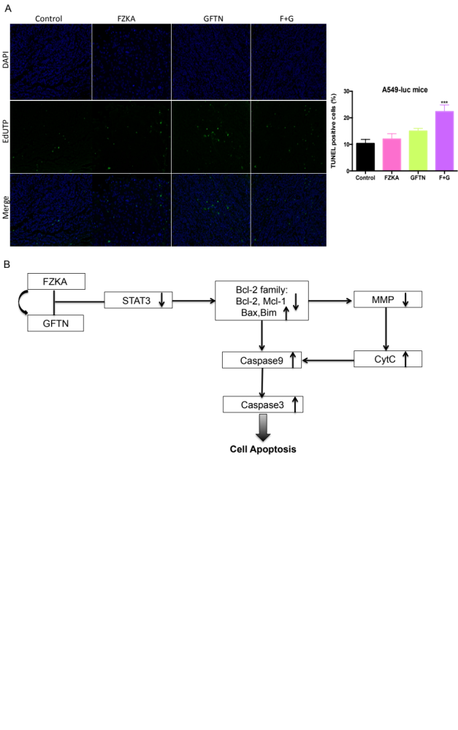
Recent Publications (minimum 5)
- Wang S#*, Pan Y#, Zhang R#, Xu T, Wu Y, Wang C, Huang H, Yang H* and Claret FX*. Hsa-miR-24-3p Increases Nasopharyngeal Carcinoma Radiosensitivity by Targeting Both the 3’UTR and 5’UTR of Jab1/ CSN5. Oncogene. 2016 Nov 24;35(47):6096-6108. doi: 10.1038/onc.2016.147.
- Wang S#*, Oh D#, Leventaki V, Drakos E, Zhang R, Sahin A, Resetkova E, Edgerton M, Wu W*, Claret FX*. MicroRNA-17 Acts as a Tumor Chemosensitizer by Targeting JAB1/CSN5 in Triple-Negative Breast Cancer. Cancer Lett. 2019 Aug 29;465:12-23. doi: 10.1016/j.canlet.2019.08.016.
- Wang S, Zhang R, Claret FX and Yang H. Involvement of microRNA-24 and DNA methylation in resistance of nasopharyngeal carcinoma to ionizing radiation. Molecular Cancer Therapeutics, 2014 Dec; 13(12):3163-74. doi: 10.1158/1535-7163.
- Wang S*, Wu W and Claret FX. Mutual regulation of microRNAs and DNA methylation in human cancers. Epigenetics. 2017 Mar 4;12(3):187-197. doi: 10.1080/15592294.2016.1273308.
- Wang S*, Claret FX, Wanyin Wu*. MicroRNAs as therapeutic targets in nasopharyngeal carcinoma. Frontiers in Oncology, 2019 Aug 13; 9: 756. doi: 10.3389/ fonc.2019.00756.

Biography
Sumei Wang was graduated from Sun-Yet Sun University and University of Texas MD Anderson Cancer Center. She has been studying oncology for more than 10 years and now is working on how Traditional Chinese Medicine treats human cancer and epigenetic alterations in cancers. She has published more than 30 papers in reputed journals and has been serving as reviewers for many SCI journals including Oncogene, Cancer Biology & Medicine, and Cancer Cell International and etc.

Presenting author details
Sumei Wang (As per the passport):
Department of Oncology, The second affiliated Hospital of Guangzhou University of Chinese Medicine
Associate Professor
Country:China
Mobile number (country code – number) : 86-18820028744
Email: wangsumei198708@163.com
Track number: https://infectionprevention.insightconferences.com/abstract-submission.php (For track number follow this link)
Category: Oral presentation
Research interest: Epigenetic modulations in human cancer and TCM treating human cancer
Your profile page URL in your department:
Year of birth: 1987
Linked In/Facebook/twitter account: no

Note: Please fill up the Red mark fields so that it would be easier for us to cite your details in the conference particulars. (Please do not forget to fix your photo and Logo above the title)

