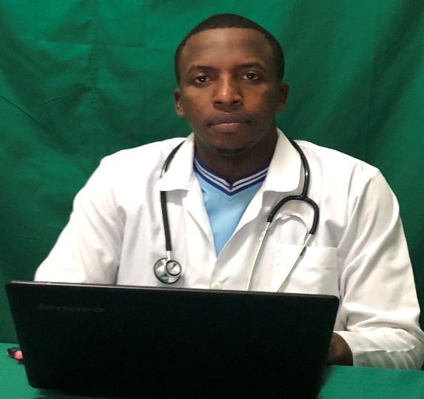
Title: Infection Prevention and control bundles in low to middle income countries
Name: Dr NGENDAHAYO KIBINGIRA Destin

Medical officer in united Nations Multidimensional Integrated stabilization Mission in the Central African Republic (MINUSCA)

ABASTRACT

Background : Healthcare associated infection (HAI) prevention /control bundles are currently recommended to reduce Healthcare associated infection burdens, although implementation in low-to-middle income countries (LMICs) may be difficult due to resources limitation.
This survey will determine the status of infection prevention/ control (IPC) bundle practice and most frequent interventional variables in low-to-middle income countries (LMICs).
Methods:
A questionnaire will be emailed to Infectious Diseases International Research Initiative (ID-IRI) Group Members and dedicated IPC doctors working in LMICs to examine self-reported practices/policies regarding IPC bundles.
Responding country incomes will be classified by World Bank definitions into low, middle and high, comparing low-to-middle income countries with a control group of high income countries.

Biography

Dr NGENDAHAYO KIBINGIRA Destin completed his master’s in public health at Atlantic Intenational universty, Honolulu, HI 96813 , USA.
Completed also Bachelor degree in general medecine at Goma University, Democratic republic of Congo .
From 2017-2020: general practitioner in RWANDA, at Ruhango Provincial Hospital, Appointed as Medical Doctor in charge of IPC ( Infection prevention and control ) and Hepatitis treatment in this hospital .
Currently senior medical officer in MINUSCA.
Dr Destin Published many articles and thesis such as :
“ the Role of vaccination in the economic growth of africa”
“The contribution of Health insurance in the development of Rwanda”

Presenting author
Full name: NGENDAHAYO KIBINGIRA Destin
Contact number: +23672514106/ +250785609675
Twitter account: @Ngendak1
Linked In account: ngenda Destin
Session name/ number:
Category: Oral presentation / physical conference

