MMP-9 – the prominent mediator of neurological damage in tuberculous meningitis
S majeedª, , S Sharma^{b*}, B.D.Radotra^{c}, P Singh^{d}, N Sharma^{e}
a:Department of advanced centre for human genetics, SKIMS,Srinagar,J&K,India,b: Lab 334, Department of Biochemistry, PGIMER, Chandigarh, -160012 India
c : Department of Histopathology, PGIMER d. Department of Neurology, PGIMER e. Department of Internal Medicine, PGIMER
Correspondence :
Professor Sadhna Sharma
Dept of Biochemistry
PGIMER, Chandigarh -160012 (India)
Phone : 91-0172-2755180
Fax: 91-0172-2745078, 2744401
Email: sadhnabiochem@gmail.com

TBM (Tuberculous meningitis) is severe form of tuberculosis causing death of one third of the affected individuals or leaving two-third of the survivors disabled[1]. The main cause of disabilities and death is the neurological destruction mainly caused by immense inflammatory response.[2] MMP-9 (Matrix metalloproteinase-9) is produced by the central nervous system in a variety of inflammatory conditions and has a role in the breakdown of extracellular matrix and blood–brain barrier. [3].Moreover, the correlation between tuberculosis infection and MMP-9 is an earlier known fact.[4, 5] Methodology & Theoretical Orientation: This study was designed to evaluate the role of MMP-9 in advancement of TBM and therapeutic role of targeting MMP-9 against TBM. In this study, the levels of MMP-9 and its inhibitor, TIMP-1(tissue inhibitor of metalloproteinases-1), were screened using zymography and reverse zymography in cerebrospinal fluid and serum of tuberculous meningitis patients at different stages of the disease. Further, role of MMP-9 as therapeutic target was studied in C6 glioma cells and mouse model of TBM infected with Mycobacterium tuberculosis H₃₇Rv. Infected cells and mice were treated with dexamethasone or SB-3CT (specific inhibitor of MMP-9) in combination with conventional antitubercular drugs. Findings: MMP-9 levels in patients were increased as the disease progressed to advanced stages. The infection lead to increased MMP-9 levels in C6 glioma cells and mice. The specific inhibition of MMP-9 by SB-3CT augmented bacillary clearance when used along with antitubercular drugs in both infected C6 glioma cells and mice model of TBM.
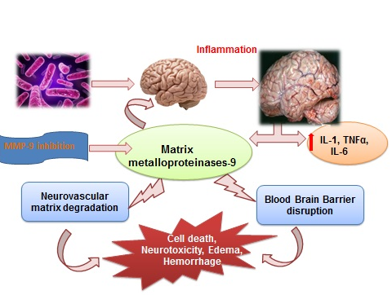

1. Rohlwink, U.K., et al., Biomarkers of cerebral injury and inflammation in pediatric tuberculous meningitis. Clin Infect Dis, 2017.
2. van Laarhoven, A., et al., Clinical Parameters, Routine Inflammatory Markers, and LTA4H Genotype as Predictors of Mortality Among 608 Patients With Tuberculous Meningitis in Indonesia. J Infect Dis, 2017. 215(7): p. 1029-1039.
3. Chen, K.M., et al., Association of plasminogen activators and matrix metalloproteinase-9 proteolytic cascade with blood-CNS barrier damage of angiostrongyliasis. Int J Exp Pathol, 2006. 87(2): p. 113-9.
4. Harris, J.E., et al., Monocytes infected with Mycobacterium tuberculosis regulate MAP kinase-dependent astrocyte MMP-9 secretion. J Leukoc Biol, 2007. 81(2): p. 548-56.
5. Rivera-Marrero, C.A., et al., M. tuberculosis induction of matrix metalloproteinase-9: the role of mannose and receptor-mediated mechanisms. Am J Physiol Lung Cell Mol Physiol, 2002. 282(3): p. L546-55.

