Spread of M. chimaera in Cardiac Surgery Operating Room in Quebec: WGS and RT-PCR for Outbreak Investigation and management
Hafid Soualhine, PhD, Laboratoire de santé publique du Quebec - and McGill international TB centre, Montreal, Quebec - Canada,
Christine Martineau, PhD, Laboratoire de sante publique du Quebec- Montréal, Quebec - Canada
Kym Antonation, PhD, National Microbiology Laboratory, Public Health Agency of Canada, Winnipeg, Manitoba Canada

Abstract
Mycobacterium chimaera outbreaks affecting patients subjected to open-chest heart surgery have been reported worldwide and associated with a high case fatality rate, reinforcing the need for strongly coordinated surveillance and outbreak control.
The ECDC, Health Canada, the U.S. Centers for Disease Control and Prevention (CDC) and others issued warnings regarding the potential risk of infection with M. chimaera for patients underwent open-heart surgery since 2012. The public health reference laboratory in Quebec undertook a laboratory active surveillance screening of all sterile site samples collected from patients presenting with M. chimaera -positive results between 2010 and 2016. The surveillance of environmental and clinical cases was extended to the nine busiest cardiac surgery centers in Quebec.
In this study, we attempted to determine the source of M. chimaera infection by establishing a molecular link between patients (n=7) and environmental strains (n=32). We developed a genome-wide strain genotyping approach and investigated the relatedness of M. chimaera isolates from patients and heat-cooler units (HCUs) from different geographical locations in Quebec. Four clinical isolates were associated to the European outbreak. We also implemented a new rapid molecular test based on quantitative real-time PCR targeting the ITS regions. This allowed us to detect rapidly the presence of M. chimaera in water samples and compare results with culture, follow up the bacterial burden in 26 contaminated HCUs.
In conclusion, four patients infected with M. chimaera during cardiac surgery were related to one site in Montreal and were associated to the worldwide outbreak. Moreover RT-PCR allowed us to monitor and follow up the contamination in HCU in operating rooms.

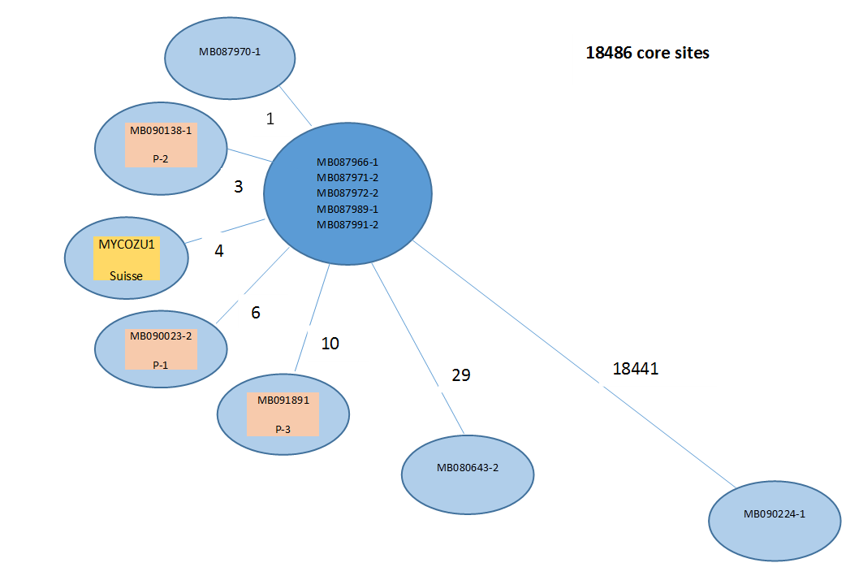
Figure: Whole genome sequence phylogeny, patients and HCUs isolates in one Canadian site
Recent publications
1. Sax H, Bloemberg G, Hasse B, Sommerstein R, Kohler P, et al. (2015) Prolonged Outbreak of Mycobacterium chimaera Infection After Open-Chest Heart Surgery. Clin Infect Dis 61: 67-75.
2. Sommerstein R, Ruegg C, Kohler P, Bloemberg G, Kuster SP, et al. (2016) Transmission of Mycobacterium chimaera from Heater-Cooler Units during Cardiac Surgery despite an Ultraclean Air Ventilation System. Emerg Infect Dis 22: 1008-1013.
3. Kohler P, Kuster SP, Bloemberg G, Schulthess B, Frank M, et al. (2015) Healthcare-associated prosthetic heart valve, aortic vascular graft, and disseminated Mycobacterium chimaera infections subsequent to open heart surgery. Eur Heart J 36: 2745-2753.
4 (PHE). PHE Investigation of Mycobacterium chimaera infection associated with cardiopulmonary bypass 2015 [cited 2015 30 April]. . Available from: https://wwwgovuk/government/publications/health-protection-report-volume-9-2015/hpr-volume-9-issue-15-news-30-april.
5. (ECDC). ECfDPaC (2015) Invasive cardiovascular infection by Mycobacterium chimaera- 30 April 2015. Available from: http://ecdc.europa.eu/en/publications/publications/mycobacterium-chimaera-infection-associated-with-heater-cooler-units-rapid-risk-assessment-30-april-2015.pdf.
6. Perkins KM, Lawsin A, Hasan NA, Strong M, Halpin AL, et al. (2016) Notes from the Field: Mycobacterium chimaera Contamination of Heater-Cooler Devices Used in Cardiac Surgery - United States. MMWR Morb Mortal Wkly Rep 65: 1117-1118.



Biography
Dr Soualhine has extensive experience in reference diagnosis of TB and mycobacteria, He did post-doctoral fellowss in France on genome sequencing, in Quebec on genomic and proteomic of drug resistance and at UBC on development of new recombinant BCG vaccine. His research career has been devoted to antimicrobial resistance in M. tuberculosis. He is interested in mycobacterial pathogenicity, molecular methods for rapid characterization and genotyping with special interest in Crohn’s disease and cystic fibrosis.
Email: hafid.soualhine@inspq.qc.ca

Notes/Comments:
The results of this study is not published or publically communicated yet.
Preliminary results and analysis will be presented during this talk.

