Characterization of phosphate transporter(s) and understanding their role in Leishmania donovani parasite
A.K. Rai, Department of Biotechnology, Motilal Nehru National Institute of Technology, Allahabad-211004, U.P., India.
K.J. Sindhu, Department of Biotechnology, Motilal Nehru National Institute of Technology, Allahabad-211004, U.P., India.
A. K. Kureel, Department of Biotechnology, Motilal Nehru National Institute of Technology, Allahabad-211004, U.P., India.
S. Saini, Department of Biotechnology, Motilal Nehru National Institute of Technology, Allahabad-211004, U.P., India.
S. Kumari, Department of Biotechnology, Motilal Nehru National Institute of Technology, Allahabad-211004, U.P., India.
P. Verma, Department of Biotechnology, Motilal Nehru National Institute of Technology, Allahabad-211004, U.P., India.

Abstract
Statement of the Problem: Inorganic phosphate (Pi) is shown to be involved in excretion of methylglyoxal (MG) in the promastigote form of Leishmania donovani parasite. Absence of Pi leads to its accumulation inside the parasite. Accumulation of MG is toxic to the parasite and utilizes glyoxylase as well as excretory pathways for its detoxification. In addition, Pi is also reported to regulate activities of ectoenzymes and energy metabolism (glucose pyruvate) etc. Thus, it cumulatively affects growth of the parasite. Therefore, the transporters which allow the movement of Pi across the membrane can prove to be a crucial drug target. Methodology & Theoretical Orientation: Bioinformatics analysis approach was applied to identify the phosphate transporters in L. donovani. Phylogenetic analysis as well as secondary structure prediction was performed for its characterization. We tried to understand the secondary structure of these two proteins and confirm modulation in their expression with the change in Pi concentration outside. We also tried to detect the expression quantitatively in a log phase culture of promastigotes and under various physiological conditions. Moreover, their modes of action were also measured in presence of different inhibitors (LiF, CCCP). Findings: We first characterized two phosphate transporters in Leishmania i) H+ dependent myo-inositol transporter PHO84, and ii) Na+ dependent transporter PHO89) based on similar studies done previously on other lower organisms and trypanosomatids. We found significantly higher expression of H⁺ dependent transporter (LdPHO84) as compared to Na⁺ dependent transporter (LdPHO89). We also inhibited the Na+ as well as H+ gradient and then confirmed their involvement in the Pi transport across the membrane. Conclusion & Significance: We thus functionally characterized two Phosphate transporters of L.donovani and its regulation by extracellular Pi for the first time. These computational results offer the possibility of identifying novel compounds which inhibit the transport of Pi across the membrane.
Image

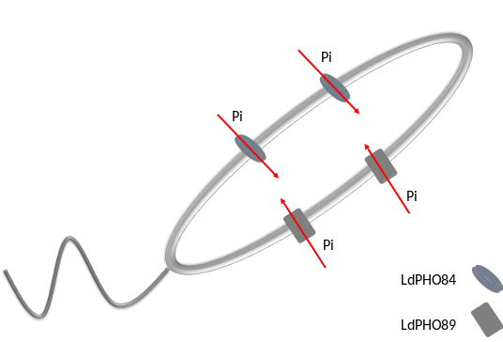
Recent publications
- Tiwari P, Verma P, Kureel AK, Saini S, Rai AK. Pi inhibits intracellular accumulation of methylglyoxal in promastigote form of L. donovani. Mol Biochem Parasitol. 2016;207:89-95.
- Lamarche MG, Wanner BL, Crepin S, Harel J. The phosphate regulon and bacterial virulence: a regulatory network connecting phosphate homeostasis and pathogenesis. FEMS Microbiol Rev. 2008;32:461-73.
- Burns DJ, Beever RE. Kinetic characterization of the two phosphate uptake systems in the fungus Neurospora crassa. J Bacteriol. 1977;132:511-9.
- Oshima Y. The phosphatase system in Saccharomyces cerevisiae. Genes Genet Syst. 1997;72:323-34.
- Rosenberg H, Gerdes RG, Chegwidden K. Two systems for the uptake of phosphate in Escherichia coli. J Bacteriol. 1977;131:505-11.


Biography
Ambak Kumar Rai is assistant professor in department of biotechnology of Motilal Nehru National Institute of Technology (MNNIT) Allahabad India. MNNIT is a premier institute of national importance in India. He has his expertise in understanding the molecular and biochemical aspects of drug resistance in Leishmania donovani. A detailed approach to understand the drug unresponsiveness offers new possibilities for therapeutic advancement. He is also inclined to understand the Immuno-regulatory aspects of Leishmania pathogenesis. Email: ambakrai@mnnit.ac.in

