Early versus Late Antiretroviral Therapy In Decreasing the Incidence of Paradoxical Immune Reconstitution Inflammatory Syndrome (IRIS) Among Adolescent and Adult Patients with HIV-Tuberculosis: A Meta-analysis
Christoper John N. Tibayan, MD, Ospital ng Makati, Philippines
Emmanuel Surposa, MD, Ospital ng Makati, Philippines

RESEARCH QUESTION Among Patients with HIV-Tuberculosis, how effective is Late Initiation of Antiretroviral Therapy compared to Early Initiation of Antiretroviral Therapy following anti Koch’s regimen in decreasing the Incidence of Paradoxical Immune Reconstitution Inflammatory Syndrome (IRIS)? BACKGROUND IRIS is defined as a worsening of existing lesions or presentation of new lesions during treatment of an opportunistic infection most frequently seen among patients on anti Koch’s regimen. Randomized controlled trials showed that delaying initiation of antiretroviral treatment for about 4 weeks or more after starting anti Koch’s regimen showed a decreased incidence of IRIS among HIV patients with concomitant tuberculosis. OBJECTIVE This meta analysis aims to compare the effects of Late Initiation of Antiretroviral Therapy with Early Initiation of Antiretroviral Therapy following anti Koch’s regimen among patients with HIV-Tuberculosis co-infection with primary outcome measured as Paradoxical TB-IRIS. MATERIALS & METHODS Online databases were used to search for randomized controlled trials published from January 2010 to June 2015. Review Manager 5.3 was used for to compute for the total odds ratios for both interventions using a fixed-effects model with 95% confidence interval. RESULTS Seven randomized controlled trials were included. Late Initiation of antiretroviral therapy (>4 weeks following initiation of anti Koch’s regimen) among patients with HIV-Tuberculosis is associated with lower odds of developing Paradoxical TB-IRIS (OR: 0.54 at 95% Confidence Interval, p <0.00001). CONCLUSION Late Initiation of Antiretroviral Therapy following standard anti Koch ’s regimen is associated with lower odds of developing Paradoxical TB-IRIS, however has been associated with increase in overall mortality as compared with mortality associated with Paradoxical IRIS. Baseline CD4+ cell counts <50/ul has been identified as an independent risk factor for both mortality and development of Paradoxical TB-IRIS. A larger study population and elimination of probable confounding variables are recommended in future researches.

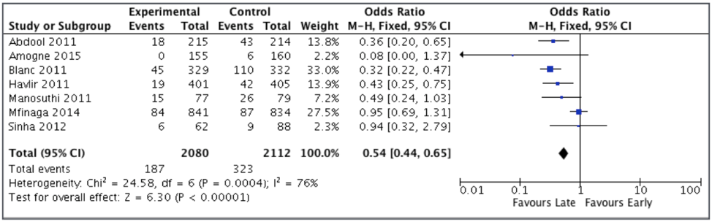
Figure 1: Forrest Plot of Comparison of Late versus Early Initiation of Antiretroviral Therapy Following Anti Koch Regimen

References
- Abdool Karim, Salim, et.al. (2011). Immune Reconstitution Inflammatory Syndrome following Antiretroviral Therapy Initiation In Tuberculosis Patients: SAPiT Trial. N Eng Journal of Medicine
- Amogne, Wondwossen, et.al. (2015). Efficicy and Safety of Antiretorviral Therpay Initiated One Week after Tuberculosis Therapy in Patients with CD4 Counts <200 cells/uL: TB- HAART Study, a Randomized Clinical Trial. Public Library of Science
- Bell, Lucy, et.al. (2014) Paradoxical Reactions and Immune Reconstitution Inflammatory Syndrome in Tuberculosis. International Society for Infectious Diseases
- Blanc, Fracois Xavier, et.al. (2011). Earlier versus Late Start of Antiretroviral Therapy in HIV Infected Adults with Tuberculosis. The New England Journal of Medicine
- Bonnet, Maryline, et.al. (2013) Incidence of Paradoxical Tuberculosis-Associated Immune Reconstitution Inflammatory Syndrome and Impact on Patient Outcome, Journal, Public Library of Science: Prospective Cohort
- Havlir, D.V., et.al. (2011). Timing of Antiretroviral Therpay in HIV-1 Infection and Tuberculosis. N Eng Journal of Medicine
- Lai, Rachel, et.al. (2013). The Immunopathogenesis of the HIV Tuberculosis Immune Reconstitution Inflammatory Syndrome, European Journal on Immunology
- Manabe, Yukari, et.al. (2009). Unmasked Tuberculosis and Tuberculosis Immune Reconstitution Inflammatory Disease: A Disease Spectrum after Initiation of Antiretroviral Therapy, Journal of Infectious Diseases
- Mansonuthi, Weewat, et.al. (2012). Time to Initiate Antiretroviral Therapy Between 4 and 12 Weeks of Tuberculosis Treatment in HIV Infected Patients: TIME Study. Journal on Acquired Immune Deficiency Syndrome
- Mfinaga, Sayoki, et.al. (2014). Early versus Delayed Initiation of Highly Active Antiretroviral Therpay for HIV- Positive Adults with Nwely diagnosed Pulmonary Tuberculosis (TB- HAART): A prospective, International, Randomised, Placebo Controlled Trial. The Lancet Journal
- McIlleron, Helen, et.al. (2007) Complications of Antiretroviral Therapy in Patients with Tuberculosis: Drug Interactions, Toxicity and Immune Reconstitution Inflammatory Syndrome, The Journal of Infectious Diseases
- Murthy, Anup, et.al. 2015 Treatment Guidelines and Prognosis of Immune Reconstitution Inflammatory Syndrome Patients: A Review, Journal of International Oral Health
- Sinha, Sanjeev, et.al. (2012). Early versus Delayed Initiation of Antiretroviral Therpay for Indian HIV-Infected Individuals with Tuberculosis on Antitiberculosis Treatment. BMC Infectious Disease
- Walker, Naomi, et.al. (2015) Immune Reconstitution Inflammatory Syndrome in HIV Infected Patients, HIV/AIDS Research and Palliative Care
- Zhou, Yang et.al., (2014) Analysis of Tuberculosis Associated Immune Reconstitution Inflammatory Syndrome in HIV/TB Co Infected Patients During HAART. Infection International

Biography

Christoper John N. Tibayan, RMT, MD is a Second Year Internal Medicine Resident at Ospital ng Makati, Makati City Philippines
Email: cjntibayanmd@gmail.com

