Preparation of ion exchangers based on prepared bacterial cellulose for Removal of Cu⁺⁺, Zn⁺⁺, Hg⁺⁺ from wastewater
S. Farag¹, H. M. Ibrahim¹, A.Amr¹ and M. S Asker², A. El-Shafaee¹
¹Textile Research Division, National Research Center, Cairo, Egypt
²Microbial Research Division, National Research Center, Cairo, Egypt

Abstract:
Herin we prepared BC as ion exchanger to be used in pollution prevention via Preparation of bacterial cellulose using Egyptian bacteria isolated in our laboratory from rotten apple, Preparation of ion exchanger based on prepared BC and functionalized by succinic anhydride and then measure Adsorption of heavy metal cation from waste water and Desorption cycles for reusability

1-Introduction
The use of biological material for heavy metal ion removal and recovery technologies has gained high credibility during recent years [1], due to high quality performance and low cost of the materials [2]. Developments in the field of the environmental biotechnology indicate that bacteria, fungi, yeast, algae, and their products can remove heavy metals from aqueous solution by adsorption as in our previous work [3]. Several bacteria are in condition to produce cellulose of reported in our previous report (accepted for publication in international conference ICCCEE24-26 July at Malaysia). From strains of the genera acetobacter, that secretes cellulose as part of its normal metabolic activity [4].
The cellulose synthesized by this bacterium is identical to that mode by plant with respect to its molecular structure [5]. However, the secreted polysaccharide is free of lignin and hemicelluloses as well as the biogenic products, which are associated with plant cellulose [6]. This cellulose has high crystallinity, high water absorption capacity and mechanical strength in the wet state, ultra –fine network structure and availability in an initial of new fields of application [7].
In this study, the possible use of bacterial cellulose that synthesized in our laboratory and using our isolated Egyptian bacteria as carbon source and in static culture and use this BC as a biosorbent for Zn⁺⁺ , Cu⁺⁺ , and Hg⁺⁺ from aqueous solutions.

2.Materials and Methods
2.1. Materials
Bacterial cellulose was prepared in our laboratory using isolated bacteria, treated molasses as carbon source at pH 6, temperature 35ºC for Five days, extracted yeast as nitrogenous source , modified SH media at static culture. The produced pellicles were purified, lyophilized and finally freeze dried.
Succinic anhydride, xylene and dry ethylamine Copper, zinc and mercury all of acetate salts were purchased from Merk, all chemicals and solvents used were analytical grade and used without further treatment or purification.

2.2. Preparation of Carboxylated Bacterial Cellulose
Bacterial cellulose (1 g) was mixed with a succinic anhydride (3 g) and xylene (50 ml), triethylamine (4.2 ml) (equimolar ratio to succinic anhydride) was added to the solution. The solution was refluxed for 8 hours. After cooling to room temperature, the solution was filtered and the solid was washed thoroughly with acetone and water to remove unreacted succinic anhydride. The resulting light-yellow solid (1.8 g). The yield was treated with sodium carbonate solution (0.01 mole/liter) for one hour under constant stirring and then filtered, the solid was washed with distilled water till the pH of the washing was neutral, then dried in oven at 60ºC.

2.3. Carboxylic Content Degree of Succinylation
The carboxylic content of prepared exchanger was determined by the back titration method [8]
0.1 g of the sample was treated with 100ml (0.01 mole /liter) NaOH standard solution by stirring at room temperature for one hour.Several drops of phenolphthalein indicator were added. The above solution was back titrated against 0.01 mole/liter HCl solution until the solution turned from pale pink to colorless the carboxylic content was calculated by equation:

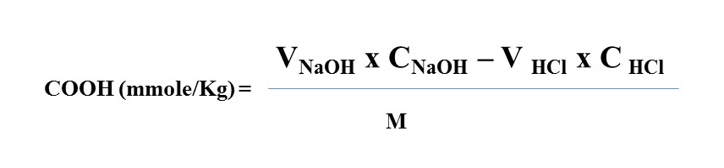
Were V_{NaOH} and V _{HCl} are the volume of standard NaOH used and standard HCl consumed respectively , C_{NaOH} and C _{HCl} are the morality of NaOH and HCl respectively and M is the weight of the analyzed sample.

2.4. Adsorption of different metal cation by prepared exchanger
Atypical adsorption experiment was conducted as follows the stock solution of Cu⁺⁺ Zn ⁺⁺and Hg⁺⁺ (200mg /L) was prepared by dissolving a certain amount of AR grade acetate salt from “Merk” in 1000ml deionized water. 25mg of modified and unmodified bacterial cellulose was added to 50 ml Erlenmeyer flask containing 25 ml solution of metal ion magnetically stirred at 120 rpm. pH adjustment was done using buffer solution from “Aldrich”. After stirring, the samples were filtered through membrane and the residual metal cation concentration in the filtrate was determined by atomic adsorption spectrophotometer. The amount of adsorption at equilibrium q_{e} (mg/g) and the percentage removal efficiency (%R) were calculated according to equations:
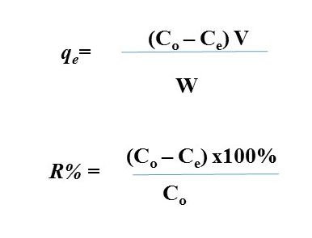
Where, C_{o} and C_{e} are the initial and equilibrium solution concentration of Cu⁺⁺ Zn⁺⁺ and Hg⁺⁺ respectively. V is the volume of the solution and W (g) is the weight of the used biosorbent and q_{e} is the equilibrium adsorption capacity (mg/g).

2.5. Desorption and Reusability of Prepared Exchanger
The regeneration of BC and functionalized BC were conducted using 0.1 mole NaCl solution as desorbing agent. The desorption lasted for 4hr under constant magnetic stirring (120 rpm) followed by repeatedly rinsing with deionized water to neutral pH.

2.6. Characterization of the Prepared Ion Exchanger
2.6.1. FTIR spectrophotometer
FTIR Using Nexus670 FTIR spectrophotometer (Leletco.USA)to verify the presence of carboxylic groups function on the surface the bacterial cellulose, FTIR was done.
2.6.2. SEM Scanning Electron Microscope
The morphology of the biosorbent was observed before and after adsorbent of metal ions usingJoel JXA840 electron probe microanalyzer, Japan

3. Results and Discussion
3.1. Ion Exchange Preparation
The protocol for synthesis of carboxylic groups in cellulose were done in our previous work [9-14].The hydroxyl groups in BC were treated with succinic anhydride to yield the stable ester and free carboxylic acid end groups, thereby increasing the number of adsorption sites on the BC surface for metal cation. Since the esterification reaction can be catalyzed by an acid or base; we used triethylamine of weak base. Triethylamine is an excellent catalyst and ensures that 70% of succinic anhydyride is consumed [15] sodium carbonate offers amildly basic condition to deprotonate the free carboxylic acid groups and converts them to their sodium salt without destroying ester bond.
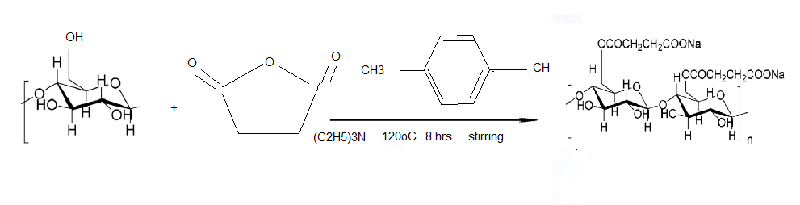
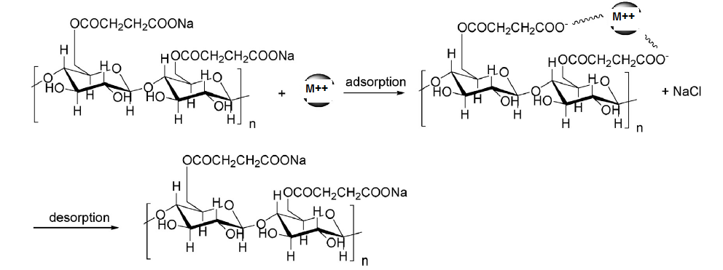
Figure (1); Reaction mechanism, adsorption and desorption cycle

The prepared ion exchanger contain (220 mmole COOH /g sample). The modification of BC was confirmed by FTIR Spectroscopy.Figure [2] shows FTIR spectra of modified and unmodified BC. Three Major different between the two spectra can be observed. The peak at 1720 cm⁻¹, in the modified BC spectrum corresponds to the adsorption of carbonyl bonds of both esters and carboxylic acid groups. The band in the 3468.89cm⁻¹in the modified BC spectrum can be ascribed to the O-H stretching bands of the terminal carboxylic acid. And the lastly, the increase and decrease in the intensities of the absorption bands at 1170.58 cm⁻¹and 1074.16 cm⁻¹ for modified BC can be attributed to C-O asymmetric stretching and C-O-C band stretching, respectively. These changes confirm the succinylation of BC, one of the carboxylates is involved in the ester bond with hydroxyls on the surface of BC while the other (as a carboxylic acid) is dangling free [16] (Aziz et at ,2009)

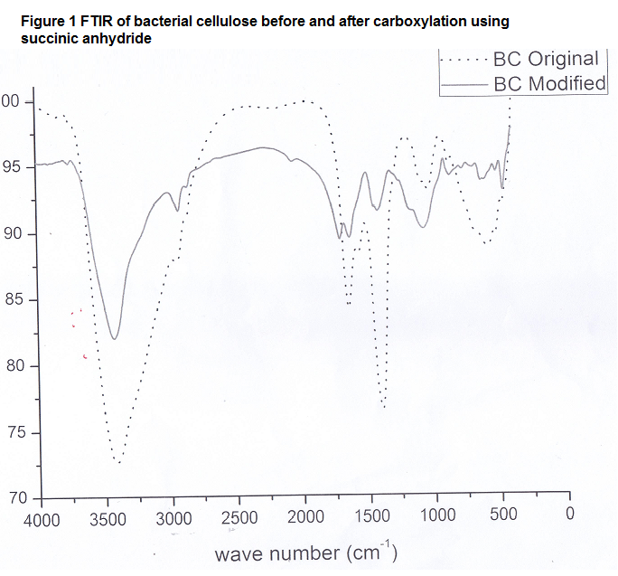
Figure 2 FT IR of bacterial cellulose before and after carboxymethylation using succinic anhydride

3.2. Adsorption mechanism
To investigate the adsorption mechanism it is necessary to the pH of solution to obtain maximum adsorption. From our previous work (9-14) normally, metal adsorbents exhibit adrastic decrease in metal affinity at low pH less than 3 due to decomplexation of the metal ions in the stronger acidity medium. Table 1 Shows optimal, pH’s for Cu⁺⁺,Zn⁺⁺ and Hg⁺⁺ respectively, absorbance capacities for modified and unmodified bacterial cellulose and adsorption percentage.
Table 1 Adsorption capacities and percentage for modified and unmodified BC
Adsorbance Capacities mg/g |  |  |  | PH | Metal Cation
Modified BC |  | Unmodified BC |  | PH
Absorbance% | 180 | Absorbance% | 140 | 4 | Cu⁺⁺
81.8% | 180 | 63.6% | 140 | 4 | Cu⁺⁺
79.5% | 175 | 61.3% | 135 | 4 | Zn⁺⁺
78.1% | 172 | 60% | 132 | 4.5 | Hg⁺⁺

The results indicate that the carboxyl groups anchored on to BC play on important role in the adsorption. The adsorption process at optimal condition, where, time (3h), at room temperature, Liquor ratio (1:2)and every metal cation has its own pH 14. To investigate the adsorption mechanism, it is necessary to detect the pH the solution during the adsorption. From our previous work, when the value of pH<4, a significant electrostatic repulsion exists between the positively charged surface of the adsorbent and metal cation. For pH>= 4 the pH value for the experiment is high, which leads to the deprotonation of positively charged groups on the adsorbent. This leads to an increase in the adsorption capacity of the prepared exchanger because of electrostatic attraction between negatively charged sites on its surface and metal cations. unmodified BC had affinity towards adsorbance of metal cation due to the presence of free OH groups which can chelate and form complex compound with the metal cation with percentage 63.6% , 61,3% and 60% for Cu⁺⁺,Zn⁺⁺ and Hg⁺⁺ respectively .
For modified BC the adsorbance % of metal cations removal from solution are 81.8%Cu, 79.5% (Zn⁺⁺)and 78% (Hg⁺⁺) respectively i.e., in the order of decreasing ionic radii.
The proportion of the metal ions adsorbed due to the incorporated carboxylic groups is higher than unmodified BC. The interaction of metal cations with polyelectrolyteshas been reported by several workers [17-20]. The results from these studies show that one metal ion is involved inchelation with two carboxylate (possibility adjacent) groups. This intermolecular association through metal ions causes configurational changes leading to the formation of metal polyelectrolyte complexes. It would be expected that for slightly bigger ions, such as Hg⁺⁺the requirements for polyelectrolyte – metal ion interaction could be different and that these metal ions less readily than Cu⁺⁺. The enhanced metal ion binding of the bacterial cellulose brought about by the incorporation of carboxylic groups can be explained in terms of additional binding sites for the metal ions. Besides, the enhanced swelling of the substrate by the metal ions solution brought about by the interposition of carboxylation would lead to increased uptake of metal ions.

3.3. Reusability of Prepared Exchanger
Table 2
Metal ions | Zerocycle mg/g | 1Cycle | 2Cycle | 3Cycle | 4Cycle | 5Cycle | Decreasing%
Cu ⁺⁺ | 180 | 178 | 175 | 174 | 173 | 172.8 | 4%
Zn ⁺⁺ | 175 | 174 | 173 | 172.5 | 172.3 | 172 | 1.71%
Hg ⁺⁺ | 172 | 171.3 | 171.1 | 171 | 170.4 | 170.2 | 1.04%

For potential practical application, it is important to examine the possibility of desorbing the metal ions adsorbed on prepared exchanger and reusing them [8]( Liu& Bai, 2006). The effect of five adsorption- desorption consecutive cycles the efficiency of the adsorption of Cu^{++,} Zn⁺⁺and Hg⁺⁺ on exchanger was studied Table 2 shows the corresponding desorption efficiencies obtained, it was found that the Cu⁺⁺, Zn⁺⁺ and Hg⁺⁺ adsorbed on modified BC were easily desorbed.
The desorption efficiency reached about 90% after the first cycle. the using of NaCl solution offers mild conditions and does not destroy the sensitive bacterial cellulose structure or the active sites[21],and is therefore suitable as the desorption solution. The results from five replicates of adsorption – desorption 4%, 1.71%, 1.04% decrease in the adsorption capacity after five cycles underscores the reusability at the adsorbent.
3.4. SEM surface morphology analysis
The SEM was recorded in order to provide further confirmation on the formation of metal cation complexes on BC surfaces. And also identify their position figure 3 shows the SEM of samples by scanning with a focused bean of electron. SEM micrographs of modified bacterial cellulose indicated in figure (a) The main structures of these samples display ahomogeneous phase in both surface and cross-section and shows a relatively compact structure and smooth, which indicates that the carboxylic groups nearly homogenous cover the surface of BC , thus improving the metal adsorption capacity as wells the adsorption speed. After metal cation adsorption the morphology at the surface show more compact smoother and the metal cation were spreading on the BC surface (all the illuminated area in each image b, c and d which means that the carboxylic groups were in homogenous distribution on the BC surface. In light of this approach, bacterial cellulose is reactive towards metal ion adsorption and has highest ion exchange efficiency after functionality. The modified BC sequestered more metal cation than a comparable unmodified BC, where the electrostatic attraction (between deprotonized carboxyl groups and metal cation) was the major removal mechanism.
Figure 3 (a) SEM of carboxylated bacterial cellulose before adsorption

Figure3 (b) SEM of carboxylated bacterial cellulose after Cu⁺⁺ adsorption

Figure 3 (c) SEM of carboxylated bacterial cellulose after Hg⁺⁺ adsorption

Figure3 (d) SEM of carboxylated bacterial cellulose after Zn⁺⁺ adsorption

4. Conclusion:
- Preparation of bacterial cellulose using Egyptian bacteria isolated in our laboratory from rotten apple
- Preparation of ion exchanger based on prepared BC and functionalized by succinic anhydride
- Adsorption of heavy metal cation from waste water
- Desorption cycles for reusability

5. References
1 | Chen, Shiyan, et al. "Carboxymethylated-bacterial cellulose for copper and lead ion removal." Journal of Hazardous Materials 161.2 (2009): 1355-1359.
2 | Farag, S., and Sheikha Saad Al Abdel Kareem. "Different natural biomasses for lead cation removal." Carbohydrate polymers 78, no. 2 (2009): 263-267.
3 | Hashem, Abdel-Lateff, Farag, and Hussein. "Treatment of alhagi residues with tartaric acid for the removal of Zn (II) ions from aqueous solution." Adsorption Science & Technology 26, no. 9 (2008): 661-678.
4 | Jonas, Rainer, and Luiz F. Farah. "Production and application of microbial cellulose." Polymer Degradation and Stability 59.1 (1998): 101-106.
5 | S. Farag, M. M. Askar, A. Amr, H. M. Ibrahim and A. El-Shafi. “Biosynthesis And Characterization of Bacterial Cellulose Using Agricultural Wastes”. Accepted for publication in (ICCEE) International Chemical Civil and Environmental Engineering. (2015). Malaysia.
6 | Guo, Hong, Shufen Zhang, Zinong Kou, Shangru Zhai, Wei Ma, and Yi Yang. "Removal of cadmium (II) from aqueous solutions by chemically modified maize straw." Carbohydrate polymers 115 (2015): 177-185.
7 | Klemm, Dieter, Friederike Kramer, Sebastian Moritz, Tom Lindström, Mikael Ankerfors, Derek Gray, and Annie Dorris. "Nanocelluloses: a new family of nature‐based materials." Angewandte Chemie International Edition 50, no. 24 (2011): 5438-5466.
8 | Liu, Chunxiu, and Renbi Bai. "Adsorptive removal of copper ions with highly porous chitosan/cellulose acetate blend hollow fiber membranes." Journal of Membrane Science 284, no. 1 (2006): 313-322.
9 | S. Farag, M. A. Abdel Fatah, M. A. Ramadan and E. A. El-Alfy. “super absorbent hydrogel based on poly (AN) starch composite for removal of cupric ions from aqueous solutions”. Egyp. J. Text. Polym. Sci. Technol. 13 No. 2, PP. 161-174, (2009)
10 | Farag, S., and E. I. Al-Afaleq. "Adsorption behavior of copper cation on palm shell as bioadsorbent." Journal of Saudi Chemical Society 13, no. 1 (2009): 135-146.
11 | Farag, S. "Synthesis and Physicochemical Studies of Starch‐Sulphonated Phenol Formaldehyde Cationic Exchangers." Starch‐Stärke 47, no. 5 (1995): 192-196.
12 | Khalil, M. I., and S. Farag. "Utilization of some starch derivatives in heavy metal ions removal." Journal of applied polymer science 69, no. 1 (1998): 45-50.
13 | Khalil, M. I., and S. Farag. "Preparation and Utilization of Some lon‐Exchange Starches." Starch‐Stärke 46, no. 1 (1994): 17-22.
14 | Khalil, M. I., S. Farag, and A. Hebeish. "Preparation and Characterization of Cationexchange Starches Containing Carboxyl Groups." Starch‐Stärke 43, no. 7 (1991): 254-261.
15 | Yu, Xiaolin, Shengrui Tong, Maofa Ge, Lingyan Wu, Junchao Zuo, Changyan Cao, and Weiguo Song. "Adsorption of heavy metal ions from aqueous solution by carboxylated cellulose nanocrystals." Journal of Environmental Sciences 25, no. 5 (2013): 933-943.
16 | Aziz, Abdellah, El Hadj Elandaloussi, Belkacem Belhalfaoui, Mohand Said Ouali, and Louis Charles De Ménorval. "Efficiency of succinylated-olive stone biosorbent on the removal of cadmium ions from aqueous solutions." Colloids and Surfaces B: Biointerfaces 73, no. 2 (2009): 192-198.
17 | Zhong, Qian-Qian, Qin-Yan Yue, Qian Li, Bao-Yu Gao, and Xing Xu. "Removal of Cu (II) and Cr (VI) from wastewater by an amphoteric sorbent based on cellulose-rich biomass." Carbohydrate polymers 111 (2014): 788-796.
18 | Shen, Wei, Shiyan Chen, Shuaike Shi, Xin Li, Xiang Zhang, Weili Hu, and Huaping Wang. "Adsorption of Cu (II) and Pb (II) onto diethylenetriamine-bacterial cellulose." Carbohydrate polymers 75, no. 1 (2009): 110-114.
19 | Sanyang, Lamin, Wan Azlina Wan Ab Karim Ghani, Azni Idris, and Mansor Bin Ahmad. "Zinc Removal from Wastewater Using Hydrogel Modified Biochar." In Applied Mechanics and Materials, vol. 625, pp. 842-846. 2014.
20 | Keshk, Sherif MAS, and Mohamed S. Omar. "Bacterial Cellulose and Its Phosphonic Dichloride for Efficient Removal of Metal Ions." American Journal of Polymer Science 4, no. 2 (2014): 46-53.
21 | Belhalfaoui, Belkacem, Abdellah Aziz, El Hadj Elandaloussi, Mohand Said Ouali, and Louis Charles De Ménorval. "Succinate-bonded cellulose: A regenerable and powerful sorbent for cadmium-removal from spiked high-hardness groundwater." Journal of hazardous materials 169, no. 1 (2009): 831-837.

