A study of constructed wetland on overflow land type upgrading campus sewage effluent
T. Y. Yeh1*
1Department of Civil and Environmental Engineering, National University of Kaohsiung, Taiwan

Correspondence to:
Prof. T. Y. Yeh
National University of Kaohsiung
Department of Civil and Environmental Engineering
Kaohsiung 811, Taiwan
Tel: 886-7-591-9536 Fax: 886-7-591-9376
E-mail: tyyeh@nuk.edu.tw

Abstract
The merits of constructed wetlands are ecosystem protection, water quality enhancement, and wastewater treatment. Campus wastewater plant effluent via overflow land constructed wetland was studied in this research. Nutrients and organic matters were demonstrated effectively via sedimentation, microbial-degradation, and plant uptake. SS、COD、DO、NH4+、NO3-N removal were also researched. Total nitrogen, total phosphorus, ammonium nitrogen removal rate were 84.1％, 47.9％, and 84.6％, respectively. The microbial genetic monitoring results showed Salmonella spp. and Listeria monocytogenes were not existed in soil and sediment. Macrophytes harvesting and sediments dredging are the promising approaches to remove nutrients and organic matters in this studied constructed wetland.

Keywords Constructed wetland, organic matters, nutrients, sediment, microbial identification, PCR

Introduction

Constructed wetland is a man-made facility to mimic natural ecosystems treating wastewater. The removal mechanisms include filtration, adsorption, precipitation, microbial degradation, and microbial adsorption. Constructed wetland also can provide ecological habitat and landscape enhancement.

In Taiwan, constructed wetland has been employed to treat sewage, piggery, and aquaculture wastewater. Campus waster often fluctuates up and down and hard to manage. By virtue of constructed wetland, used wastewater can be recycled and sustainable water resources can be achieved.

Materials and methods
Study site
The overflow land constructed wetlands are situated in the University of Kaohsiung campus (22o73’N, 120o28’E). The length, width, average depth and flow velocity were 585m,5.2m, 0.5m and 67.5m/hr (1.88cm/s) respectively, while the detention pond at point has a depth of 1.2m.

Water quality analysis
Water parameters, including particulate matter (SS), and nutrients (Nitrogen and Phosphorus) were investigated.

Microbial PCR analysis
Deoxyribonucleic acid (DNA) extraction and polymerase chain reaction- denaturing gradient gel electrophoresis (PCR-DGGE) analysis were analyzed according to Boon et al. (2001). The Wizard DNA Clean-Up Kit (Promega, Madison, Wisconsin) was used to detect microbial community dynamics in the process of nitrogen transformation in the 1-g sediment samples from surface-flow wetlands. Bacterial200-bp fragments of 16S rDNA V3 region for subsequent denaturing gradient gel electrophoresis (DGGE) analysis were obtained with the primer combination of 341 f with a gas chromatography clamp (40-nucleotide GC-rich sequence, 5-CCTACGGGAGGCAGCA G-3)and 534r (5-ATTACCGCGGCTGCTGG-3).

The PCR mixtures contained 10 ng of DNA extract, 4 pmol of each primer, and 5 U of Taq polymerase (Takara, Shiga, Japan) in the final concentration of 2.5 mM of Mg C12 and 0.12 mM ofdeoxyribonucleoside triphosphates in PCR buffer. The PCR amplification was conducted for 35 cycles: denaturation at 94°C for 1 min, annealing at 55°C for 1 min, and extension at 72°C for 2 min. The equal concentration of each amplified PCR product (2500 ng) was further performed with DGGE using a Bio-Rad DCode system (Bio-Rad, Hercules, California), as described by the manufacturer. The 10% Polyacrylamide gel with a 30 to 60% denaturant gradient was used, and electrophoresis was performed at 60°C and 70 V for 14 h. The gels were then stained with SybrGreenl and photographed. The relative intensity of amplified bands in the gels was analyzed with Phoreti ID software (Nonlinear Dynamics, Newcastle upon Tyne, United Kingdom). The PCR-amplified products were eletro-eluted from gel and then sequenced by provider (MdBio, Taipei, Taiwan).
Those sequences were evaluated using the basic local alignment search tool (BLAST) to determine the closest relatives in the GenBank databases (www.ncbi.nlm.nih.gov). Alignment of nucleotide sequences of PCR-amplified products generated a matrix of similarity coefficients with the neighbor-joining method (Saitouand Nei, 1987). The dendrogram based on the similarity coefficient was plotted with un-weighted pair-group method with arithmetic mean (UPGMA) method for clustering (Felsenstein, 1993).

Data and Statistical analysis
Data were evaluated relative to the control to understand their statistical variations. A triplicate of water and sediment samples were measured and recorded for statistical analyses. Statistical significance was assessed using a mean comparison test. Differences between treatment concentration means of parameters were determined by Student’s t test. One-way ANOVA was also employed to show the variation among sample groups, level of p < 0.05 considered statistically significant was used in all comparisons. Means are reported mean ± standard deviation. All statistical analyses were performed with Microsoft Office EXCEL 2007.

Results and discussion

- Microbial identification
PCR was monitored and shown in fig. 2 and 3. The length of the water channel is 585m while velocity is 67.5 m/hr(0.0188 m/s)，
River water depth of about 0.15-0.2 m. The W*D = 5.12 m *0.9 m. The sampling time is PM13:00 , the duration is 3 months stared from March 5, 2016.The water quality parameters are reported in Table 3.

Door coli (Salmonella spp.) Gram-negative bacilli, spore, Tony flagellated good at sports, under aerobic or facultative anaerobic, thermal weak acidic environment (PH <4.5) their development will be inhibited.
Listeria (scientific name: Listeria monocytogenes), and a list of monocytes Listeria, Listeria is a facultative anaerobic bacteria, the disease pathogen Listeria. It is mainly food-vector, is one of the deadliest food-borne pathogens, resulting in two to three percent of those infected. In which Listeria's disease is a major cause of death, the death rate is even higher than salmonella and botulism.
Listeria genus of gram-positive bacteria, environmental adaptability, widely distributed in nature, often found in soil, plants and saprophytic many mammals feces, which results in Figure 2 to Figure 3.
- pH
The pH data are in fig. 4. The influent is 7.29, midpoint is 7.7 while effluent is 7.7. The decrease of pH indicates precipitation and nitrification occurred.
3. DO
DO plot is in fig.5. The influent is 5.0±0.4mg/L, the efflurnt is 7.3±0.07mg/L while the most eutrophic point recreation pond is 2.11±0.13mg/L. The DO results indicate eutrophication will reduce dissolved oxygen.

4. SS
Suspended solid results are recorded in fig. 6. The influent is 9±6mg/, the effluent is 58.3±54.8mg/L while the recreation pond is 11±3.4mg/L. Leaves, grit, and algae accumulation induced the sudden increase of suspended solid.
5. Turbidity
The turbidity results are in fig.7. The influent is 9.22±3.54(NTU), the effluent is 11.7±2.86(NTU) while the recreation pond is 29.2±5.58(NTU). Algae growth is strongly corrected with the turbidity.
6. Ammonium nitrogen
The ammonia nitrogen is recorded in fig. 9. The influent is 38.2±5.0 mg/L, the effluent is 28.3±2.59mg/L while the recreation pond is 28.3±2.59mg/L. The total ammonium nitrogen removal rate is 84.6％. External feeding caused in the jump of ammonium nitrogen concentration.
7. Total nitrogen
The total nitrogen results are in fig. 10. The influent is 35.67±25.38mg/L, the effluent is 5.67±7.37g/L while the recreation pond is 20±10mg/L. The promising total nitrogen removal indicated nitrification and denitrification occurred.
8. Total phosphorus
The total phosphorus data are in fig.10. The influent is9.53±1.01mg/L, the effluent is 14.2±5.86mg/L while the recreation pond is 14.2±5.86mg/L. The total phosphorus removal rate is 47.9％. The phosphorus removal is not very significant in the studied system which is consistent with previous study.
9. SOD
Determination of SOD is an indicator of river has a greater impact on the natural water of dissolved oxygen. Research has pointed out, SOD may account for the rivers of the total oxygen consumption of 40-50%, the ability to understand the purpose of measuring the sediment in water consumption of dissolved oxygen (DO) of the studied system.
10. Methane emission
The methane emission is increase in day time and decrease at night. Methane anaerobic microbial-degradation is the major reason.

Conclusion

Nitrification occurred in the low organic condition and sufficient oxygen. Plant uptake might induce nitrogen decreasing. Nitrification and denitrification also play the important roles. The microbial genetic monitoring results showed Salmonella spp. and Listeria monocytogenes were not existed in soil and sediment.It is promising to employ constructed wetlands to enhance water quality in tropical regions like Taiwan.

References
An, Y.J., Kampbell, D.H., Breidenbach, G.P. (2002) Escherichia coli and total coliforms in water and sediments at lake marinas. Environmental Pollution, 120, 771-778.

Alvarez, J.A., Becares, E. (2006) Seasonal decomposition of Typha latifolia in a free-water surface constructed wetland. Ecological Engineering, 28, 99-105.

Aslam, M.M., Malik, M., Baig, M.A. (2007) Treatment performances of compost-based and gravel-based vertical flow wetlands operated identicaly for refinery wastewater treatment in Pakistan, Ecological Engineering, 30, 34-42.

Bavor, H.J., Roser, D.J., Smalls, I.C. (1989) Performance of solid-matrix wetland systems viewed as fixed film bioreactors. Constructed Wetlands for Wastewater Treatment Municipal, USA.

Bartram, J., Burch, M., Falconer, I., Jones, G. (1999) Situation assessment,

planning and management, In: World Health Organization, editor. Toxic cyanobacteria in water. Monitoring and Management, LONDON.

Bojcevska, H., Tonderski, K. (2007) Impact of loads, season, and plant species on the performance of a tropical constructed wetland polishing effluent from sugar factory stabilization ponds. Ecological Engineering, 29, 66-76.

Brix, H. (1997) Do Macrophytes play a role in constructed treatment wetland?. Water Science Technology, 35. 11-17.

Campbell, C.S., Ogden, M.H. (2005) Constructed Wetlands in the Sustainable Landscape, John Wiley & Sons Lnc, Chichester, New York.

Calheiros, C.S.C., Rangel, A.O.S.S., Castro, P.M.L. (2007) Constructed wetland systems vegetated with different plants applied to the treatment of tannery wastewater. Water research, 41, 1790-1798.

Chen, X.C., Kong, H.N., He, S.B., Wu, D.Y., Li, C.J., Huang, X.C. (2009)
Reducing harmful algae in raw water by light-shading. Process Biochemistry, 44, 357-360.

Chung, A.K.C., Wu, Y., Tam, N.F.Y. (2008) Nitrogen and phosphate mass balance in a sub-surface flow constructed wetland for treating municipal wastewater. Ecological Engineering, 32, 81-89.

Davis, K., Anderson, M.A., Yates, M.V. (2005) Distribution of indicator bacteria in Canyon Lake California. Water Research, 39, 1277-1288.

Dierberg, F.E., DeBusk, T.A. (2008) Particulate phosphorus transformations in south Florida stormwater treatment areas used for Everglades protection. Ecological Engineering, 34, 100-115.

Fleming-Singer M.S., Horne A.J. (2006) Balancing wildlife needs and nitrate removal in constructed wetlands: The case of the Irvine Ranch Water District’s San Joaquin Wildlife Sanctuary. Ecologic Engineering, 26, 147-166.

Table 1. Wetland overland flow system overall removal efficiency
Table 2. Wetland overland flow system overall removal efficiency
Table 3. Wetland overland flow system overall removal efficiency

Table 1. Wetland overland flow system overall removal efficiency
Water background  parameter | T  (℃) | H⁺  (mg/L) | Conductivity  (μs) | ORP  (mv) | TDS  (ppm) | SALT  (ppm) | Turbidity  (NTU)
In put | 25.8±  1.41 | 7.55±  0.42 | 1049.33±23 | 117.33±3.05 | 691.67±  15.04 | 543.67±25.14 | 9.22±3.53
Out put | 27.7±  0.57 | 7.30±  0.07 | 760.67±17 | 112.33  ±1.52 | 501.67±  12.013 | 380±9 | 29.23±5.56
Table 2. Wetland overland flow system overall removal efficiency

背景水質  參數 | 懸浮  固體  S.S  (mg/L) | D.O  溶氧  (mg/L) | BOD  (mg/L) | COD  (mg/L) | (NH3-N)  (mg/L) | NO₃⁻  (mg/L) | T.N  (mg/L)
In put | 23.8±  6.45 | 5.0±0.4 | 66.2±7.9 | 83.5±5.13 | 38.2±5.0 | 0.3±0.1 | 36.1±2.21
Out put | 7.40±  1.34 | 7.82±0.15 | 11.7±0.25 | 36.1±2.21 | 13.1±1.6 | 0.7±0.2 | 5.61±7.37
Table 3. Wetland overland flow system overall removal efficiency
背景水質參數(mg/L) | 硫酸根  (SO⁴₂⁻) | 磷酸鹽  (PO₄²⁻) | 總磷  (T.P)
In put | 116.6±37.8 | 9.1±0.1 | 21.5±9.12
Out put | 110.0±17.3 | 7.5±0.5 | 14

Fig 1. overland flow system and aerial schematic side
Fig 2. Soil and sediment microbio analysis, Salmonella
Fig 3. Soil and sediment microbio analysis, Listeria
Fig 4. pH changes in Water
Fig 5. Changes of dissolved oxygen water quality
Fig 6. Changes of suspended solids in water quality
Fig 7. Change the water turbidity
Fig 8. Wetland water through the filter case
Fig 9. Changes of ammonia water quality
Fig 10. Change the water quality of T.N
Fig 11. The change of total phosphorus
Fig 12. Change the water quality of COD

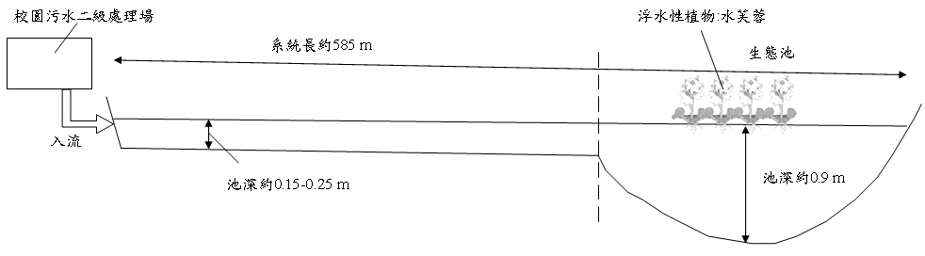
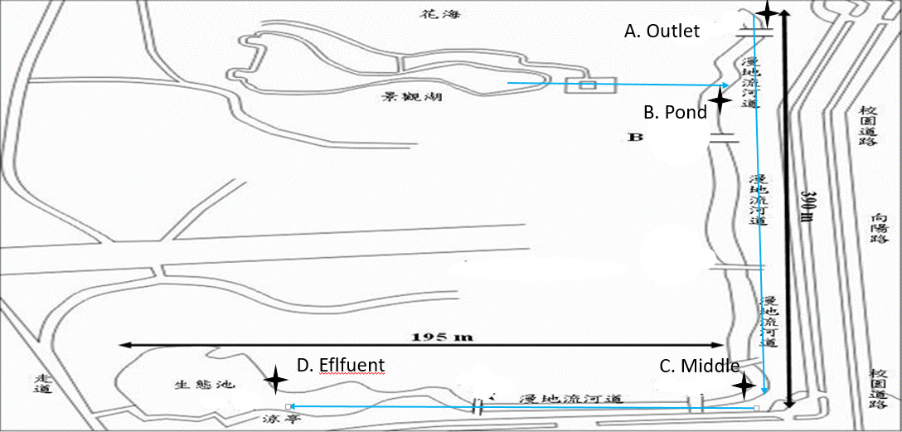

Fig1、overland flow system and aerial schematic side

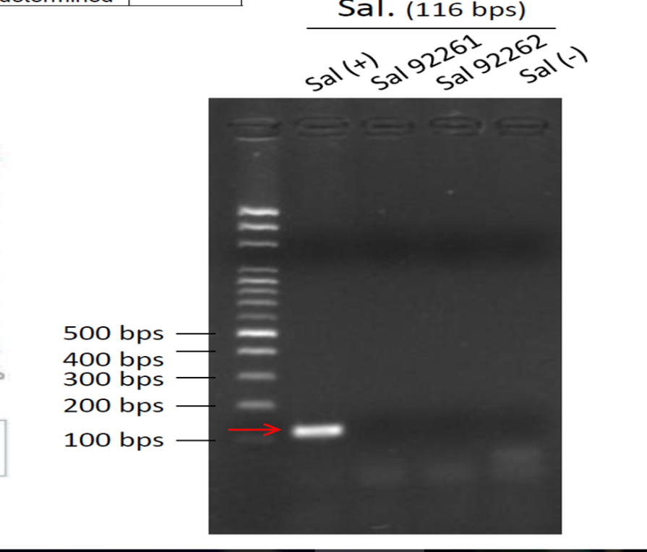
Fig 2、Soil and sediment microbio analysis, Salmonella

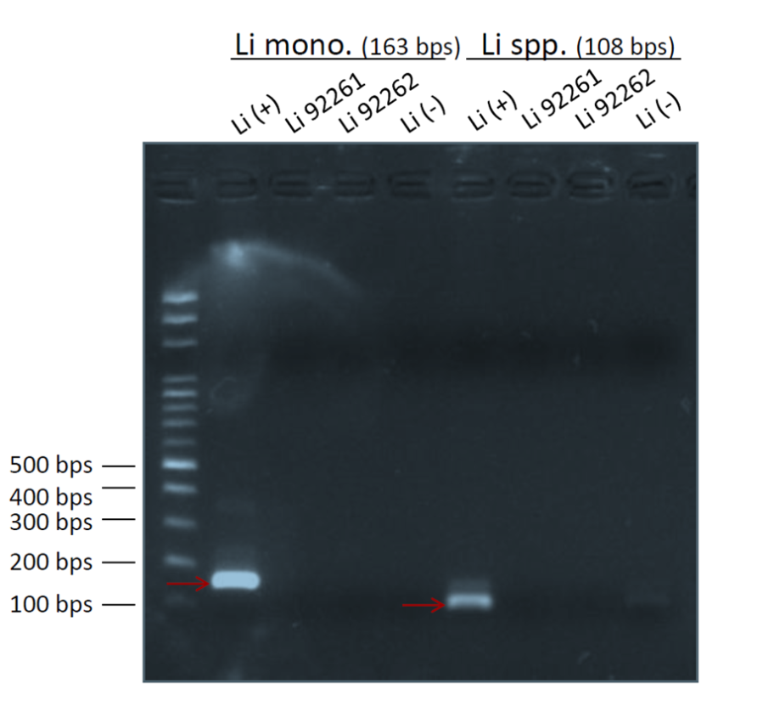
Fig 3、Soil and sediment microbio analysis, Salmonella

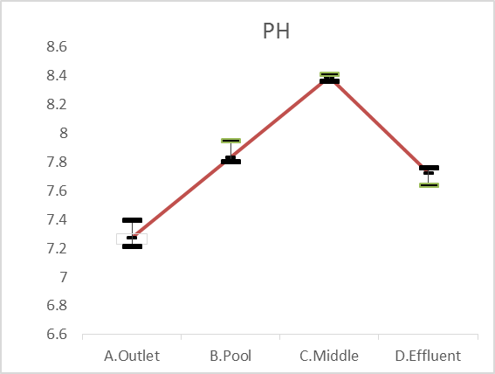
Fig 4. pH changes in Water

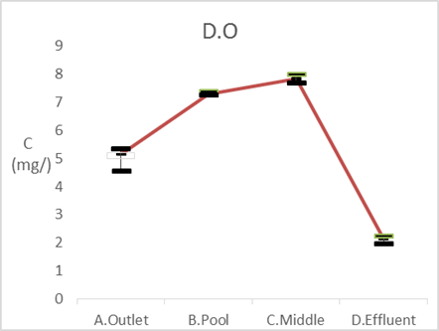
Fig 5. Changes of dissolved oxygen water quality
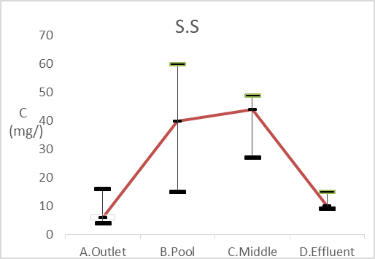
Fig 6. Changes of suspended solids in water quality

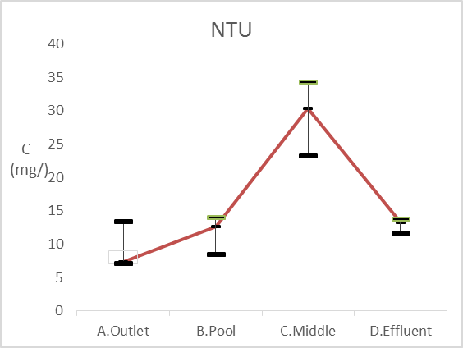
Fig 7. Change the water turbidity
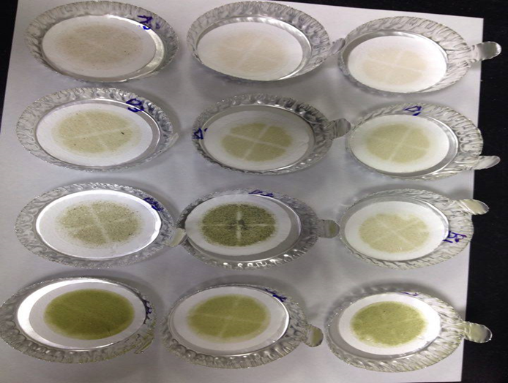
Fig 8. Wetland water through the filter case

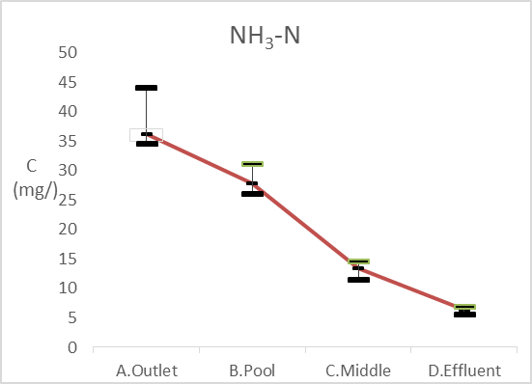
Fig 9. Changes of ammonia water quality
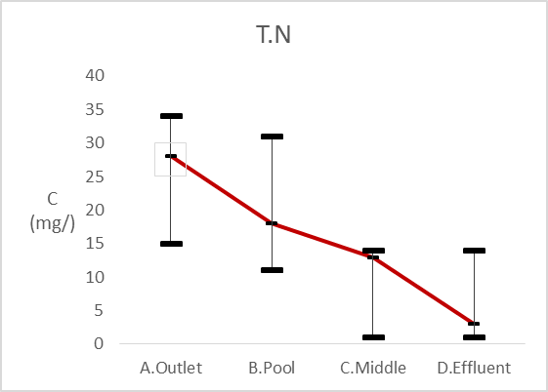
Fig 10. Change the water quality of T.N
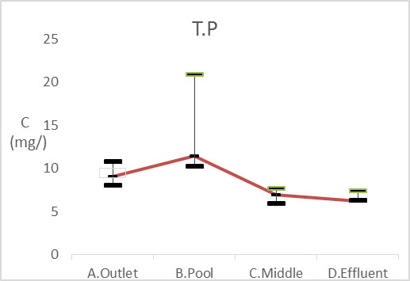
Fig 11. The change of total phosphorus

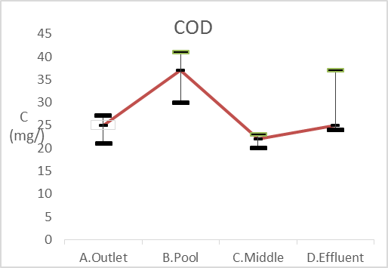
Fig 12. Change the water quality of BOD

